**How you used the “str” and “hist” commands in the R Programming exercise along with the outcome of the “str” command and the plot generated by the “hist” command.**

By using these following syntaxes, I have executed all these commands in Rstudios. To obtain the desired outcome.

1. **load “usedcars.csv” dataset and store it into a local R variable named “usedcars” using “read.csv” R command.**

To extract the data from the file .csv we need to use these syntaxes in Rstudios.

* This is the Syntax to read the data: name <- read.csv (“file”, header, stringsAsFactors)
* File is file name that is “usedcars”
* Header is if true or false, true – when there is a column names in that table, false – when there is no column names for that table.
* StringsAsFactors to override the default behavior for R.
* ‘,’ (sep) this semi-colon separated file to e correctly imported.
* Display <- read.csv(“usedcars(1).csv”, TRUE) I have used it in Rstudio as shown in the screen shot below.

1. **Display the structure of the “usedcars” variable using the “str” R command**.

I have used this str command in Rstudio by using syntaxes below:

* Str(name) - where it displays the structure of the data frame using the structure function.
* Class(name) - to take look at the data class.
* Head(name) – the data is the result.

1. **Draw a histogram that shows the number of cars manufactured on each year using “hist” R command.**

To draw a histogram for the number of cars manufactured on each year I have used the following syntaxes:

* Hist(name$columnname)
* $ - we can extract data from specific column.

In below screenshot you will find the execution of the syntaxes mentioned above.

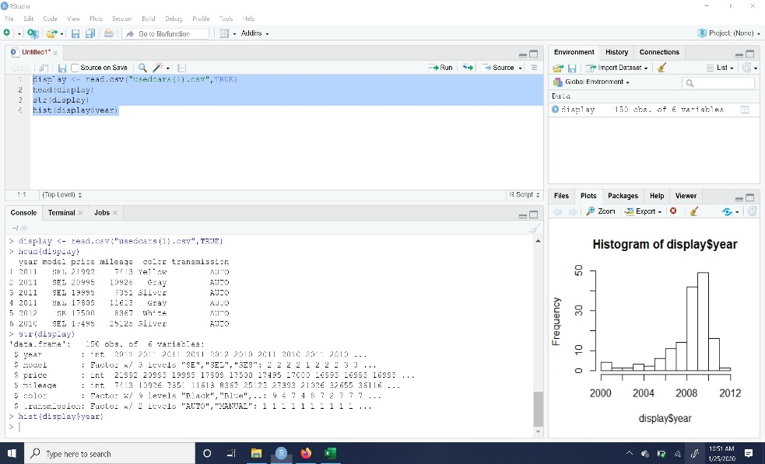

The below graph shows the bar graph of the number of cars manufactured on each year, in X-axis we have years, in Y-axis we have frequency.

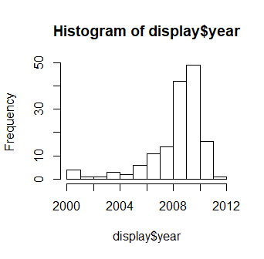

**What are your interpretations of the histogram data/plot?**

It is a visual representation of a data from datasets. Histogram consists of both X and Y axis. There are various bars of different heights. The bars in histogram is often called as bins.

* **Advantages**: Histogram works with vast range of data. It provides more concrete form of consistency, as the intervals are always equal. Like it studies the process of the data that is collected from an outcome. Usually the y-axis is a frequency count of items that are falling into each category. Examples are marks obtained by students; I found some images in internet to get clear understanding of the histogram like below:

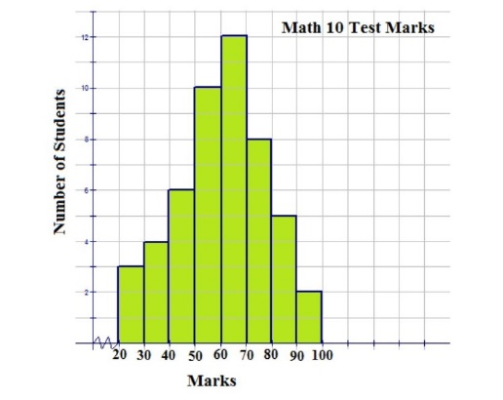

* **Disadvantages**: It can’t intercept the exact reading because it is grouped into categories. It is very tough to relate any two sets of data. It can only use continuous data like some measurements, years etc.

**What interesting insights you can draw from the plot?**

Histogram tells us not only with the bar graph but also it can compare to normal curve. As we can also fill in the colors in bins and we can also use colors for borders of bins too. We can also change the labels on x- axis and y- axis. We have xlim and ylim to divide the axes range. These are few interesting facts that I can draw from this plot. I took an example from internet to describe my understanding:

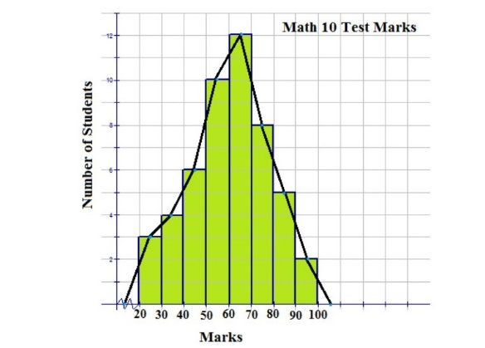

**References**:

1. <https://swcarpentry.github.io/r-novice-inflammation/11-supp-read-write-csv/>
2. <https://swcarpentry.github.io/r-novice-inflammation/10-supp-addressing-data/>
3. <https://www.datacamp.com/community/tutorials/make-histogram-basic-r?utm_source=adwords_ppc&utm_campaignid=1565261270&utm_adgroupid=67750485268&utm_device=c&utm_keyword=&utm_matchtype=b&utm_network=g&utm_adpostion=1t1&utm_creative=295208661514&utm_targetid=aud-299261629574:dsa-473406586075&utm_loc_interest_ms=&utm_loc_physical_ms=9001834&gclid=CjwKCAiA66_xBRBhEiwAhrMuLYnTW5l_oE46uoZzZjAz1LB9FfWogZasZNSHlUoC5ocCyn8QH7Q59RoCSTMQAvD_BwE>
4. In Rstudio type help (hist) in console, then press enter you get all the information of histogram in Rstudio.
5. <https://stat.ethz.ch/R-manual/R-devel/library/graphics/html/hist.html>
6. <https://histogramsdennard.weebly.com/pros-and-cons-of-histograms.html>
7. <https://www.scribd.com/doc/286371635/advantages-and-disadvantages-pictures>