**R commands:**

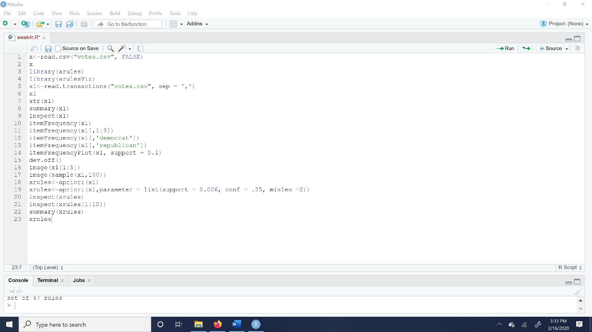

**There outcomes:**

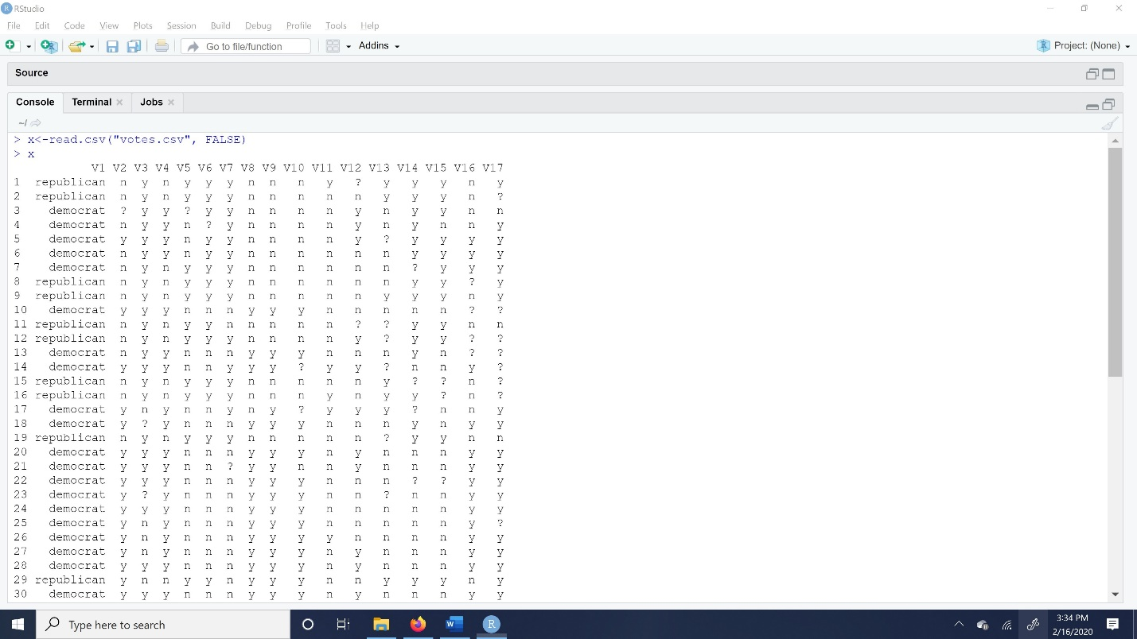

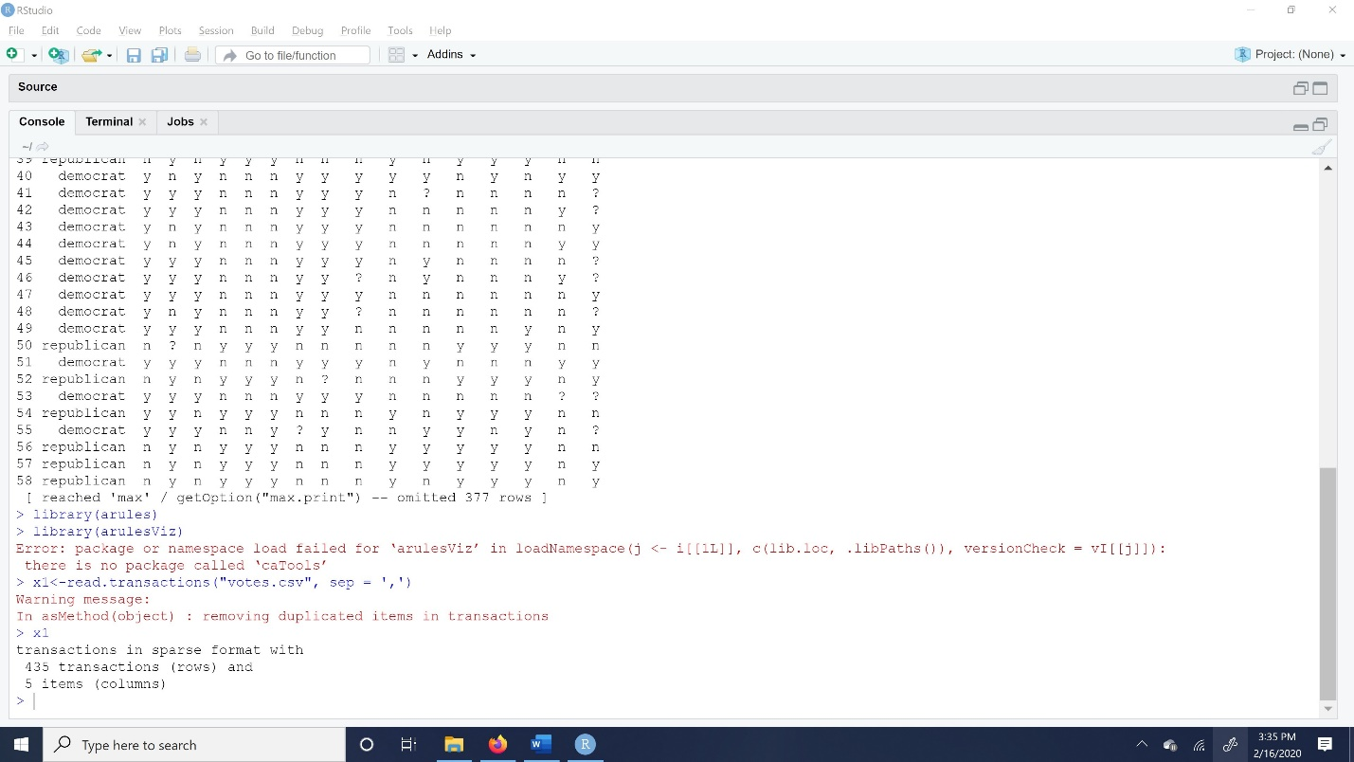

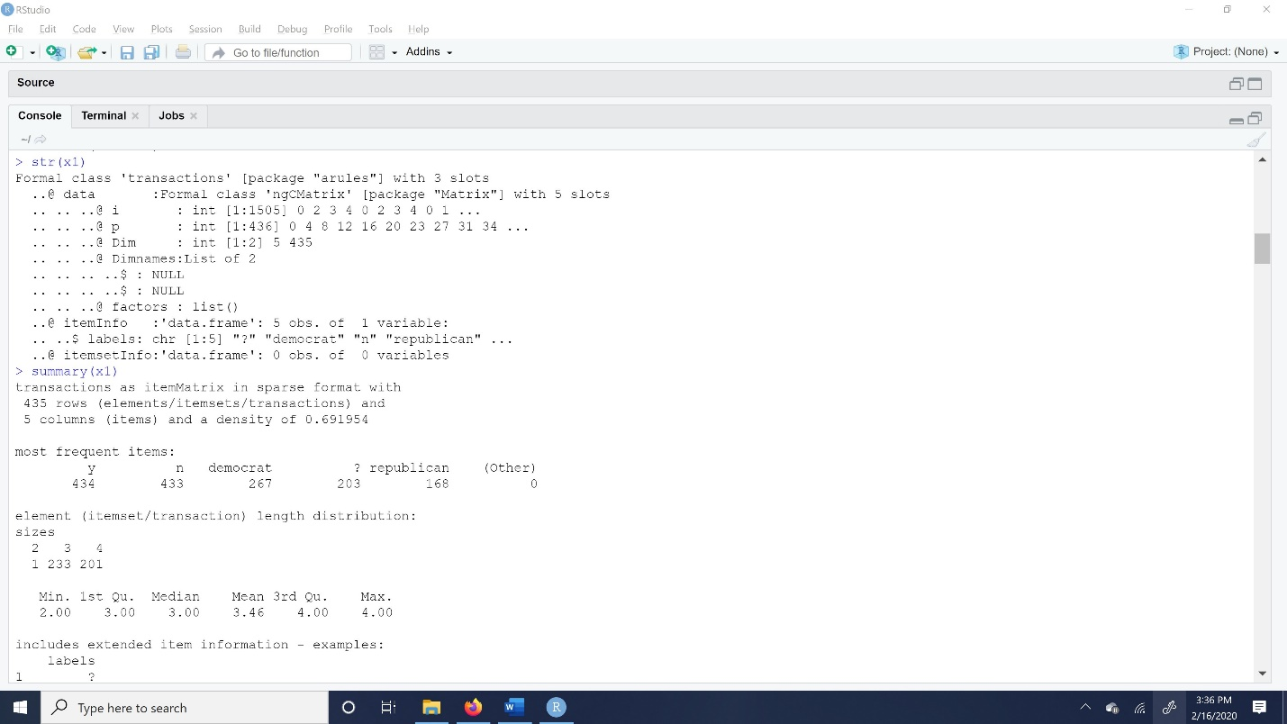

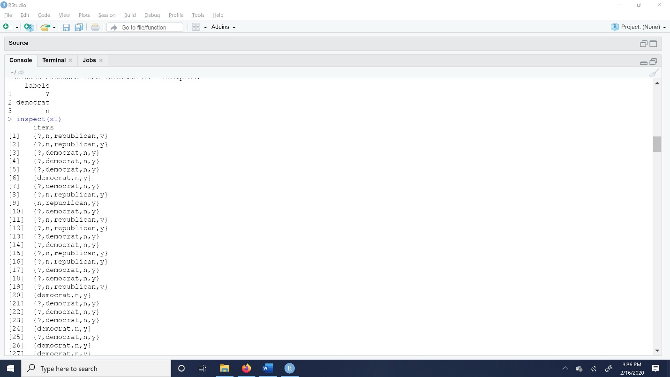

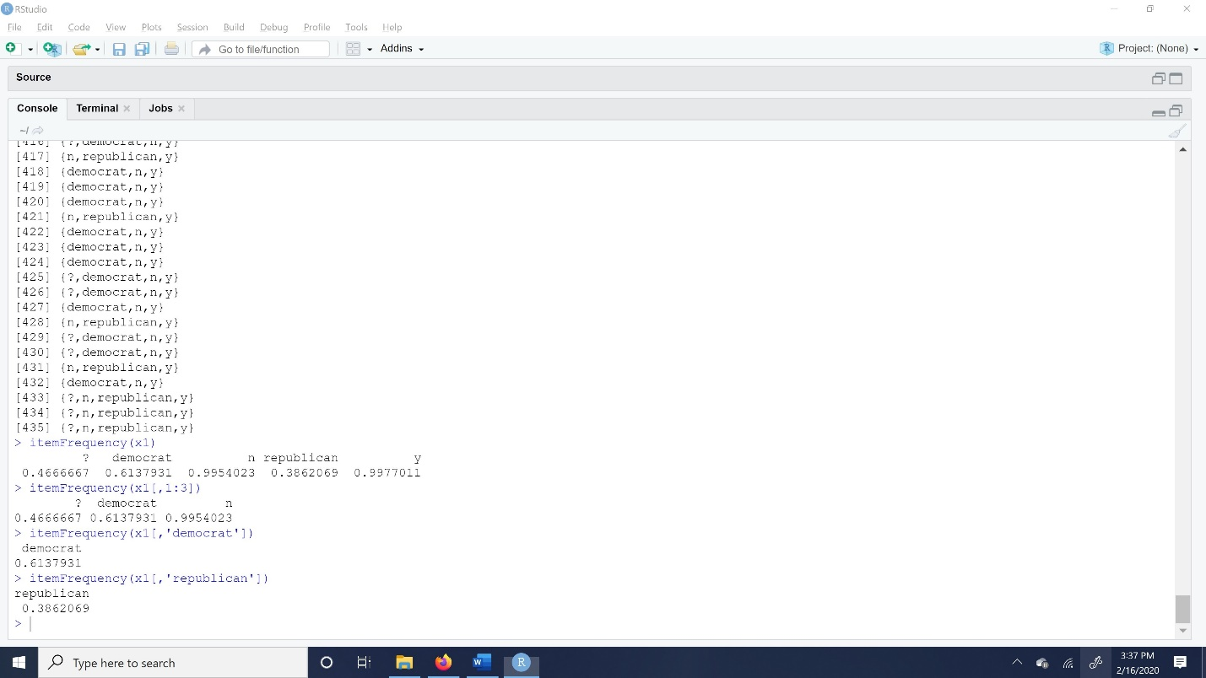

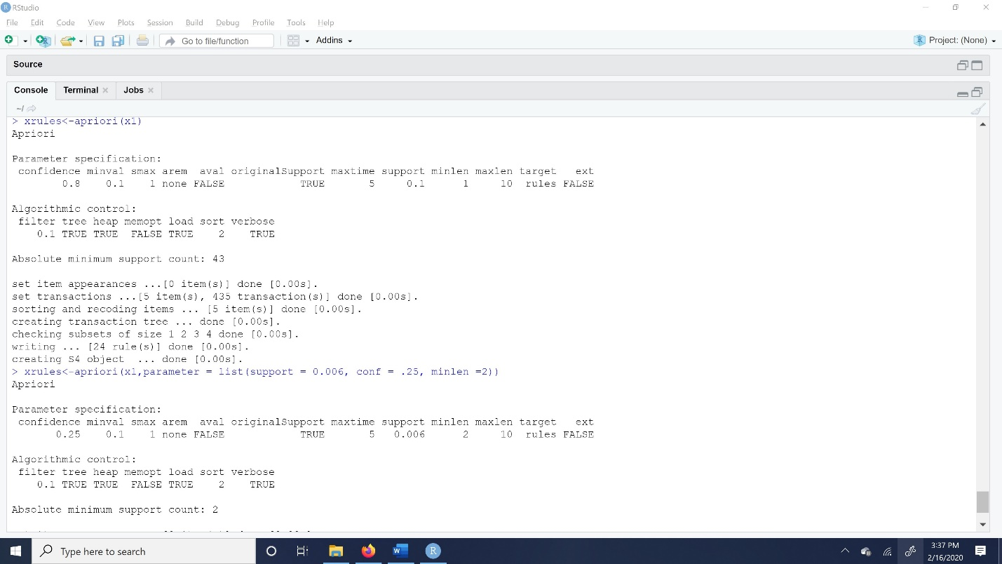

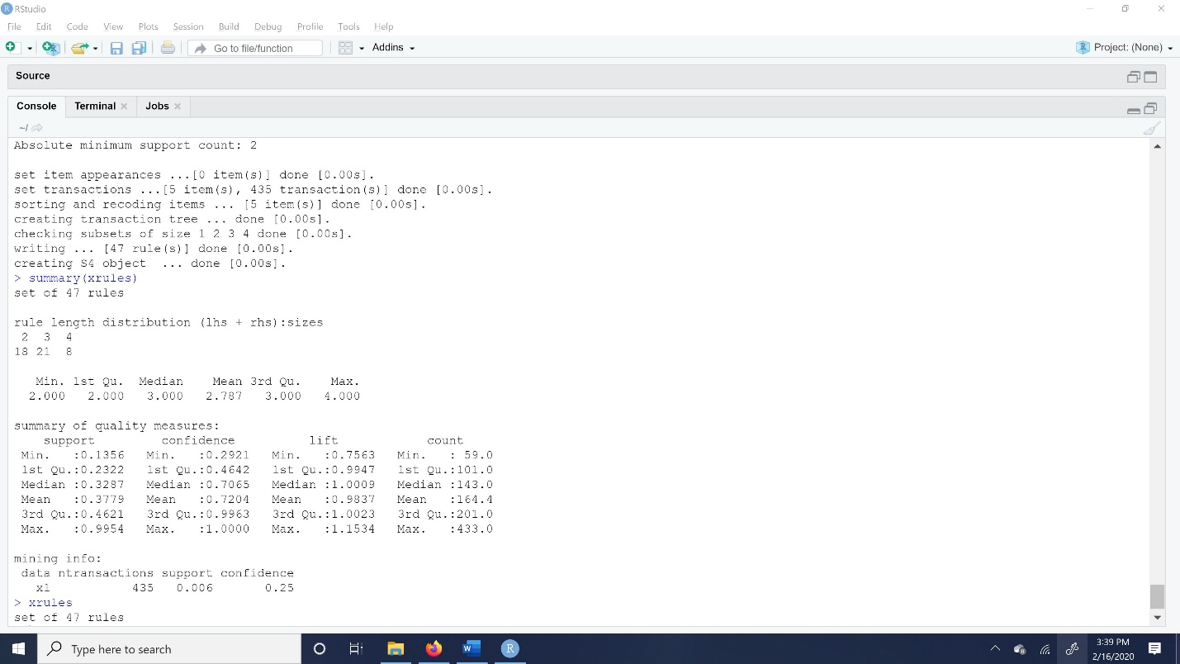

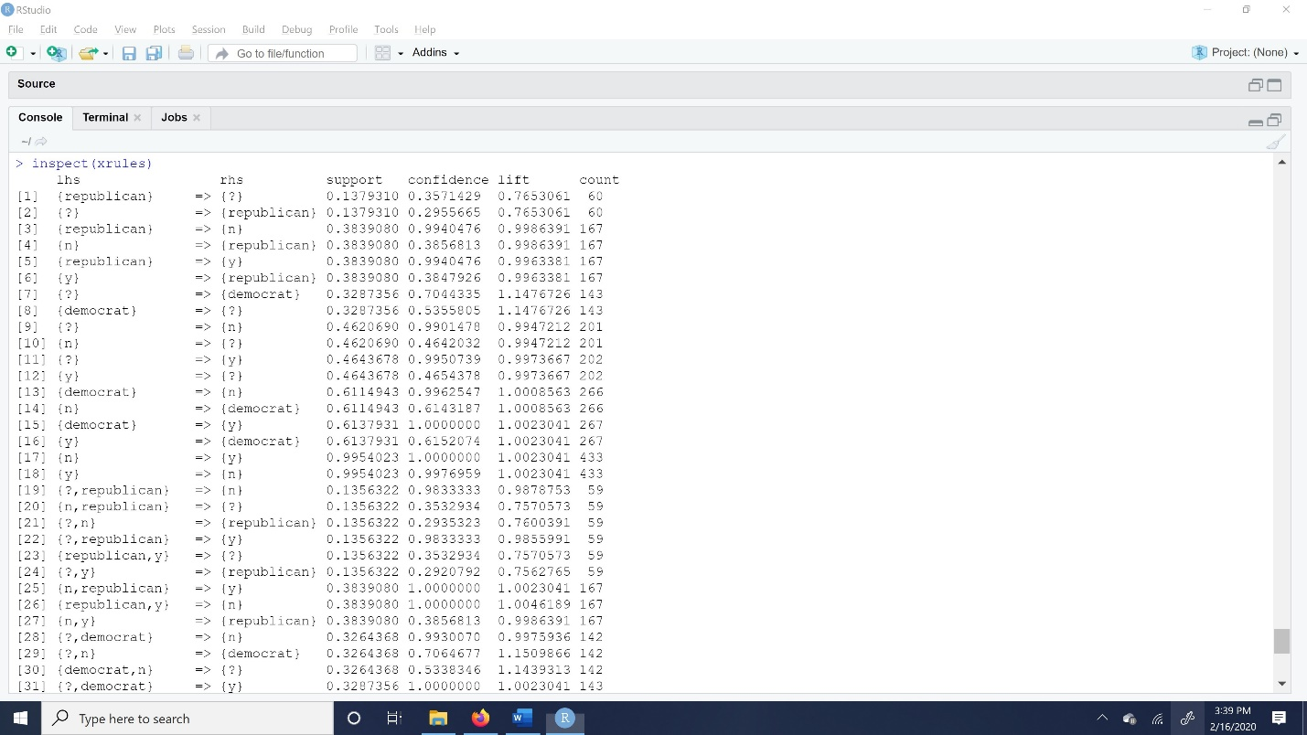

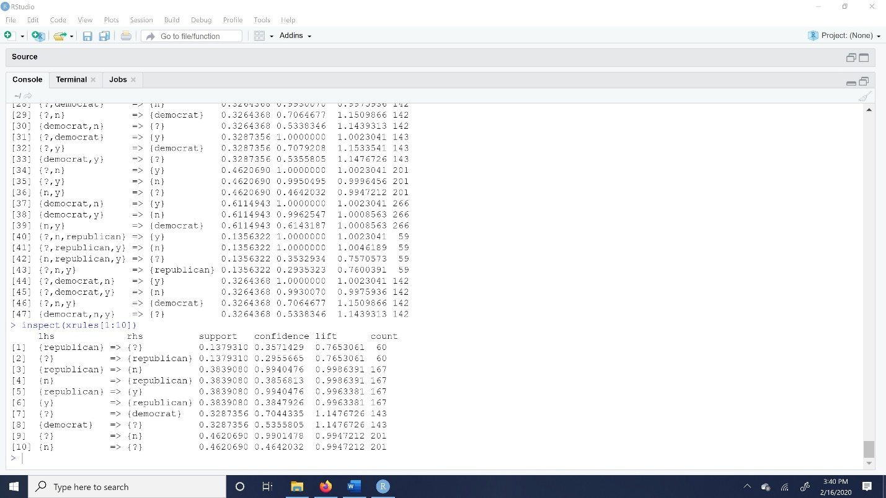

These are the itemfrequencyplots for ‘votes’:

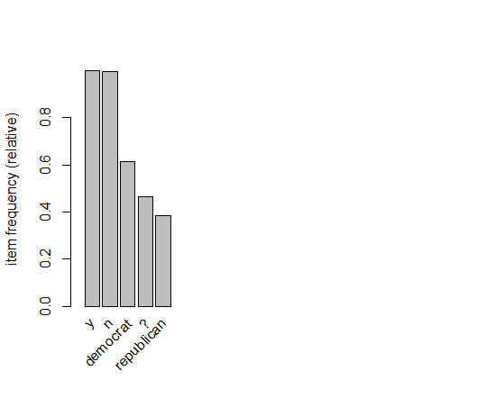

Plots of Image R commands are shown below:

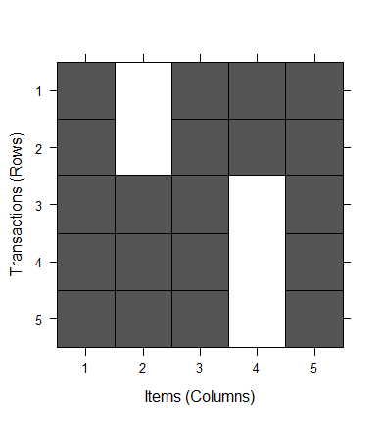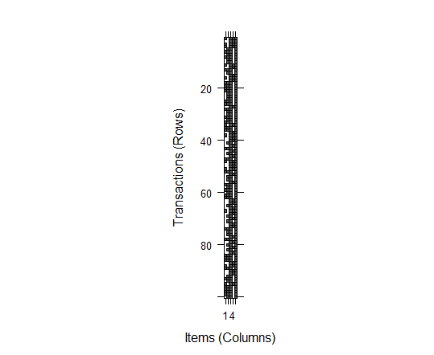

My interpretation of choosing the support of a rule measures is how frequently it occurs in the itemset. By default, support value 0.1. if, we consider very small value then number of rules get increased. From confidence we can measure the accuracy of rules. And we also can figure out the LHS, RSH, Lift and Count. The capacity to find thresholds that are support, confidence, LHS, RHS, Lift and Count for all the patterns. Often in real world data there will be tones of patterns to undergo association rules to solve the data mining problems.