Foundational project(IAM+CLI+S3Bucket+Policies+ Hosted static website)
Project: AWS S3 Static Website Hosting with Secure IAM Access

IAM USER CREATION

Why this step?
- AWS root user should never be used for daily operations
- Best practice is least-privilege IAM user

What I did
- Logged in using root account
- Created a dedicated IAM user for CLI usage
- Granted only S3-related permissions

IAM Policy Used (Learning phase)
AmazonS3FullAccess

Access keys
- Generated Access Key ID and Secret Access Key
- Used them for AWS CLI authentication

AWS CLI INSTALLATION & CONFIGURATION

Why AWS CLI?
- Enables programmatic access
- Core DevOps skill
- Avoids console-only dependency

Installation (Windows)
msiexec.exe /i https://awscli.amazonaws.com/AWSCLIV2.msi

Verify installation
aws --version

Configure CLI
aws configure
Entered:
AWS Access Key ID : <access-key>
AWS Secret Access Key : <secret-key>
Default region name : ap-south-1
Default output format : json

Verification (MOST IMPORTANT)
aws sts get-caller-identity
This confirms:
- Credentials are valid
- CLI is correctly authenticated
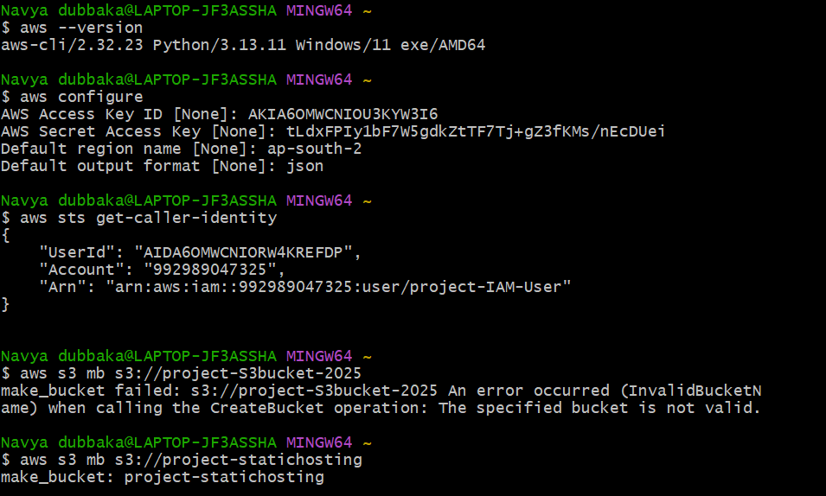

S3 BUCKET CREATION

Why S3?
- Serverless
- Highly available
- Cost-effective
- Ideal for static content

Bucket creation via CLI
aws s3 mb s3://project-statichosting

Bucket naming rules followed
- Globally unique
- Lowercase
- No spaces
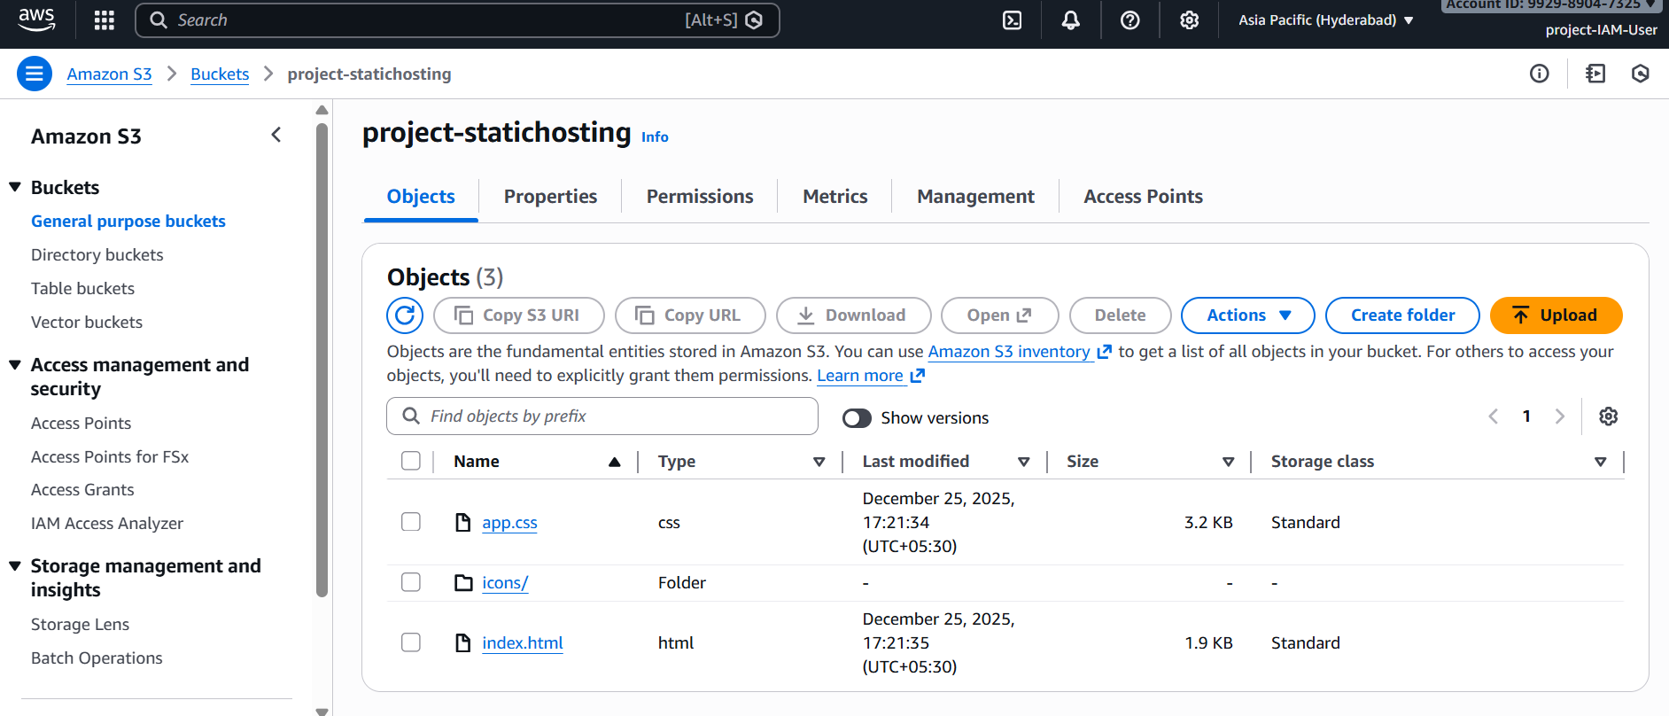

WEBSITE FILE UPLOAD USING AWS CLI

Local folder structure
project/
├── index.html
├── css/
├── images/
└── js/

Upload full website at once
aws s3 sync . s3://project-statichosting
Why sync?
- Preserves directory structure
- Efficient uploads
- Industry best practice

STATIC WEBSITE HOSTING CONFIGURATION

Why?
- Enables browser access
- Converts S3 bucket into a web endpoint

Console steps
S3 → Bucket → Properties → Static website hosting
Configured:
Index document: index.html
Generated endpoint:
http://project-statichosting.s3-website.ap-south-1.amazonaws.com

PUBLIC ACCESS CONTROL (CRITICAL SECURITY STEP)

Why needed?
- S3 buckets are private by default
- Website won’t load without public read permission

Bucket Policy Applied
{
"Version": "2012-10-17",
"Statement": [
{
"Sid": "PublicReadForStaticWebsite",
"Effect": "Allow",
"Principal": "*",
"Action": "s3:GetObject",
"Resource": "arn:aws:s3:::project-statichosting/*"
}
]
}

Applied using CLI
aws s3api put-bucket-policy \
--bucket project-statichosting \
--policy file://policy.json

Block Public Access settings
Disabled:
- Block public bucket policies
- Block public access through ACLs
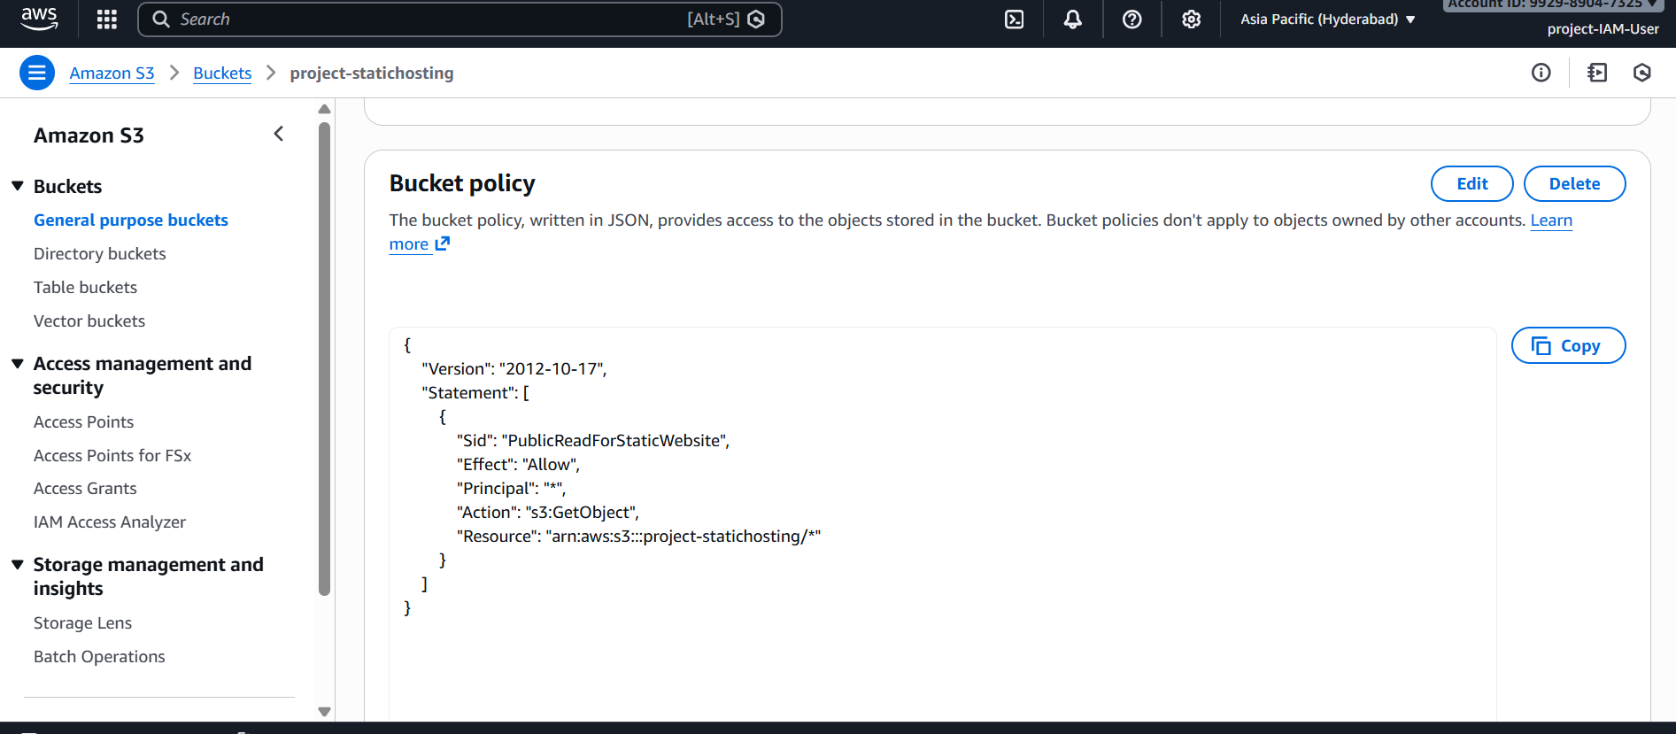

VALIDATION & TESTING

Website tested using:
S3 Website Endpoint
http://project-statichosting.s3-website.ap-south-2.amazonaws.com/
Confirmed:
- HTML loads
- CSS loads
- Images render
- No permission errors
