**Fastpath Quick Start Guide**

* Getting Started
  + Fastpath Overview
  + Terminology
  + Admin Console Overview
* Using Fastpath for the First Time
  + Install Fastpath
  + Configuring Fastpath
  + Create Workgroups and Workgroup Queues
  + Run a Test Chat Session

**Getting Started**

This guide is designed to get you up and running quickly with Fastpath in a LDAP environment. Starting with an overview, you'll see how the parts of the system work together, and then, creating workgroup to test the system and see that it works correctly.

**Note:** The screen shots and components shown in this guide are for illustration purposes and may differ somewhat from your implementation.

### Fastpath Overview

Fastpath provides queuing and routing for instant messaging to intelligently link people together. It can be used to provide customer support or sales chat on a website or to link departments together inside an organization.

Fastpath is built on the Openfire and Spark platforms. Before configuring Fastpath, you need to understand how its components work together.

#### Fastpath System Components

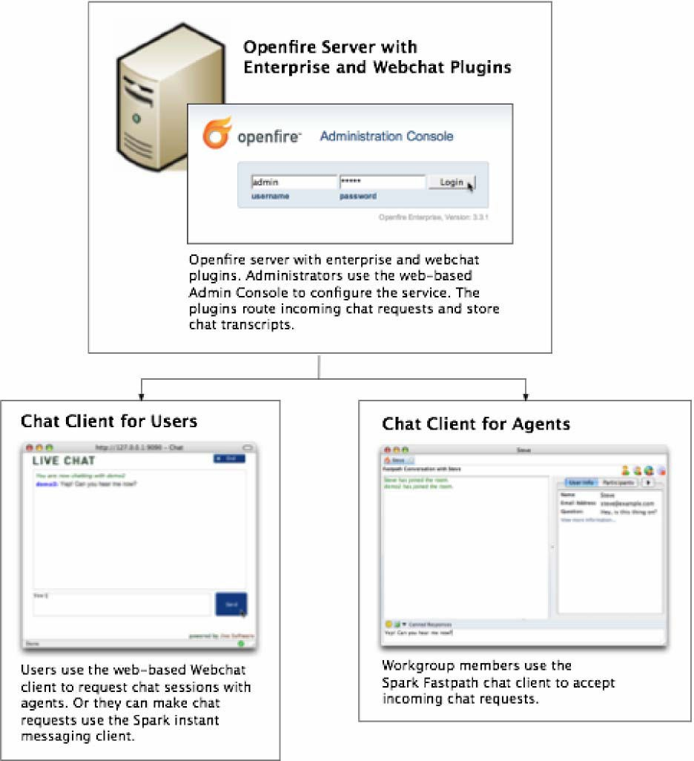

**Deploying the Spark Fastpath Webchat Client**

##### To make the chat service work on your website, you need to deploy the Spark Fatspath Webchat client application to your application server (the server must have Servlet 2.3 or greater support). You'll find installation instructions in the webchat readme file.

How the chat process works (using the Spark Fastpath Webchat client)

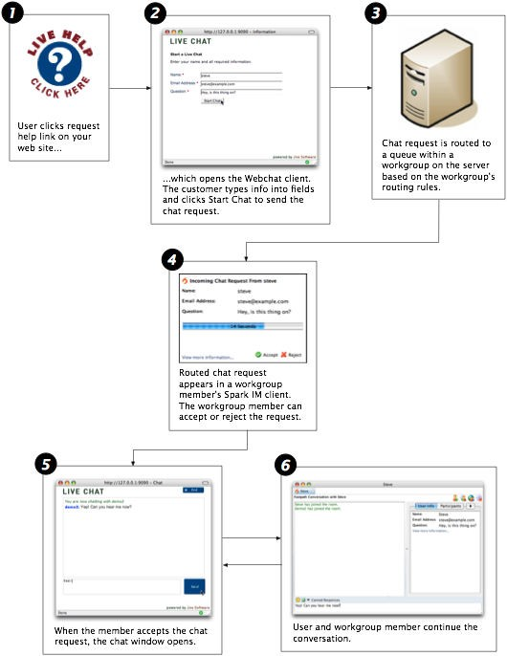

**Terminology**

**admin console:** The web-based administration tool used to manage Fastpath.

**administrator:** The person who will use the Admin Console to configure and manage Fastpath.

**Enterprise plugin:** The Openfire plugin that enables Fastpath functionality on the server side. It executes routing rules and stores chat transcripts.

**chat session:** A text-based conversation between a Fastpath workgroup member and another user (that requests the chat session).

**queue:** Each workgroup can contain multiple queues, which are used to route chat requests to the most appropriate workgroup members based on routing rules.

**request offer:** An incoming chat request offered to an agent. The agent can accept the offer, decline it, or wait until it times out and is routed elsewhere.

**Spark:** An instant messaging client. Fastpath chat is used by workgroup members to answer incoming chat requests. It can also be used to request workgroup chats as an alternative to the Webchat client.

**user:** A person who has been added to the Openfire system and assigned a password. Users can be added to workgroups to become workgroup members.

**Webchat client:** A client for communicating with a Fastpath workgroup through a web browser. Or, the Spark IM client can be used to chat with a workgroup.

**workgroup:** A cluster of request queues and associated members. Workgroups are usually defined by a particular set of business responsibilities (such as "Sales" or "IT Helpdesk"). For example, a workgroup could be devoted to answering customer inquiries about a particular product the company sells.

**workgroup member:** Any user that's a member of a workgroup and that accepts chat requests for the workgroup.

**Openfire:** Open Source IM server. The Fastpath server plugin is installed into an existing Openfire instance.

### Admin Console Overview

The Fastpath extensions to the Openfire Admin Console allow you to set up, configure, and administer the Fastpath application and its users. With the console you can:

* Create workgroups and configure workgroup members
* Monitor chat sessions and queue activity
* View server, workgroup, and queue statistics

The administrative tasks described in this guide assume you have access to the admin console.

Fastpath Quickstart - 5

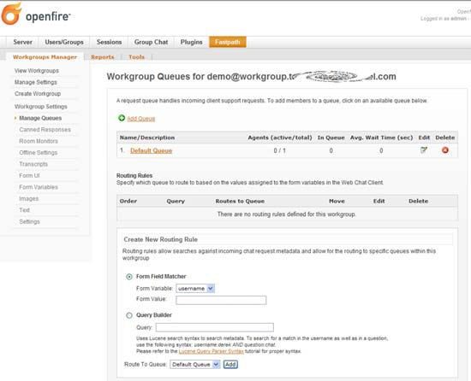

**Using Fastpath for the First Time**

When you use Fastpath for the first time, you’ll use the demo workgroup and the demo workgroup member account to begin setting up your system and to see how the Fastpath components work together.

In the default installation, the Fastpath Service plugin along with the Spark Fastpath Webchat plugin are installed on the Openfire Server. Later you can install the Spark Fastpath Webchat plugin to your own application server to fit the needs of your deployment.

### Install Fastpath

#### To set up and test your Fastpath installation

1. Workgroup members use the Spark IM client to accept incoming chat requests and conduct chat sessions. For the purpose of setup and testing, install the latest release of Spark on one workgroup member computer for now. Download the latest release of Spark from jivesoftware.com/products/ spark. Or, if you're using Spark Manager, download Spark from your local Spark Manager server. Run the Spark installer.
2. Ensure that the Openfire IM server, Fastpath Service plugin, and Spark Fastpath Webchat are installed as described in the installation guide. Log in to the Openfire Admin Console using server admin credentials.
3. In the Admin Console, click the Fastpath tab. The Workgroup Summary screen displays, showing a summary of all workgroups currently in the system. Openfire servers using LDAP to manage Users and Groups will not have any workgroups by default.

**Configuring Fastpath**

Now that you've installed the Spark and tested the system, you can configure your installation. You configure Fastpath by:

* 1. Creating workgroups and workgroup queues.
  2. Adding workgroup members and groups to workgroup queues.

To get started, you can use most of Fastpath's default server and other settings.

### Create Workgroups and Workgroup Queues

**Help.** For more information on setting up routing rules for workgroups, refer to the Admin Console online Help.

In Fastpath, you use workgroups to organize a set of members to handle chat requests. Workgroups are usually organized by function or specialty. Each workgroup contains one or more queues; the Fastpath server routes chat requests to workgroup queues based on routing rules you set up for each queue.

The following example shows chat request routing for a company that sells sports equipment. The company has divided its support agents into workgroups based on the roles of sales and support, and queues within each workgroup based on the sport.

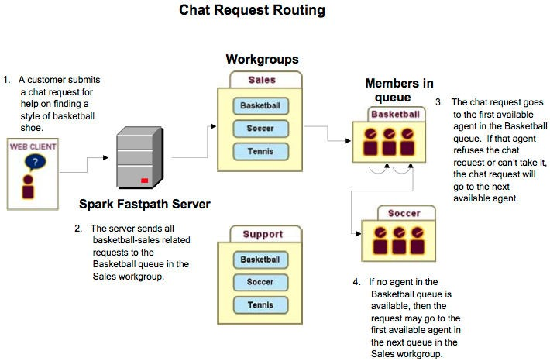

Create a Workgroup and Add Initial Users

When you create a workgroup, you give it a name, description, and its initial members (optional). New workgroups also come with a default queue. You can add more queues at any time.

**To create a workgroup:** In the Admin Console, click the Fastpath tab, and then, under Workgroups Manager, in the Workgroup Summary click create workgroups.

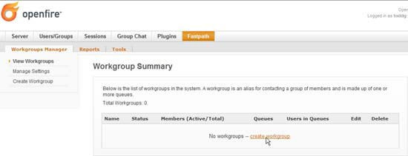

You must provide Workgroup Name in order create the workgroup. The other fields are option and can be modified later.

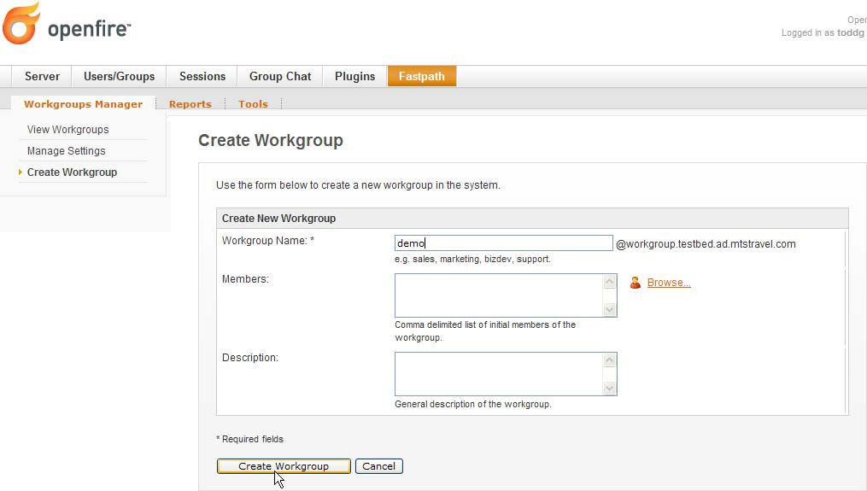

Add a Queue to a Workgroup

This example shows you how to add a queue to the new workgroup you created. **To add a queue to a workgroup**

1. In the Admin Console, click the Fastpath tab.
2. In the Name column of the Workgroup Summary screen, click the name of the workgroup you created.
3. In the sidebar pane under Workgroup Settings, click Manage Queues.
4. In the Workgroup Queues screen, click Add Queue.

Fastpath Quickstart - 8

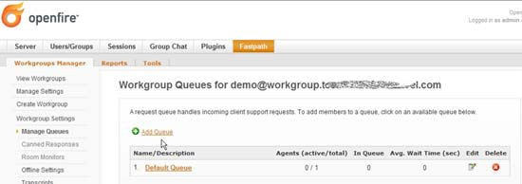

The Workgroup Queue Creation screen displays:

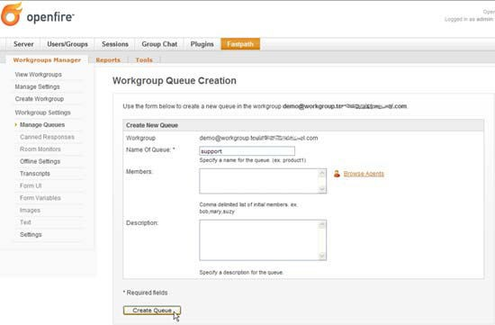

1. Complete the fields as described and then click the Create Queue button. The Workgroup Queues screen displays, showing the newly created queue. Next, you’ll add agents and agent groups to your queue.**Add Workgroup Queue Members**

Fastpath Quickstart - 9

In the previous section, you created a new queue for the workgroup you created. In this section, you1l see how to add additional users and user groups.

To add users and user groups

1. In the Admin Console, click the Fastpath tab and then, in the Name column of the Workgroups Summary screen, click the name of your workgroup.
2. In the sidebar pane under Workgroup Settings, click Manage Queues.
3. In the Workgroup Queues screen, click the name of the desired queue. The Manage Queue screen displays.
4. Scroll down to the Add Agents section and click the Browse link to the right of the Add Agents box.

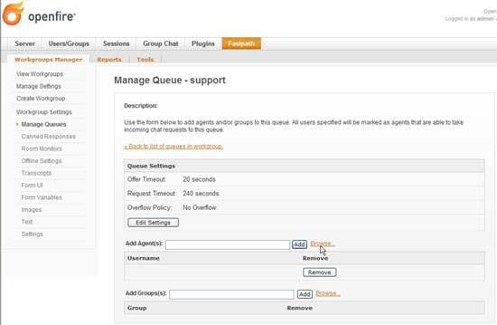

The Possible Agents to Add dialog box displays.

1. After selecting the desired users to add, click the Done button.

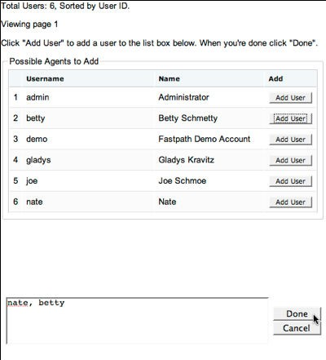

1. In the Manage Queue screen, click the Add button to add the users you selected.
2. To add Fastpath groups, click the Browse link next to the Add Groups box, select the groups you want from the dialog box, and then click the Done button.
3. In the Manage Queue screen, click the Add button to add the groups you selected.
4. Under Queue Settings, click Edit Settings to edit how you want Fastpath to determine which member is the best choice to receive a request offer.

##### Fastpath Quickstart - 10

Fastpath Quickstart - 11

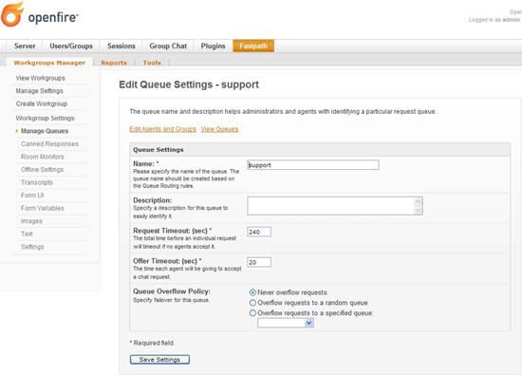

1. When finished, click the Save Settings button. **Add Workgroup Queue Routing Rules**

You can add rules that direct new chat requests to particular queues. This is similar to the way some email programs route a message to particular folders based on the message's content. For example, you might want to ensure that some requests get to the support queue instead of the sales queue.

When you create a routing rule, you are telling Fastpath to examine a particular variable for a particular value. For example, you might set a rule in which the email address given must contain a particular domain name in order for the chat request to be routed to a particular queue.

To add queue routing rules

* 1. In the Admin Console, click the Fastpath tab and then, in the Name column of the Workgroups Summary screen, click the name of your workgroup.
  2. In the sidebar pane under Workgroup Settings, click Manage Queues.
  3. In the Workgroup Queues screen, scroll to the Routing Rules part of the screen.
  4. Under Create New Routing Rule, note that there are two subsections; these are alternate ways to create a rule:
     + **Form Field Matcher** provides a dropdown that lists all of the variables that Fastpath can query on. This is the simple way to build routing rules. Select the variable you want, and then enter the value that should be present in that variable in order for the request to be routed to the queue.
     + **Query Builder** provides a place where you can create your own query by typing in its syntax. This is an advanced option. The variables you'd enter here are the same as those you can see listed in the Form Variable dropdown. (See Apache's Query Parser Syntax for more information on the Lucene syntax used here.)
  5. In the Route to Queue dropdown list, select the queue for which the rule should be used, then click Add.

Fastpath Quickstart - 12

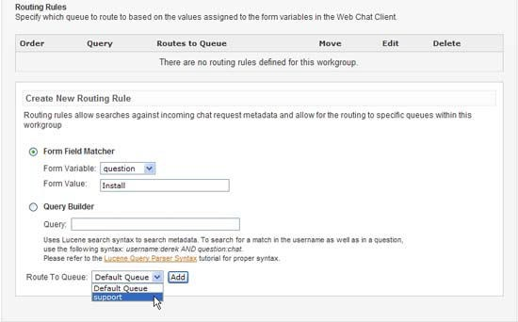

When you have added multiple rules, you can use the up and down arrows in the Move column under Routing Rules to prioritize how rules are evaluated. For example, if you want to ensure that some chat requests get routed to a particular queue because of a value in the email variable — and regardless of the values given in the question variable — you could create a rule that queries on the email variable and move the rule to the top of the list.

**Note:** You can set the chat request form's user interface fields and hidden variables using the Admin Console. To set these, click the Fastpath tab, then click the name of the workgroup whose form you want to design. To set form fields, under Workgroup Settings click Form UI; for variables, under Workgroup Settings click Form Variables.

View the Summary of Workgroup Activity

The workgroup summary screen shows you how many members are assigned to each workgroup and how many of the total are currently engaged in an active chat session. You can also see the number of queues and agents in the queues.

**Workgroup status.** "Open" status indicates a member is currently signed in to the workgroup through the Spark client and the workgroup is currently accepting chat requests. "Waiting for member" means the workgroup is not accepting chat requests because no member is available to chat. "Closed" means the workgroup is not accepting chat requests.

To view the workgroup activity summary:

* In the Admin Console, click the Fastpath tab. The Workgroup Summary screen displays.

Fastpath Quickstart - 13

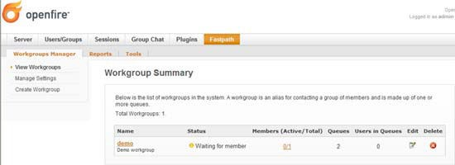

Open or Close a Workgroup Manually

Suppose your support center is closed for the day and you want to prevent new requests from being received, but you don't want to shut out the customers who are already in the workgroup queue or are being helped by a workgroup member. You can manually close the workgroup to new requests.

To manually close a workgroup to new requests

1. In the Admin Console, click the Fastpath tab.
2. In the Workgroup Summary screen, click the name of the workgroup.
3. Under Workgroup Settings, click Settings.
4. To close the workgroup, in the Current Status row, click the Close button. The button changes to read "Enable" and the green dot icon indicating an open status changes to red.

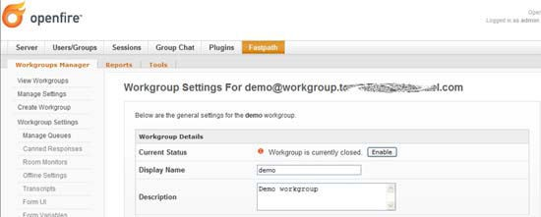

1. To open the workgroup, click the Enable button.

Set Workgroup Email Transcript Properties

The system will occasionally need to send emails of session transcripts to webchat client users. You'll need to set up a workgroup email account to make this possible.

**Note:** You must have an email server defined for Openfire in order for your email Transcript settings to work. To define the server, in the Admin Console go to Server > Email Settings.

To set up email transcript capability for a workgroup

1. In the Admin Console, click the Fastpath tab; then, in the Workgroups Summary screen, click the name of the workgroup for which you want to set up email.

Fastpath Quickstart - 14

1. In the sidebar pane under Workgroup Settings, click Transcripts. The Transcript Settings screen displays.

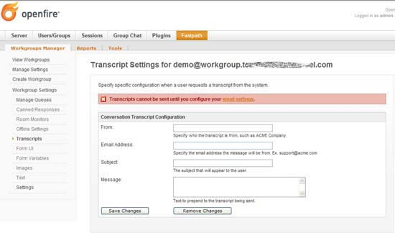

1. Type in email account information for the workgroup in the fields provided, including subject and message. When finished, click the Save Changes button.

**Note:** SMTP settings are controlled under Email Settings in the Server tab of the Admin Console. For more information, refer to the Admin Console online Help.

Set Workgroup Offline Properties

Use the workgroup offline settings to display a message to users when the workgroup is closed.

**Note:** You must have an email server defined for Openfire in order for your offline message settings to work. To define the server, in the Admin Console go to Server > Email Settings.

To set offline properties for a workgroup

1. In the Admin Console, click the Fastpath tab; then, in the Workgroup Summary screen, click the name of the workgroup.
2. In the sidebar pane under Workgroup Settings, click Offline Settings. The Workgroup Offline screen displays.

Fastpath Quickstart - 15

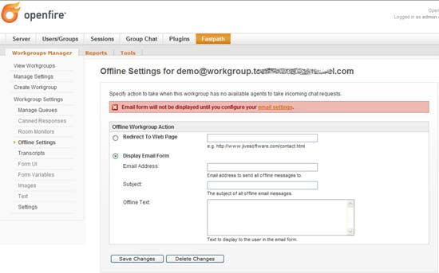

1. Type in the offline message information and then click the Save Changes button.

**Run a Test Chat Session**

By running a test chat session, you’ll see how the Spark Fastpath Webchat client and the Spark IM client work during a basic chat session. You’ll use the test workgroup that you created for this test.

To run a test chat session

1. After you install Spark, start the application and log in using the credentials of one of the workgroup users and the name of your server.

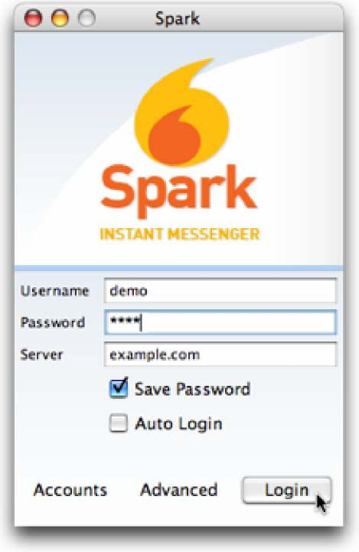

When you log in, Spark automatically logs you in to the demo workgroup.

1. Navigate to the Fastpath tab and then, the sub-tab Tools, to go to the host page and click the live help link for the test workgroup.
2. In the Live Chat window, fill in the required fields and then click the Start Chat button.

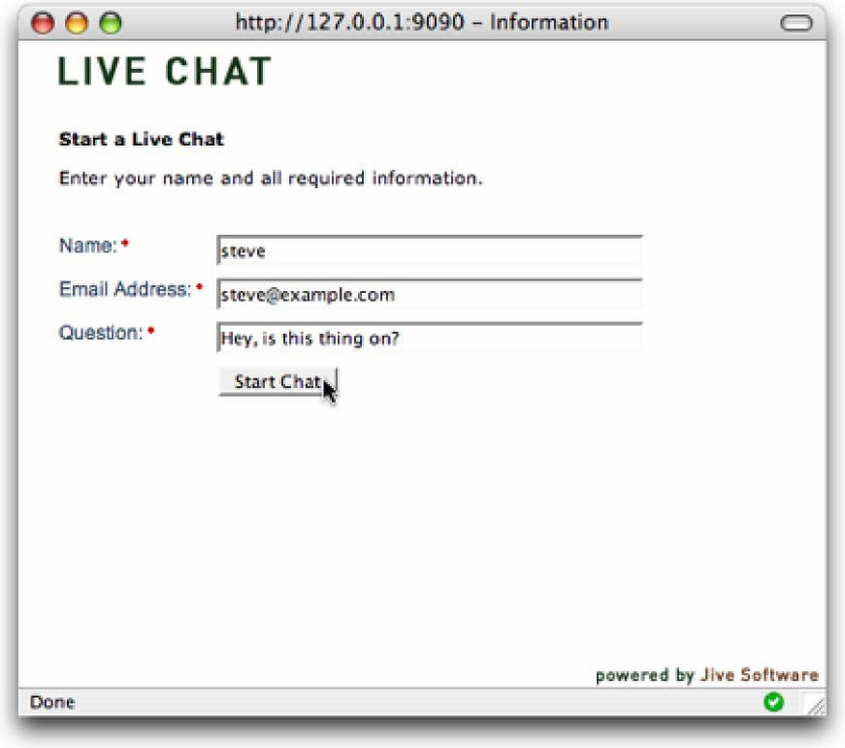

1. Click Accept in the chat request message that Fastpath displays.

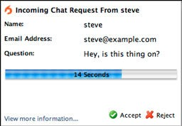

1. In the Fastpath chat window that opens, type a response to yourself.

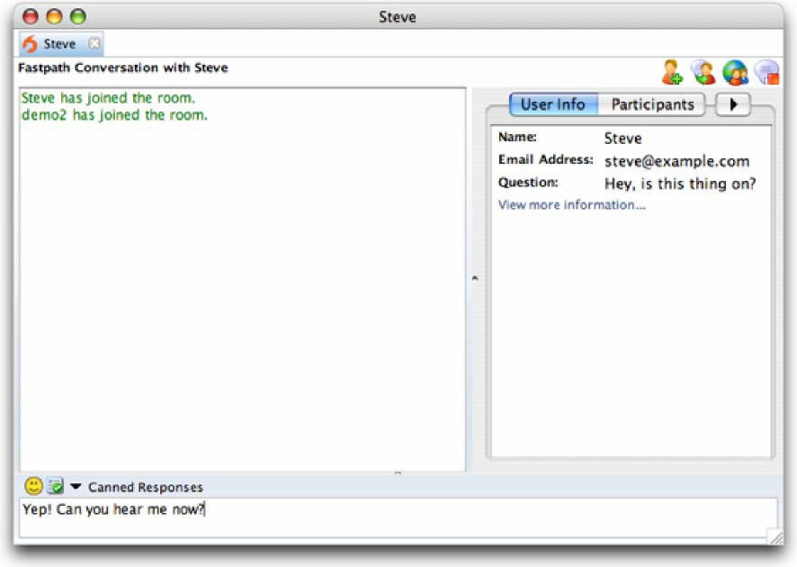

1. Switch back to the Live Chat window to see that your response went through.

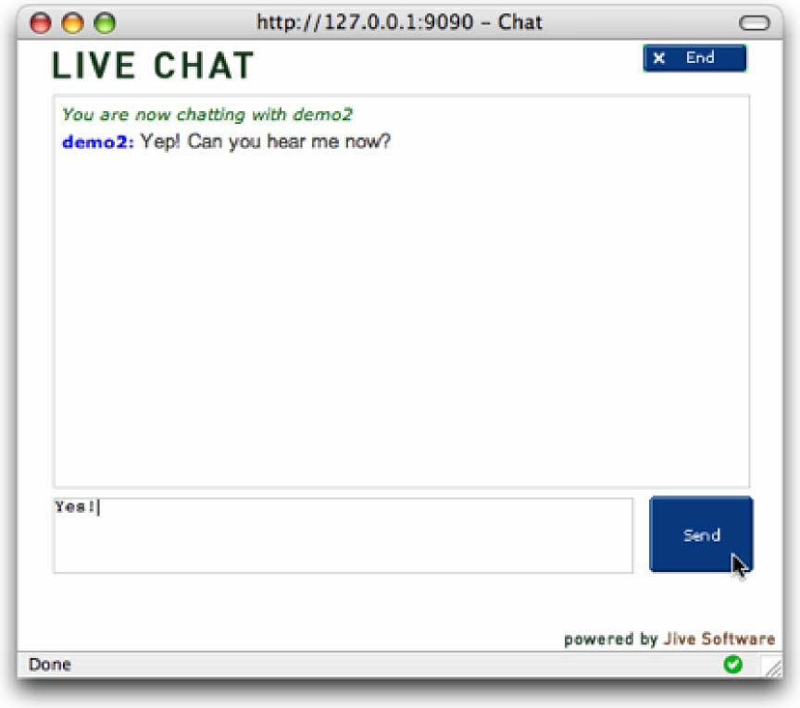

1. Close the chat session in both the Fastpath chat window and the Live Chat window.

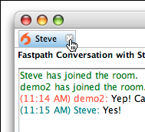

**Fastpath Quick Start Guide**

* + Getting Started
    - Fastpath Overview
    - Terminology
    - Admin Console Overview
  + Using Fastpath for the First Time
    - Install Fastpath
    - Run a Test Chat Session
    - Configuring Fastpath
    - Create Workgroups and Workgroup Queues

**Getting Started**

This guide is designed to get you up and running quickly with Fastpath in a non-LDAP environment. LDAP environments will require a different Quick Start document. Starting with an overview, you'll see how the parts of the system work together, and then, using the default installation, use the demo account and workgroup to test the system and see that it works correctly.

**Note:** The screen shots and components shown in this guide are for illustration purposes and may differ somewhat from your implementation.

### Fastpath Overview

Fastpath provides queuing and routing for instant messaging to intelligently link people together. It can be used to provide customer support or sales chat on a website or to link departments together inside an organization.

Fastpath is built on the Openfire and Spark platforms. Before configuring Fastpath, you need to understand how its components work together.

#### Fastpath System Components

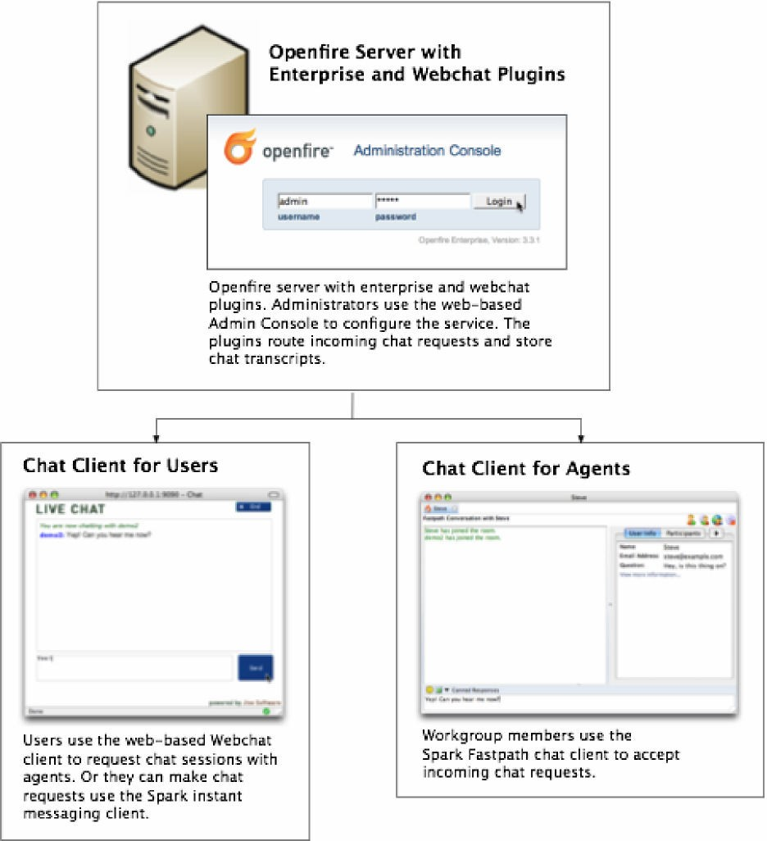

**Deploying the Spark Fastpath Webchat Client**

##### To make the chat service work on your website, you need to deploy the Spark Fatspath Webchat client application to your application server (the server must have Servlet 2.3 or greater support). You'll find installation instructions in the webchat readme file.

How the chat process works (using the Spark Fastpath Webchat client)

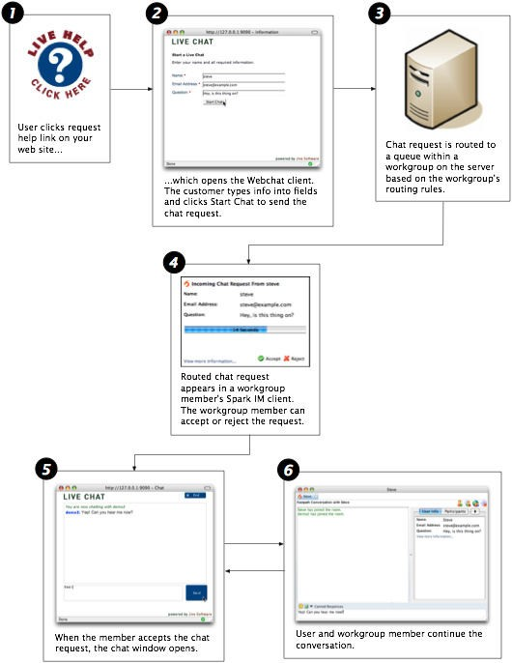

**Terminology**

**admin console:** The web-based administration tool used to manage Fastpath.

**administrator:** The person who will use the Admin Console to configure and manage Fastpath.

**Enterprise plugin:** The Openfire plugin that enables Fastpath functionality on the server side. It executes routing rules and stores chat transcripts.

**chat session:** A text-based conversation between a Fastpath workgroup member and another user (that requests the chat session).

**queue:** Each workgroup can contain multiple queues, which are used to route chat requests to the most appropriate workgroup members based on routing rules.

**request offer:** An incoming chat request offered to an agent. The agent can accept the offer, decline it, or wait until it times out and is routed elsewhere.

**Spark:** An instant messaging client. Fastpath chat is used by workgroup members to answer incoming chat requests. It can also be used to request workgroup chats as an alternative to the Webchat client.

**user:** A person who has been added to the Openfire system and assigned a password. Users can be added to workgroups to become workgroup members.

**Webchat client:** A client for communicating with a Fastpath workgroup through a web browser. Or, the Spark IM client can be used to chat with a workgroup.

**workgroup:** A cluster of request queues and associated members. Workgroups are usually defined by a particular set of business responsibilities (such as "Sales" or "IT Helpdesk"). For example, a workgroup could be devoted to answering customer inquiries about a particular product the company sells.

**workgroup member:** Any user that's a member of a workgroup and that accepts chat requests for the workgroup.

**Openfire:** Open Source IM server. The Fastpath server plugin is installed into an existing Openfire instance.

### Admin Console Overview

The Fastpath extensions to the Openfire Admin Console allow you to set up, configure, and administer the Fastpath application and its users. With the console you can:

* Create workgroups and configure workgroup members
* Monitor chat sessions and queue activity
* View server, workgroup, and queue statistics

The administrative tasks described in this guide assume you have access to the admin console.

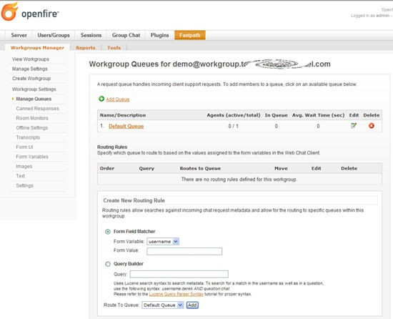

## Using Fastpath for the First Time

When you use Fastpa h fo the first t me, you’ll use the demo workgroup and the demo workgroup member account to begin setting up your system and to see how the Fastpath components work together.

In the default installation, the Fastpath Service plugin along with the Spark Fastpath Webchat plugin are installed on the Openfire Server. Later you can install the Spark Fastpath Webchat plugin to your own application server to fit the needs of your deployment.

### Install Fastpath

#### To set up and test your Fastpath installation

1. Workgroup members use the Spark IM client to accept incoming chat requests and conduct chat sessions. For the purpose of setup and testing, install the latest release of Spark on one workgroup member computer for now. Download the latest release of Spark from jivesoftware.com/products/ spark. Or, if you're using Spark Manager, download Spark from your local Spark Manager server. Run the Spark installer.
2. Ensure that the Openfire IM server, Fastpath Service plugin, and Spark Fastpath Webchat are installed as described in the installation guide. Log in to the Openfire Admin Console using the admin credentials. If you did not change the default password, use the default:
   * username: admin
   * password: admin

F

a

s

t

p

a

th

Q

u

ic

k

s

t

a

r

t

-

5

1. In the Admin Console, click the Fastpath tab. The Workgroup Summary screen displays, showing a summary of all workgroups currently in the system. Verify that the demo workgroup exists.

**Note:** The demo workgroup is set up automatically during installation. You can delete the demo workgroup when it's no longer needed.

**Run a Test Chat Session**

By running a test chat session, you’ll see how the Spark Fastpath Webchat client and the Spark IM client work during a basic chat session. You’ll use the test workgroup that you created for this test.

To run a test chat session

1. After you install Spark, start the application and log in using the demo credentials and the name of your server.
   * Username: demo
   * Password: demo

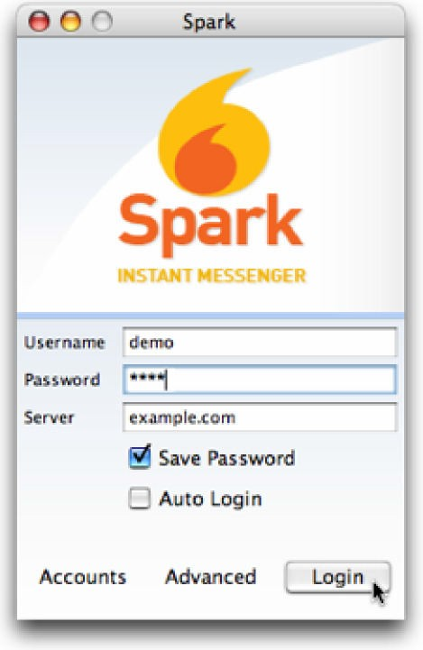

When you log in, Spark automatically logs you in to the demo workgroup.

1. Navigate to the Fastpath tab and then, the sub-tab Tools, to go to the host page and click the live help link for the test workgroup.
2. In the Live Chat window, fill in the required fields and then click the Start Chat button.

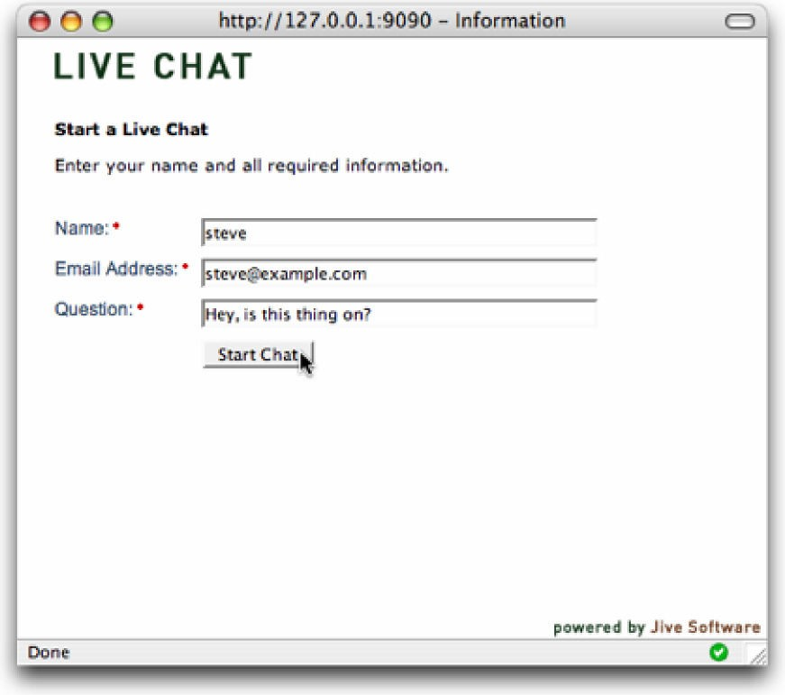

1. Click Accept in the chat request message that Fastpath displays.

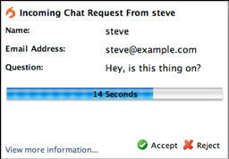

1. In the Fastpath chat window that opens, type a response to yourself.

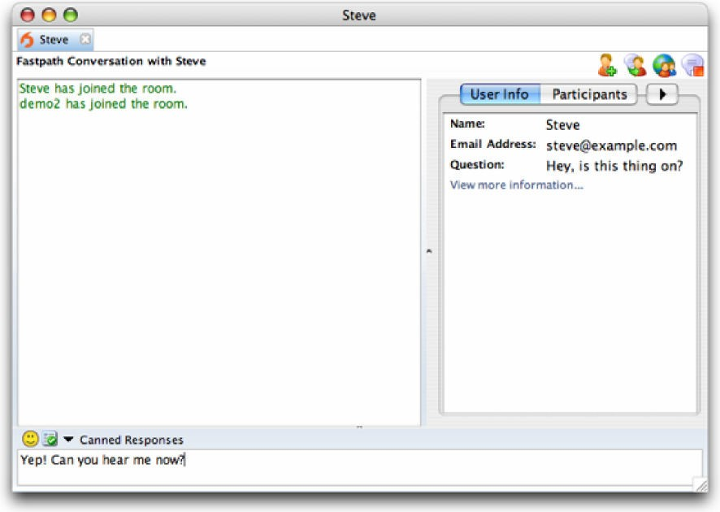

1. Switch back to the Live Chat window to see that your response went through.

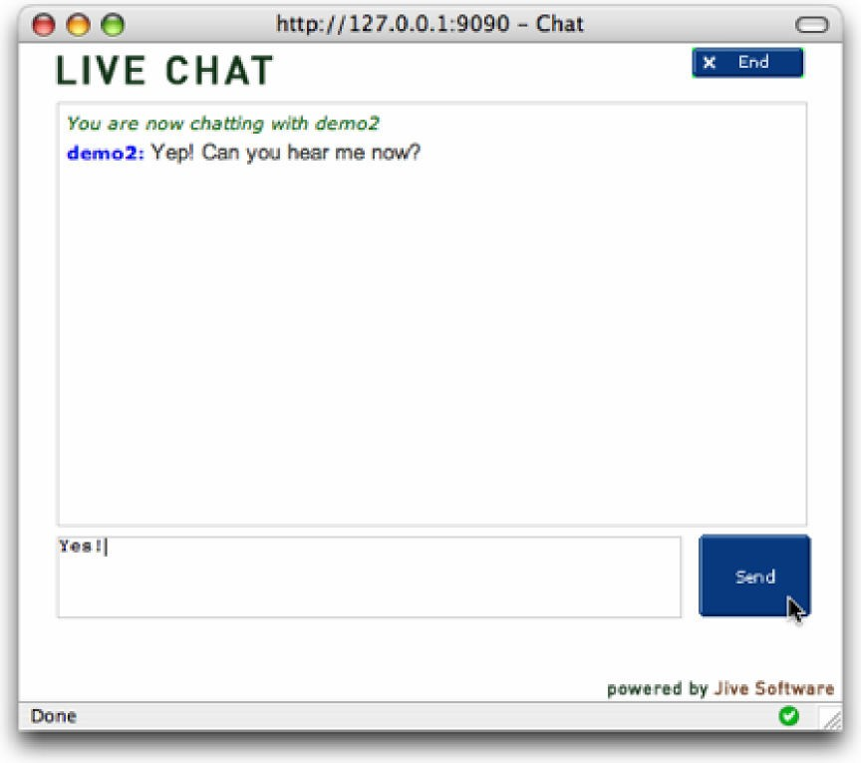

7 Close the chat session in both the Fastpath hat window and the Live Chat wi dow.

## Configuring Fastpath

Now that you've insta led the Spark and ested the system, you can con igu e your nstallation. You configure Fastpath by:

1. Creating users for your Fastpath system.
2. Creating workgroups and workgroup queues.
3. Adding workgroup members and groups to workgroup queues.

To get started, you can use most of Fastpath's default server and other settings.

F

a

s

t

p

a

th

Q

u

ic

k

s

t

a

r

t

-

9

**Create Users**

After verifying your Fastpath installation, you’ll need to add users to the Fastpath system.

**Users vs. Workgroup Members.** Fastpath makes a distinction between users and workgroup members. Users are general system users who might or might not belong to a workgroup. All workgroup members, however, are users.

To create a new user

1. In the Admin Console, click the Users/Groups tab; in the sidebar, under Users, click Create New User.

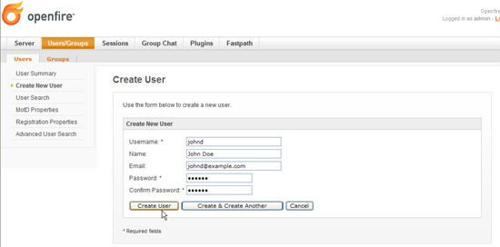

1. In the Create User screen, complete the fields. Required fields have an asterisk to the right of their names. When you're finished, click the Create User button.

**Create Workgroups and Workgroup Queues**

**Help.** For more information on setting up routing rules for workgroups, refer to the Admin Console online Help.

In Fastpath, you use workgroups to organize a set of members to handle chat requests. Workgroups are usually organized by function or specialty. Each workgroup contains one or more queues; the Fastpath server routes chat requests to workgroup queues based on routing rules you set up for each queue.

The following example shows chat request routing for a company that sells sports equipment. The company has divided its support agents into workgroups based on the roles of sales and support, and queues within each workgroup based on the sport.

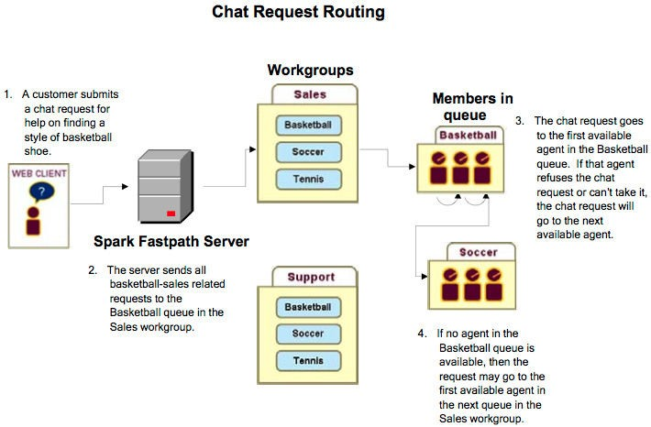

Create a Workgroup and Add Initial Users

When you create a workgroup, you give it a name, description, and its initial members. New workgroups also come with a default queue. You can add more queues at any time.

**To create a workgroup:** In the Admin Console, click the Fastpath tab, and then, in the sidebar pane under Workgroups Manager, click Create Workgroup.

Add a Queue to a Workgroup

This example shows you how to add a queue to the new workgroup you created. **To add a queue to a workgroup**

1. In the Admin Console, click the Fastpath tab.
2. In the Name column of the Workgroup Summary screen, click the name of the workgroup you created.
3. In the sidebar pane under Workgroup Settings, click Manage Queues.
4. In the Workgroup Queues screen, click Add Queue.

F

a

s

tp

a

t

h

Q

u

i

c

k

s

ta

r

t

-

1

2

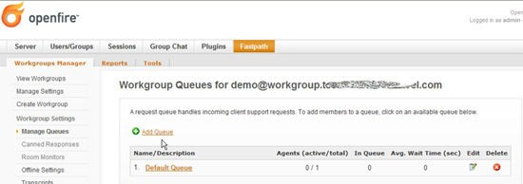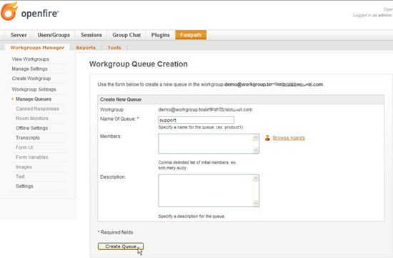

The Workgroup Queue Creation screen displays:

1. Complete the fields as described and then click the Create Queue button. The Workgroup Queues screen displays, showing the newly created queue. Next, you’ll add agents and agent groups to your queue.

Add Workgroup ueue Membe s

In the previous section, you created a new queue for the workgroup you created. In this section, you1l see how to add additional users and user groups.

To add users and user groups

1. In the Admin Console, click the Fastpath tab and then, in the Name column of the Workgroups Summary screen, click the name of your workgroup.
2. In the sidebar pane under Workgroup Settings, click Manage Queues.
3. In the Workgroup Queu s screen, click h ame of the de red ueue. he Manage Q eue screen display .

F

a

s

tp

a

t

h

Q

u

i

c

k

s

ta

r

t

-

1

3

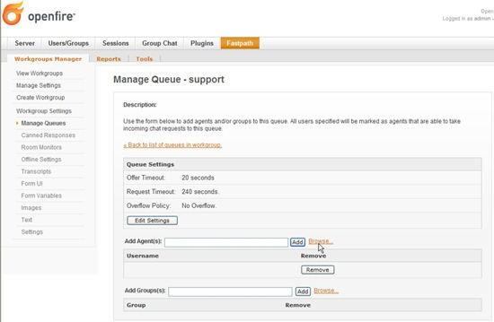

1. Scroll down to the Add Agents section and click the Browse link to the right of the Add Agents box.

The Possible Agents to Add dialog box displays.

1. After selecting the desired users to add, click the Done button.



1. In the Manage Queue screen, click the Add button to add the users you selected.
2. To add Fastpath groups, click the Browse link next to the Add Groups box, select the groups you want from the dialog box, and then click the Done button.
3. In the Manage Queue screen, click the Add button to add the groups you selected.
4. Under Queue Settings, click Edit Settings to edit how you want Fastpath to determine which member is the best choice to receive a request offer.

##### Fastpath Quickstart - 14

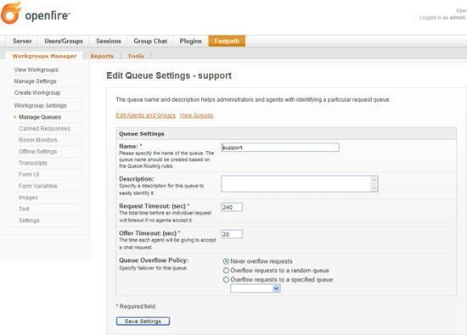

1. When finished, click the Save Settings butt n. **Add Workgroup Queue Routing Rules**

You can add rules that direct new chat requests to particular queues. This is similar to the way some email programs route a message to particular folders based on the message's content. For example, you might want to ensure that some requests get to the support queue instead of the sales queue.

When you create a routing rule, you are telling Fastpath to examine a particular variable for a particular value. For example, you might set a rule in which the email address given must contain a particular domain name in order for the chat request to be routed to a particular queue.

To dd queue routing rules

* 1. In the Admin Console, click the Fastpath tab and then, in the Name column of the Workgroups Summary screen, click the name of your workgroup.
  2. In the sidebar pane under Workgroup Settings, click Manage Queues.
  3. In the Workgroup Queues screen, scroll to the Routing Rules part of the screen.
  4. Under Create New Routing Rule, note that there are two subsections; these are alternate ways to create a rule:
     + **Form Field Matcher** provides a dropdown that lists all of the variables that Fastpath can query on. This is the simple way to build routing rules. Select the variable you want, and then enter the value that should be present in that variable in order for the request to be routed to the queue.
     + **Query Builde** provides a place whe e ou can create your own query b typ ng in its syntax. This is an advanced option. The variables you'd enter her are the same as those you can see listed in the Form Va iable dropdown. (See Apache's Query Parser Syntax for more information on the Lucene syntax used here.)

F

a

s

tp

a

t

h

Q

u

i

c

k

s

ta

r

t

-

1

5

* 1. In th Route to Queue dropdown list, s lect the qu ue for which the rule sho ld be us d, t en click Add.

F

a

s

tp

a

t

h

Q

u

i

c

k

s

ta

r

t

-

1

6

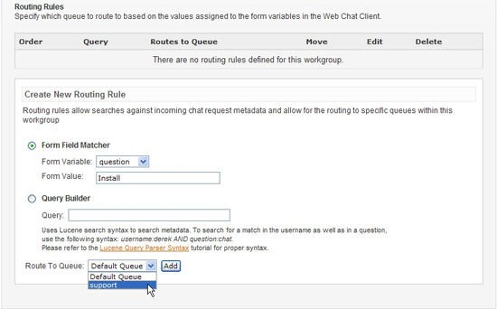

W en ou have added multipl rules, yo can use the up and down arrows in t e Mov column under Routin Rules to prior tize h w rules ar valuated. For ex mple, if you want to ensure hat some chat requ st get routed to a partic lar queue because of a value in the email variable — and regardless of the values given in the question variable — you could create a rule that queries on the email variable and move the rule to the top of the list.

**Note:** You can set the chat request form's user interface fields and hidden variables using the Admin Console. To set these, click the Fastpath tab, then click the name of the workgroup whose form you want to design. To set form fields, under Workgroup Settings click Form UI; for variables, under Workgroup Settings click Form Variables.

View the Summary of Workgroup Activity

The workgroup summary cree shows you how many m mbers re assigned to each workgroup and ho many of the to al are currently engaged in an activ chat sessi n. You ca also see the number of que es and agents in the queues.

**Workgroup statu .** "Open" status indicates a member is currently signed in to the workgroup through the Spark client and the workgroup is currently accepting chat requests. "Waiting for member" means the workgroup is no accepting chat requests because no member is available to chat. "Closed" means the workgroup is not accepting chat requests.

To view the workgroup activity summary:

* In the Admin Console, click the Fastpath tab. The Workgroup Summary screen displays.

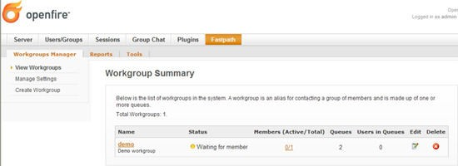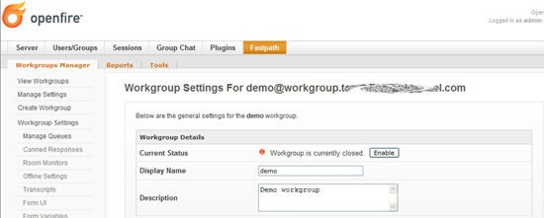

Open or Close a Workgroup Manually

Suppose your support center is closed for the day and you want to prevent new requests from being received, but you don't want to shut out the customers who are already in the workgroup queue or are being helped by a workgroup member. You can manually close the workgroup to new requests.

To manually close a workgroup to new requests

1. In the Admin Console, click the Fastpath tab.
2. In the Workgroup Summary screen, click the name of the workgroup.
3. Under Workgroup Settings, click Settings.
4. To close the workg oup, in the Current S atus ow, click the Close bu ton. The button changes to ead "Enable and the green dot icon indicating an open s atus changes to red.
5. o open the wo kgroup, click the Enabl utton.

Set Workgroup Email Transcript Properties

The sys em will occ s nally eed to send emails of ses ion transcript to webchat client ser . Yo 'll need to set up a workgroup email account to make this possible.

**Note:** You must have an email server defined for Openfire in order for your email Transcript settings to work. To define the server, in the Admin Console go to Server > Email Settings.

To set up email transcript capability for a workgroup

F

a

s

tp

a

t

h

Q

u

i

c

k

s

ta

r

t

-

1

7

1. In the Admi onsole, click the F stpath tab; then, in th Workgroups Summary scre n, click the name f the workgroup for whi h yo want to set up email.

F

a

s

tp

a

t

h

Q

u

i

c

k

s

ta

r

t

-

1

8

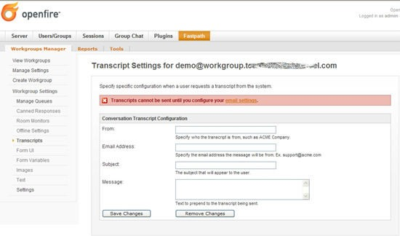

1. In the sidebar pane under Workgroup Settings, click Transcripts. The Transcript Settings screen displays.
2. Type in email account information for the workgroup in the fields provided, including subject and message. When finished, click the Save Changes button.

**Note:** SMTP se tings are controlled under Email Settings in the Server tab of the Ad in Console For more information, refer to the Admin Console online Help.

Set Workgroup Offline Properties

Use the workgroup offline settings to display a message to users when the workgroup is closed.

**Note:** You must have n email s r er defined for O enfir in ord r for your offline message settings to work. To define the server, in the Admin Console go to Server > Email Settings.

T set offline propertie for a workgroup

1. In the Admin Console, click the Fastpath tab; then, in the Workgroup Summary screen, click he name of the workgroup.
2. n t e sidebar pane under Workgroup Settings, click Offlin Settin s. The Workgroup Offline screen displays.

F

a

s

tp

a

t

h

Q

u

i

c

k

s

ta

r

t

-

1

9

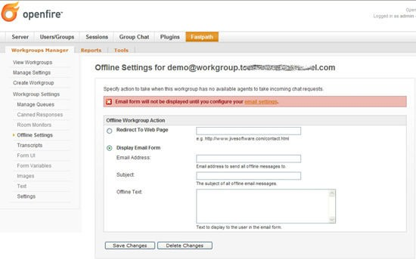

1. Type in the offline message information and t en click the Save Changes button

**Fastpath Quick Start Guide**

Getting Started Fastpath Overview Terminology

Using Fastpath for the First Time Configuring Fastpath

Create Users

Create Workgroups and Workgroup Queues Deploying the Webchat Client

**Getting Started**

This guide is designed to get you up and running quickly with Fastpath. Starting with an overview, you'll see how the parts of the system work together, and then, using the default installation, use the demo account and workgroup to test the system and see that it works correctly.

Fastpath is included as part of Openfire Enterprise. Installing the Openfire Enterprise and webchat plugins will give you the features described in this guide. For more information on these plugins, see the Openfire plugins list at ignite realtime.

**Note:** The screen shots and components shown in this guide are for illustration purposes and may differ somewhat from your implementation.

**Fastpath Overview**

Fastpath provides queuing and routing for instant messaging to intelligently link people together. It can be used to provide customer support or sales chat on a website or to link departments together inside an organization.

Fastpath is built on the Openfire and Spark platforms. Before configuring Fastpath, you need to understand how its components work together.

**Fastpath System Components**

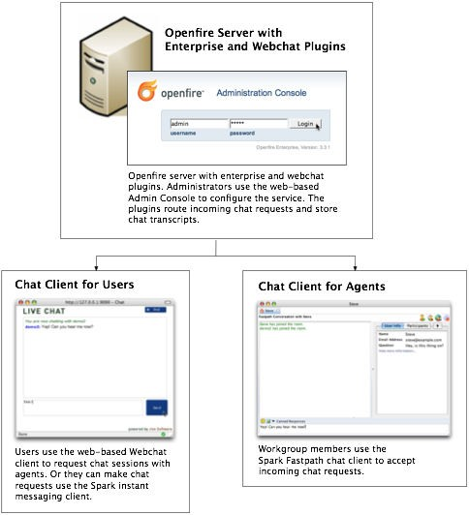

**Deploying the Webchat Client**

To make the chat service work on your website, you need to deploy the Webchat client application to your application server (the server must have Servlet 2.3 or greater support). You'll find installation instructions in the webchat readme file.

**How the chat process works (using the Webchat client)**

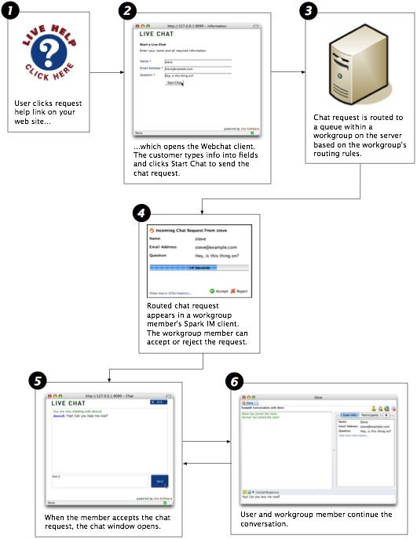

**Terminology**

**admin console:** The web-based administration tool used to manage Fastpath.

**administrator**: The person who will use the Admin Console to configure and manage Fastpath.

**Enterprise plugin:** The Openfire plugin that enables Fastpath functionality on the server side. It executes routing rules and stores chat transcripts.

**chat session:** A text-based conversation between a Fastpath workgroup member and another user (that requests the chat session).

**queue:** Each workgroup can contain multiple queues, which are used to route chat requests to the most appropriate workgroup members based on routing rules.

**request offer:** An incoming chat request offered to an agent. The agent can accept the offer, decline it, or wait until it times out and is routed elsewhere.

**Spark:** An instant messaging client. Fastpath chat is used by workgroup members to answer incoming chat requests. It can also be used to request workgroup chats as an alternative to the Webchat client.

**user:** A person who has been added to the Openfire system and assigned a password. Users can be added to workgroups to become workgroup members.

**Webchat client:** A client for communicating with a Fastpath workgroup through a web browser. Or, the Spark IM client can be used to chat with a workgroup.

**workgroup:** A cluster of request queues and associated members. Workgroups are usually defined by a particular set of business responsibilities (such as "Sales" or "IT Helpdesk"). For example, a workgroup could be devoted to answering customer inquiries about a particular product the company sells.

**workgroup member:** Any user that's a member of a workgroup and that accepts chat requests for the workgroup.

**Openfire:** Open Source IM server. The Fastpath server plugin is installed into an existing Openfire instance.

**Admin Console Overview**

The Fastpath extensions to the Openfire Admin Console allow you to set up, configure, and administer the Fastpath application and its users. With the console you can:

* + Create workgroups and configure workgroup members
  + Monitor chat sessions and queue activity
  + View server, workgroup, and queue statistics

The administrative tasks described in this guide assume you have access to the admin console.

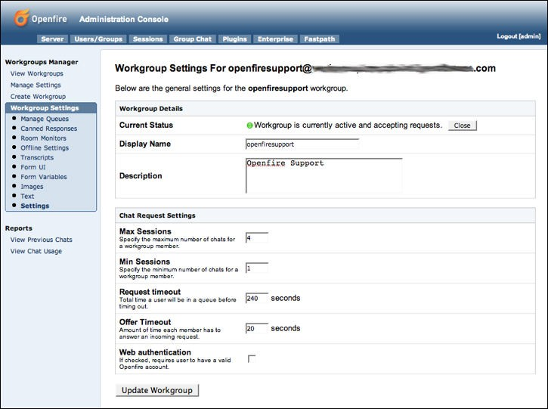

**Using Fastpath for the First Time**

When you use Fastpath for the first time, you'll use the demo workgroup and the demo workgroup member account to begin setting up your system and to see how the Fastpath components work together.

In the default installation, the Fastpath server plugin along with the Webchat Client application plugin are installed on the Openfire Server. Later you can install the Webchat applications to your own application server to fit the needs of your deployment.

**Install Fastpath**

**To set up and test your Fastpath installation**

1. Workgroup members use the Spark IM client to accept incoming chat requests and conduct chat sessions. For the purpose of setup and testing, install the latest release of Spark on one workgroup member computer for now. Download the latest release of Spark from jivesoftware.com/products/ spark. Or, if you're using Spark Manager, download Spark from your local Spark Manager server. Run the Spark installer.
2. Ensure that the Openfire IM server and Fastpath server plugin is installed as described in the installation guide. Log in to the Openfire Admin Console using the admin credentials. If you did not change the default password, use the default:
   * username: admin
   * password: admin
3. In the Admin Console, click the Fastpath tab. The Workgroup Summary screen displays, showing a summary of all workgroups currently in the system. Verify that the demo workgroup exists.

**Note:** The demo workgroup is set up automatically during installation. You can delete the demo workgroup when it's no longer needed.

**Run a Test Chat Session**

By running a test chat session, you'll see how the Webchat Client and the Spark IM client work during a basic chat session. You'll use the demo workgroup that came with the installation for this test. Later, once you know how to set up your own workgroups, you can delete the demo workgroup if you'd like.

**To run a test chat session**

1. After you install Spark, start the application and log in using the demo credentials and the name of your server.
   * Username: demo
   * Password: demo

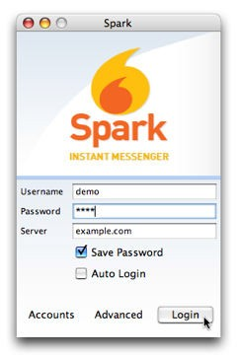

When you log in, Spark automatically logs you in to the demo workgroup.

1. Navigate to the Webchat webpage: in the Admin Console, click the Fastpath tab and then, in the sidebar pane under Tools, click Webchat to go to the host page and click the live help link for the demo workgroup.
2. In the Live Chat window, fill in the required fields and then click the Start Chat button.

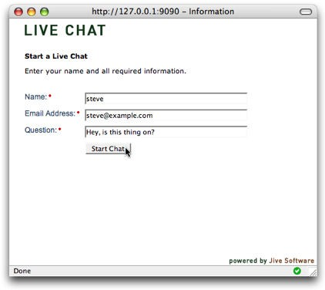

1. Click Accept in the chat request message that Fastpath displays.

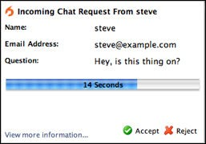

1. In the Fastpath chat window that opens, type a response to yourself.

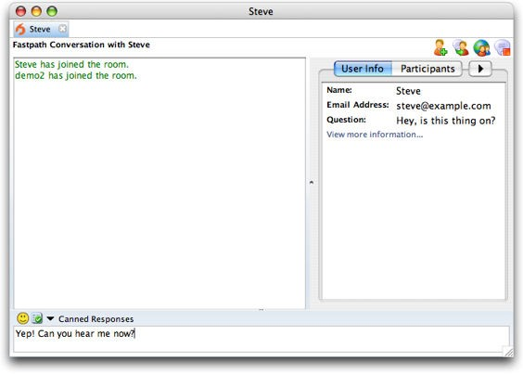

1. Switch back to the Live Chat window to see that your response went through.

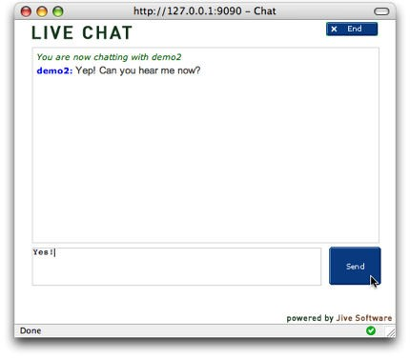

1. Close the chat session in both the Fastpath chat window and the Live Chat window.



**Configuring Fastpath**

Now that you've installed the Spark and tested the system, you can configure your installation. You configure Fastpath by:

1. Creating users for your Fastpath system.
2. Creating workgroups and workgroup queues.
3. Adding workgroup members and groups to workgroup queues.

To get started, you can use most of Fastpath's default server and other settings.

**Create Users**

After verifying your Fastpath installation, you'll need to add users to the Fastpath system.

**Users vs. Workgroup Members.** Fastpath makes a distinction between users and workgroup members. Users are general system users who might or might not belong to a workgroup. All workgroup members, however, are users.

**To create a new user**

1. In the Admin Console, click the Users/Groups tab; in the sidebar, under Users, click Create New User.

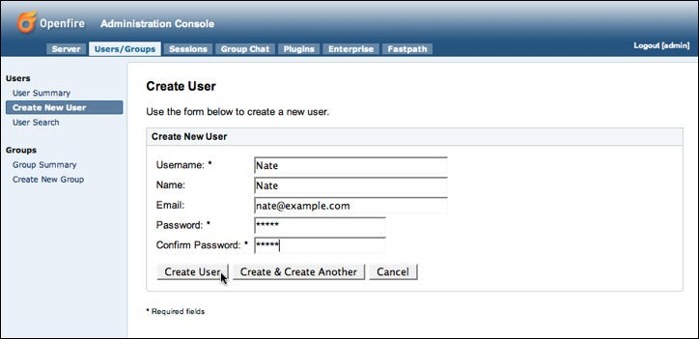

1. In the Create User screen, complete the fields. Required fields have an asterisk to the right of their names. When you're finished, click the Create User button.

**Create Workgroups and Workgroup Queues**

**Help.** For more information on setting up routing rules for workgroups, refer to the Admin Console online Help.

In Fastpath, you use workgroups to organize a set of members to handle chat requests. Workgroups are usually organized by function or specialty. Each workgroup contains one or more queues; the Fastpath server routes chat requests to workgroup queues based on routing rules you set up for each queue.

The following example shows chat request routing for a company that sells sports equipment. The company has divided its support agents into workgroups based on the roles of sales and support, and queues within each workgroup based on the sport.

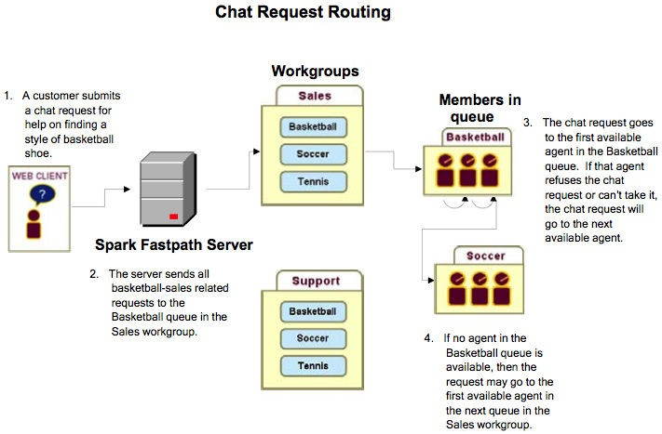

**Create a Workgroup and Add Initial Users**

When you create a workgroup, you give it a name, description, and its initial members. New workgroups also come with a default queue. You can add more queues at any time.

To create a workgroup: In the Admin Console, click the Fastpath tab, and then, in the sidebar pane under Workgroups Manager, click Create Workgroup.

**Add a Queue to a Workgroup**

This example shows you how to add a queue to the new workgroup you created.

**To add a queue to a workgroup**

1. In the Admin Console, click the Fastpath tab.
2. In the Name column of the Workgroup Summary screen, click the name of the workgroup you created.
3. In the sidebar pane under Workgroup Settings, click Manage Queues.
4. In the Workgroup Queues screen, click Add Queue.

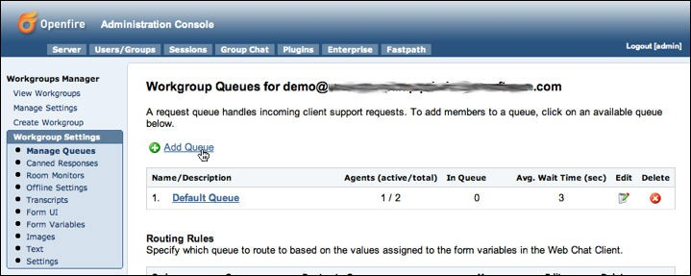

The Workgroup Queue Creation screen displays:

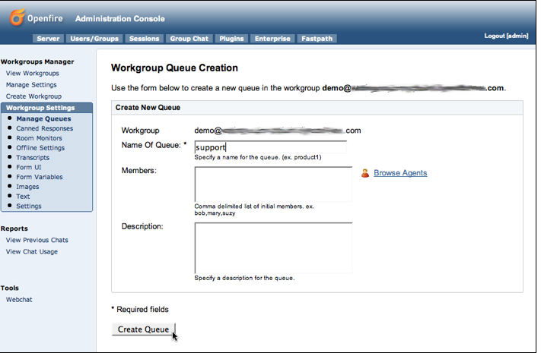

1. Complete the fields as described and then click the Create Queue button. The Workgroup Queues screen displays, showing the newly created queue. Next, you'll add agents and agent groups to your queue.

**Add Workgroup Queue Members**

In the previous section, you created a new queue for the workgroup you created. In this section, you'll see how to add additional users and user groups.

**To add users and user groups**

1. In the Admin Console, click the Fastpath tab and then, in the Name column of the Workgroups Summary screen, click the name of your workgroup.
2. In the sidebar pane under Workgroup Settings, click Manage Queues.
3. In the Workgroup Queues screen, click the name of the desired queue. The Manage Queue screen displays.
4. Scroll down to the Add Agents section and click the Browse link to the right of the Add Agents box.

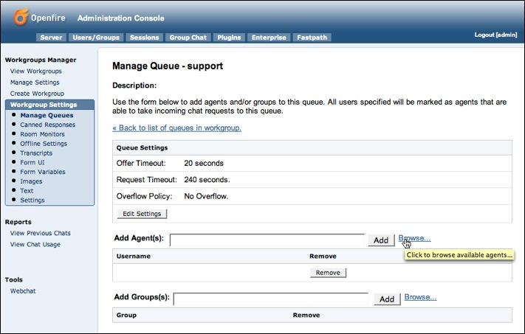

The Possible Agents to Add dialog box displays.

1. After selecting the desired users to add, click the Done button.

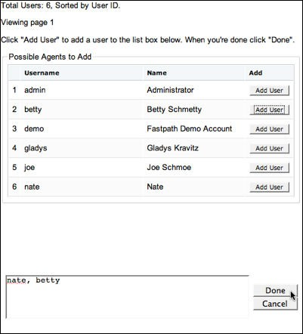

1. In the Manage Queue screen, click the Add button to add the users you selected.
2. To add Fastpath groups, click the Browse link next to the Add Groups box, select the groups you want from the dialog box, then click the Done button.
3. In the Manage Queue screen, click the Add button to add the groups you selected.
4. Under Queue Settings, click Edit Settings to edit how you want Fastpath to determine which member is the best choice to receive a request offer.

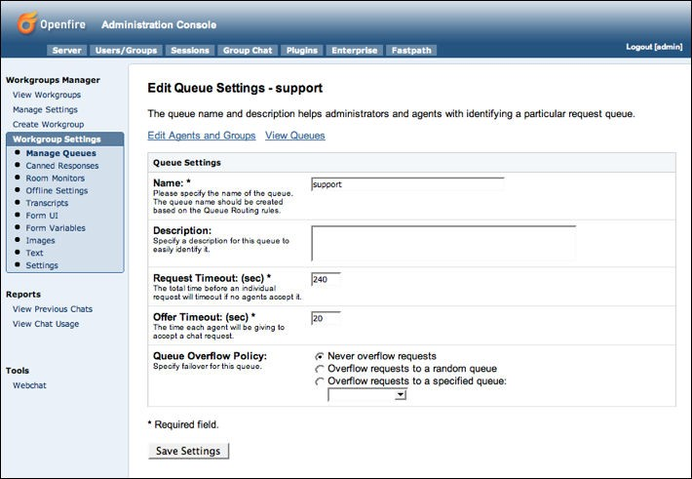

1. When finished, click the Save Settings button.

**Add Workgroup Queue Routing Rules**

You can add rules that direct new chat requests to particular queues. This is similar to the way some email programs route a message to particular folders based on the message's content. For example, you might want to ensure that some requests get to the support queue instead of the sales queue.

When you create a routing rule, you are telling Fastpath to examine a particular variable for a particular value. For example, you might set a rule in which the email address given must contain a particular domain name in order for the chat request to be routed to a particular queue.

**To add queue routing rules**

1. In the Admin Console, click the Fastpath tab and then, in the Name column of the Workgroups Summary screen, click the name of your workgroup.
2. In the sidebar pane under Workgroup Settings, click Manage Queues.
3. In the Workgroup Queues screen, scroll to the Routing Rules part of the screen.
4. Under Create New Routing Rule, note that there are two subsections; these are alternate ways to create a rule:
   * **Form Field Matcher** provides a dropdown that lists all of the variables that Fastpath can query on. This is the simple way to build routing rules. Select the variable you want, then enter the value that should be present in that variable in order for the request to be routed to the queue.
   * **Query Builder** provides a place where you can create your own query by typing in its syntax. This is an advanced option. The variables you'd enter here are the same as those you can see listed in the Form Variable dropdown. (See Apache's Query Parser Syntax for more information on the Lucene syntax used here.)
5. In the Route to Queue dropdown list, select the queue for which the rule should be used, then click Add.

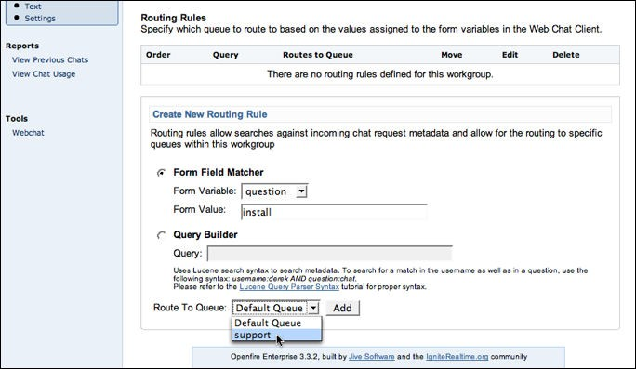

When you have added multiple rules, you can use the up and down arrows in the Move column under Routing Rules to prioritize how rules are evaluated. For example, if you want to ensure that some chat requests get routed to a particular queue because of a value in the email variable — and regardless of the values given in the question variable — you could create a rule that queries on the email variable and move the rule to the top of the list.

**Note:** You can set the chat request form's user interface fields and hidden variables using the Admin Console. To set these, click the Fastpath tab, then click the name of the workgroup whose form you want to design. To set form fields, under Workgroup Settings click Form UI; for variables, under Workgroup Settings click Form Variables.

**View the Summary of Workgroup Activity**

The workgroup summary screen shows you how many members are assigned to each workgroup and how many of the total are currently engaged in an active chat session. You can also see the number of queues and agents in the queues.

**Workgroup status.** "Open" status indicates a member is currently signed in to the workgroup through the Spark client and the workgroup is currently accepting chat requests. "Waiting for member" means the workgroup is not accepting chat requests because no member is available to chat. "Closed" means the workgroup is not accepting chat requests.

To view the workgroup activity summary:

* + In the Admin Console, click the Fastpath tab. The Workgroup Summary screen displays.

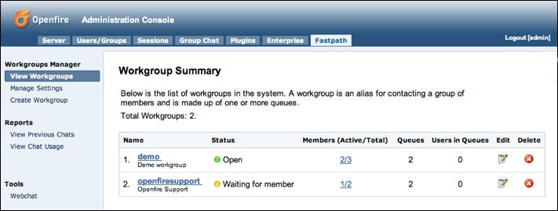

**Open or Close a Workgroup Manually**

Suppose your support center is closed for the day and you want to prevent new requests from being received, but you don't want to shut out the customers who are already in the workgroup queue or are being helped by a workgroup member. You can manually close the workgroup to new requests.

**To manually close a workgroup to new requests**

1. In the Admin Console, click the Fastpath tab.
2. In the Workgroup Summary screen, click the name of the workgroup.
3. Under Workgroup Settings, click Settings.
4. To close the workgroup, in the Current Status row, click the Close button. The button changes to read "Enable" and the green dot icon indicating an open status changes to red.

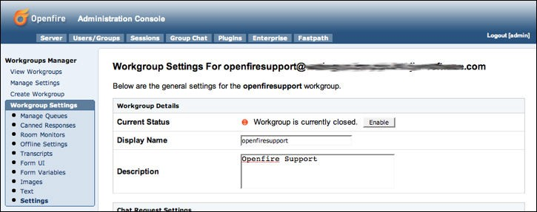

1. To open the workgroup, click the Enable button.

**Set Workgroup Email Transcript Properties**

The system will occasionally need to send emails of session transcripts to webchat client users. You'll need to set up a workgroup email account to make this possible.

**To set up email transcript capability for a workgroup**

1. In the Admin Console, click the Fastpath tab; then, in the Workgroups Summary screen, click the name of the workgroup for which you want to set up email.
2. In the sidebar pane under Workgroup Settings, click Transcripts. The Transcript Settings screen displays.

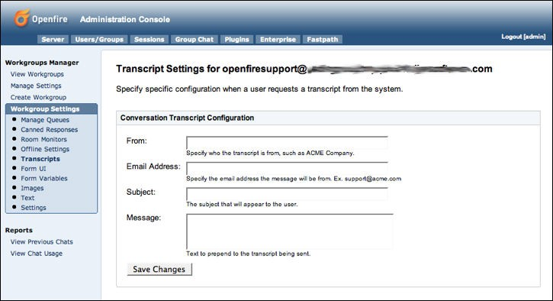

1. Type in email account information for the workgroup in the fields provided, including subject and message. When finished, click the Save Changes button.

**Note:** SMTP settings are controlled under Email Settings in the Server tab of the Admin Console. For more information, refer to the Admin Console online Help.

**Set Workgroup Offline Properties**

Use the workgroup offline settings to display a message to users when the workgroup is closed.

**Note:** You must have an email server defined for Openfire in order for your offline message settings to work. To define the server, in the Admin Console go to Server > Email Settings.

**To set offline properties for a workgroup**

1. In the Admin Console, click the Fastpath tab; then, in the Workgroup Summary screen, click the name of the workgroup.
2. In the sidebar pane under Workgroup Settings, click Offline Settings. The Workgroup Offline screen displays.

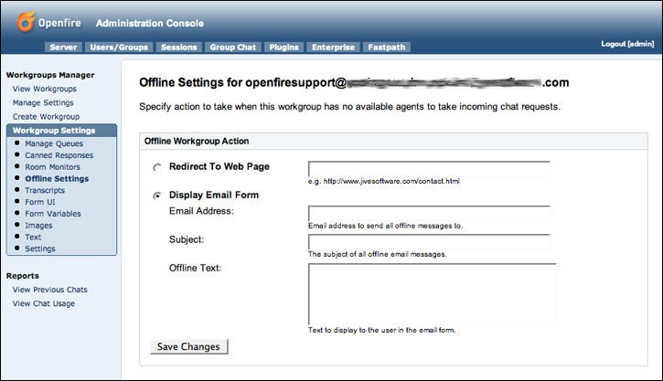

1. Type in the offline message information and then click the Save Changes button.