METRO TICKET BOOKING SYSTEM

1. Project Overview
Metro Ticket Booking System is a ServiceNow-based application developed to simplify the process of booking metro tickets.
The system allows users to select their source station, destination station, number of passengers, journey type, and automatically calculates the ticket amount. A QR code is also generated for the booked ticket.
The project demonstrates the use of Service Catalog, Catalog Items, Variables, Tables, Client Scripts, Auto-population, and Service Portal in ServiceNow.
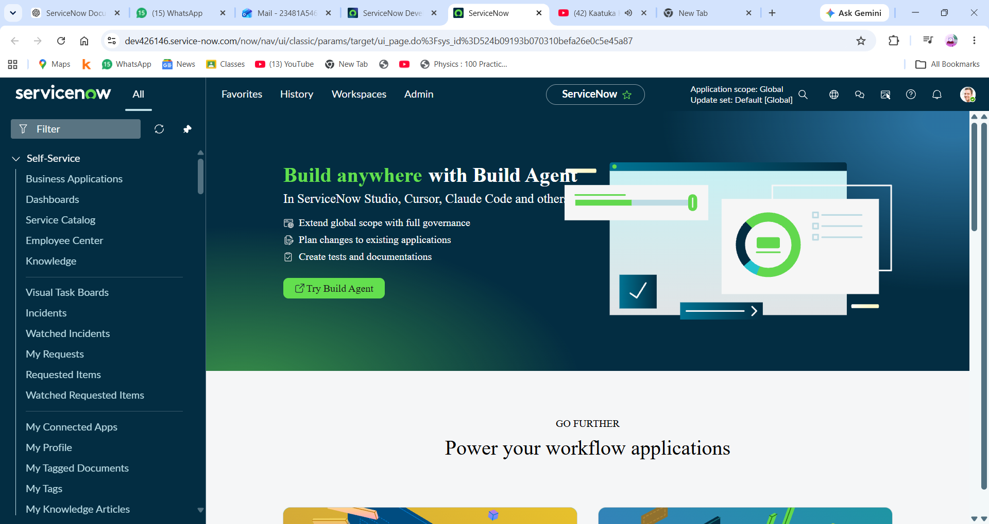
2. Objectives
The main objectives of this project are:
- To create a simple metro ticket booking system.
- To provide an easy interface for users to book tickets.
- To store metro station and fare details in a custom table.
- To automatically calculate the ticket fare.
- To support single and return journeys.
- To calculate the fare based on the number of passengers.
- To generate a QR code for the booked ticket.
- To understand and implement ServiceNow Service Catalog features.
Technology | Purpose
ServiceNow | Application development platform
Service Catalog | Metro ticket booking interface
Catalog Item | Booking form
Custom Table | Store station and fare details
Client Script | Dynamic form behaviour
Auto-populate | Automatically populate fare/details
Service Portal | User-facing interface
JavaScript | Calculations and client-side logic
QR Code | Digital ticket representation

4. System Architecture
The basic flow of the application is:
User
↓
Service Portal
↓
Metro Ticket Booking Catalog Item
↓
Select Source & Destination
↓
Select Journey Type
↓
Enter Number of Passengers
↓
Fare Calculation
↓
Ticket Booking
↓
QR Code Generation
5. Custom Table — Metro Station Details
A custom table named metrostationdetails was created to store metro station and fare-related information.
The table contains details required for calculating the ticket price between stations.
Example fields
- Station Name
- Station Code/Details
- Fare Information
- Return Fare
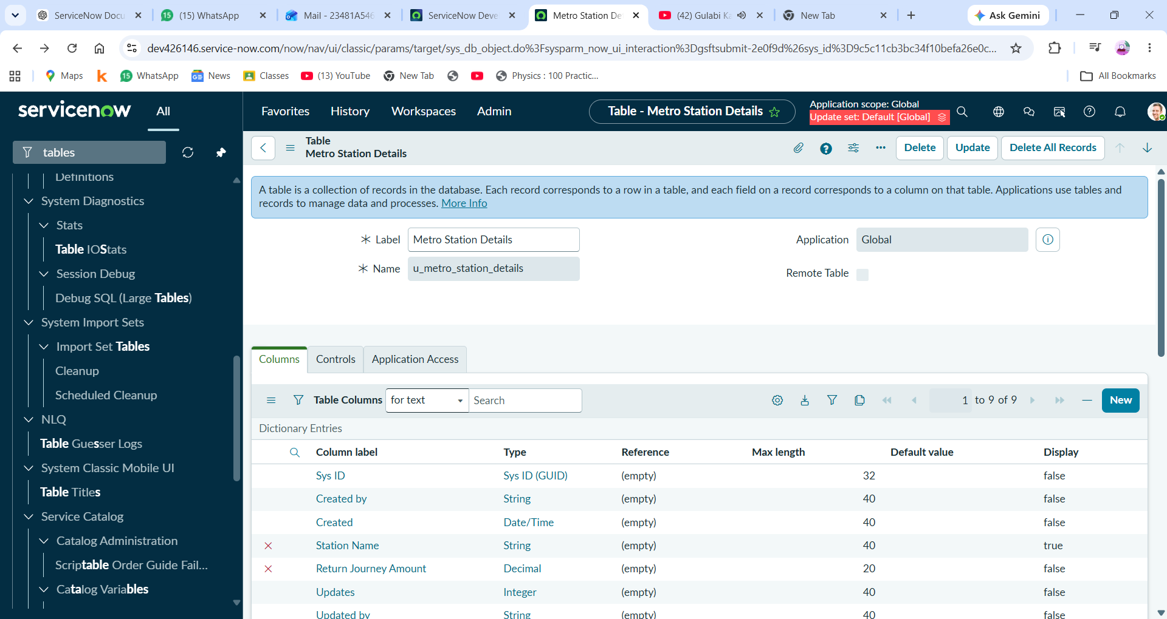

6. Service Catalog
A Service Catalog item named Book A Metro Ticket was created for users to book metro tickets.
The catalog item provides the required fields for entering journey details.
Main variables used
- Source Station
- Destination Station
- Journey Type
- Number of Passengers
- Amount for Single Journey
- Amount Including Return
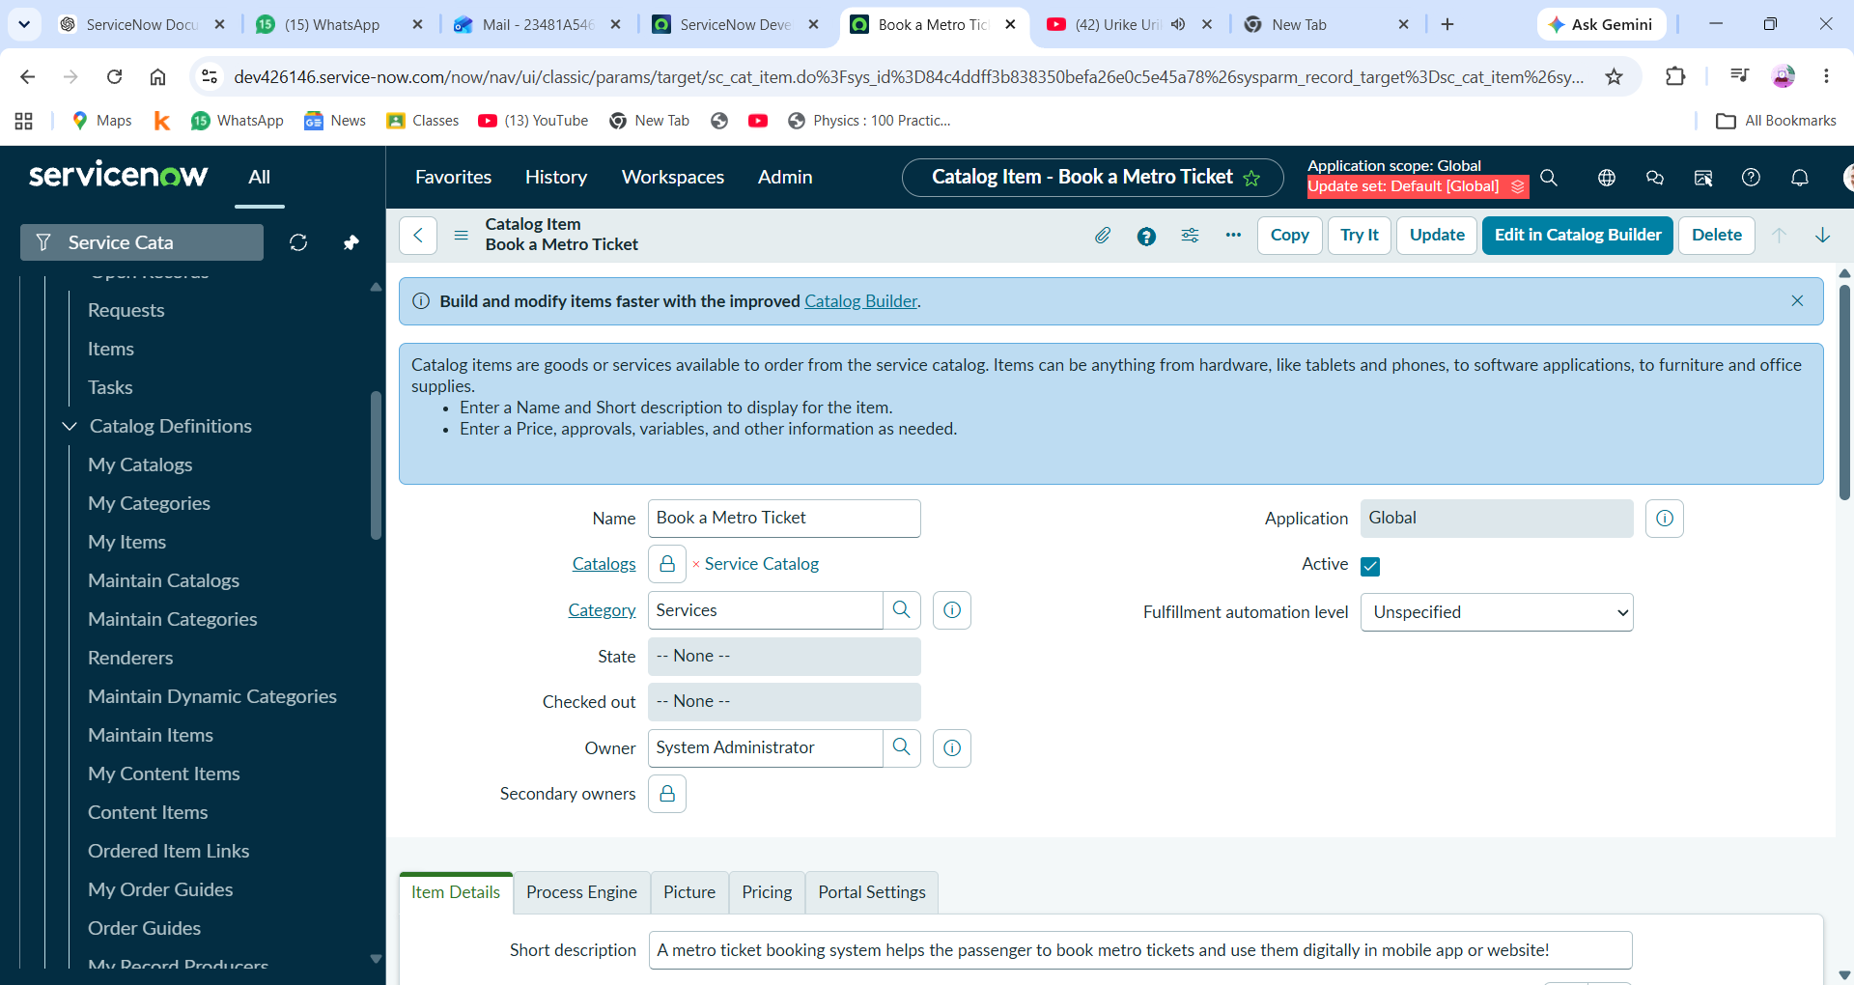

7. Catalog Variables
Different variable types were used to collect information from the user
Variable | Purpose
Source Station | Select starting metro station
Destination Station | Select destination
Journey Type | Select Single/Return journey
Number of Passengers | Enter passenger count
Amount for Single Journey | Display calculated fare
Amount Including Return | Display final fare

Reference variables were used where appropriate to retrieve station information from the custom metro station table
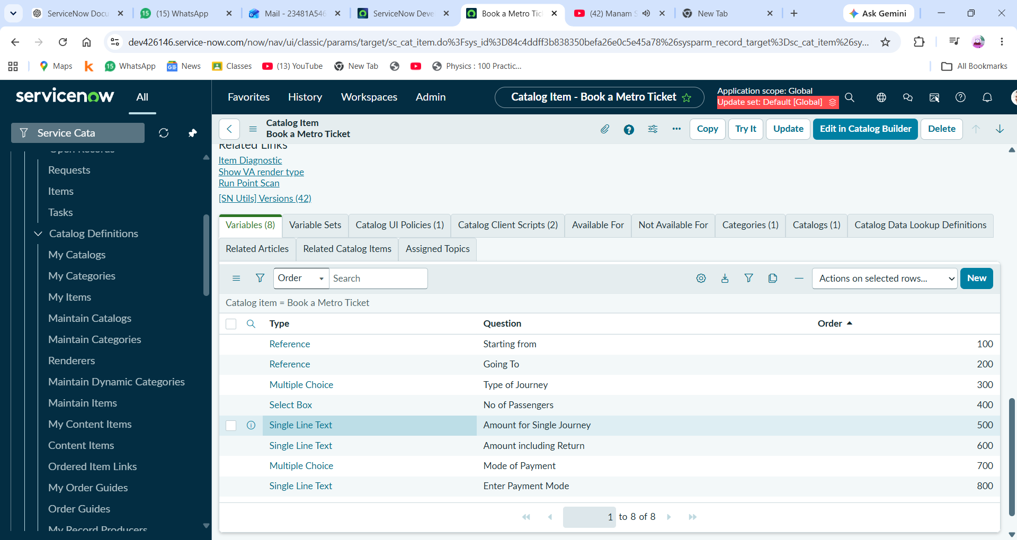

8. Station Selection
The user selects the source station and destination station from the available metro stations.
The station information is connected to the custom metrostationdetails table.
This allows the system to retrieve the required station and fare information dynamically.
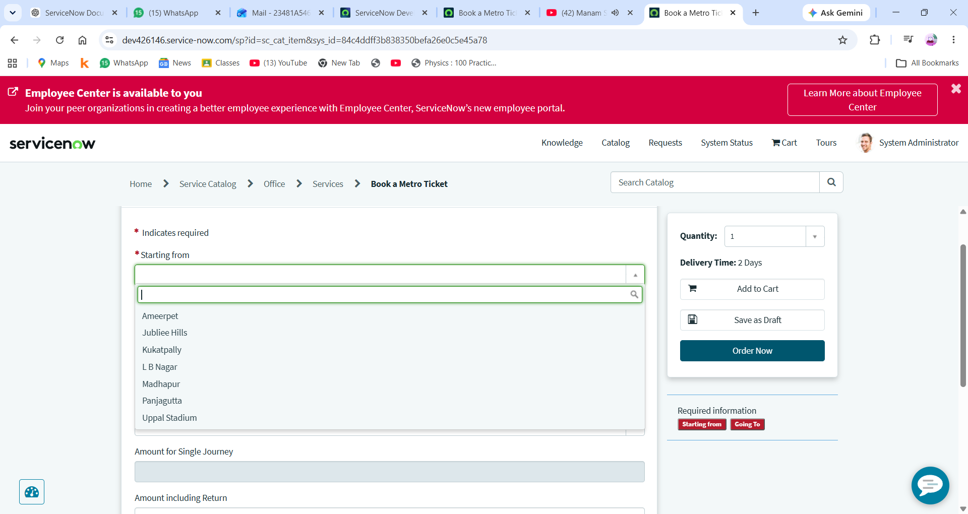

9. Automatic Fare Calculation
The system automatically calculates the ticket amount based on:
- Source station
- Destination station
- Journey type
- Number of passengers
For example:
Single Journey Fare
×
Number of Passengers
=
Total Fare
For a return journey:
Single Journey Fare × 2
×
Number of Passengers
=
Return Journey Fare
The calculated amount is automatically displayed in the corresponding fields.
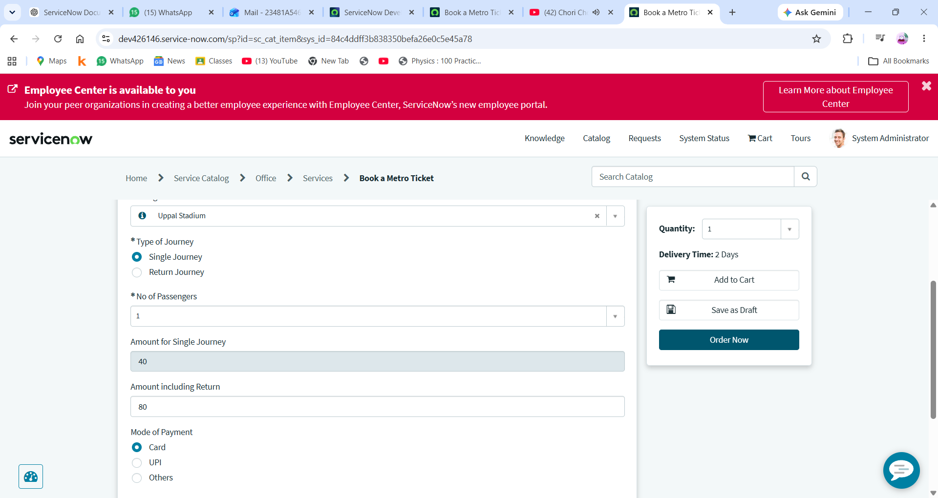

10. Client Script / Automation
Client-side scripting was used to dynamically handle form behaviour and fare calculations.
The scripts help the application:
- Read selected values.
- Calculate the ticket amount.
- Update the fare fields.
- Handle passenger count.
- Handle single and return journeys.
- Provide dynamic behaviour on the booking form.
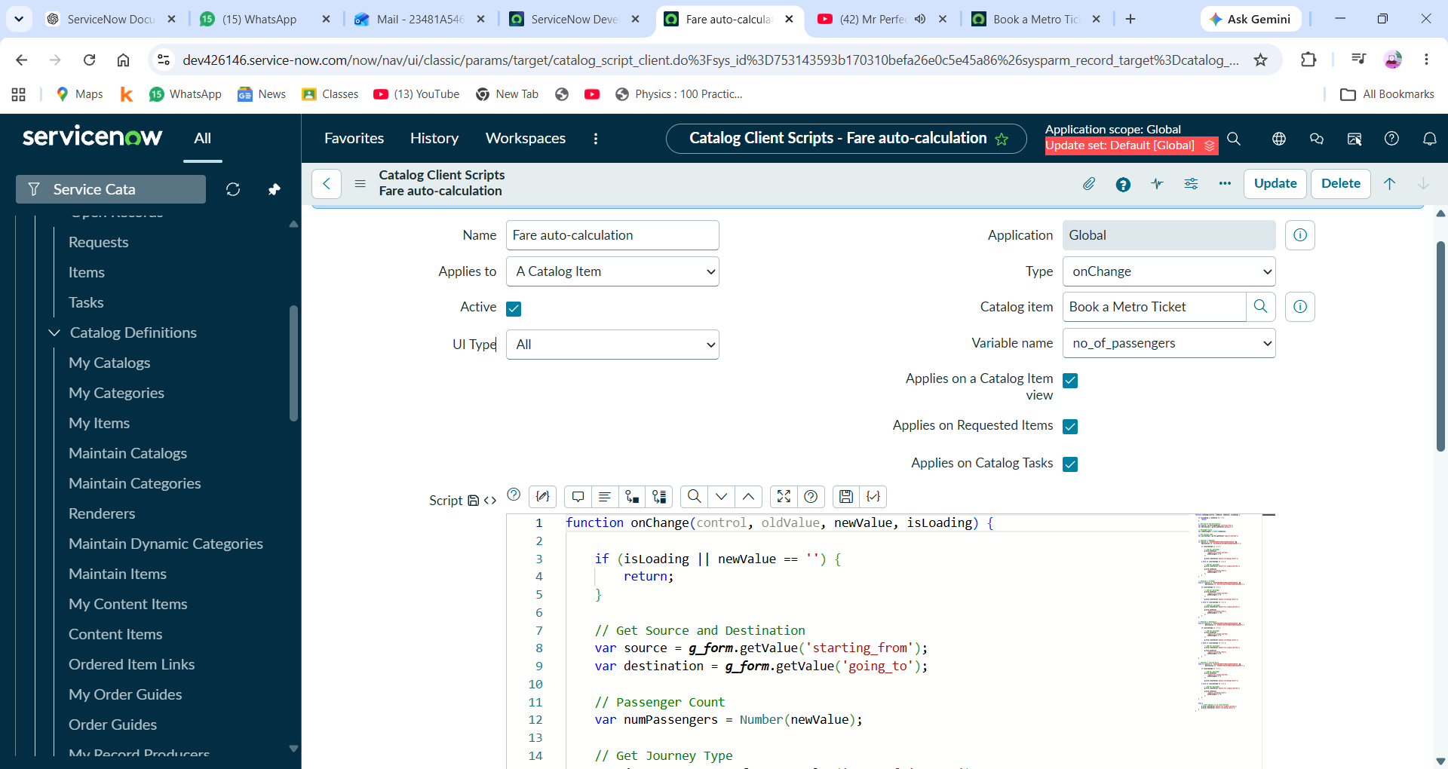

11. Service Portal
The Metro Ticket Booking functionality was made available through the ServiceNow user-facing interface.
Users can open the Book A Metro Ticket catalog item and enter their journey details.
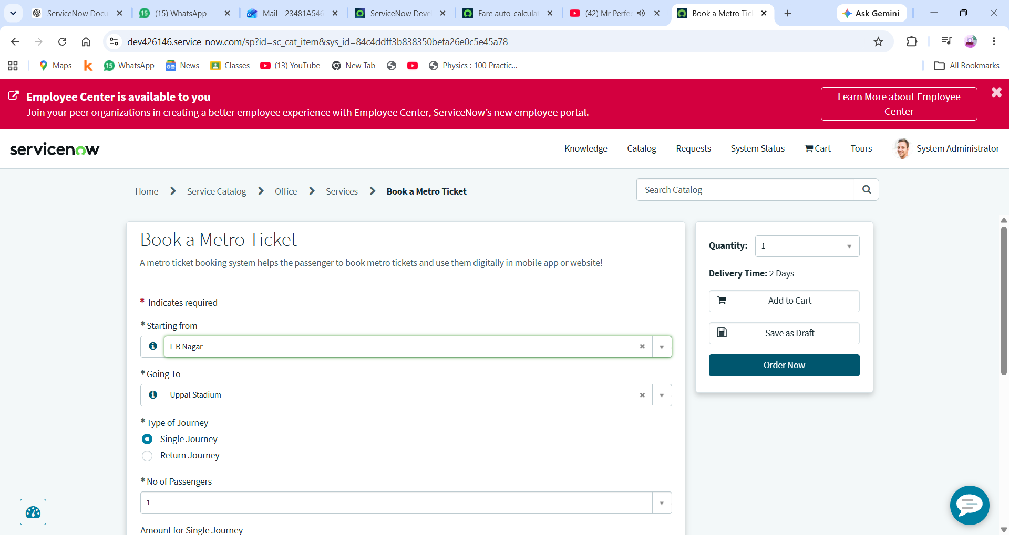

12. Ticket Booking
After entering the required details, the user submits the booking request.
The system processes the entered information and creates the corresponding ticket/request in ServiceNow.
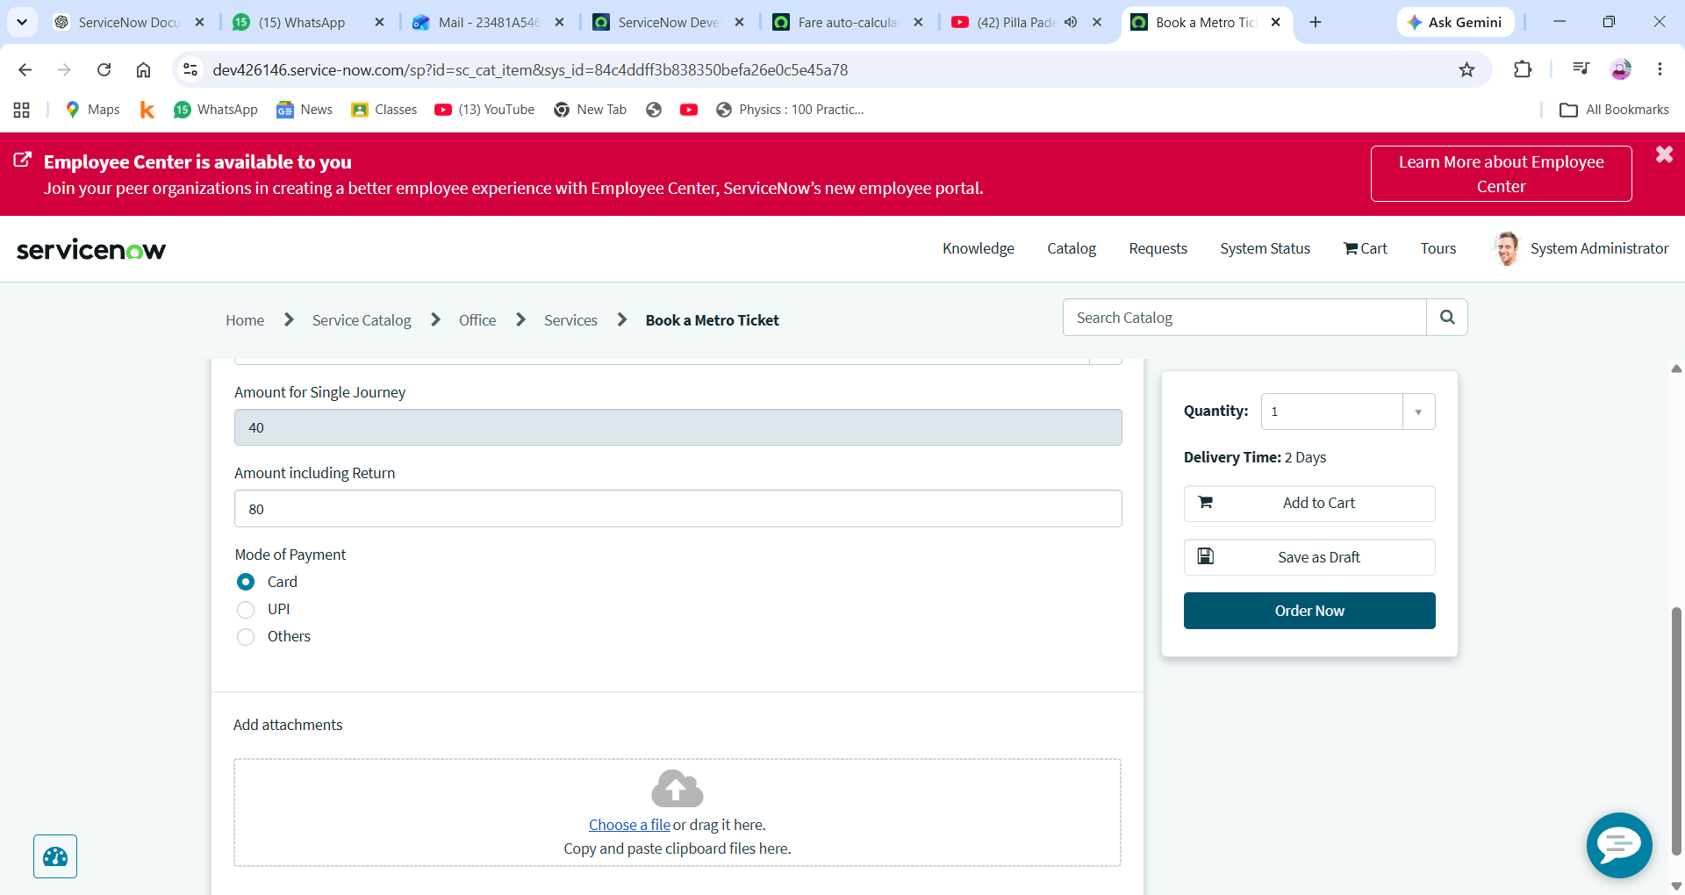

13. QR Code Generation
A QR code functionality was implemented to provide a digital representation of the metro ticket.
The QR code can contain ticket-related information that can be used to identify the booking.
This provides a more convenient way to represent the generated metro ticket digitally.
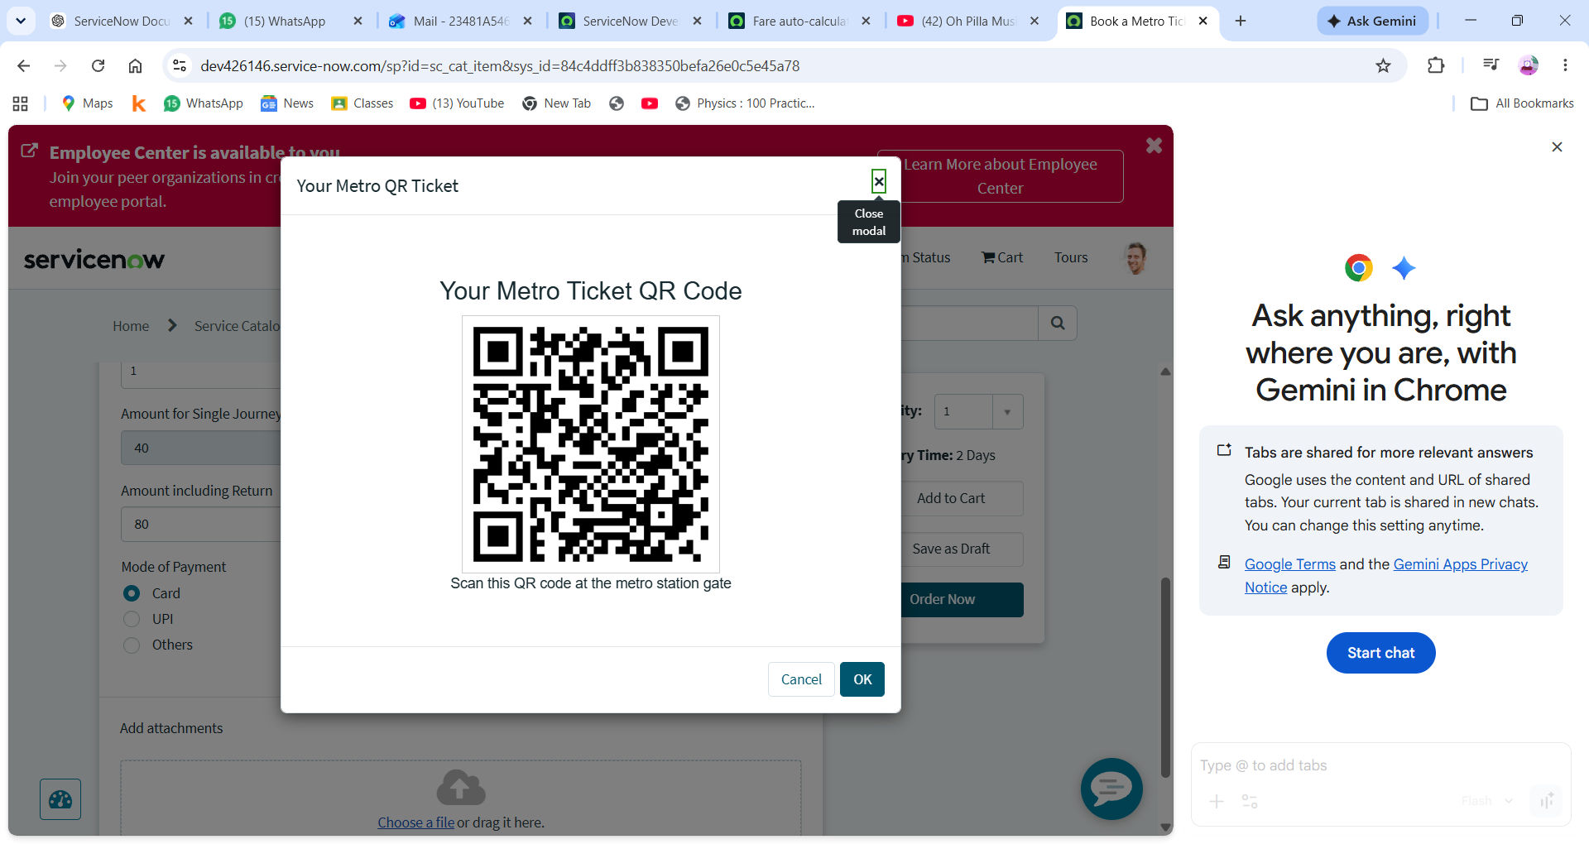

14. Complete Working Flow
The complete working process can be summarized as:

1. Open Service Portal
↓
2. Select "Book A Metro Ticket"
↓
3. Select Source Station
↓
4. Select Destination Station
↓
5. Select Journey Type
↓
6. Enter Number of Passengers
↓
7. Fare is Automatically Calculated
↓
8. Submit Booking
↓
9. Ticket is Created
↓
10. QR Code is Generated
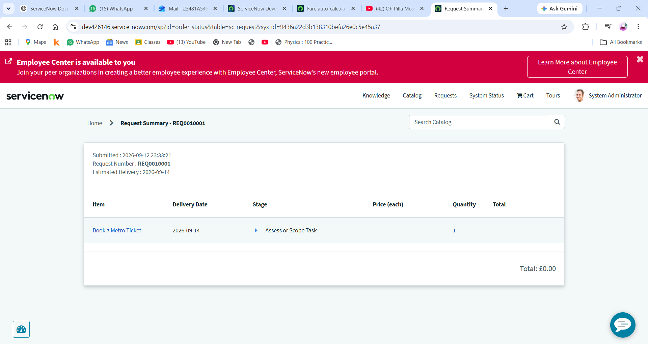

15. Key ServiceNow Concepts Used
This project helped implement and understand several ServiceNow concepts:
- Service Catalog
- Catalog Items
- Catalog Variables
- Reference Variables
- Custom Tables
- Table Records
- Client Scripts
- Auto-population
- Service Portal
- JavaScript
- Form Validation
- Dynamic Field Behaviour
- QR Code Integration

16. Project Features
👤 User Features
- Select source station
- Select destination station
- Select journey type
- Enter number of passengers
- View automatically calculated fare
- Submit metro ticket booking
- Generate QR code
⚙️ System Features
- Custom metro station table
- Dynamic fare calculation
- Automatic field population
- Single/return journey calculation
- Passenger-based fare calculation
- Digital QR ticket

17. Demo Video
https://www.youtube.com/watch?v=kaBRmBEJdOw&utm_source=chatgpt.com
A demonstration video of the project is available below:
Metro Ticket Booking System — Demo Video
The video demonstrates the complete booking process, including station selection, fare calculation, ticket submission, and QR code generation.

18. Future Enhancements
The project can be enhanced in the future by adding:
- Online payment integration
- Live metro station availability
- Multiple metro routes
- Ticket cancellation
- Booking history
- Admin dashboard
- Email/SMS ticket confirmation
- QR code scanning and ticket validation
- Real-time metro information

19. Conclusion
The Metro Ticket Booking System demonstrates how ServiceNow can be used to develop a simple and interactive ticket booking application.
The project combines Service Catalog, custom tables, catalog variables, client-side scripting, automatic fare calculation, Service Portal, and QR code generation to create a complete booking workflow.
It provided practical experience in configuring ServiceNow applications and implementing business logic using JavaScript.

