Programs on patterns

Date:01-09-2025

1. Print a square pattern. Code:

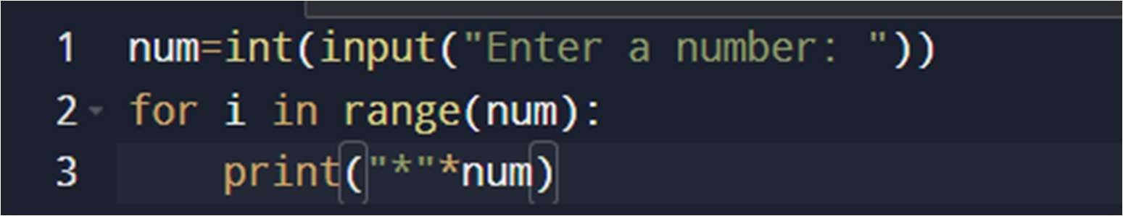

Output:

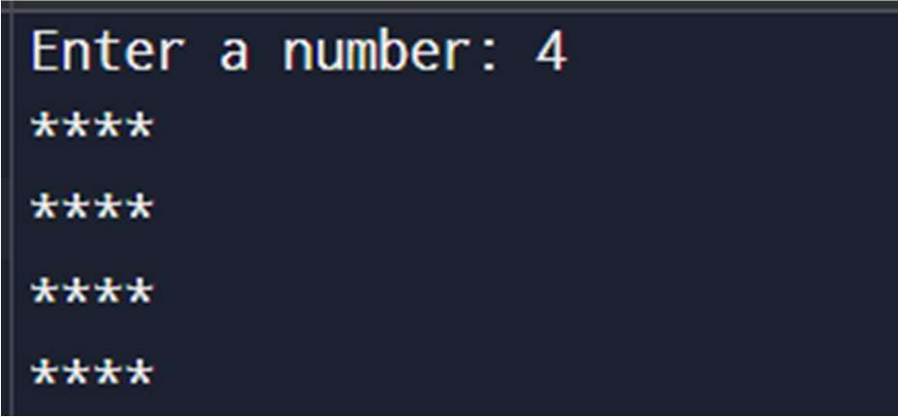

1. Print hollow square pattern for the given input. Code:

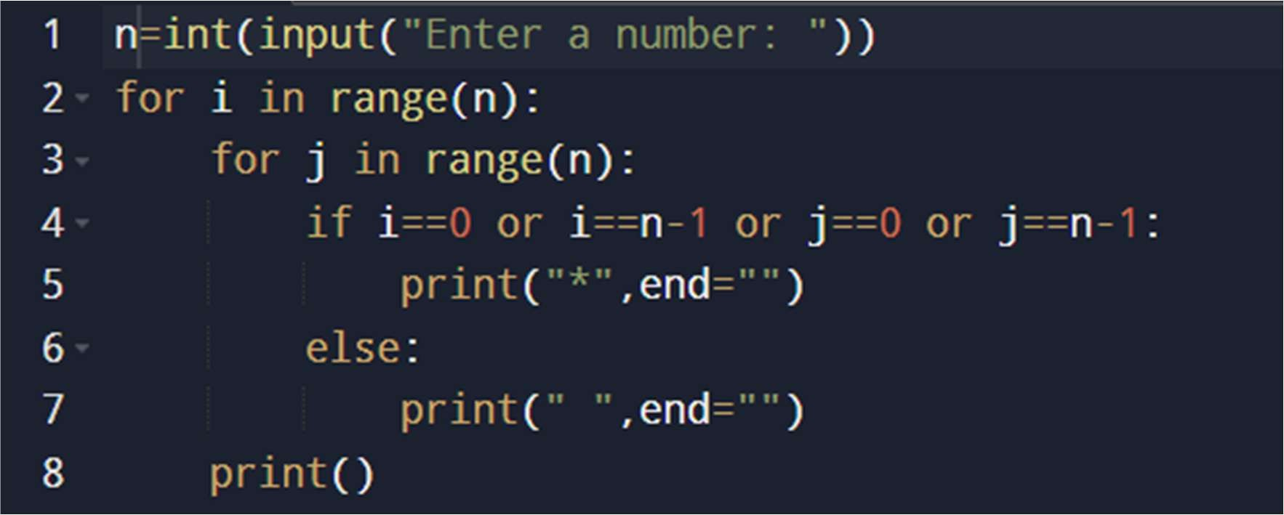

Output:

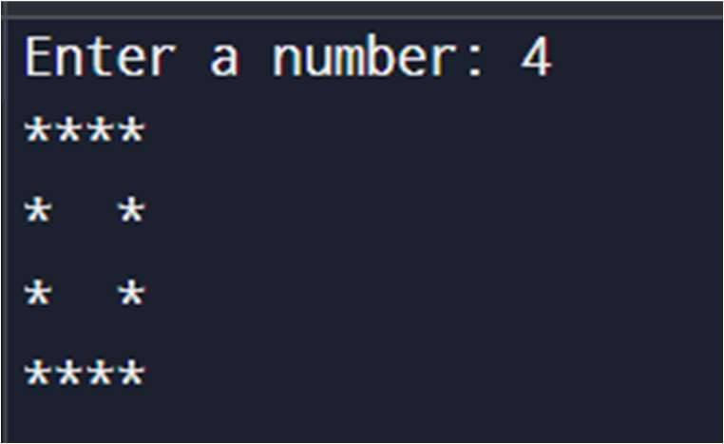

1. Rhombus Star Pattern for he given input. Code:

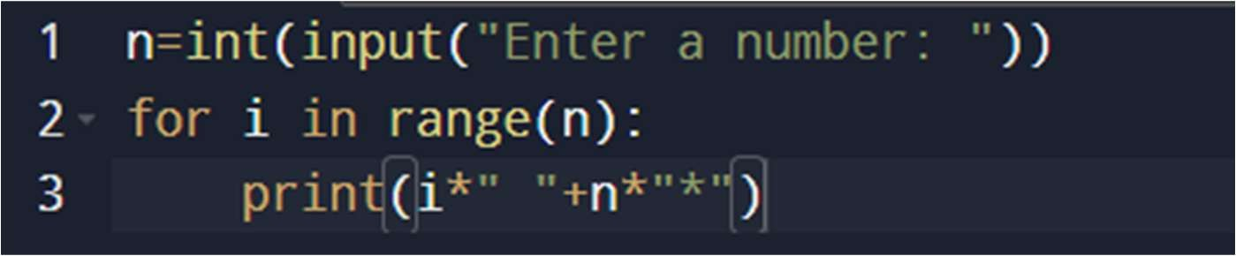

Output:

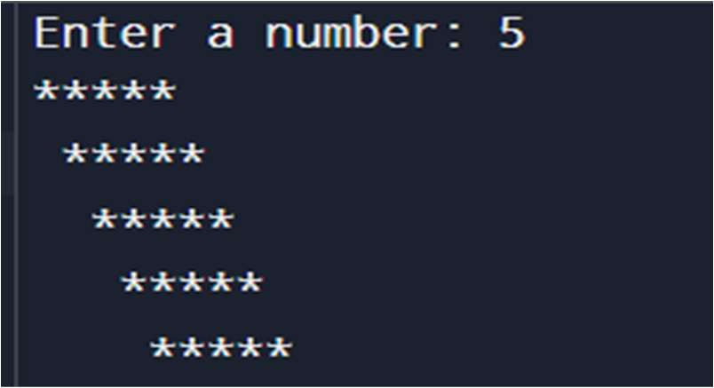

(or)

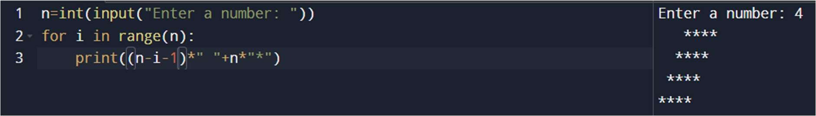

1. Rectangular star pattern. Code:

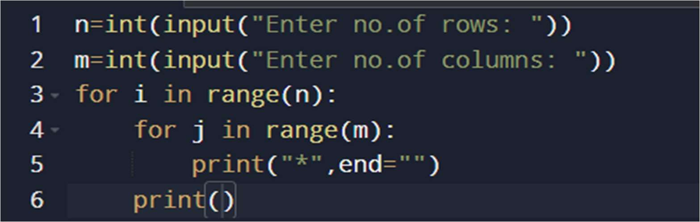

Output:

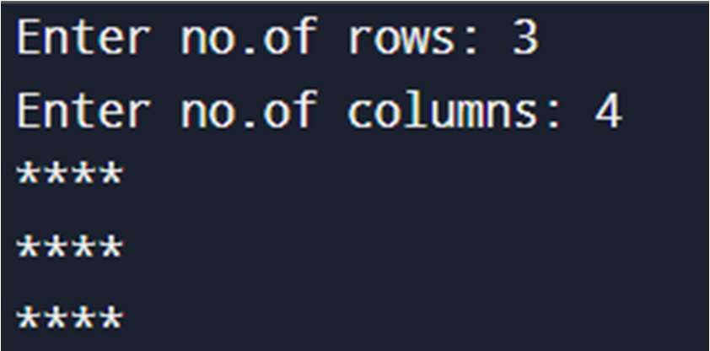

1. Hollow Rectangle Star Pattern. Code:

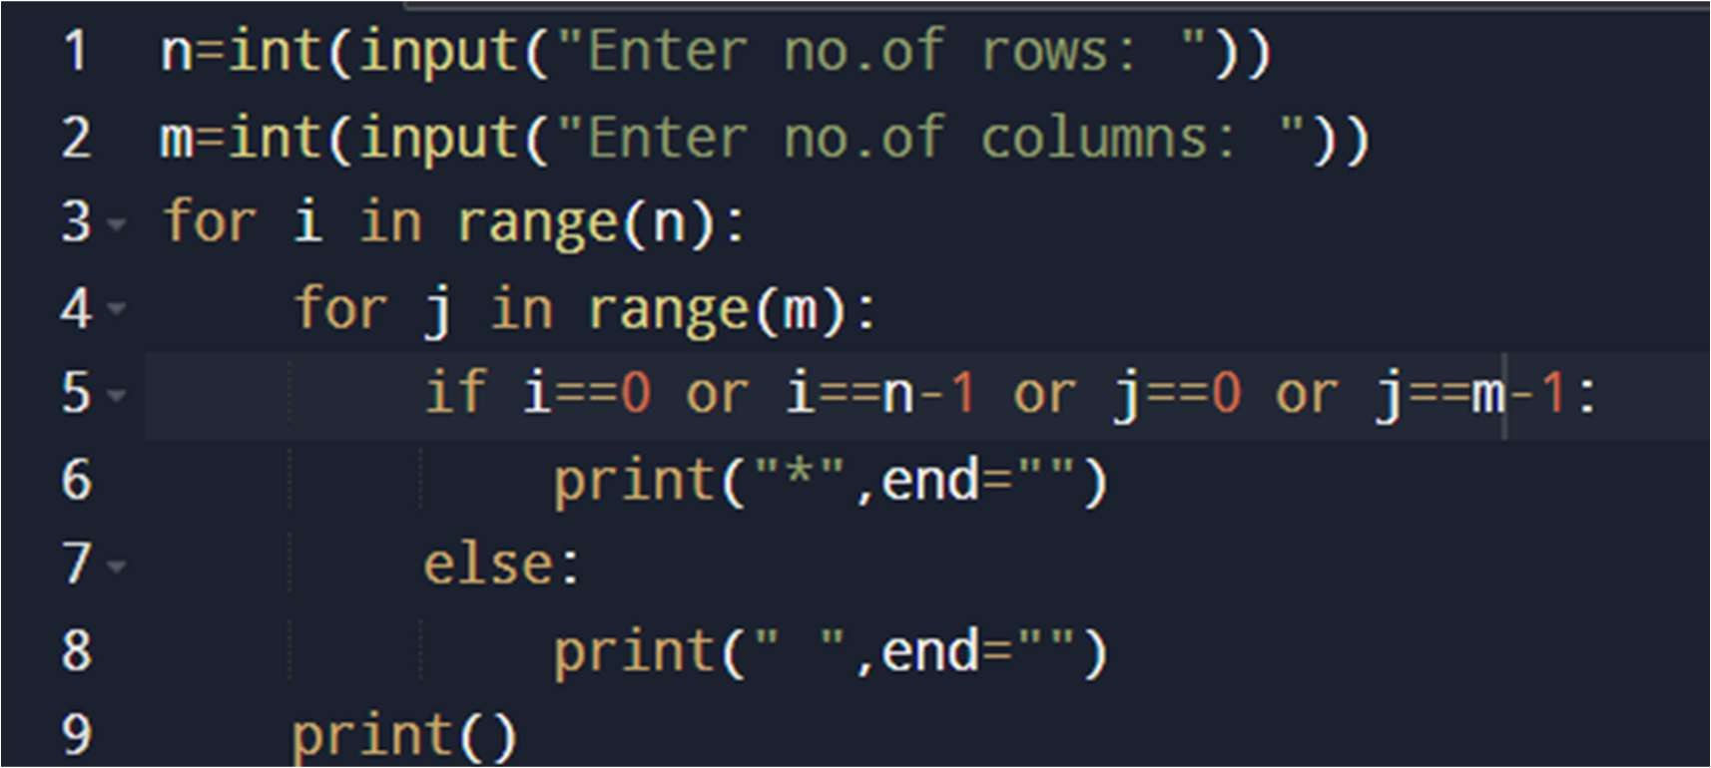

Output: Test case1:

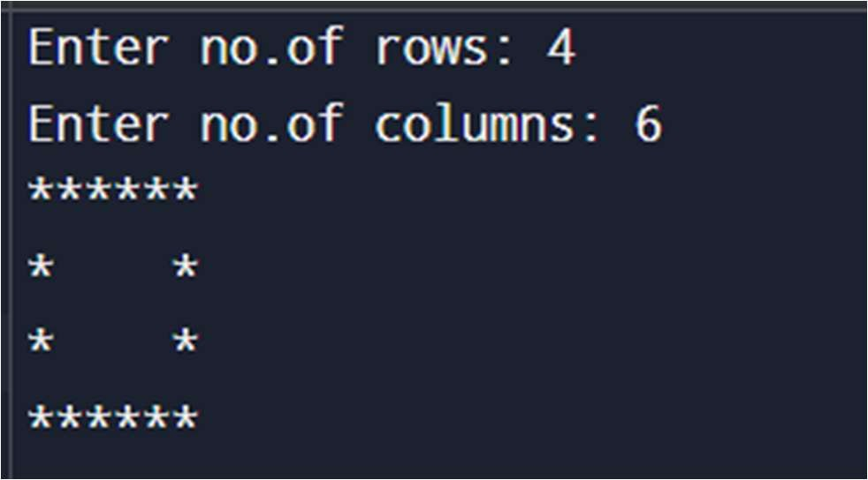

Test case2:

