## String functions

Date:02-09-2025

|  |  |  |  |  |  |  |  |  |  |  |  |  |  |  |  |  |  |  |  |  |  |  |  |  |  |  |  |  |  |  |  |  |  |  |  |  |  |  |  |  |  |  |  |  |  |  |  |  |  |  |  |  |  |  |  |  |  |  |  |  |  |  |  |  |  |  |  |  |  |  |  |  |  |  |  |  |  |  |  |  |  |  |  |  |  |  |  |  |  |  |  |  |
| --- | --- | --- | --- | --- | --- | --- | --- | --- | --- | --- | --- | --- | --- | --- | --- | --- | --- | --- | --- | --- | --- | --- | --- | --- | --- | --- | --- | --- | --- | --- | --- | --- | --- | --- | --- | --- | --- | --- | --- | --- | --- | --- | --- | --- | --- | --- | --- | --- | --- | --- | --- | --- | --- | --- | --- | --- | --- | --- | --- | --- | --- | --- | --- | --- | --- | --- | --- | --- | --- | --- | --- | --- | --- | --- | --- | --- | --- | --- | --- | --- | --- | --- | --- | --- | --- | --- | --- | --- | --- | --- | --- | --- |
| | **Function** | **Description** | **Example** | **Output** | | --- | --- | --- | --- | | len(s) | Returns length of string | len("hello") | 5 | | s.upper() | Converts to uppercase | "hello".upper() | "HELLO" | | s.lower() | Converts to lowercase | "HELLO".lower() | "hello" | | s.title() | Converts to title case | "hello world".title() | "Hello World" | | s.capitalize() | Capitalizes first letter | "python".capitalize() | "Python" | | s.find(sub) | Finds index of substring (or -1) | "python".find("th") | 2 | | s.index(sub) | Like find(), but error if not found | "python".index("th") | 2 | | s.rfind(sub) | Finds last index of substring | "banana".rfind("a") | 5 | | s.startswith(x) | Checks if string starts with x | "hello".startswith("he") | True | | s.endswith(x) | Checks if string ends with x | "hello".endswith("lo") | True | | s.count(x) | Counts occurrences of substring | "banana".count("a") | 3 | | s.strip() | Removes spaces (start + end) | " hi ".strip() | "hi" | | s.lstrip() | Removes left spaces | " hi".lstrip() | "hi" | | s.rstrip() | Removes right spaces | "hi ".rstrip() | "hi" | | s.replace(a, b) | Replaces substring | "I like C".replace("C","Python") | "I like Python" | | s.split(delim) | Splits string into list | "a,b,c".split(",") | ['a','b','c'] | | d.join(list) | Joins list into string | "-".join(['a','b','c']) | "a-b-c" | | s.isalpha() | Checks if all chars are alphabets | "abc".isalpha() | True | | s.isdigit() | Checks if all chars are digits | "123".isdigit() | True | | s.isalnum() | Checks if alphanumeric | "abc123".isalnum() | True | | s.isspace() | Checks if only spaces | " ".isspace() | True | | s.swapcase() | Swaps case | "Hello".swapcase() | "hELLO" | |

### Programs that uses string functions.

1.Check whether given character is alphabet or not.

Code:

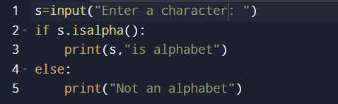

Output:

Test case1:



Test case2:

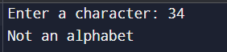

2.Count number of alphabets,digits,special characters in a given string.

Code: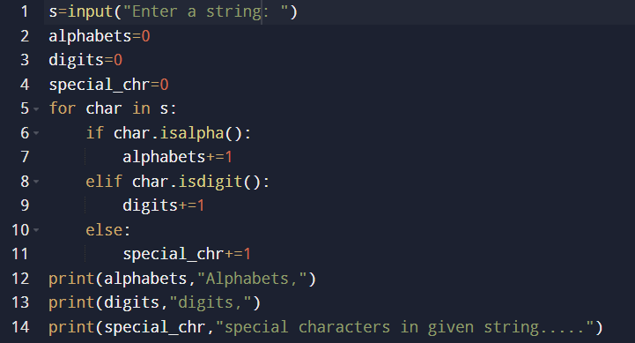

Output:

Test case1:

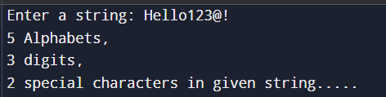

Test case2:

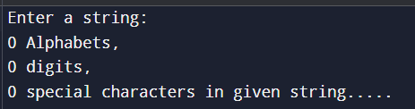

3. Remove all characters from string except alphabets.

Code:

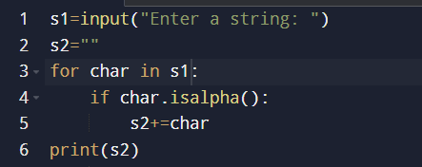

Output:

Test case1:

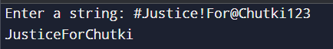

Test case2:



4. Replace a sub-string in a string.

Code:

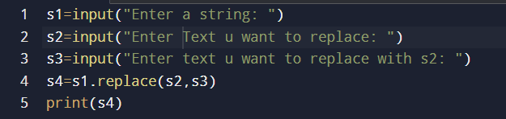

Output:

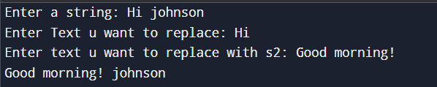

5. Find non-repeating characters in a string.

Code:

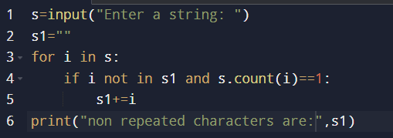

Output:

Testcase1:

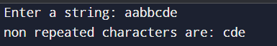

Testcase2:

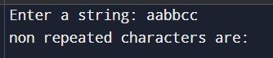

6.Remove brackets from an algebraic expression.

Code:

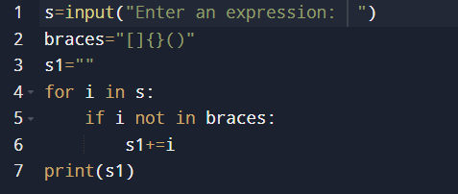

Output:

