## Date:03-09-2025

1a).Check whether the given number is prime number or not.

Code:

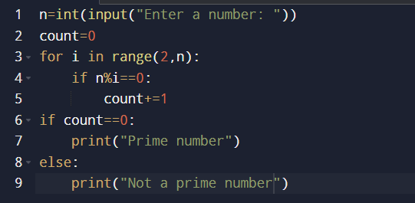

Output:

Test case1:

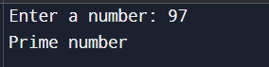

Test case2:

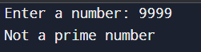

1b).Print prime numbers in given range.

Code:

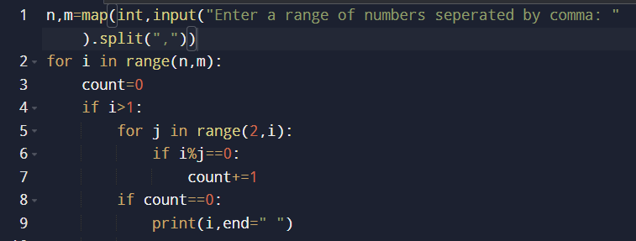

Output:



2.Check whether the given string is palindrome or not.

Code:

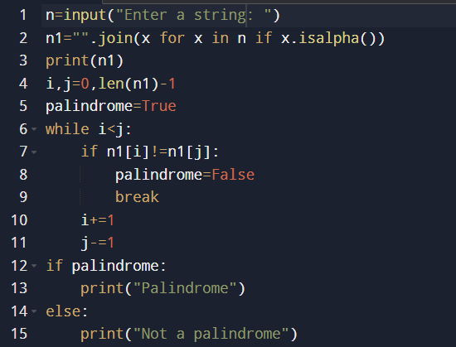

Output:

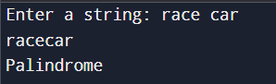

3.Check whether the given number is armstrong number or not.

Code:

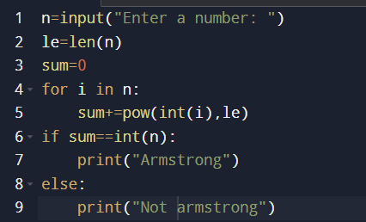

Output:

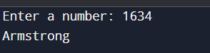

4. Check whether the given number is strong or not.

Code:

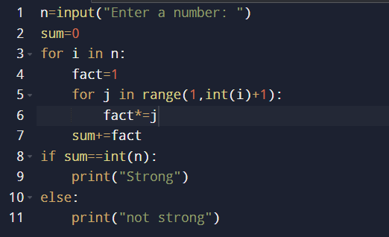

output:

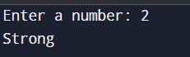

5.Fibonacci series upto nth term.

Code:

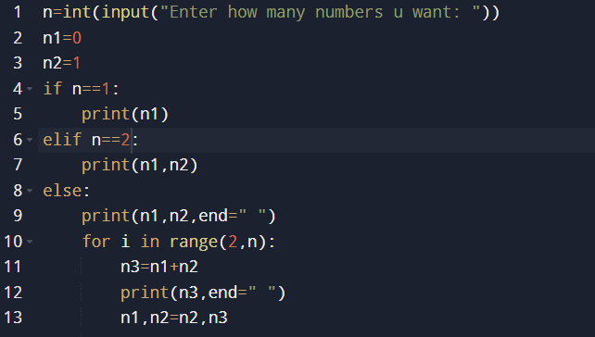

Output:

