## Date:04-09-2025

1.Print factorial of a number.

Code:

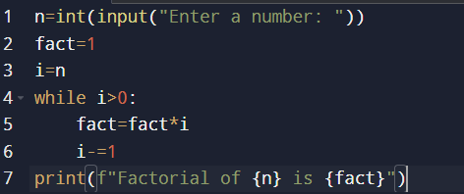

Output:



2.Factors of a number.

Code:

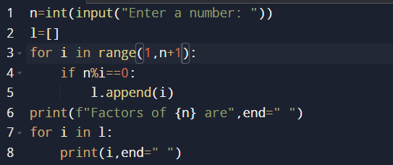

Output:



3.Find given number is perfect or not.

Code:

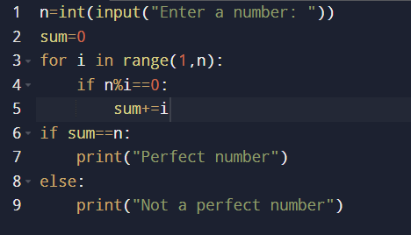

Output:



4.Find given number is perfect square or not.

Code:



Output:



5.Find given number is harshad number or not.

Code:

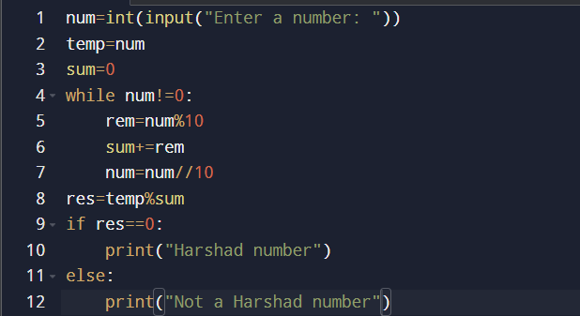

Output:

