## Date:05-09-2025

1.Find given pair of numbers are Friendly pair or not.

Code:

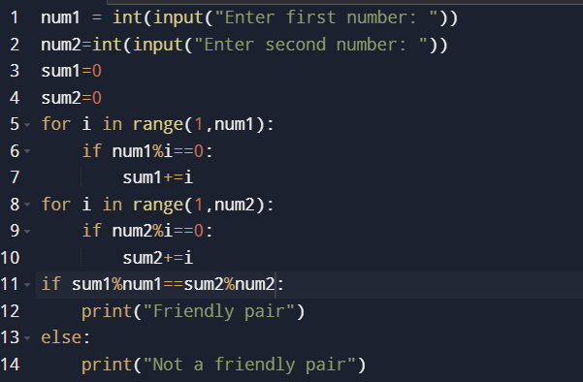

Output:

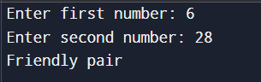

2.Find given number is abundant number or not.

Code:

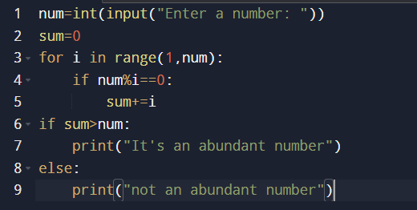

Output:

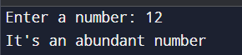

3.Find given number is strong number or not.

Code:

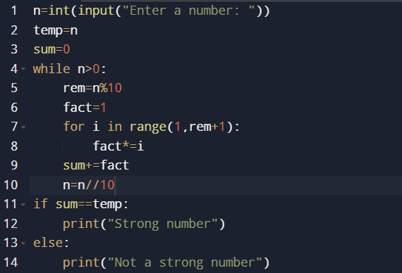

Output:

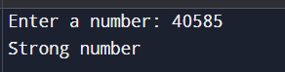

4.Find given number is automorphic number or not.

Code:

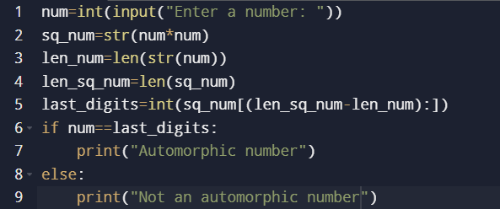

Output:

