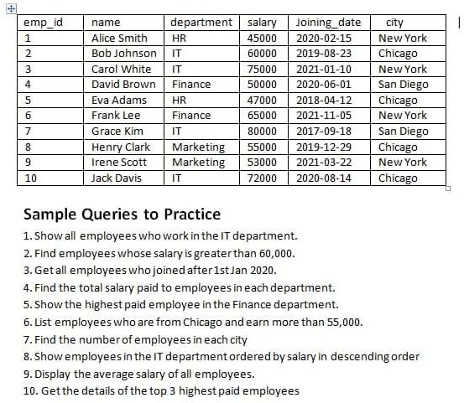

1. **show all employees who work in the IT department.**

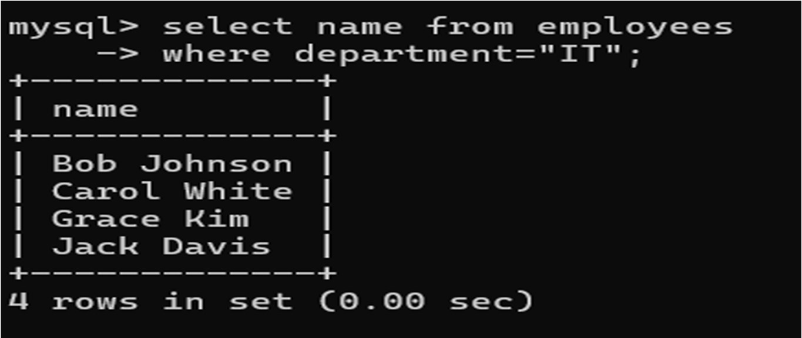

1. **Find employees whose salary is greater than 60,000.**

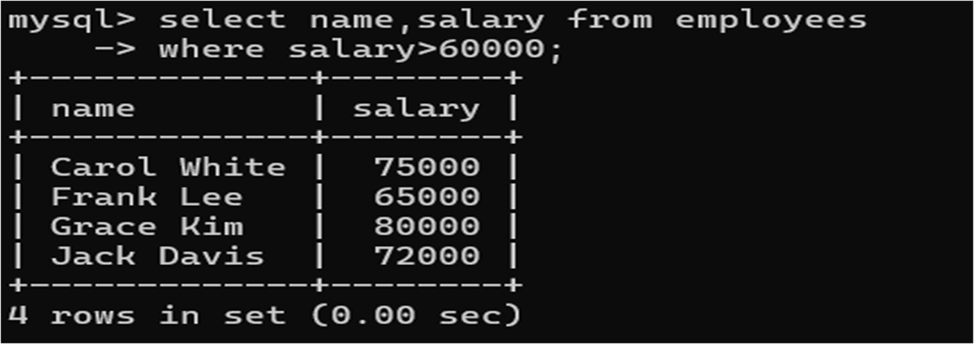

1. 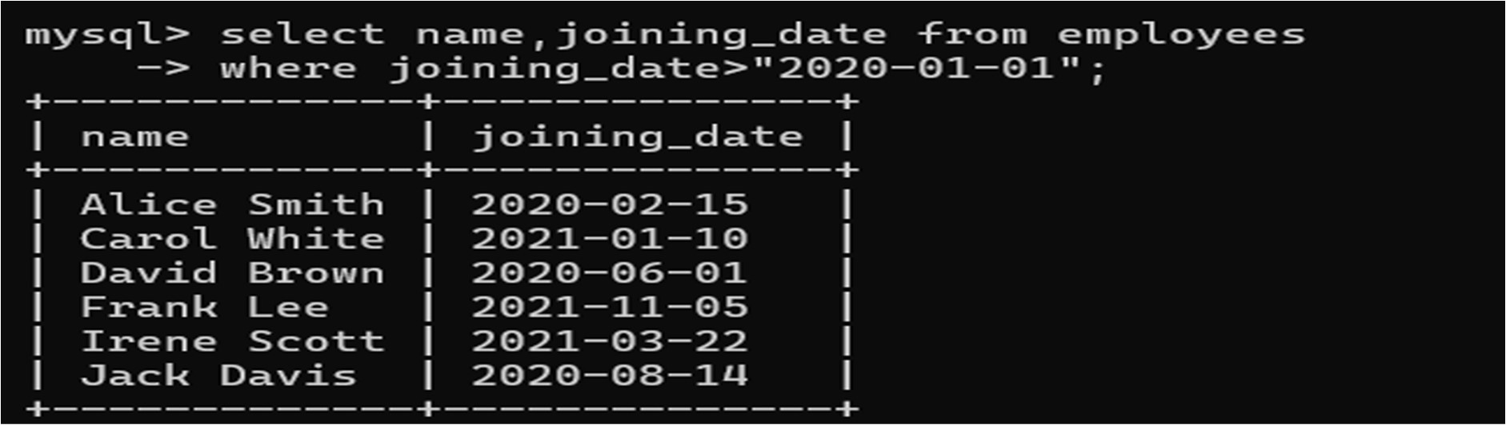**Get all employees who joined after 1st jan 2020.**
2. **Find the total salary paid to employees in each department.**

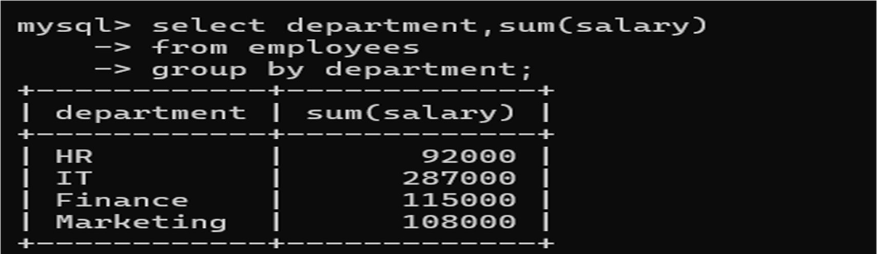

1. **Show the highest paid employee in the Finance department.**

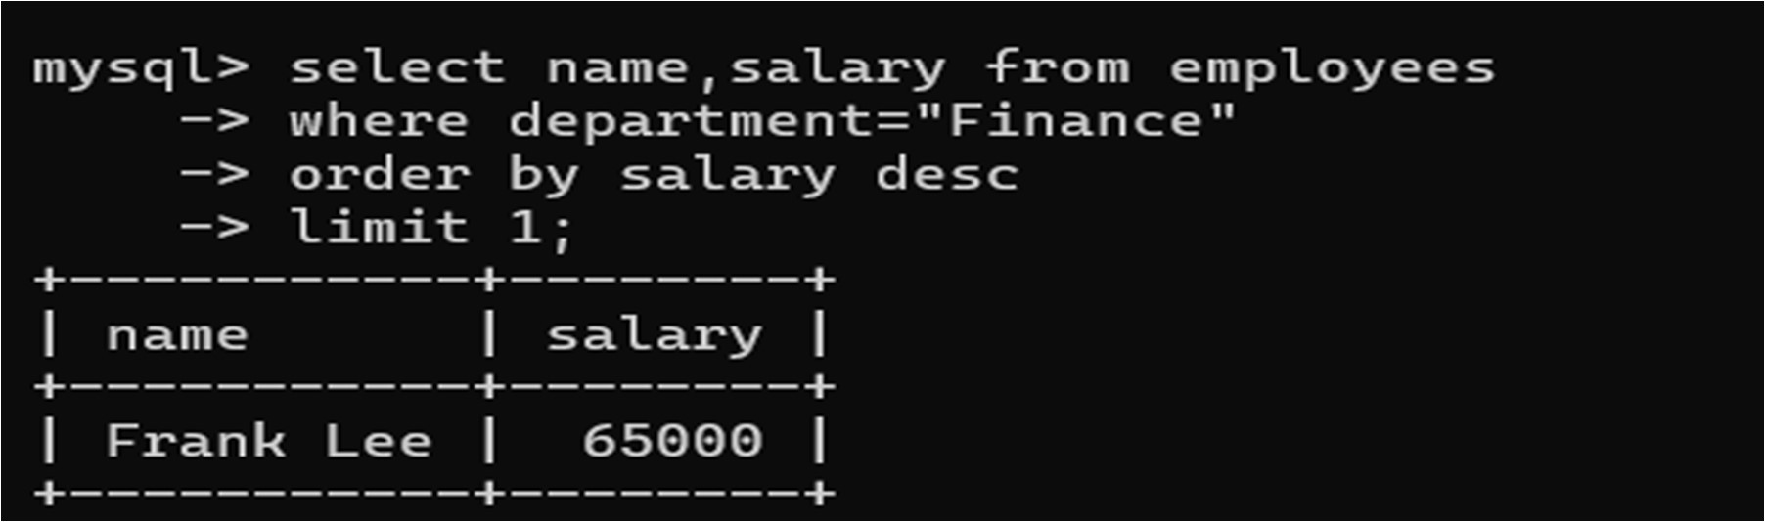

1. **List employees who are from Chicago and earn more than 55,000.**

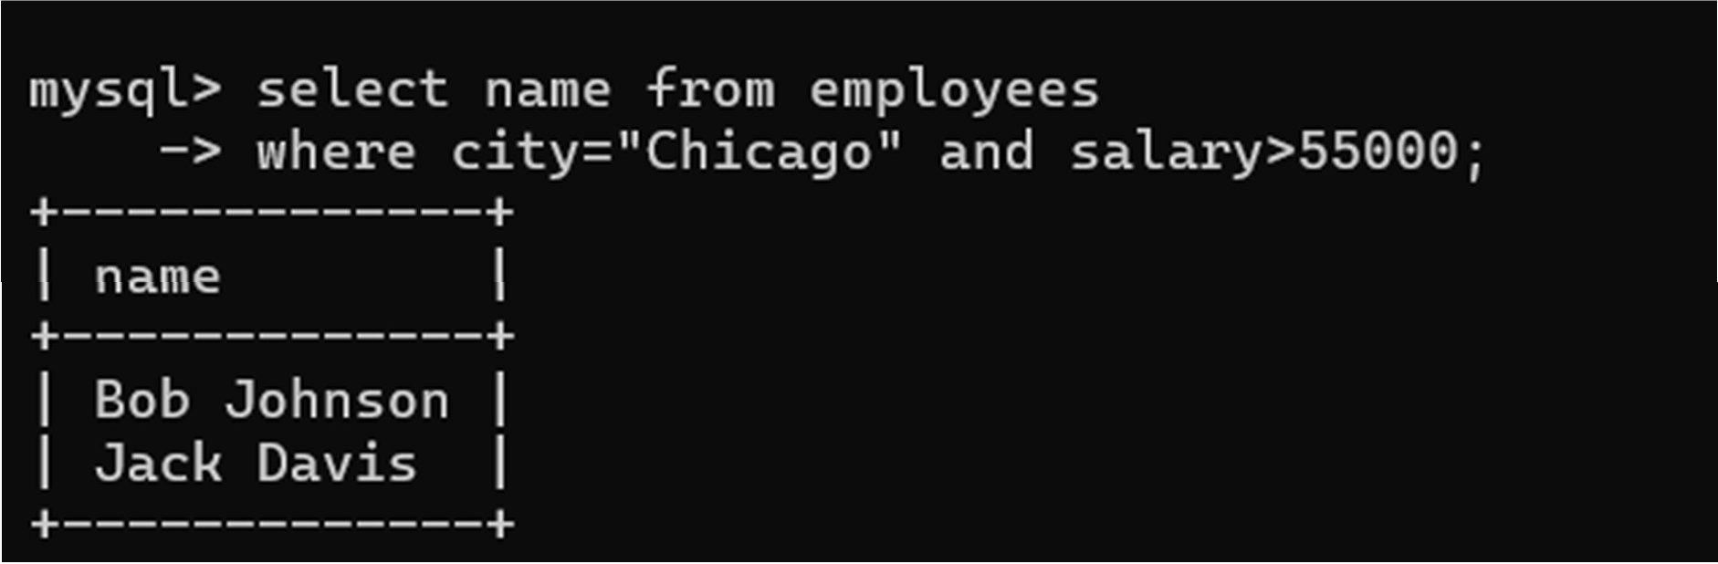

1. **Find the number of employees in each city.**

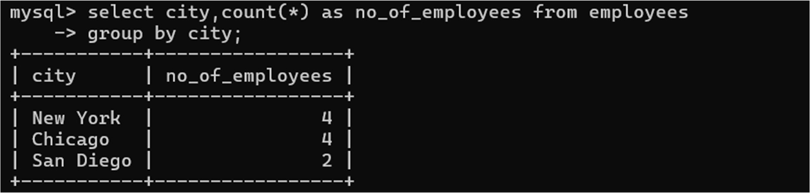

1. **Show employees in the IT department ordered by salary in descending order.**

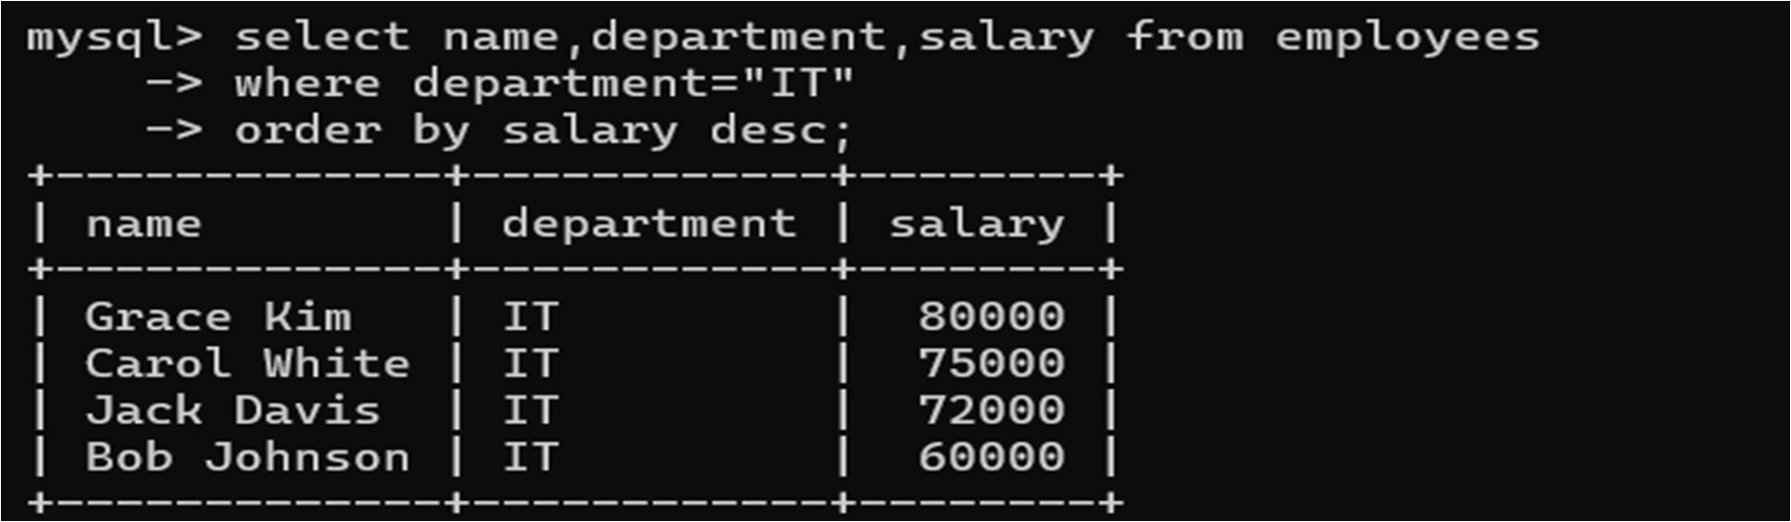

1. **Display the average salary of all employees.**

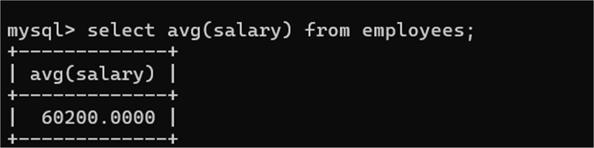

1. **Get the details of the top 3 highest paid employees.**

