Python practice

Name:K.Navya

Roll Num:22kq1a0208

Date:15-08-2025

1.Reverse a given string without using built-in reverse functions.

Code:

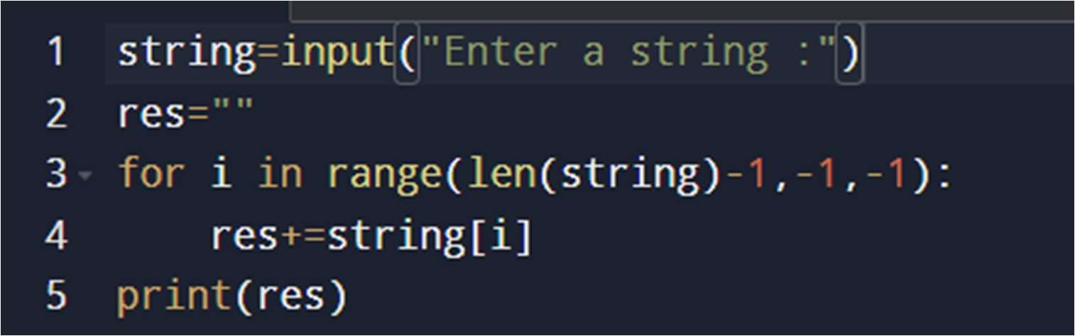

Sample Test Cases:

Test case 1:

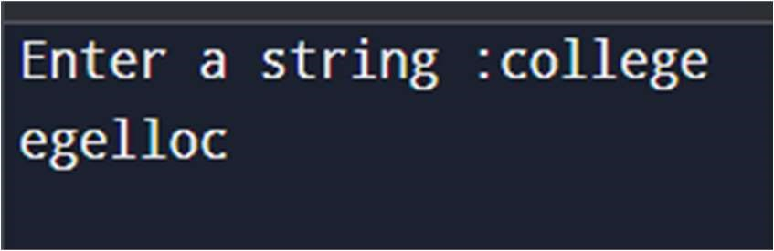

Test Case2:

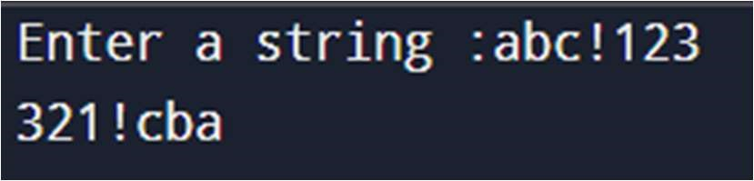

2.Check if a string is palindrome or not.

A palindrome is a word, number, phrase, or other sequence of symbols that reads the same backwards as forwards.

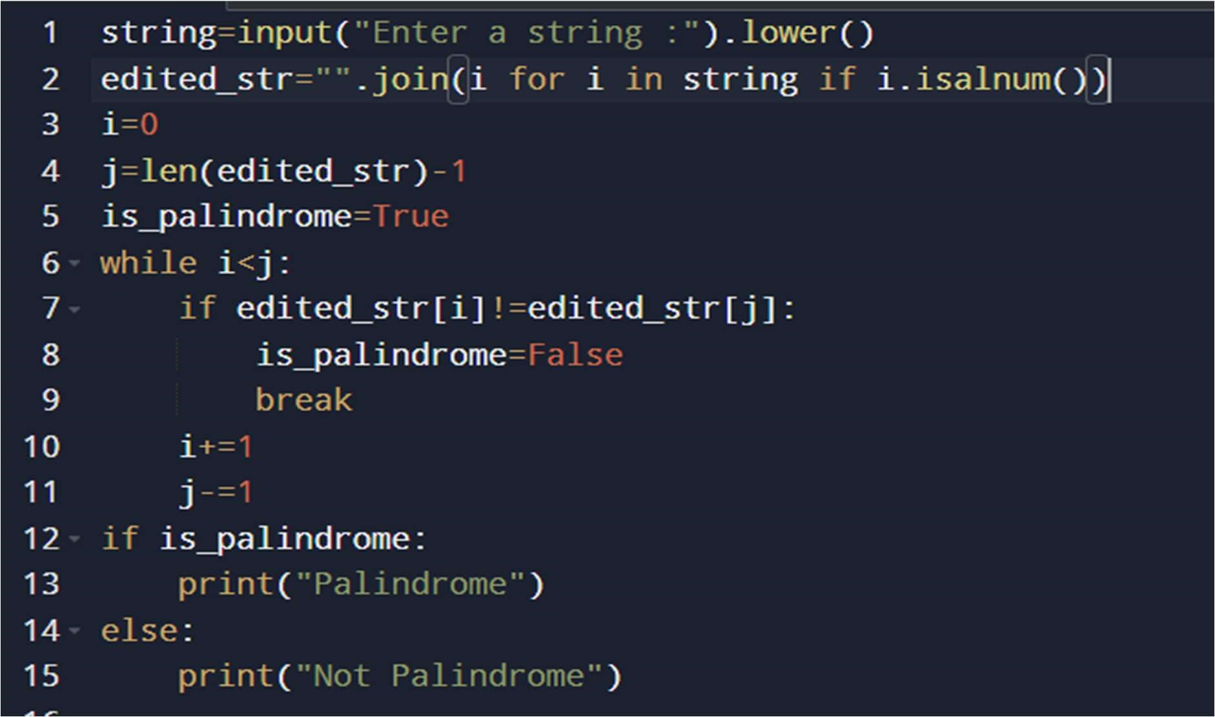

Sample Test cases:

Test Case1:

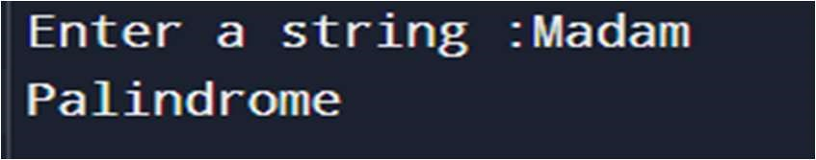

Test Case2:

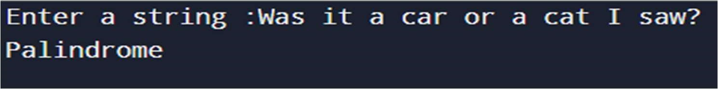

Test Case3:

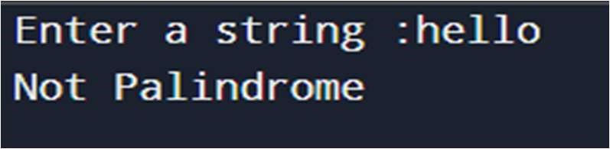

3.Count the number of vowels and consonants in a string.

Code:

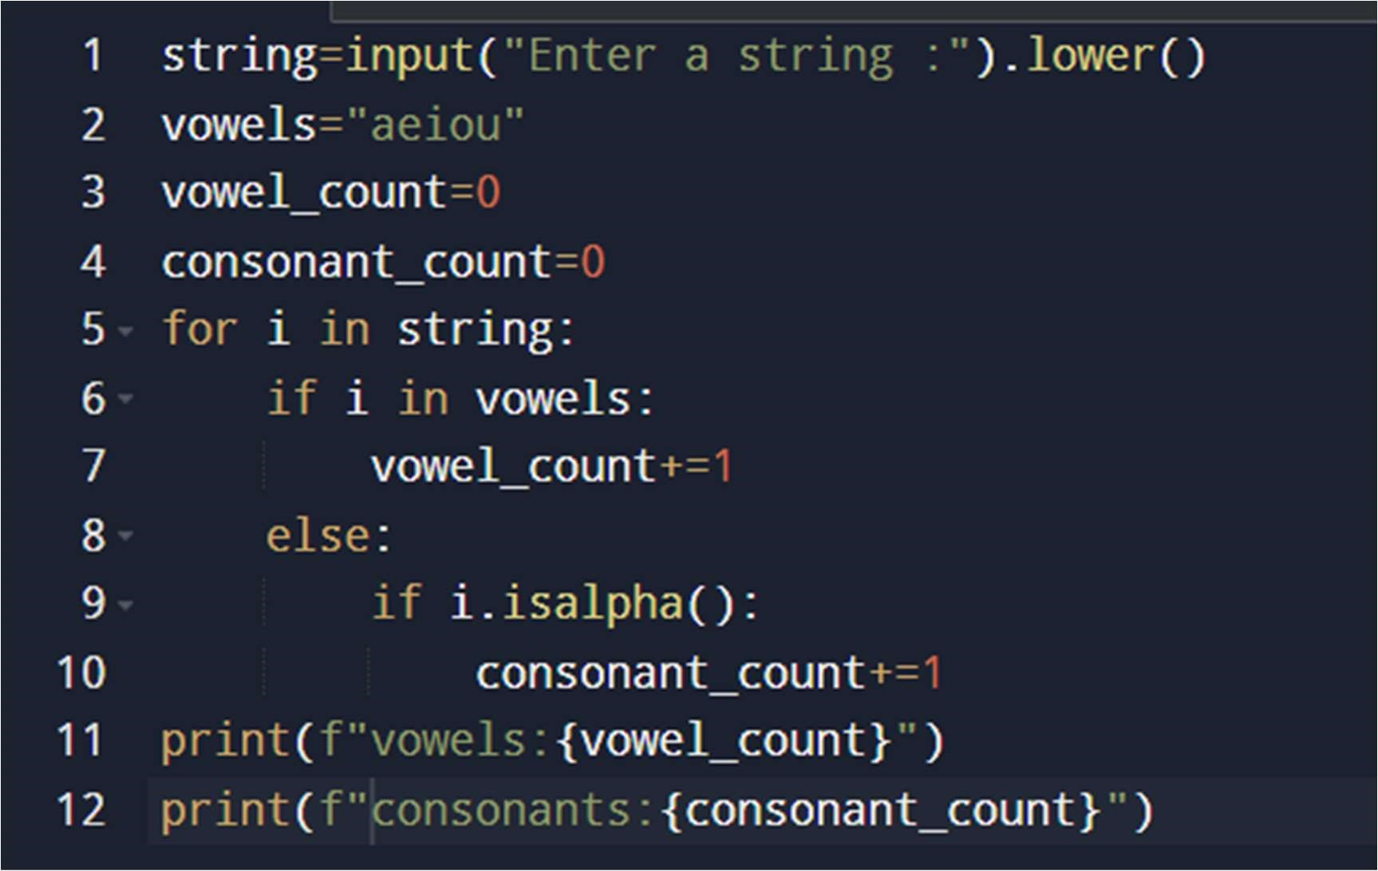

Sample Test Cases:

Test Case1:

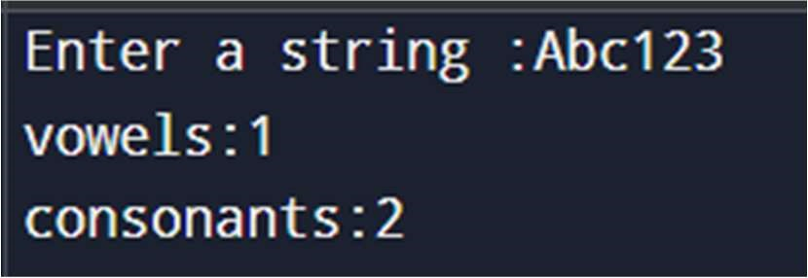

Test Case2:

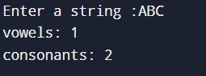

Test Case3:

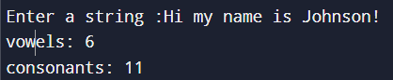

4.Remove all spaces from the string.

Code:

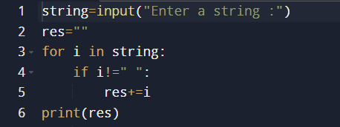

Sample Test Cases:

Test Case 1:

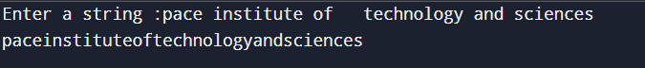

Test Case 3:

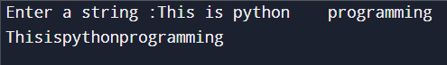

5.Count the frequency of each character in string.

Code:

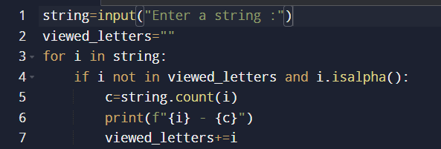

Sample Test Cases:

Test case1:

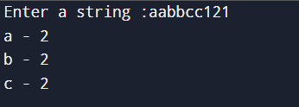

Test case2:

