1. Sum of natural numbers in a given range. Code:

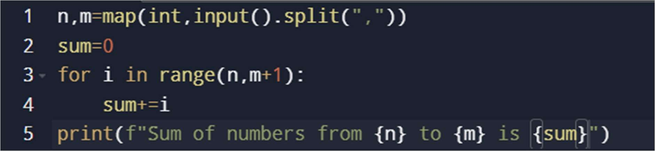

Output:

Test1

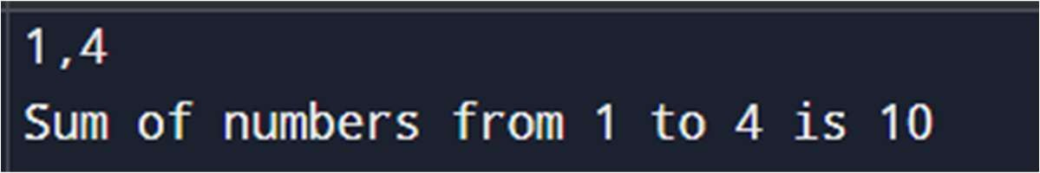

Test2

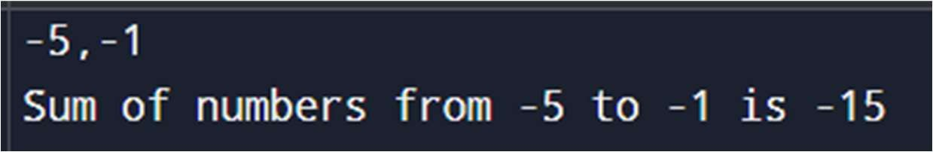

1. Greatest of two numbers.



Output: Test1

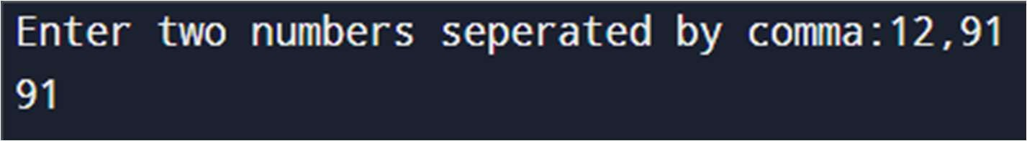

Test2

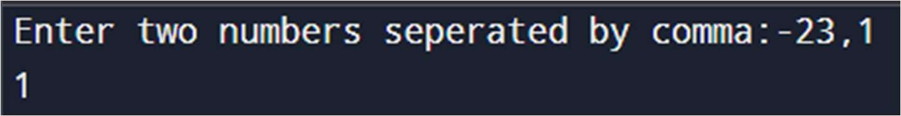

1. Greatest of three numbers. Code:

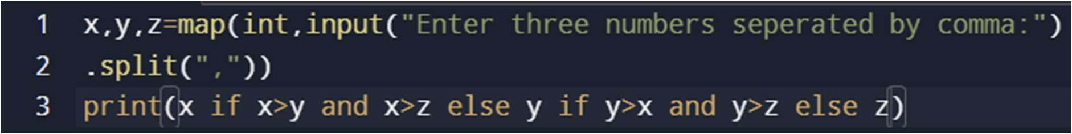

Output:

Test1

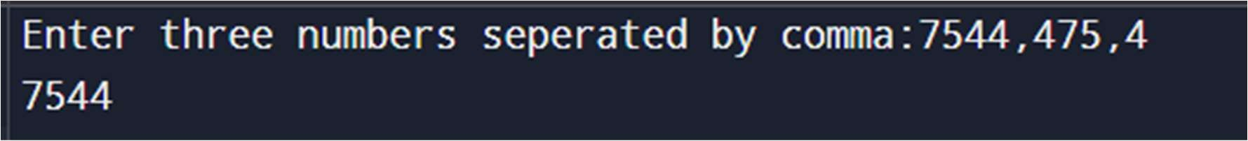

Test2

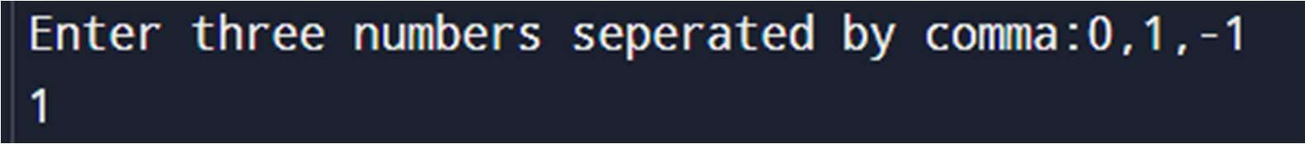

1. find given year is leap or not. Code:

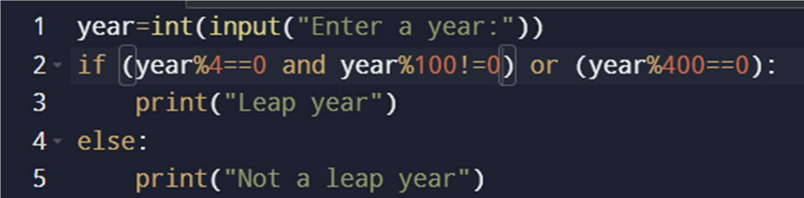

Output: Test1



Test2

