Date:20-08-2025

1. Check whether given number is prime number or not. Code:

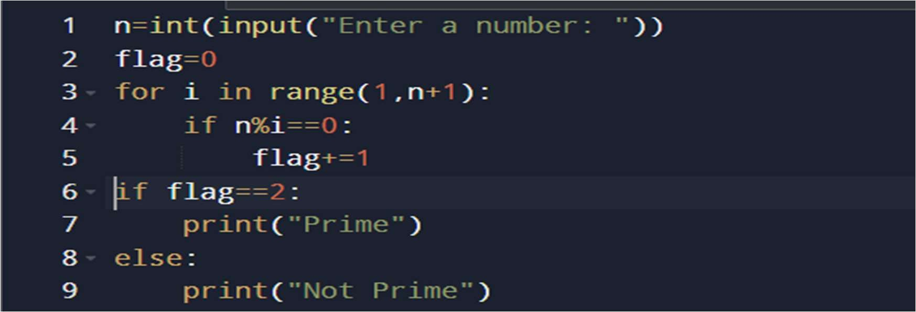

Output:

Test1

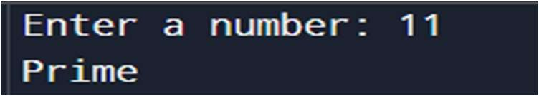

Test2

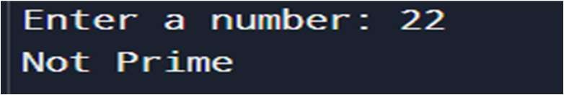

1. Prime numbers in given range.

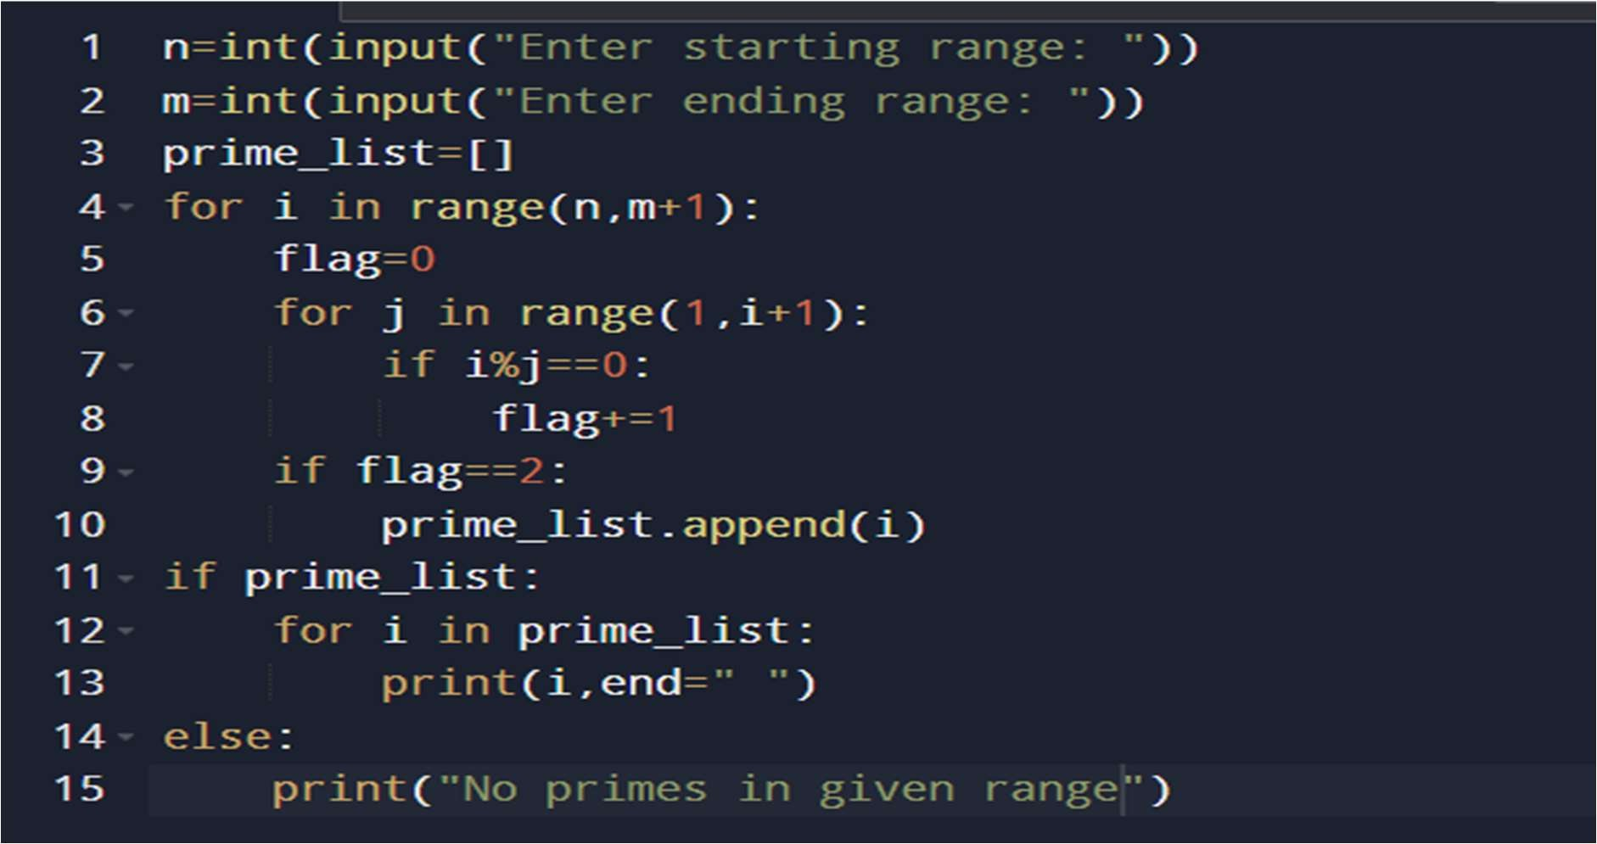

Output:

Test1:

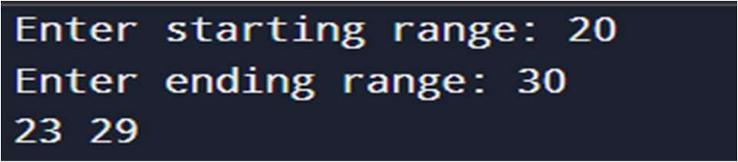

Test2:

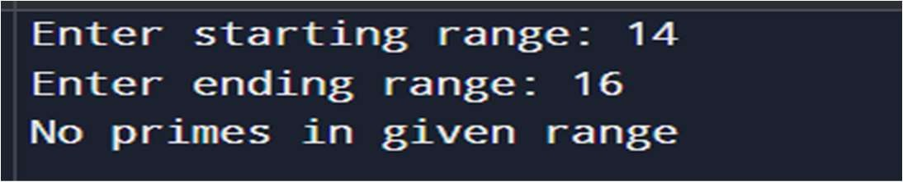

1. Sum of digits of given number. Code:

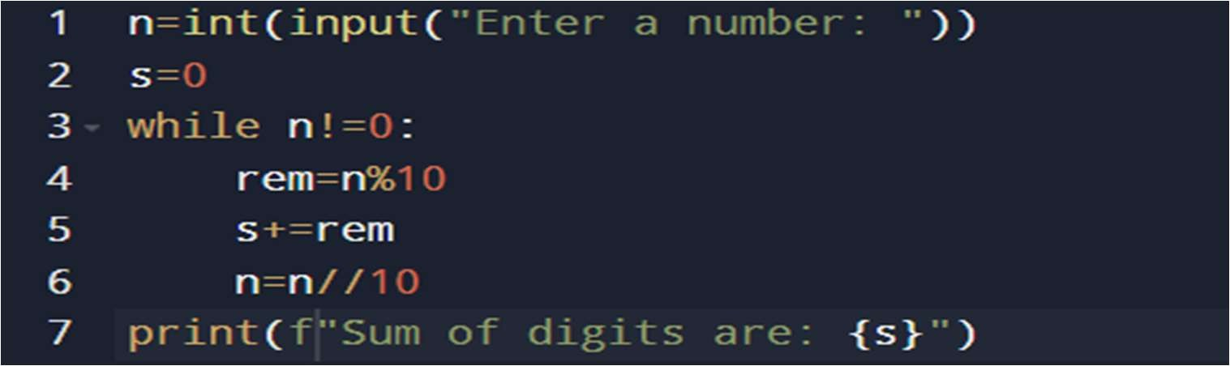

Output:

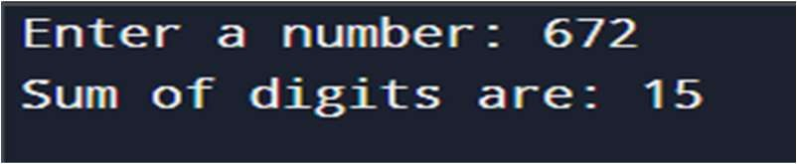

1. Reversing a number. Code:

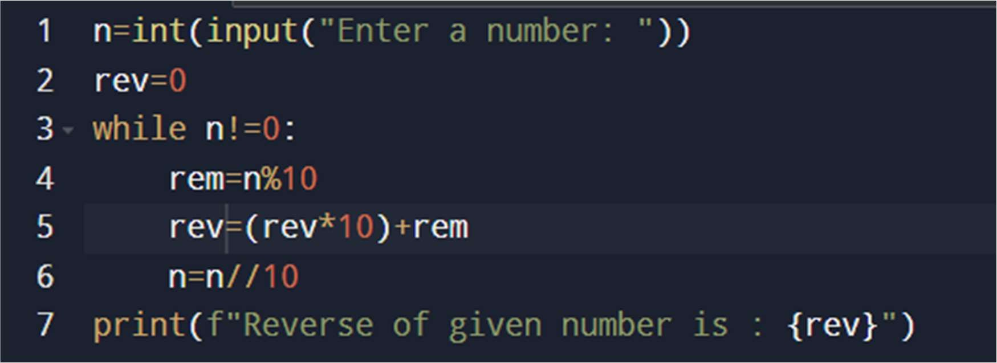

Output:

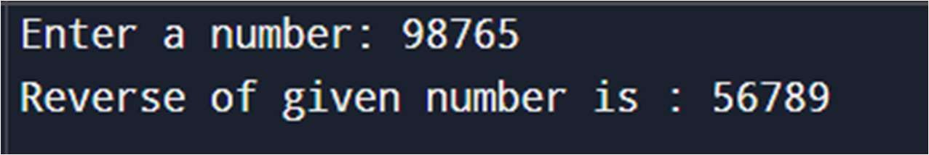

1. Find given string is palindrome or not. Code:

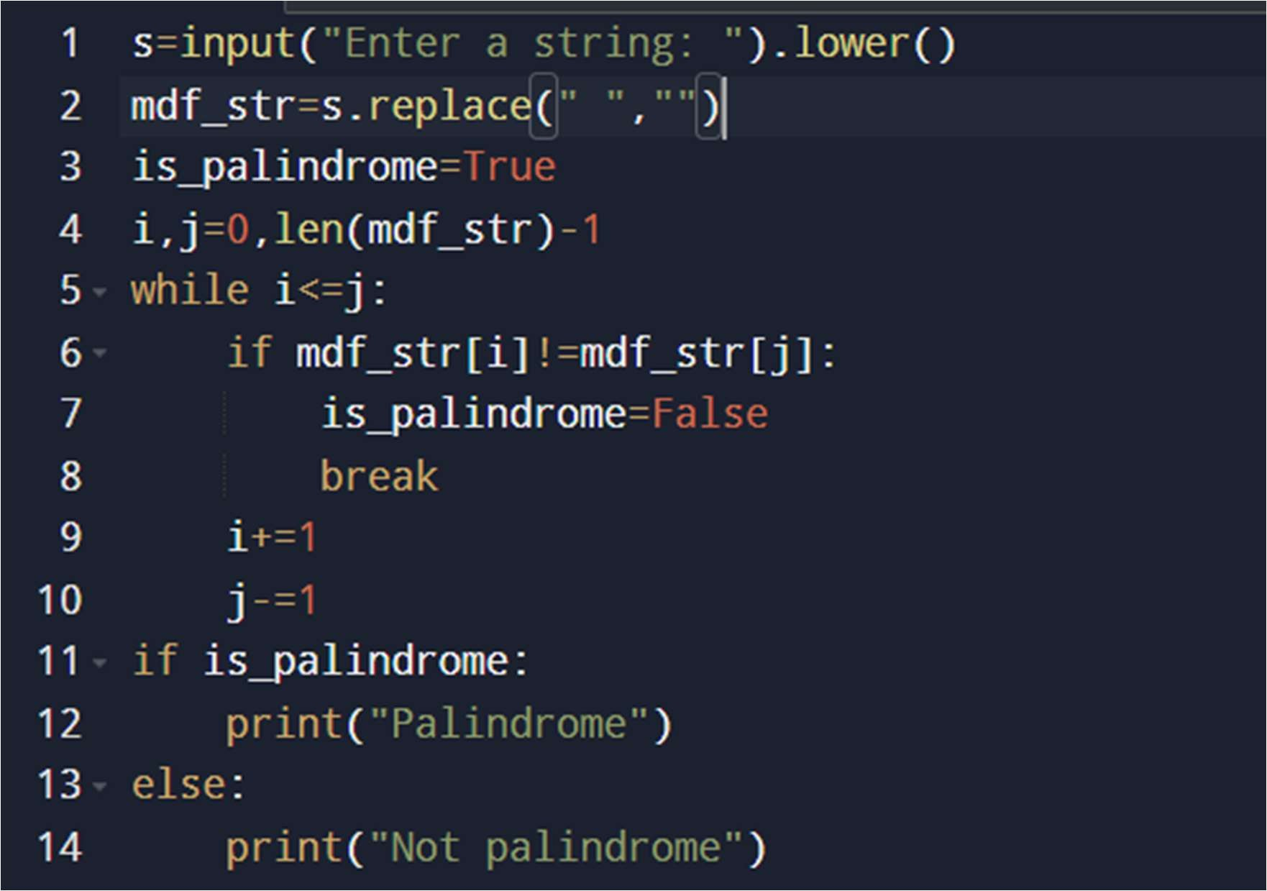

Output:

