# Date:21-08-2025

**1.Check whether the Armstrong number.**

Code:

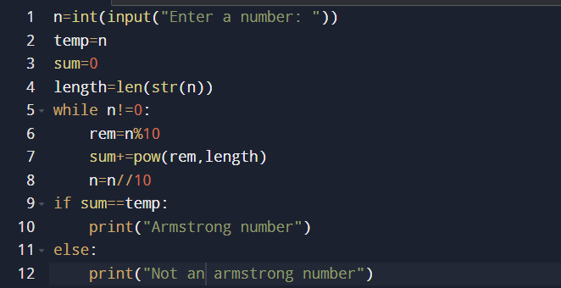

Output:

Test1:



Test2:

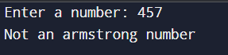

**2.Armstrong numbers in a given range**.

Code:

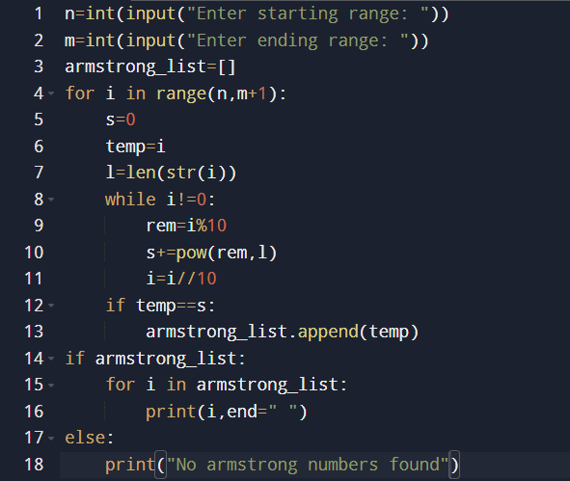

Output:

Test1:

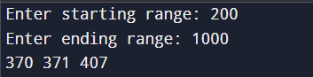

Test2:

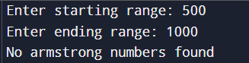

3. **Find the Fibonacci Series up to Nth Term.**

Code:

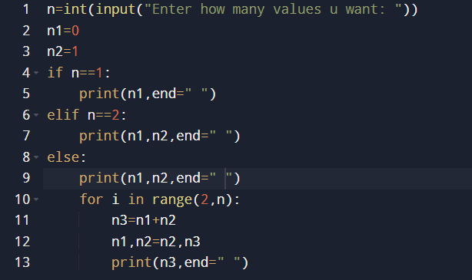

Output:

Test1:



Test2:



**4.Fibonacci series upto given number.**

Code:

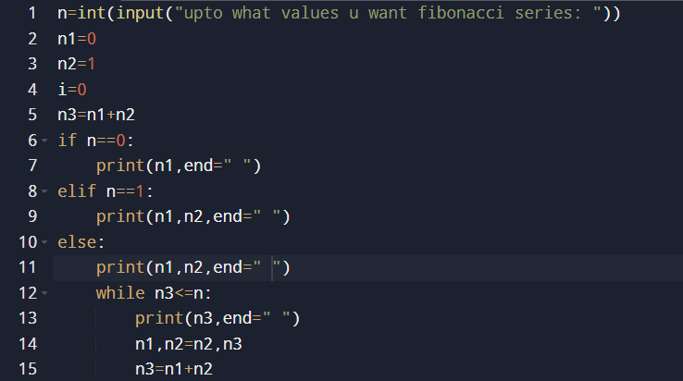

Output:

Test1:



Test2:



**5.Factorial of a given number.**

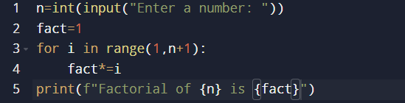

Output:

