## Date:22-08-2025

**1.Program to find power of a number.**

Code:

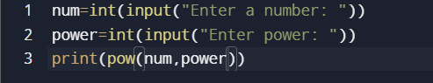

Output:

Test1:

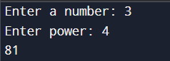

Test2:

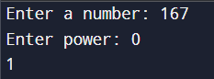

(OR)

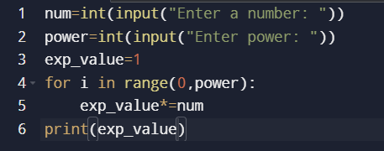

Output:

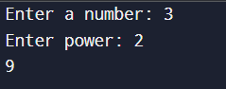

**2.Factors of number.**

Code:

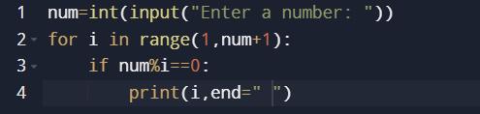

Output:

Test1:



**3.Prime factors of a number.**

Code:

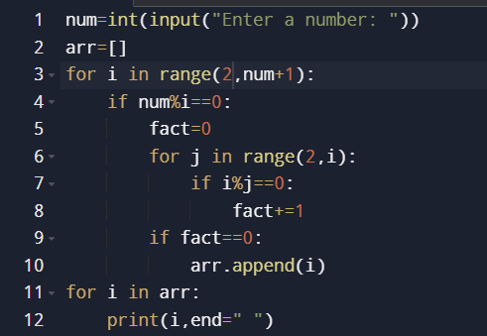

Output:



**4.Find given number is strong or not.**

Code:

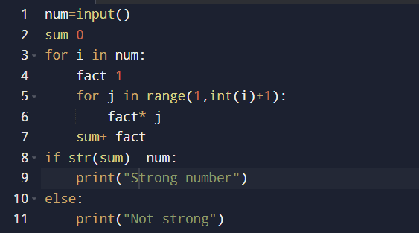

Output:

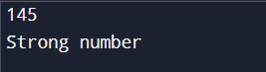

**5.Find given number is perfect or not.**

Code:

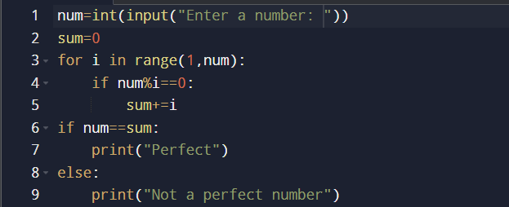

Output:

