**SHELL SCRIPT --- ASSIGNMENT**

1. Create a script named “myscript” in current directory to do the following.

a) display “hello user”

b) list files in current directory

c) name of logged in user

d) date

a. create a script as $ vi .myscript.sh



b.$ ls

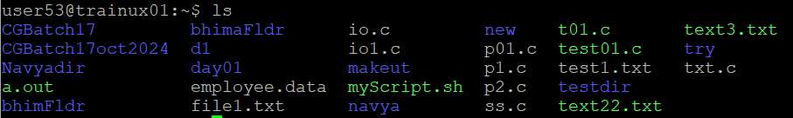

c. $ whoami



d. $ date



2. Add execute permission and Run the script from

a) current directory

command: $ chmod +x myscript.sh





3. Create a subdirectory named “test”

Command: $ mkdir test

4. Change to “test” directory. Run the script “myscript” [Hint: You will have to update PATH to include the directory containg script to run script from any location].

