1. Search and display all \*.c and \*.h files in all subdirectories starting from current directory

Command : $ find . -name “\*.c” -o -name “\*.h”

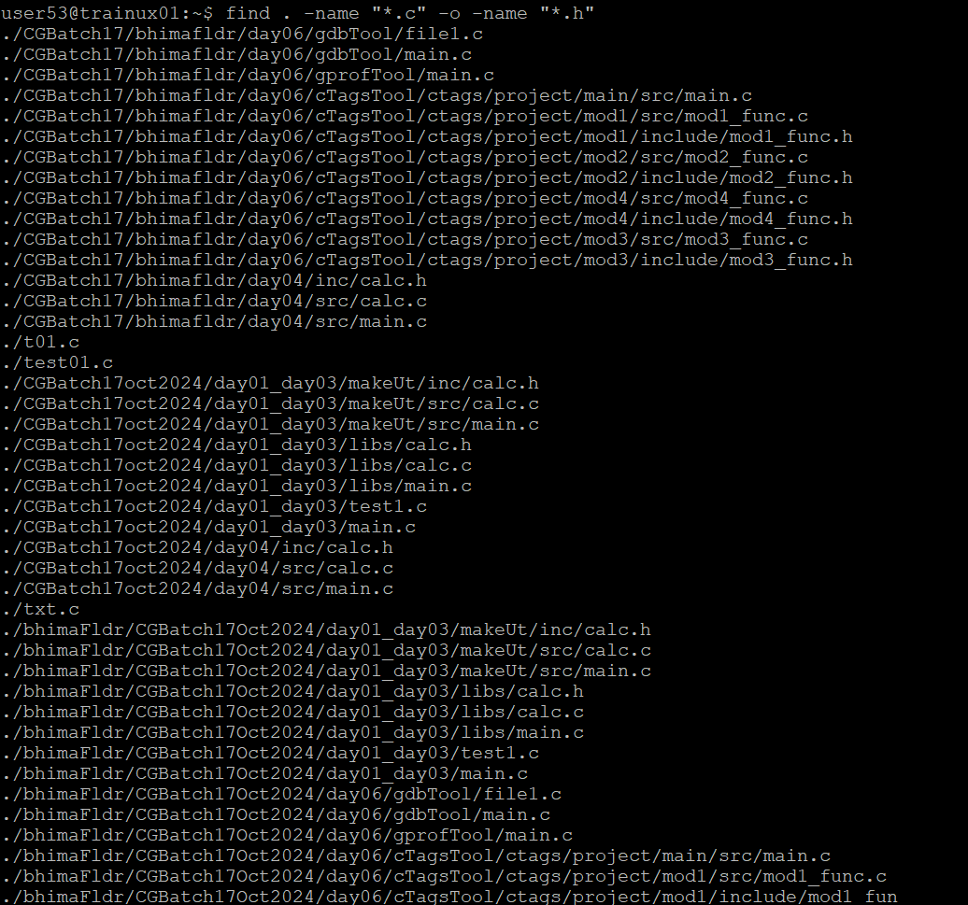

1. Search and display all directories in all subdirectories starting from current directory

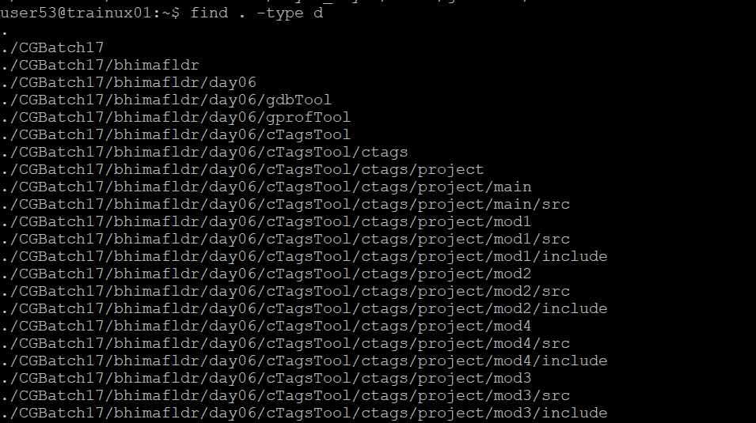

1. Search and display all files with permissions only rw with user and execute permission for others

Command: $ find . -perm 777

