**LINUX ENVIRONMENTAL VARIABLES ------ ASSIGNMENT**

1. State the command for the following.

a. view current environment variables

b. display the PATH environment variable value

c. update PATH to include the path to your home directory

command: a. $ env

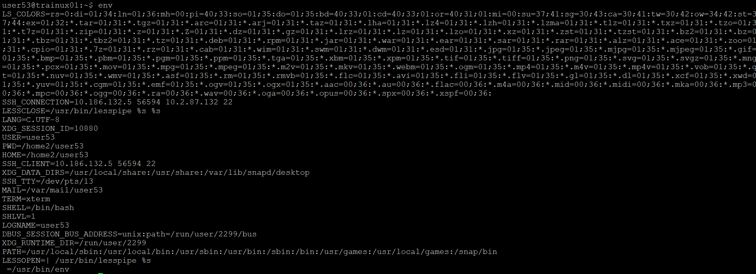

b. $ echo $PATH



c. $ export PATH=$PATH:$HOME



2. How will you make the environment changes applicable to all users? Which script is to be modified?

Command: $ /etc/profile

3. I have installed an application named “myapp”. After installation, if I invoke the application, it fails with error as “Command myapp not found”. How will you fix this?

Command: $ export PATH=$PATH:/usr/local/bin

