**GREP ---- ASSIGNMENT**

1. Use any .c file. Using grep command extract and display

a. all lines beginning with #include with line numbers

command: $ grep -n “^#include” sw.c



b. display all lines which do not begin with #include

command: $ grep -v “^#include” sw.c

c. display the line number of main()

command: $ grep -n “main()” sw.c



d. extract all lines containing characters of opening and closing parathesis {(,))

command: $ grep ‘[{}] sw.c

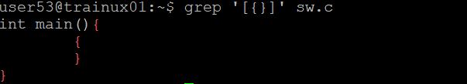

2. Perform the above operations on a set of *.c files

a.command : $ grep -n “^#include” *.c

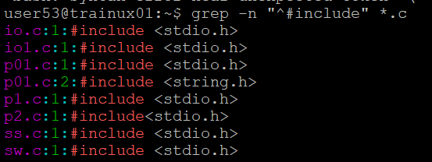

b. command: $ grep -v “^#include” *.c

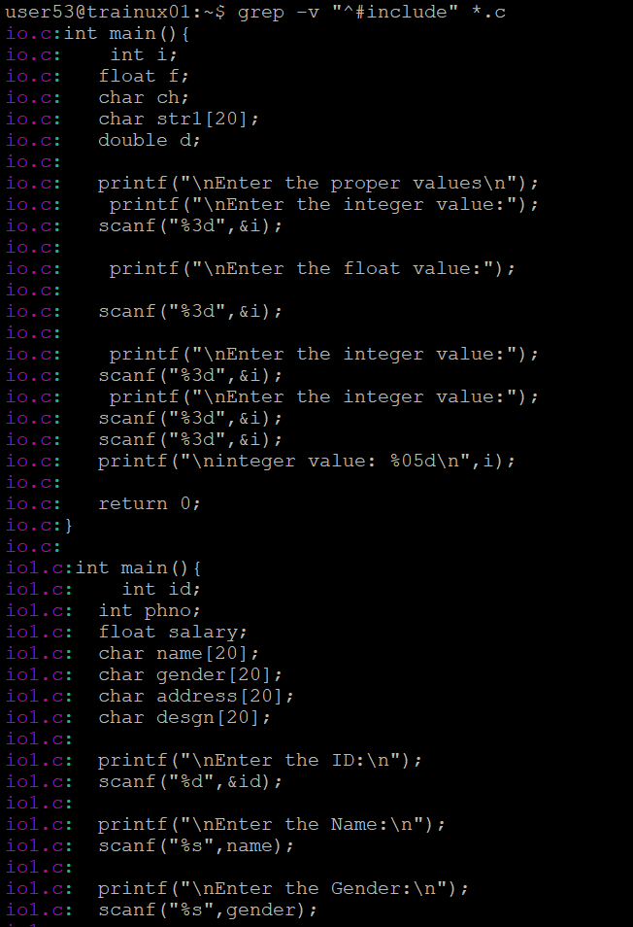

c. command: $ grep -n “main()” *.c

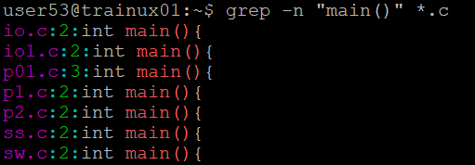

d.command: $ grep ‘[{}]’ *.c

