**Industrial Internship Report on**

**”Password Manager”**

**Prepared by**

**Navyashree R**

|  |
| --- |
| *Executive Summary* |
| This report provides details of the Industrial Internship provided by upskill Campus and The IoT Academy in collaboration with Industrial Partner UniConverge Technologies Pvt Ltd (UCT).  This internship was focused on a project/problem statement provided by UCT. We had to finish the project including the report in 6 weeks’ time.  My project was to work on building a code for password manager which securely stores and manages user passwords. It allows users to store their passwords for various accounts, generate strong passwords, and retrieve passwords when needed.  This internship gave me a very good opportunity to get exposure to Industrial problems and design/implement solution for that. It was an overall great experience to have this internship. |

**TABLE OF CONTENTS**

1 Preface 3

2 Introduction 4

2.1 About UniConverge Technologies Pvt Ltd 4

2.2 About upskill Campus 8

2.3 Objective 9

2.4 Reference 9

2.5 Glossary 10

3 Problem Statement 11

4 Existing and Proposed solution 12

5 Proposed Design/ Model 13

5.1 High Level Diagram (if applicable) 13

5.2 Low Level Diagram (if applicable) 13

5.3 Interfaces (if applicable) 13

6 Performance Test 14

6.1 Test Plan/ Test Cases 14

6.2 Test Procedure 14

6.3 Performance Outcome 14

7 My learnings 15

8 Future work scope 16

# Preface

The 6-week upskill campus internship program for Python focused on equipping participants with a comprehensive understanding of Python programming language and its applications.Throughout the program, there were regular assessments, coding challenges, and projects to reinforce learning and practical application of concepts. Mentors provided guidance and feedback to help interns improve their coding skills and problem-solving abilities. Additionally, there were interactive sessions and workshops to discuss industry trends, best practices, and career opportunities in Python development. By the end of the program, participants gained a solid foundation in Python programming and were well-prepared to pursue further learning or start their careers in Python development.

Such kind of Internships provide practical, hands-on experience in a real-world work environment. This experience allows individuals to apply theoretical knowledge gained through academic study to solve actual problems and complete tasks relevant to their field of interest; they also offer opportunities to develop and refine skills that are in demand in the industry. Whether it's technical skills like programming languages or soft skills like communication and teamwork, internships provide a platform for continuous learning and skill enhancement

My project was based on writing a code for The password manager is a Python project that securely stores and manages user passwords. It allows users to store their passwords for various accounts, generate strong passwords, and retrieve passwords when needed.

The scope of this project involves implementing encryption algorithms to secure password storage, designing a user interface to input and retrieve passwords, and developing functions to generate strong passwords and store/retrieve them from a database.

Im very grateful for the opportunity given by USC/UCT to provide project based internships where students not only learn new technologies but also gain a hands-on experience .

How Program was planned

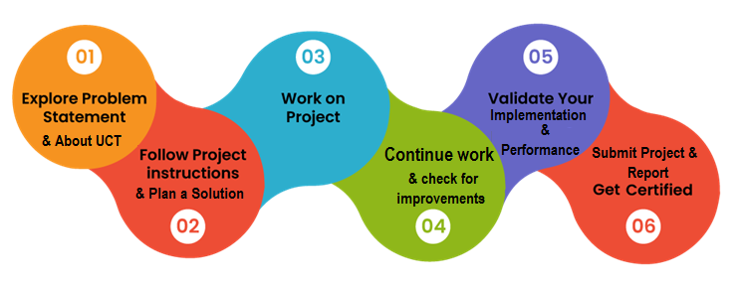

I’ve learned how to code in python and make projects for real-world implementation, This was great experience to learn as well as implement it on hands-on projects. Would love to have further learning through this platform.

Thanks to upskill campus, Youtube learning videos, Python hub to have helped me in successfully completing the project and gain knowledge.

I would suggest my juniors to make use of this wonderful platform and enhance their technical skills .

# Introduction

## About UniConverge Technologies Pvt Ltd

A company established in 2013 and working in Digital Transformation domain and providing Industrial solutions with prime focus on sustainability and RoI.

For developing its products and solutions it is leveraging various**Cutting Edge Technologies e.g. Internet of Things (IoT), Cyber Security, Cloud computing (AWS, Azure), Machine Learning, Communication Technologies (4G/5G/LoRaWAN), Java Full Stack, Python, Front end**etc.

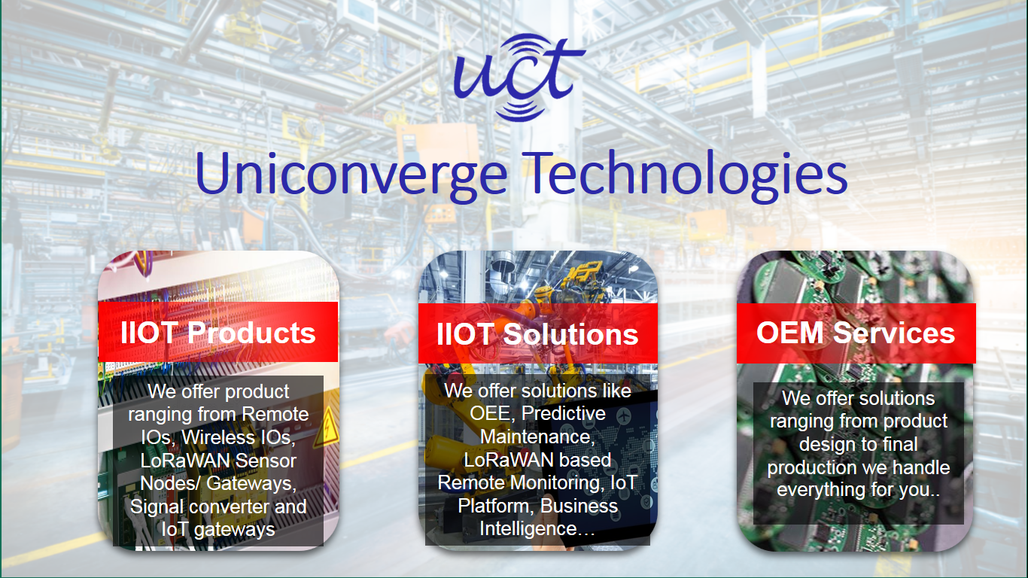

1. UCT IoT Platform **(****)**

**UCT Insight** is an IOT platform designed for quick deployment of IOT applications on the same time providing valuable “insight” for your process/business. It has been built in Java for backend and ReactJS for Front end. It has support for MySQL and various NoSql Databases.

* It enables device connectivity via industry standard IoT protocols - MQTT, CoAP, HTTP, Modbus TCP, OPC UA
* It supports both cloud and on-premises deployments.

It has features to  
• Build Your own dashboard  
• Analytics and Reporting  
• Alert and Notification  
• Integration with third party application(Power BI, SAP, ERP)  
• Rule Engine

 

1. **Smart Factory Platform (****)**

Factory watch is a platform for smart factory needs.

It provides Users/ Factory

* with a scalable solution for their Production and asset monitoring
* OEE and predictive maintenance solution scaling up to digital twin for your assets.
* to unleased the true potential of the data that their machines are generating and helps to identify the KPIs and also improve them.
* A modular architecture that allows users to choose the service that they what to start and then can scale to more complex solutions as per their demands.

Its unique SaaS model helps users to save time, cost and money.

 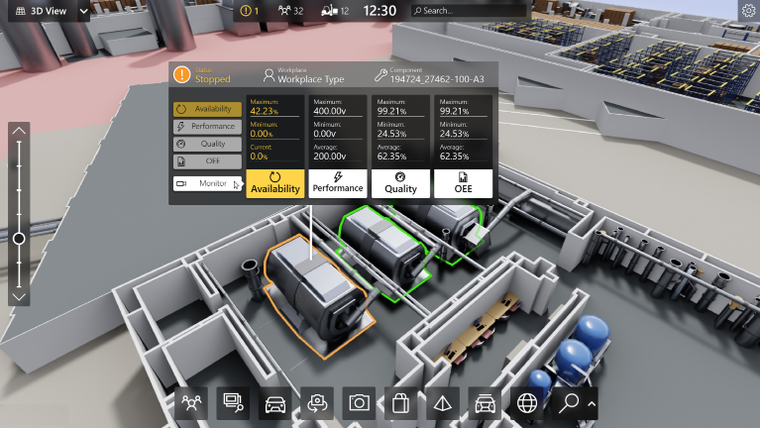

1. 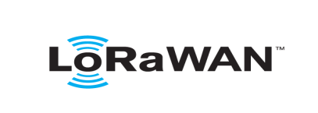 based Solution

UCT is one of the early adopters of LoRAWAN teschnology and providing solution in Agritech, Smart cities, Industrial Monitoring, Smart Street Light, Smart Water/ Gas/ Electricity metering solutions etc.

1. Predictive Maintenance

UCT is providing Industrial Machine health monitoring and Predictive maintenance solution leveraging Embedded system, Industrial IoT and Machine Learning Technologies by finding Remaining useful life time of various Machines used in production process.



## About upskill Campus (USC)

upskill Campus along with The IoT Academy and in association with Uniconverge technologies has facilitated the smooth execution of the complete internship process.

USC is a career development platform that delivers **personalized executive coaching** in a more affordable, scalable and measurable way.



Seeing need of upskilling in self paced manner along-with additional support services e.g. Internship, projects, interaction with Industry experts, Career growth Services

<https://www.upskillcampus.com/>

upSkill Campus aiming to upskill 1 million learners in next 5 year

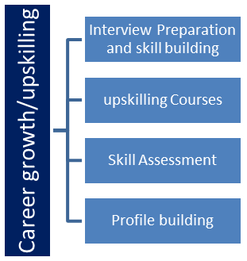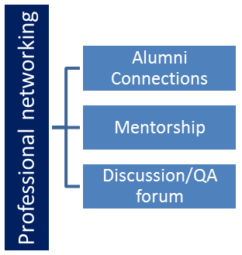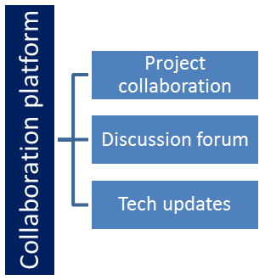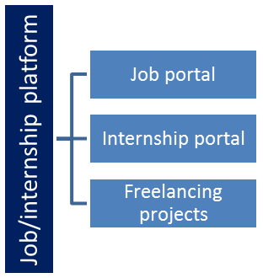

## The IoT Academy

The IoT academy is EdTech Division of UCT that is running long executive certification programs in collaboration with EICT Academy, IITK, IITR and IITG in multiple domains.

## Objectives of this Internship program

The objective for this internship program was to

 ☛ get practical experience of working in the industry.

 ☛ to solve real world problems.

 ☛ to have improved job prospects.

 ☛ to have Improved understanding of our field and its applications.

 ☛ to have Personal growth like better communication and problem solving.

# Problem Statement

In the assigned problem statement

As many of them could not remember their passwords for various things it is important to store them somewhere safe to retrieve them when required , so my project involved implementing encryption algorithms to secure password storage, designing a user interface to input and retrieve passwords, and developing functions to generate strong passwords and store/retrieve them from a database.

## Code submission (Github link): <https://github.com/Navyashree-Ramprasad/upskillcampus/blob/main/password%20manager..py>

## Report submission (Github link) : <https://github.com/Navyashree-Ramprasad/upskillcampus/blob/main/Password_manager_Navyashree_USC_UCT.docx>

## 

## My learnings

Building a password manager involves implementing encryption algorithms, user authentication systems, and secure data storage mechanisms. Developing these technical skills enhanced my proficiency in programming, cryptography, and software security, which are highly valued in many technical roles.

Creating a password manager requires you to address various challenges, such as designing a user-friendly interface, ensuring data integrity, and implementing robust security measures. Overcoming these challenges strengthened my problem-solving skills

Developing a password manager necessitates a deep understanding of security principles, including encryption, hashing, and secure communication protocols. This project allowed me to gain hands-on experience in implementing security measures, thereby enhancing my knowledge and expertise in cyber security—a critical area in today's digital landscape.

Therefore this was wonderful opportunity for me to learn all the in demand skills to be ready for my placements.

**Future work scope**

The code that I demonstrated was a basic one which just showed how this application would work , if enough time was permitted I could integrate it with real world password managers and the user-interface of it could have been upgraded to make it more user friendly.