PYTHON 10 CASE STUDIES
1. Integrated University Fee and Eligibility Audit
Problem Statement
Combine fee payments, attendance, internal marks, and examination eligibility records. Identify students with outstanding conditions and generate a reason-wise report.
Algorithm
• Start and store student records.
• For each student, create an empty list of reasons.
• Check fee balance, attendance, and internal marks.
• Add a reason for every unmet condition.
• Display Eligible if no reasons exist; otherwise display the reasons.
• Stop.
Flowchart
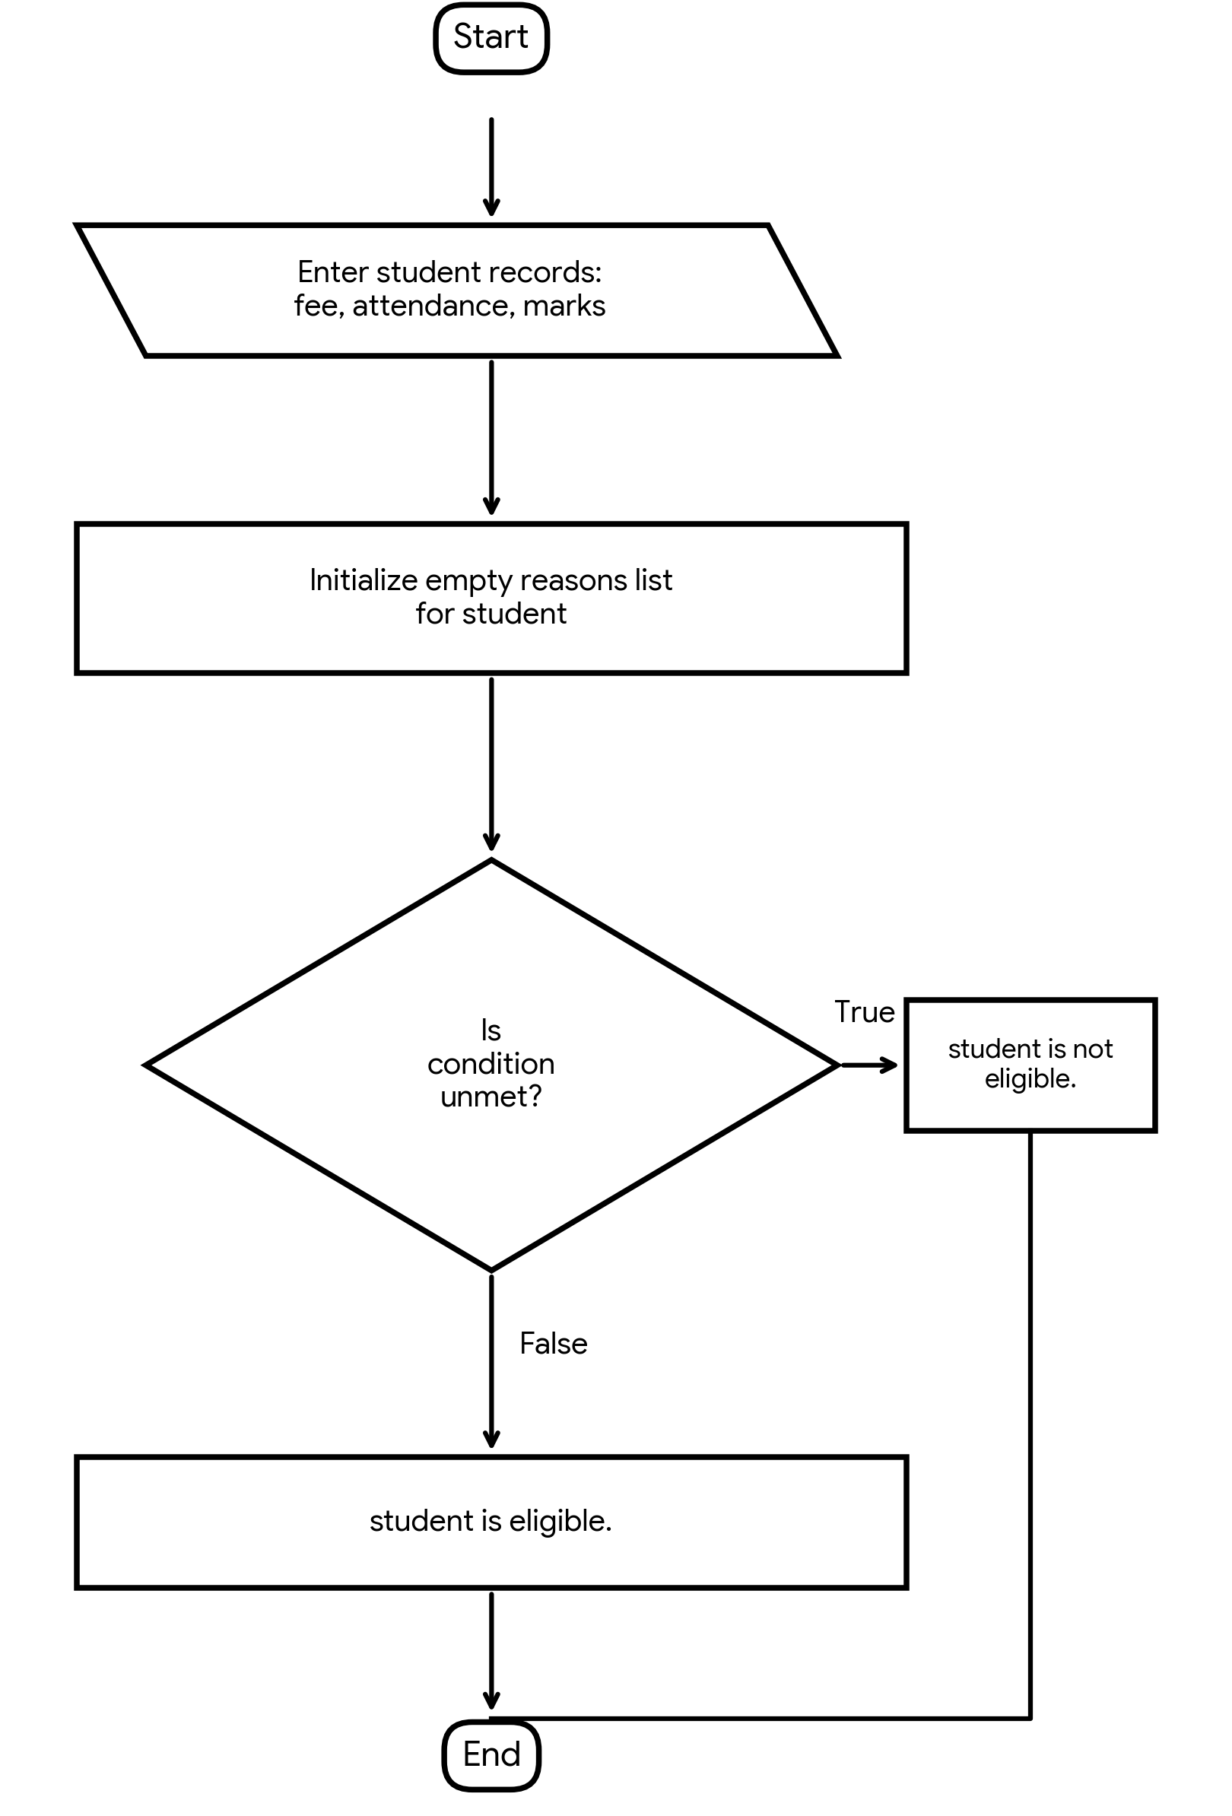
Pseudocode
FOR each student:
reasons = empty list
IF fee balance > 0: add "Outstanding fees"
IF attendance < 75: add "Low attendance"
IF internal marks < 40: add "Low internal marks"
IF reasons is empty:
display Eligible
ELSE:
display Not Eligible and reasons
Python Source Code
students = [
("S101", 0, 82, 65),
("S102", 2500, 68, 35),
("S103", 0, 72, 55)
]
for sid, fee, attendance, marks in students:
reasons = []
if fee > 0:
reasons.append("Outstanding fees")
if attendance < 75:
reasons.append("Low attendance")
if marks < 40:
reasons.append("Low internal marks")
if len(reasons) == 0:
print(sid, "Eligible")
else:
print(sid, "Not Eligible:", ", ".join(reasons))
Test Cases
Input / Record | Test Details | Expected Result
S101 | Rs.0; 82%; 65 marks | Eligible
S102 | Rs.2,500; 68%; 35 marks | Outstanding fees, low attendance, low marks
S103 | Rs.0; 72%; 55 marks | Low attendance
Program Output
S101 Eligible
S102 Not Eligible: Outstanding fees, Low attendance, Low internal marks
S103 Not Eligible: Low attendance
Process finished with exit code 0

2. Smart Hostel Resource Monitoring
Problem Statement
Analyse room-wise electricity and water consumption, calculate charges, identify threshold violations, and compare resource utilization across floors.
Algorithm
• Start and store room, floor, electricity, and water details.
• Calculate electricity charge as units x Rs.8.
• Calculate water charge as kilolitres x Rs.20.
• Add charges to obtain the total bill.
• Check both thresholds and display warnings.
• Stop.
Flowchart
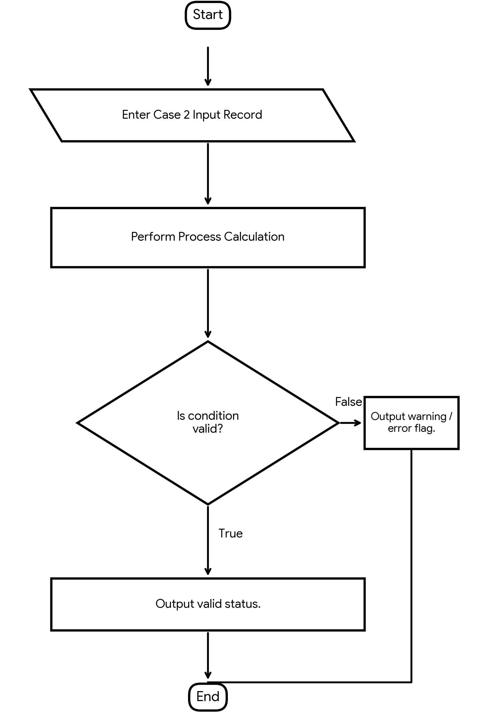
Pseudocode
FOR each room:
electricity_charge = units * 8
water_charge = kilolitres * 20
total = electricity_charge + water_charge
IF units > 200: display high electricity consumption
IF water > 15: display high water consumption
display room, floor and total
Python Source Code
rooms = [
("R101", 1, 180, 12),
("R102", 1, 240, 18),
("R201", 2, 150, 10)
]
for room, floor, electricity, water in rooms:
e_charge = electricity * 8
w_charge = water * 20
total = e_charge + w_charge
print(room, "Floor:", floor, "Bill:", total)
if electricity > 200:
print("High electricity consumption")
if water > 15:
print("High water consumption")
Test Cases
Input / Record | Test Details | Expected Result
R101 | 180 units; 12 kL | Bill Rs.1,680; no warning
R102 | 240 units; 18 kL | Bill Rs.2,280; both warnings
R201 | 150 units; 10 kL | Bill Rs.1,400; no warning
Program Output
R101 Floor: 1 Bill: 1680
R102 Floor: 1 Bill: 2280
High electricity consumption
High water consumption
R201 Floor: 2 Bill: 1400
Process finished with exit code 0

3. Multi-Route Courier Dispatch Planning
Problem Statement
Process package weights, destination zones, vehicle capacities, and delivery priorities. Allocate packages to vehicles and identify packages that cannot be dispatched.
Algorithm
• Start and store packages with ID, zone, weight, and priority.
• Store the remaining capacity for each zone.
• Sort packages by priority ascending.
• For each package, check its zone's remaining capacity.
• Dispatch if capacity is sufficient; otherwise mark it pending.
• Reduce capacity after dispatch and stop.
Flowchart
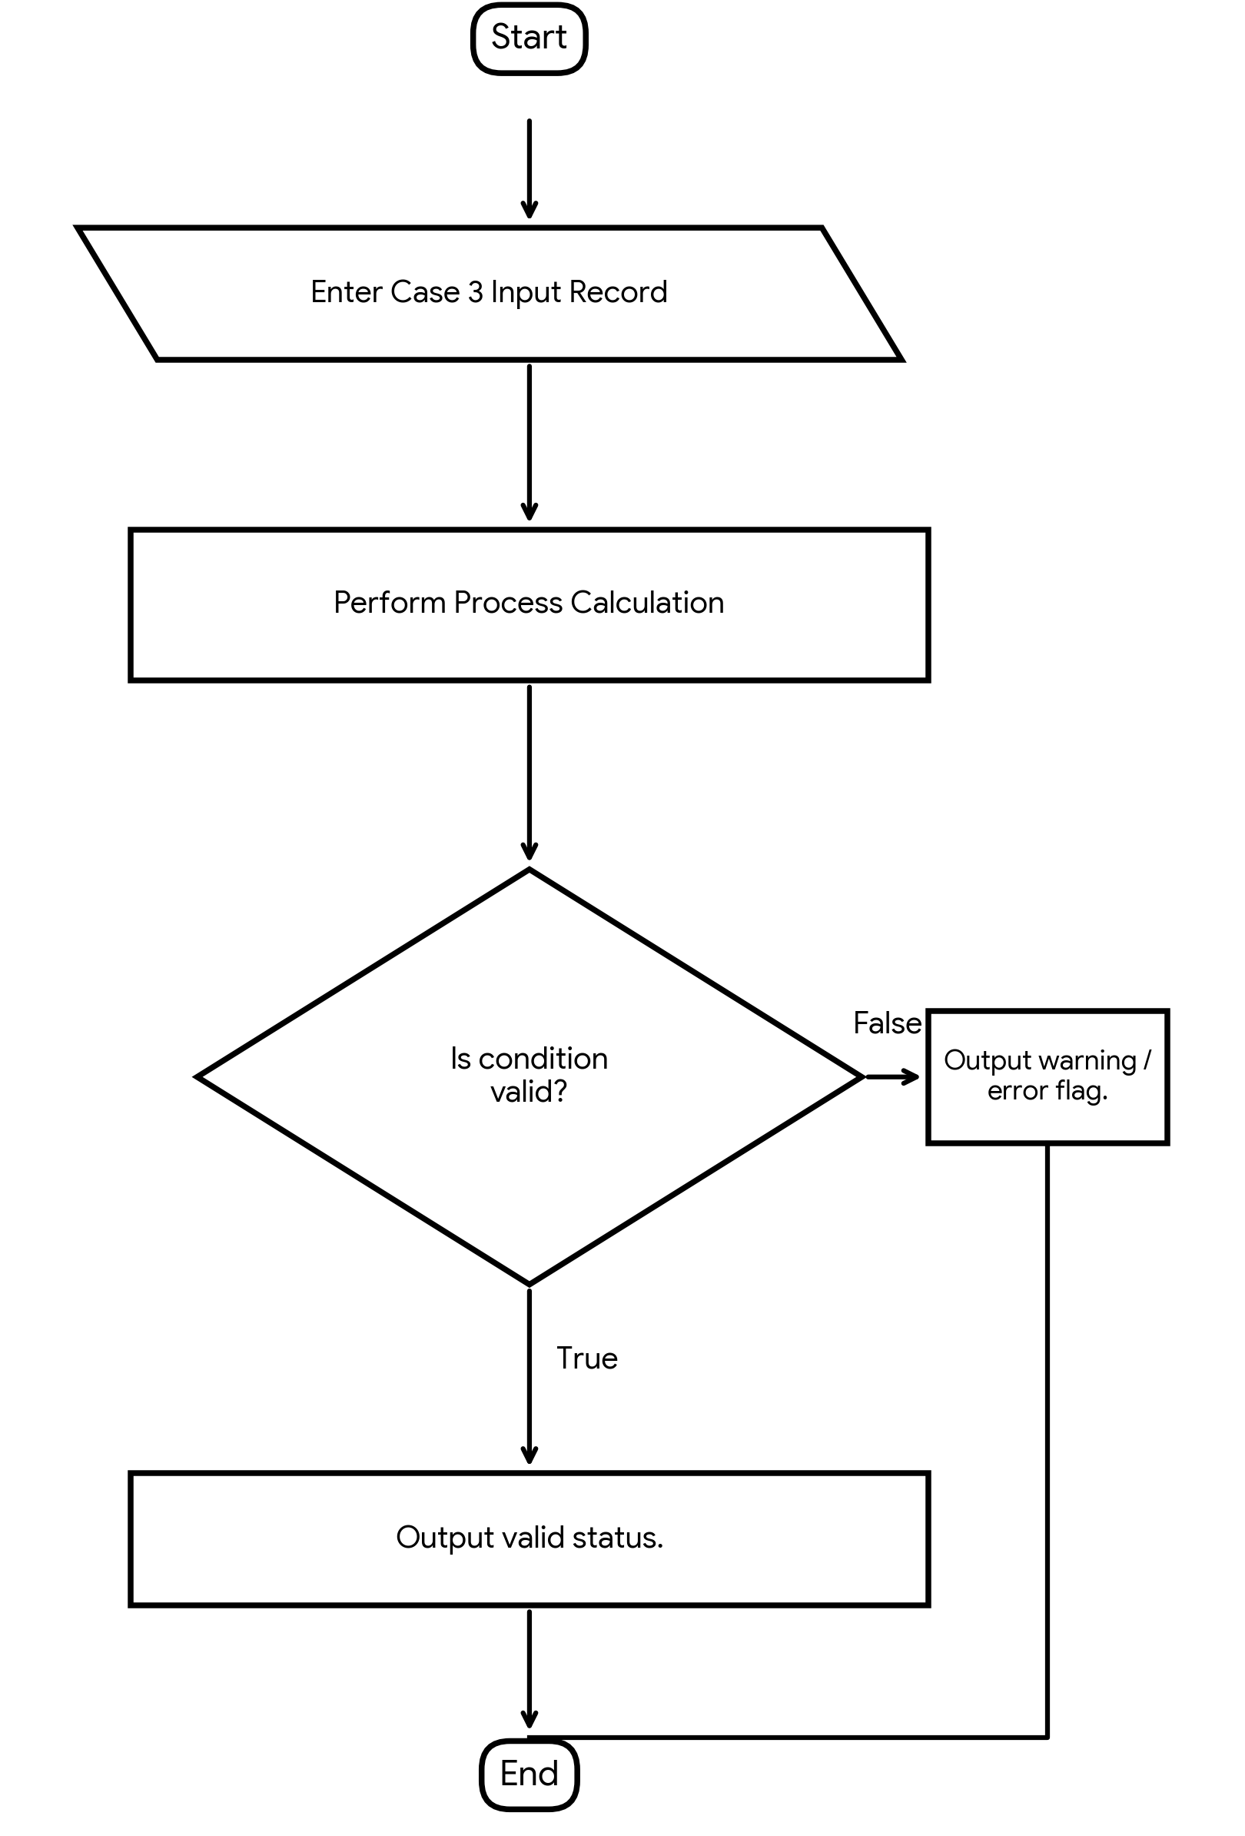
Pseudocode
SORT packages by priority ascending
FOR each package:
IF package weight <= remaining capacity for its zone:
display Dispatched
subtract package weight from capacity
ELSE:
display Cannot dispatch
Python Source Code
packages = [
("P1", "A", 8, 1),
("P2", "A", 6, 2),
("P3", "B", 5, 1),
("P4", "A", 4, 1)
]
capacity = {"A": 10, "B": 5}
packages.sort(key=lambda p: p[3])
for pid, zone, weight, priority in packages:
if weight <= capacity[zone]:
print(pid, "Dispatched to zone", zone)
capacity[zone] -= weight
else:
print(pid, "Cannot dispatch")
Test Cases
Input / Record | Test Details | Expected Result
P1 | Zone A; 8 kg; priority 1 | Dispatched
P3 | Zone B; 5 kg; priority 1 | Dispatched
P4 | Zone A; 4 kg; priority 1 | Cannot dispatch
P2 | Zone A; 6 kg; priority 2 | Cannot dispatch
Program Output
P1 Dispatched to zone A
P3 Dispatched to zone B
P4 Cannot dispatch
P2 Cannot dispatch
Process finished with exit code 0

4. Campus Festival Registration and Financial Audit
Problem Statement
Reconcile participant lists, registration fees, sponsorship contributions, and expenses. Detect duplicate registrations and calculate the final financial balance.
Algorithm
• Start and read participant IDs, sponsorship, and expenses.
• Build a unique participant list and record duplicate IDs.
• Calculate registration income from unique participants.
• Add sponsorship to registration income.
• Subtract expenses and display the final balance.
• Stop.
Flowchart
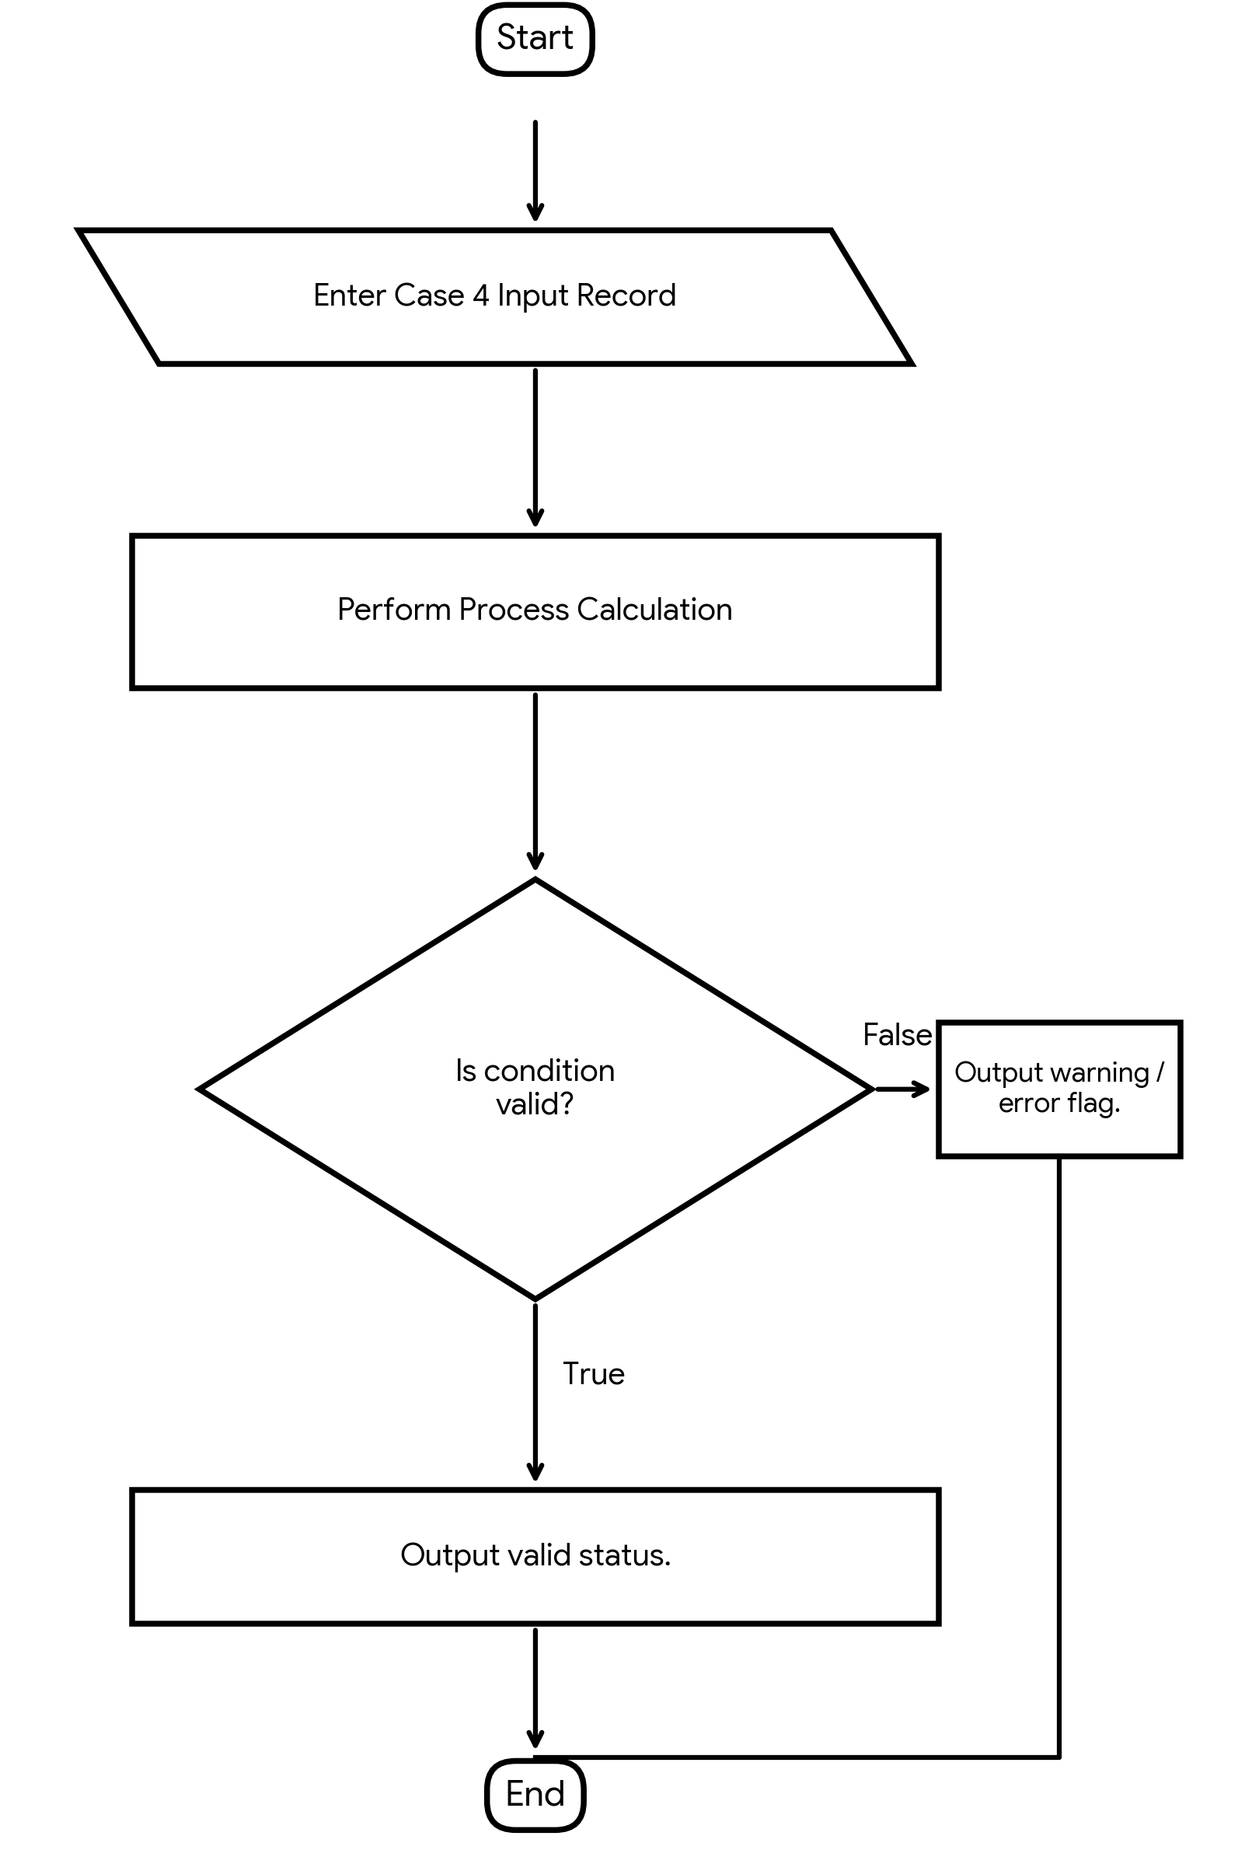
Pseudocode
unique = empty list
duplicates = empty list
FOR each participant ID:
IF ID already in unique:
add ID to duplicates if not recorded
ELSE:
add ID to unique
registration_income = number of unique IDs x fee
total_income = registration_income + sponsorship
balance = total_income - expenses
DISPLAY audit report
Python Source Code
participants = ["S101", "S102", "S103", "S102", "S104"]
fee = 200
sponsorship = 5000
expenses = 6500
unique = []
duplicates = []
for pid in participants:
if pid in unique:
if pid not in duplicates:
duplicates.append(pid)
else:
unique.append(pid)
registration_income = len(unique) * fee
total_income = registration_income + sponsorship
balance = total_income - expenses
print("Unique participants:", len(unique))
print("Duplicate IDs:", duplicates)
print("Total income:", total_income)
print("Expenses:", expenses)
print("Final balance:", balance)
Test Cases
Input / Record | Test Details | Expected Result
Participant IDs | S101, S102, S103, S102, S104 | 4 unique; duplicate S102
Financial values | Fee Rs.200; sponsorship Rs.5,000 | Total income Rs.5,800
Expenses | Rs.6,500 | Final balance -Rs.700
Program Output
Unique participants: 4
Duplicate IDs: ['S102']
Total income: 5800
Expenses: 6500
Final balance: -700
Process finished with exit code 0

5. Integrated Student Record Consistency Checker
Problem Statement
Validate student identifiers, names, marks, attendance, and course records stored in lists and tuples. Detect duplicates, missing values, and inconsistent academic records.
Algorithm
• Start and store student records in a nested list.
• Create a list of IDs already seen.
• For each record, check duplicate ID and missing values.
• Validate marks and attendance ranges.
• Display all errors or mark the record as valid.
• Stop.
Flowchart
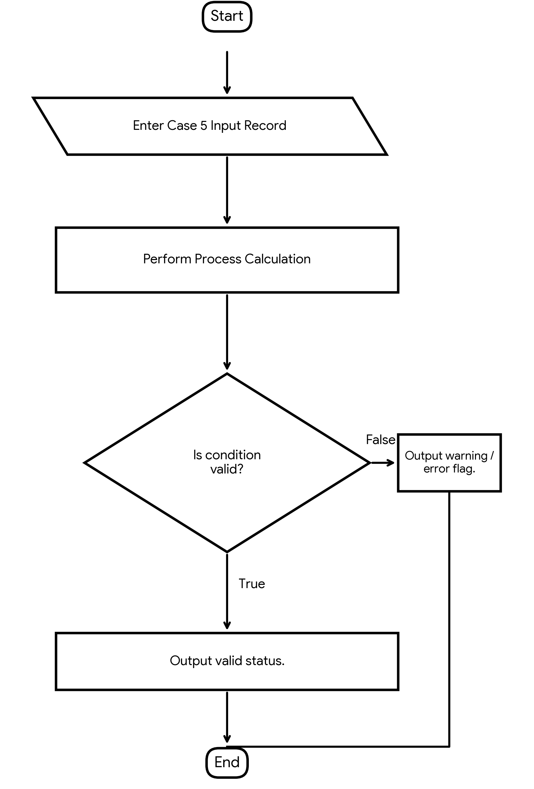
Pseudocode
seen = empty list
FOR each student record:
errors = empty list
check ID duplication
check name and course are not empty
check 0 <= marks <= 100
check 0 <= attendance <= 100
display errors or Valid
Python Source Code
students = [
["S101", "Anu", 85, 90, "Python"],
["S102", "", 110, 75, "Maths"],
["S101", "Ravi", 70, 105, ""]
]
seen = []
for sid, name, marks, attendance, course in students:
errors = []
if sid in seen:
errors.append("Duplicate ID")
else:
seen.append(sid)
if name == "":
errors.append("Missing name")
if marks < 0 or marks > 100:
errors.append("Invalid marks")
if attendance < 0 or attendance > 100:
errors.append("Invalid attendance")
if course == "":
errors.append("Missing course")
print(sid, errors if errors else "Valid")
Test Cases
Input / Record | Test Details | Expected Result
S101 | Anu; 85 marks; 90% attendance; Python | Valid
S102 | Empty name; marks 110 | Missing name and invalid marks
Repeated S101 | Attendance 105; course empty | Duplicate ID, invalid attendance, missing course
Program Output
S101 Valid
S102 ['Missing name', 'Invalid marks']
S101 ['Duplicate ID', 'Invalid attendance', 'Missing course']
Process finished with exit code 0

6. University Examination Result Moderation
Problem Statement
Process marks across multiple subjects, apply specified moderation rules, preserve maximum-mark constraints, and compare original and moderated outcomes.
Algorithm
• Start and store original subject marks.
• Initialize original and moderated totals.
• For each mark, validate the range.
• Add five marks and cap the result at 100.
• Update totals and display each comparison.
• Display original and moderated totals; stop.
Flowchart
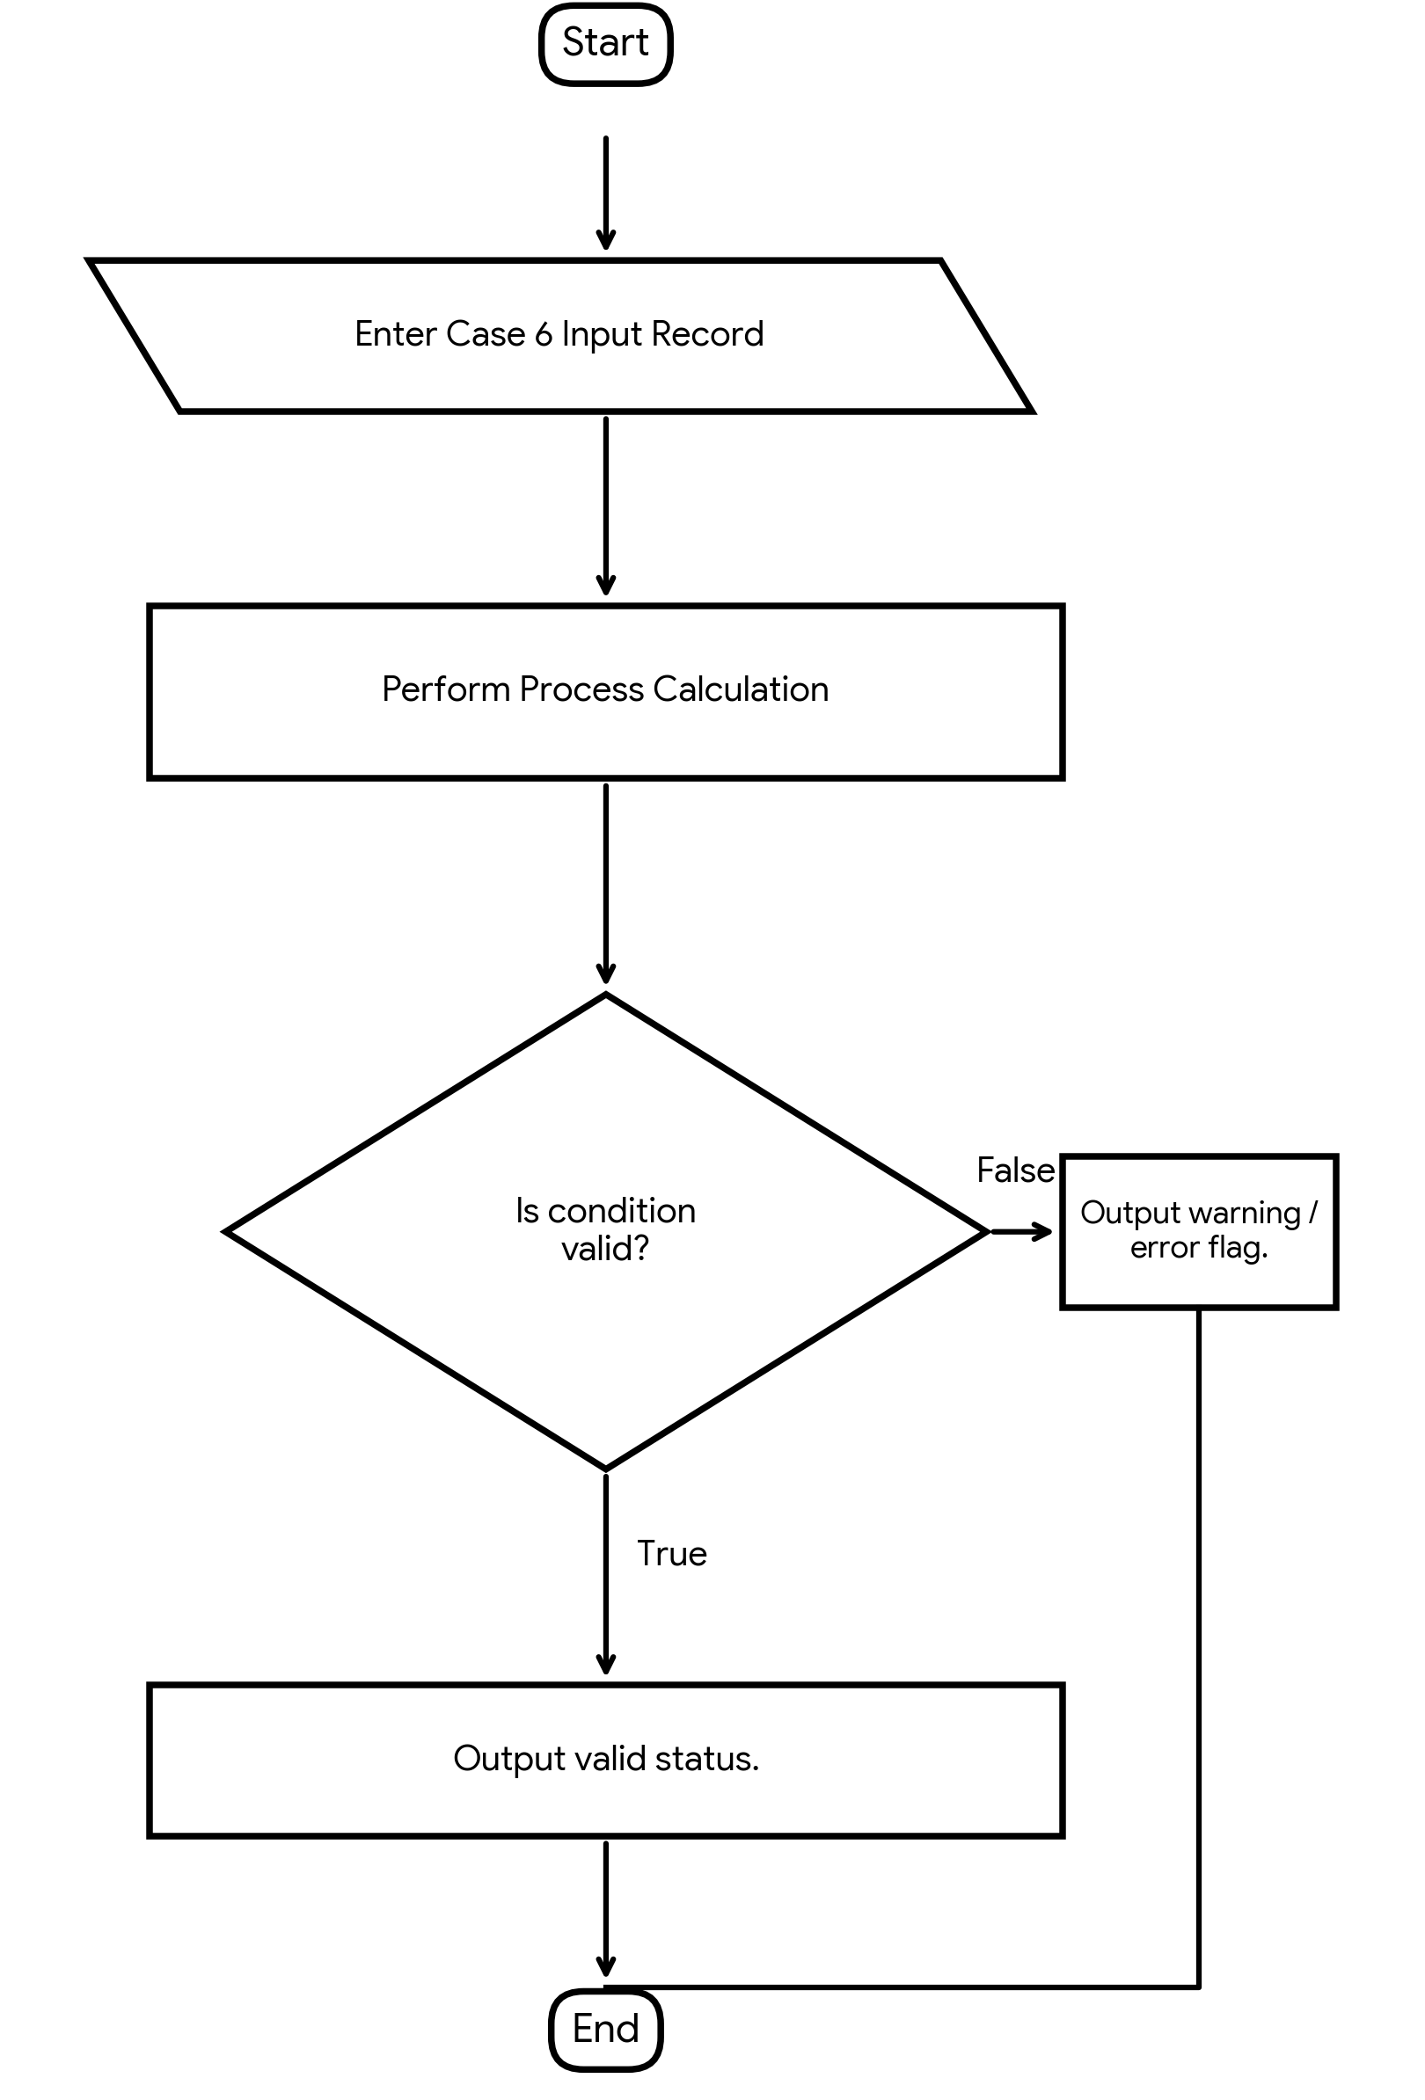
Pseudocode
original_total = 0
moderated_total = 0
FOR each mark:
IF mark is outside 0..100:
report invalid mark
ELSE:
moderated = minimum (mark + 5, 100)
update original and moderated totals
display both marks
DISPLAY totals
Python Source Code
marks = [45, 68, 97, 32]
original_total = 0
moderated_total = 0
for mark in marks:
if mark < 0 or mark > 100:
print("Invalid mark", mark)
else:
moderated = min(mark + 5, 100)
original_total += mark
moderated_total += moderated
print("Original:", mark, "Moderated:", moderated)
print("Original total:", original_total)
print("Moderated total:", moderated_total)
Test Cases
Input / Record | Test Details | Expected Result
45 | Add 5 | 50
68 | Add 5 | 73
97 | Cap at 100 | 100
32 | Add 5 | 37
Program Output
Original: 45 Moderated: 50
Original: 68 Moderated: 73
Original: 97 Moderated: 100
Original: 32 Moderated: 37
Original total: 242
Moderated total: 260
Process finished with exit code 0

7. Smart Electricity Billing for Multiple Apartments
Problem Statement
Calculate apartment-wise bills using progressive tariffs, fixed charges, and rebates. Identify billing discrepancies and rank apartments by consumption.
Algorithm
• Start and store apartment IDs, units, and recorded bills.
• Calculate charges using progressive slabs.
• Add fixed charge and apply rebate when eligible.
• Compare calculated bills with recorded bills.
• Sort apartments by consumption descending and display results.
• Stop.
Flowchart
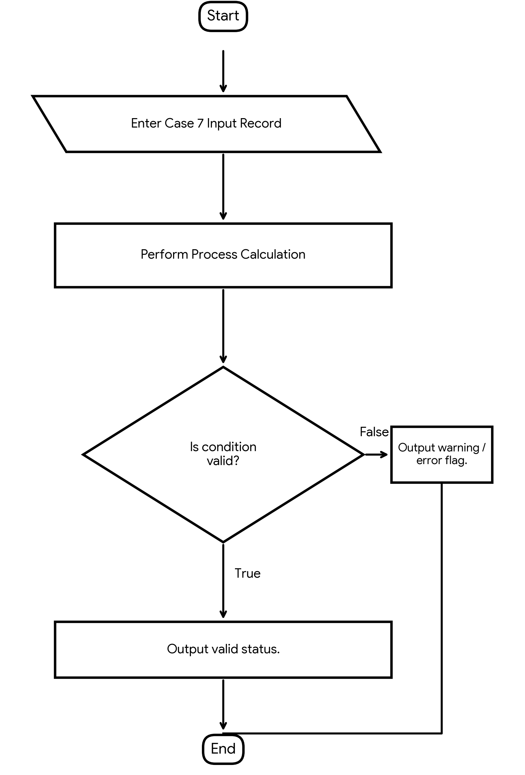
Pseudocode
FOR each apartment:
IF units <= 100:
energy = units x 3
ELSE IF units <= 200:
energy = 300 + (units - 100) x 5
ELSE:
energy = 800 + (units - 200) x 8
bill = energy + 100
IF units < 100: bill = bill - 50
compare bill with recorded bill
SORT apartments by units descending
Python Source Code
apartments = [
("A101", 80, 290),
("A102", 150, 700),
("A103", 250, 1400)
]
results = []
for aid, units, recorded in apartments:
if units <= 100:
energy = units * 3
elif units <= 200:
energy = 300 + (units - 100) * 5
else:
energy = 800 + (units - 200) * 8
bill = energy + 100
if units < 100:
bill -= 50
print(aid, "Bill:", bill, "Recorded:", recorded, "Discrepancy:", bill != recorded)
results.append((aid, units))
results.sort(key=lambda item: item[1], reverse=True)
print("Consumption ranking:", results)
Test Cases
Input / Record | Test Details | Expected Result
A101 | 80 units; recorded Rs.290 | Calculated Rs.290; no discrepancy
A102 | 150 units; recorded Rs.700 | Calculated Rs.650; discrepancy
A103 | 250 units; recorded Rs.1,400 | Calculated Rs.1,300; discrepancy
Program Output
A101 Bill: 290 Recorded: 290 Discrepancy: False
A102 Bill: 650 Recorded: 700 Discrepancy: True
A103 Bill: 1300 Recorded: 1400 Discrepancy: True
Consumption ranking: [('A103', 250), ('A102', 150), ('A101', 80)]
Process finished with exit code 0

8. Hospital Resource Allocation and Capacity Monitoring
Problem Statement
Analyse nested lists of bed occupancy, available staff, and equipment across wards. Identify resource shortages and prioritize cases using supplied rules.
Algorithm
• Start and store ward capacity, occupancy, staff, and equipment values.
• Calculate available beds.
• Compare actual staff and equipment with requirements.
• Display every shortage and flag wards with no available beds.
• Sort cases by priority and display the order.
• Stop.
Flowchart
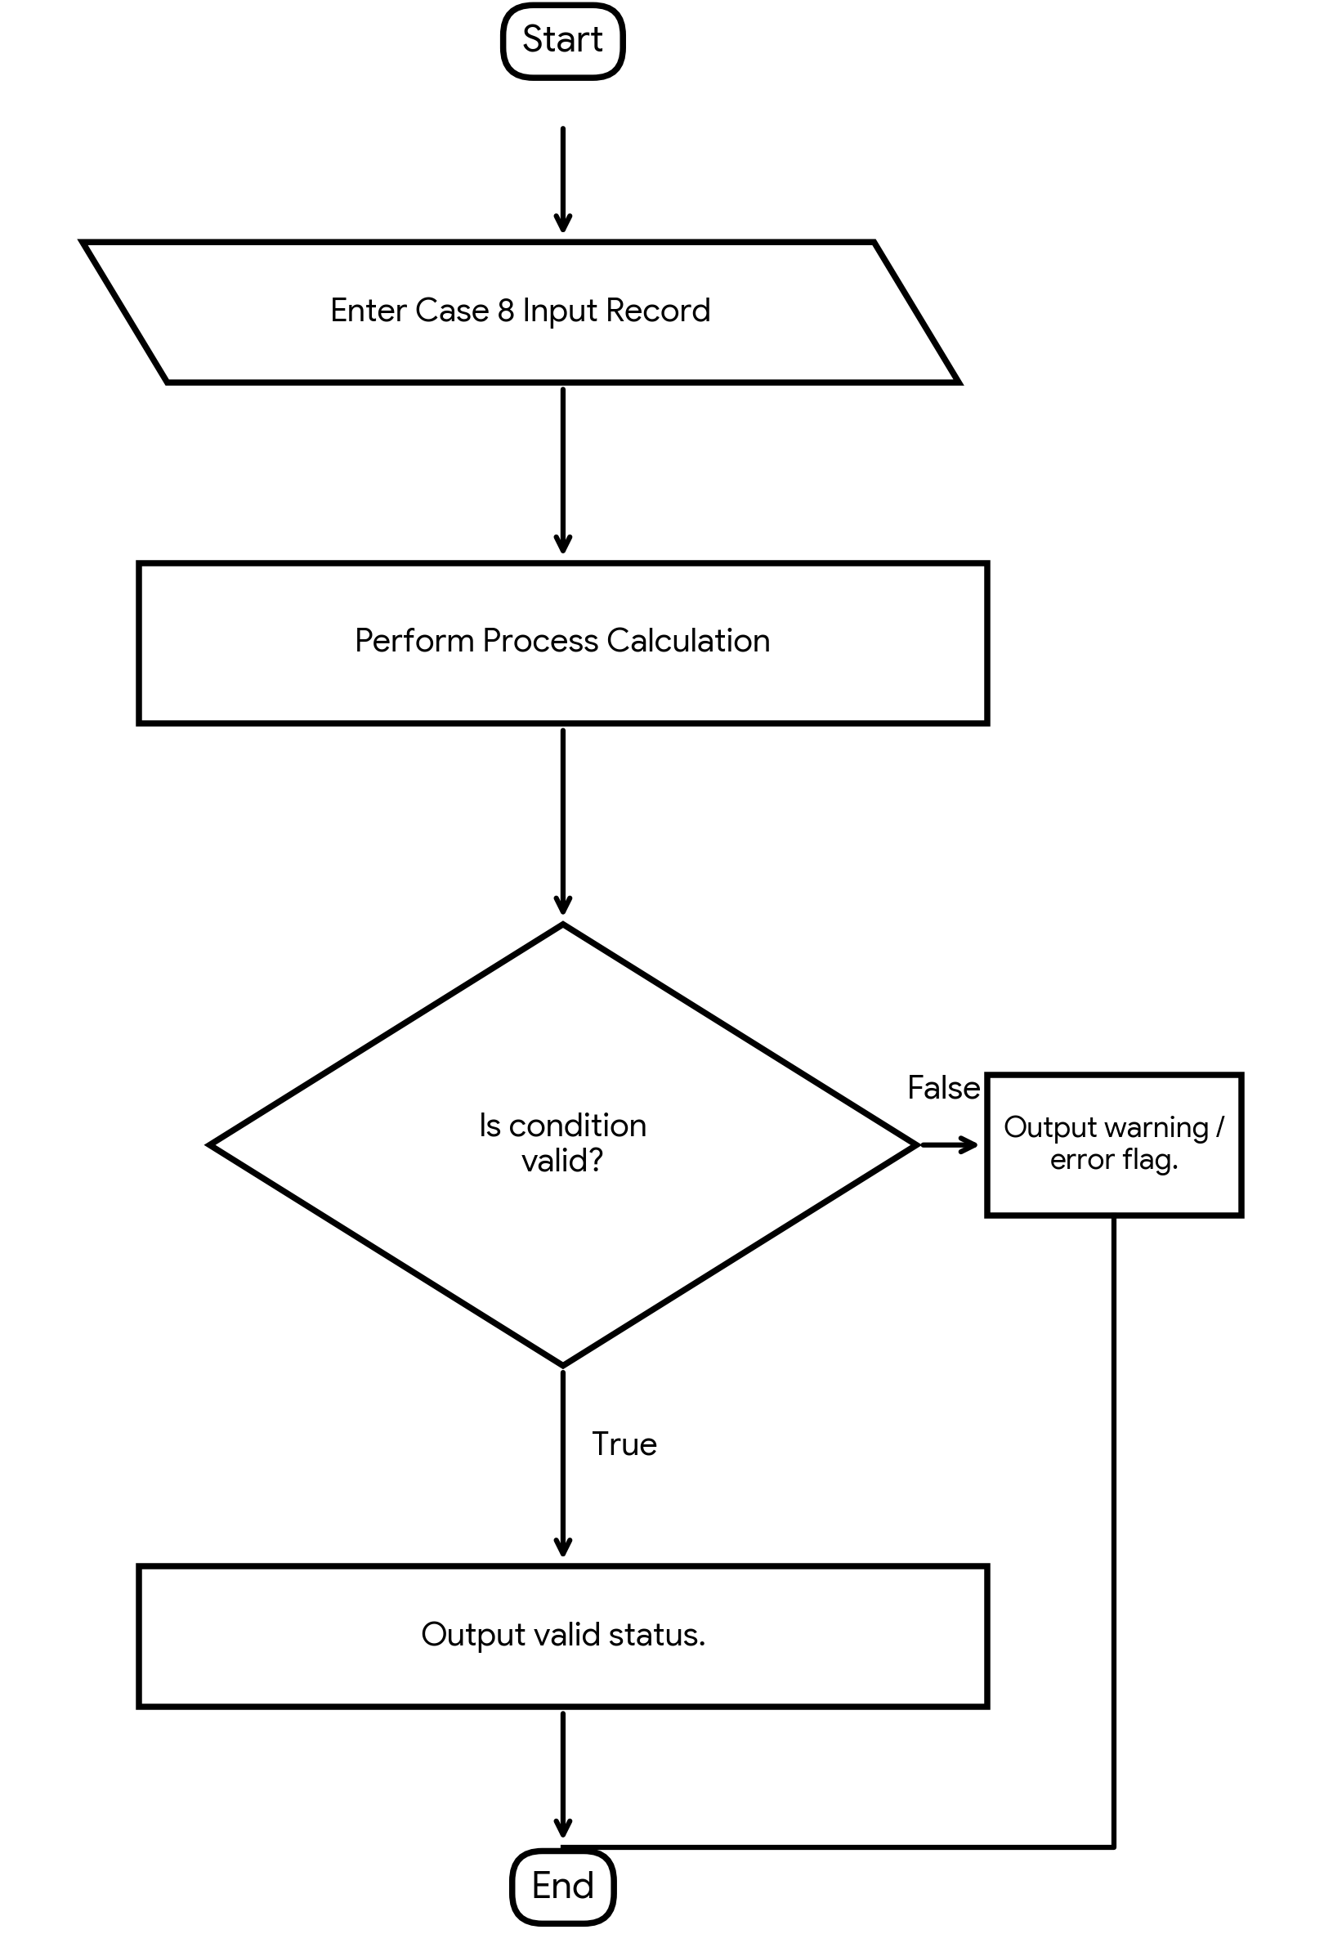
Pseudocode
FOR each ward:
available_beds = capacity - occupied
IF staff < required_staff: report shortage
IF equipment < required_equipment: report shortage
IF available_beds == 0: report no beds
SORT cases by priority ascending
DISPLAY results
Python Source Code
wards = [
["General", 30, 25, 8, 10, 5, 6],
["Emergency", 20, 20, 5, 8, 2, 4],
["ICU", 10, 8, 6, 6, 5, 4]
]
for ward in wards:
name, capacity, occupied, staff, req_staff, equipment, req_eq = ward
available = capacity - occupied
print(name, "Available beds:", available)
if staff < req_staff:
print("Staff shortage")
if equipment < req_eq:
print("Equipment shortage")
if available == 0:
print("No beds available")
cases = [("Case A", 2), ("Case B", 1), ("Case C", 3)]
cases.sort(key=lambda case: case[1])
print("Priority order:", cases)
Test Cases
Input / Record | Test Details | Expected Result
General | 30 beds; 25 occupied; staff 8/10; equipment 5/6 | 5 beds; staff and equipment shortages
Emergency | 20 beds; 20 occupied; staff 5/8; equipment 2/4 | No beds; staff and equipment shortages
ICU | 10 beds; 8 occupied; staff 6/6; equipment 5/4 | 2 beds; no shortage
Program Output
General Available beds: 5
Staff shortage
Equipment shortage
Emergency Available beds: 0
Staff shortage
Equipment shortage
No beds available
ICU Available beds: 2
Priority order: [('Case B', 1), ('Case A', 2), ('Case C', 3)]
Process finished with exit code 0

9. Integrated Warehouse Order Prioritization
Problem Statement
Process product demand, stock levels, order quantities, and priority categories. Determine fulfilment feasibility and calculate outstanding quantities for each order.
Algorithm
• Start and store stock levels and orders.
• Sort orders by priority ascending.
• For each order, find current product stock.
• Fulfil the smaller of requested quantity and available stock.
• Calculate outstanding quantity and update stock.
• Display order results and remaining stock; stop.
Flowchart
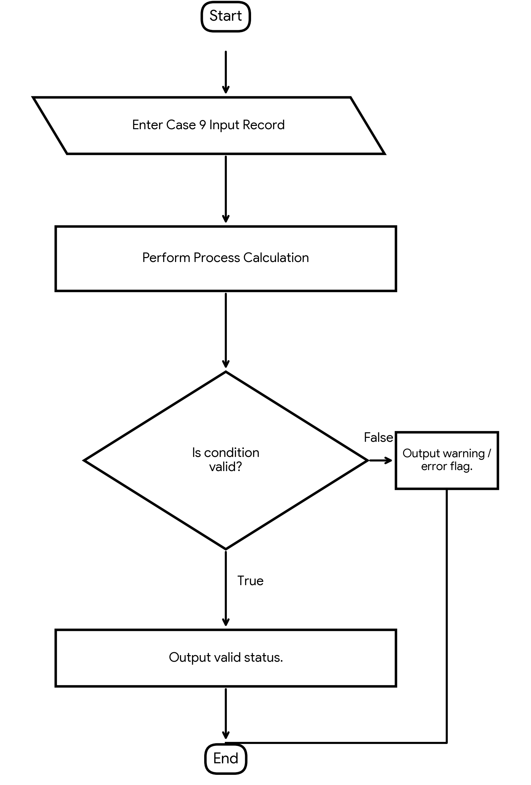
Pseudocode
SORT orders by priority ascending
FOR each order:
fulfilled = minimum(requested_quantity, stock)
outstanding = requested - fulfilled
stock = stock - fulfilled
display fulfilled and outstanding
DISPLAY remaining stock
Python Source Code
stock = {"P1": 20, "P2": 10}
orders = [
("O101", "P1", 15, 1),
("O102", "P1", 10, 2),
("O103", "P2", 12, 1)
]
orders.sort(key=lambda order: order[3])
for oid, product, quantity, priority in orders:
available = stock[product]
fulfilled = min(quantity, available)
outstanding = quantity - fulfilled
stock[product] -= fulfilled
print(oid, "Fulfilled:", fulfilled, "Outstanding:", outstanding)
print("Remaining stock:", stock)
Test Cases
Input / Record | Test Details | Expected Result
O101 | P1 stock 20; request 15; priority 1 | Fulfilled 15; outstanding 0
O103 | P2 stock 10; request 12; priority 1 | Fulfilled 10; outstanding 2
O102 | P1 stock remaining 5; request 10 | Fulfilled 5; outstanding 5
Program Output
O101 Fulfilled: 15 Outstanding: 0
O103 Fulfilled: 10 Outstanding: 2
O102 Fulfilled: 5 Outstanding: 5
Remaining stock: {'P1': 0, 'P2': 0}
Process finished with exit code 0

10. Multi-Day Bus Route Performance Analysis
Problem Statement
Analyse passenger demand, journey times, fuel usage, and bus capacities across multiple days. Identify overloaded routes and compare operating efficiency.
Algorithm
• Start and store route data for each day.
• Compare passengers with bus capacity.
• Calculate fuel efficiency as distance divided by fuel used.
• Display journey time, efficiency, and capacity status.
• Compare route records and stop.
Flowchart
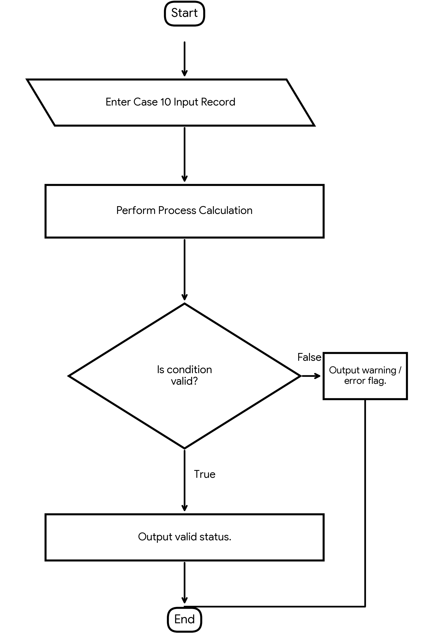
Pseudocode
FOR each route record:
IF fuel <= 0: report invalid fuel value
ELSE: efficiency = distance / fuel
IF passengers > capacity: display Overloaded
ELSE: display Within capacity
display journey time and efficiency
Python Source Code
routes = [
("R1", "Monday", 55, 50, 100, 150, 20),
("R2", "Monday", 40, 50, 120, 160, 15),
("R1", "Tuesday", 48, 50, 100, 145, 18)
]
for route, day, passengers, capacity, distance, time, fuel in routes:
if fuel <= 0:
print(route, day, "Invalid fuel value")
continue
efficiency = distance / fuel
print(route, day, "Time:", time, "Fuel efficiency:", round(efficiency, 2), "km/l")
if passengers > capacity:
print("Overloaded route")
else:
print("Within capacity")
Test Cases
Input / Record | Test Details | Expected Result
R1 Monday | 55 passengers; capacity 50; 100 km; 20 L | Overloaded; 5.00 km/L
R2 Monday | 40 passengers; capacity 50; 120 km; 15 L | Within capacity; 8.00 km/L
R1 Tuesday | 48 passengers; capacity 50; 100 km; 18 L | Within capacity; 5.56 km/L
Program Output
R1 Monday Time: 150 Fuel efficiency: 5.0 km/l
Overloaded route
R2 Monday Time: 160 Fuel efficiency: 8.0 km/l
Within capacity
R1 Tuesday Time: 145 Fuel efficiency: 5.56 km/l
Within capacity
Process finished with exit code 0

