Assignment 3

1a.) Importing all the required libraries and setting the seed value as 2121

Analysis: I could see that there is just slight variation in the results of mean and max

b) We will be calculating 98th percentile of BMI

Here 98th sample percentile and 98th population percentile is same.

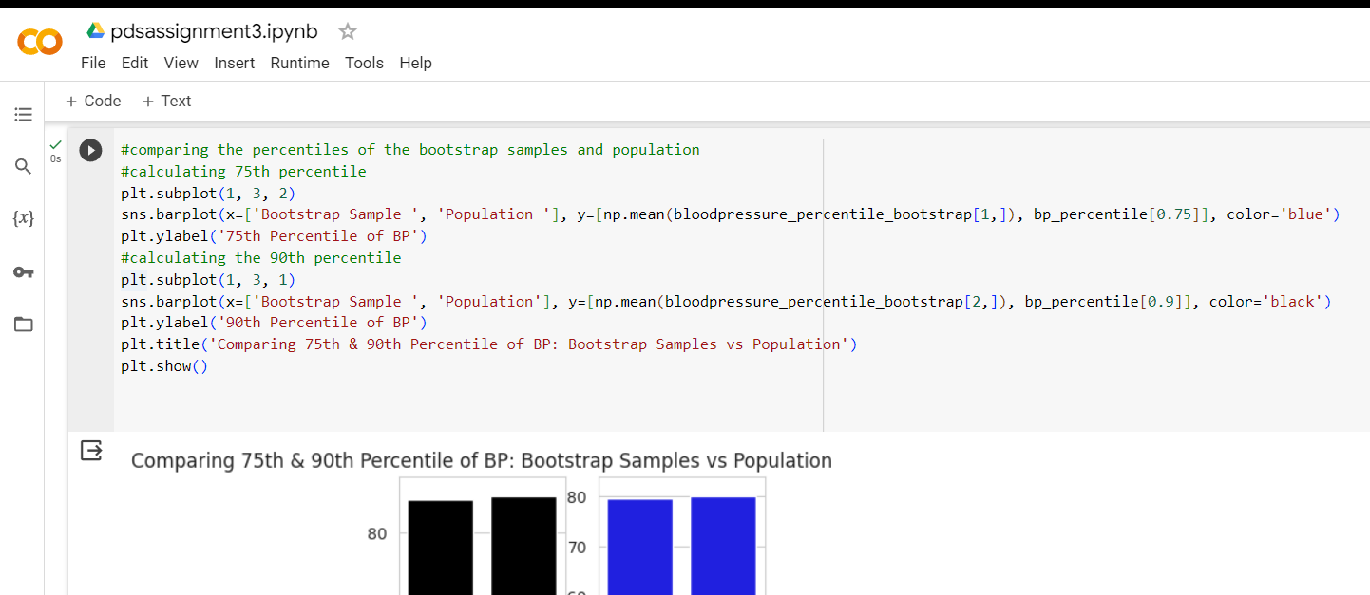

While comparing the population data, the analysis of the bootstrap sample mean, standard deviation, and percentile (75th, and 90th) is evident from the above representation. Therefore, we may say that the bootstrap samples fairly represent the population's features and also utilize them to produce accurate estimations of BP data.