Ideation Phase

Brainstorm & Idea Prioritization Template

Date | 12/09/2026
Student Name | Navya Sri Tangellamudi
Project Name | Intergalactic Space Travel Request System (ISTR)
Maximum Marks | 4 Marks

Brainstorm & Idea Prioritization Template:
Brainstorming provides a free and open environment that encourages every member of the ISTR project team to participate in creative thinking that leads to problem solving. Prioritizing volume over value, out-of-the-box ideas were welcomed and built upon, and all participants collaborated to develop a rich set of solutions for automating intergalactic mission approvals.
This template captures how the ISTR team unleashed its imagination during the ideation phase, moving from problem definition to idea generation, grouping, and prioritization.
Reference: https://www.mural.co/templates/brainstorm-and-idea-prioritization

Step-1: Team Gathering, Collaboration and Select the Problem Statement
The ISTR team gathered stakeholders representing Requesters, Managers, Finance, Mission Control, and Admin perspectives to ensure the brainstorm addressed real approval pain points across the mission lifecycle. Before collaborating, the team defined the goal of the session and agreed on the key rules of brainstorming: stay on topic, encourage wild ideas, defer judgment, listen to others, go for volume, and be visual wherever possible.

PROBLEM STATEMENT
How might we streamline and automate the end-to-end approval process for intergalactic mission requests, so that Managers, Finance, and Mission Control can review, approve, and launch missions quickly, securely, and with full transparency?

Step-2: Brainstorm, Idea Listing and Grouping
Each team member contributed ideas addressing the problem statement. Ideas were then clustered into related themes to make the volume of input easier to review and prioritize.

Workflow Automation
- Auto-populate manager field from requester record
- Build a single Flow Designer flow to handle Manager → Finance → Mission Control approvals

- Auto-route high/critical risk missions directly to Mission Control
- Use Update Sets to migrate configuration across environments
- Add a UI Action to launch a mission once fully approved
Security & Access Control
- Create separate roles: space.requester, space.approver, space.finance, space.admin
- Group stakeholders into Explorers, Finance, Mission Control, and Compliance
- Restrict cost field edits to Finance only
- Restrict mission launch action to Admins only
- Add field-level ACLs to protect sensitive fields like mission control notes
User Experience
- Build a dynamic Mission Request catalog item with conditional fields
- Require diplomatic officer only for Alien Negotiation missions
- Give each role a tailored dashboard with pending tasks and summaries
- Add contextual tooltips explaining each form field
- Show a simple status screen after submission with next steps
SLA, Notifications & Audit
- Start SLA timers at each approval stage
- Send automated notifications at submission, approval, and launch
- Escalate automatically if an approval SLA is breached
- Maintain a full audit trail of every approval and state change
- Track journal notes from Mission Control for high-risk missions

Step-3: Idea Prioritization
The team evaluated every idea against two dimensions — Importance (impact on the mission approval process) and Feasibility (ease of implementation in ServiceNow) — to decide what to build first. Ideas were placed into four quadrants: Quick Win (high importance, high feasibility), Major Project (high importance, lower feasibility), Fill-in (lower importance, high feasibility), and Thankless Task (lower importance, lower feasibility).

Idea | Importance | Feasibility | Quadrant
Custom table u_space_travel_request with core fields | High | High | Quick Win
Roles & groups (Requester, Manager, Finance, | High | High | Quick Win

Idea | Importance | Feasibility | Quadrant
Mission Control, Admin)
ISTR Approval Flow (Manager → Finance → Mission Control) | High | Medium | Major Project
Risk-based routing to Mission Control | High | Medium | Major Project
SLA definitions per approval stage | High | Medium | Major Project
Role-specific dashboards | Medium | High | Fill-in
Tooltips & help text on form fields | Medium | High | Fill-in
Automated email/event notifications | Medium | High | Fill-in
Compliance group for policy oversight | Low | Medium | Thankless Task
AI-driven risk assessment (future enhancement) | Low | Low | Thankless Task

This prioritization confirmed that the ISTR team should build the custom table, roles/groups, and core approval flow first (Quick Wins and Major Projects), while dashboards, tooltips, and notifications rounded out the experience, and advanced ideas like AI-driven risk assessment were deferred to the future roadmap.

Visual Prioritization: Importance vs. Feasibility
Plotting the same ten ideas on a quadrant chart makes the prioritization easier to defend at a glance — the ideas that landed in “Quick Win” and “Major Project” became the foundation of Phase 2, while the rest were scheduled for later or deferred entirely.

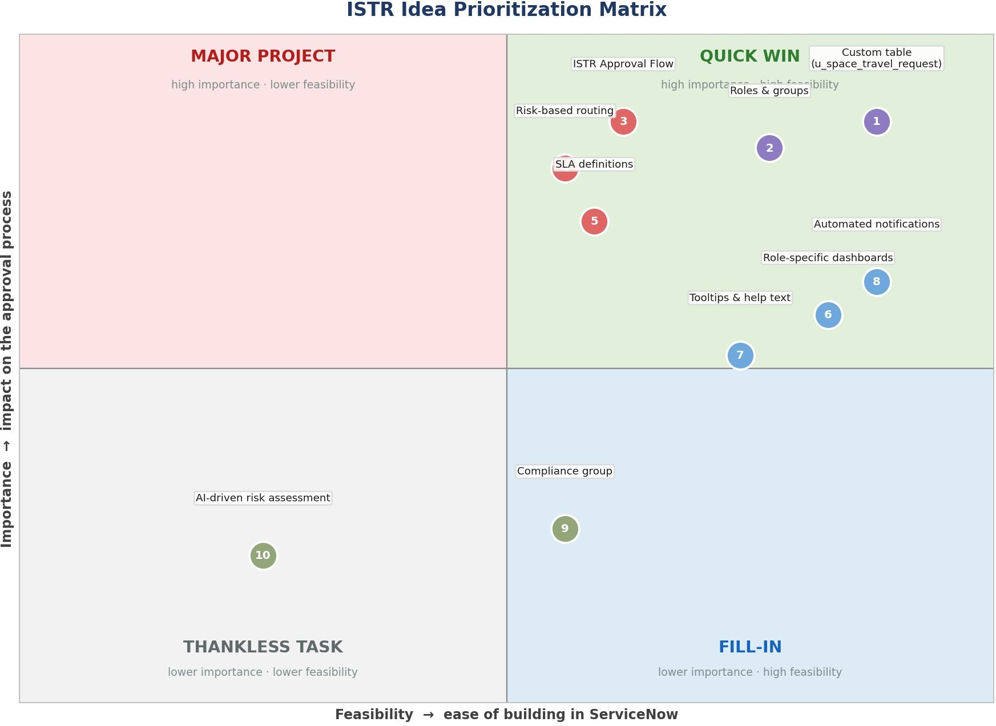

From Brainstorm to Build
Every idea that survived prioritization can be traced to a specific phase of the ISTR build. This closes the loop on the ideation exercise: nothing brainstormed was decorative — each idea either shipped, is scheduled, or was consciously deferred with a reason.

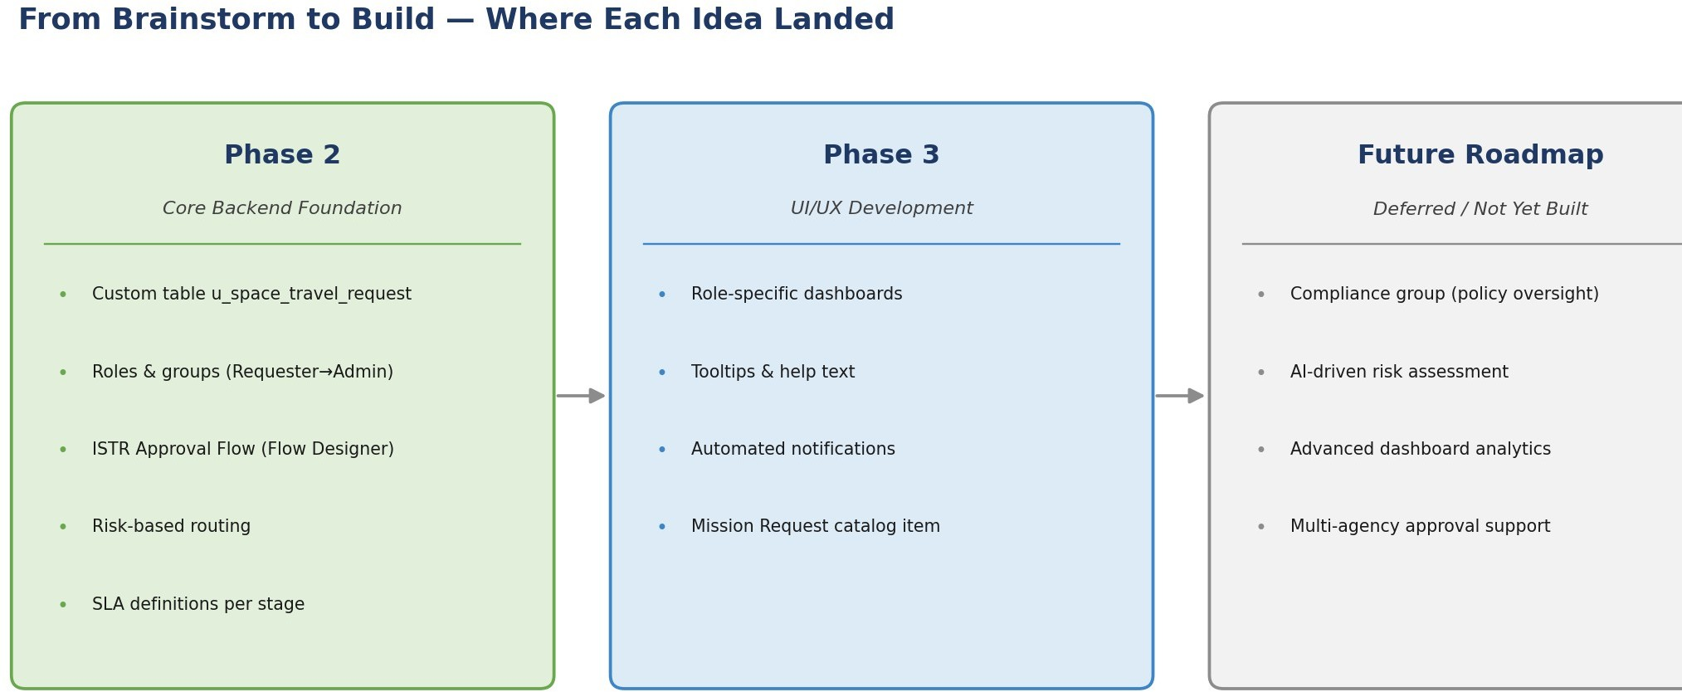
Summary
The brainstorming session generated ten concrete ideas across four themes — Workflow Automation, Security & Access Control, User Experience, and SLA/Notifications/Audit. Prioritizing by importance and feasibility showed that the highest-value work (the custom table, roles and groups, and the core approval flow) was also the most buildable, which is why those became the backbone of Phase 2. Lower-feasibility but high-importance ideas, like risk-based routing and SLA definitions, were treated as Major Projects and scheduled deliberately rather than rushed. The exercise gave the ISTR project a clear, defensible reason for every feature that made it into the final build — and for every idea, like AI-driven risk assessment, that was consciously left for a future release.

