Ideation Phase

Define the Problem Statements

Date | 12/09/2026
Student Name | Navya Sri Tangellamudi
Project Name | Intergalactic Space Travel Request System (ISTR)
Maximum Marks | 2 Marks

Customer Problem Statement Template:
Create a problem statement to understand each ISTR stakeholder's point of view. The Customer Problem Statement template helps the team focus on what matters most to Requesters, Managers, Finance Officers, Mission Control, and Admins as they create experiences these users will love.
A well-articulated problem statement allows the ISTR team to find the ideal solution for the challenges each stakeholder faces when submitting, reviewing, or approving space mission requests.

I am | Describe customer with 3-4 key characteristics - who are they? | Describe the persona and their attributes here
I'm trying to | List their outcome or “job” the care about  - what are they trying to achieve? | List the thing they are trying to achieve here
but | Describe what problems or barriers stand in the way – what bothers them most? | Describe the problems or barriers that get in the way here
because | Enter the “root cause” of why the problem or barrier exists – what needs to be solved? | Describe the reason the problems or barriers exist
which makes me feel | Describe the emotions from the customer's point of view – how does it impact them emotionally? | Describe the emotions that result from experiencing the problems or barriers

Reference: https://miro.com/templates/customer-problem-statement/

Example:

I am | I'm trying to | but | because | which makes me feel
a mission requester | submit a space mission request quickly | the approval process takes days | there is no automated routing or tracking of approvals | Frustrated

ISTR Problem Statements
Applying the framework above, the ISTR team defined the following problem statements across the key stakeholder roles in the mission request lifecycle.

PS | I am (Customer) | I'm trying to | But | Because | Feels
PS-1 | a Requester submitting a space mission request | get my mission approved and scheduled quickly | I have no visibility into where my request is stuck | approvals happen manually across emails with no shared tracking system | Anxious
PS-2 | a Manager reviewing my team's mission requests | approve valid missions quickly and reject risky ones | I don't have a single place to see all pending requests | there is no role-based dashboard showing tasks awaiting my action | Overwhe lmed
PS-3 | a Finance Officer validating mission budgets | confirm each mission's cost is accurate and within limits | cost details reach me late and in inconsistent formats | there is no structured field or validation for mission cost | Uncertai n
PS-4 | a Mission Control Officer overseeing high-risk missions | review and approve every High or Critical risk mission before launch | I am not always notified when a high-risk mission needs my review | there is no automated risk-based routing to Mission Control | Concern ed
PS-5 | an Admin responsible for system integrity and launches | maintain a complete, trustworthy audit trail of every mission | records and approval history are scattered and hard to verify | there is no centralized state tracking or audit logging | Exposed

Persona Pain Flow
The diagram below traces each stakeholder's journey from goal to root cause to emotional impact, making it easier to see the pattern across roles: every persona is blocked by the same underlying gap — the absence of a connected, automated system of record.

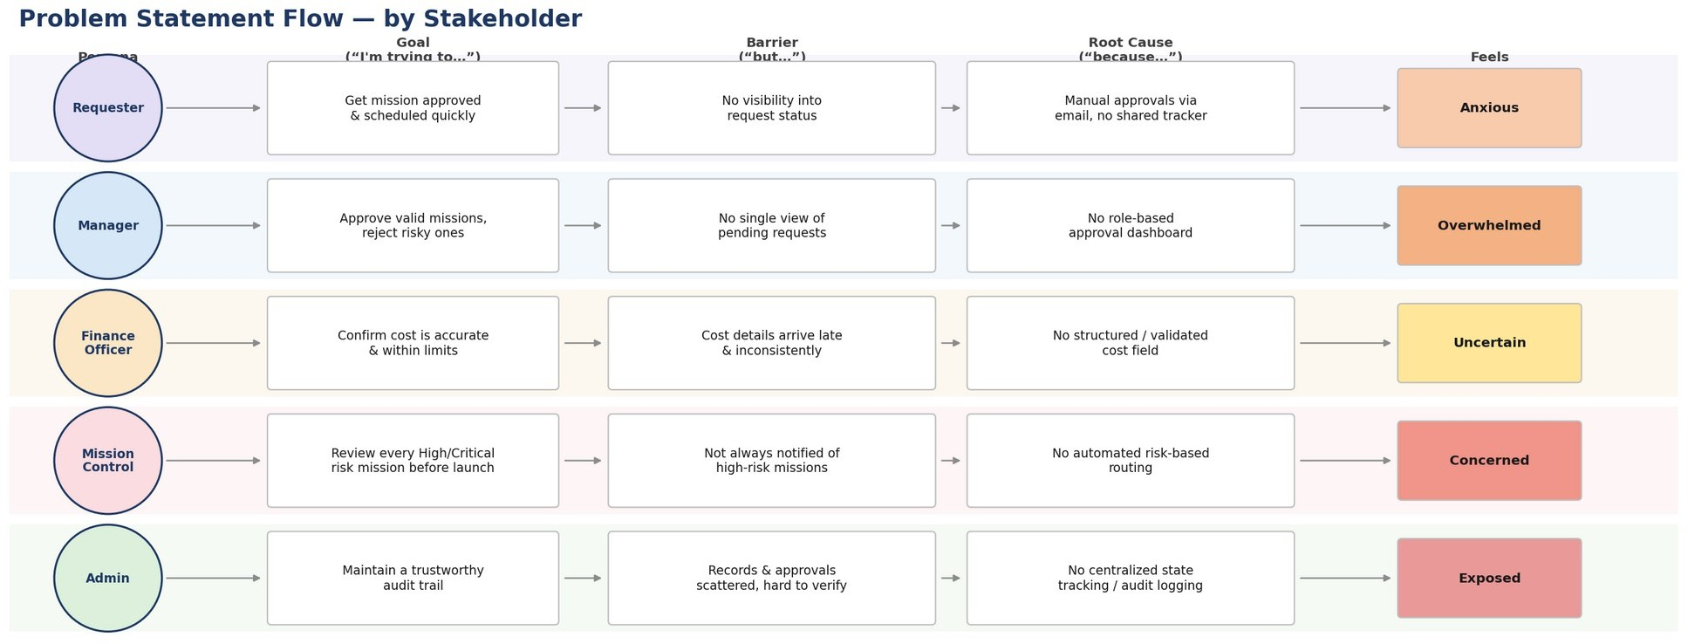

Prioritization: Impact vs. Frequency
Not every problem statement carries the same weight. Plotting each one by how often it occurs and how severe its impact is helps decide what ISTR should solve first.

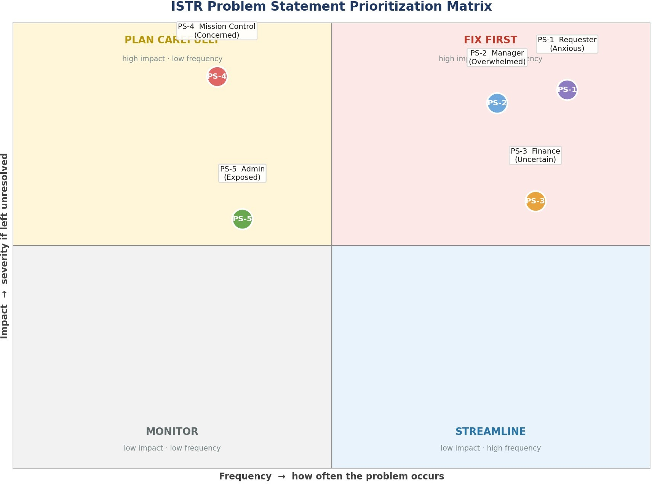

PS-1 and PS-2 sit in the “Fix First” quadrant — they happen on every single mission and directly block the core approval flow, which is why Manager and Requester visibility features were prioritized early in Phase 2. PS-4 is high-impact but lower-frequency, so it still requires an automated (not manual) safeguard, since the cost of missing it is severe. PS-3 and PS-5 are important but slightly less urgent, and are addressed through validation rules and audit logging respectively.

Problem → ISTR Solution Traceability
Every problem statement maps directly to a concrete feature already scoped into ISTR, confirming that the system design addresses real stakeholder pain — not assumptions.

PS | ISTR Feature That Resolves It | How It Helps
PS-1 | Real-time status screen + SLA timers + automated notifications | Requester sees exactly where a request stands at every stage instead of chasing status over email.
PS-2 | Role-based Manager dashboard (Flow Designer task list) | All requests awaiting the Manager's approval appear in one place, tagged by SLA urgency.

PS | ISTR Feature That Resolves It | How It Helps
PS-3 | Structured, validated cost field (Finance-only edit) | Cost is captured consistently at submission time, so Finance reviews accurate data from the start.
PS-4 | Automated risk-based routing to Mission Control | Flow Designer automatically flags and routes every High/Critical mission  — no manual lookup required.
PS-5 | Centralized audit trail, journal logs & state tracking | Every approval, edit, and state change is timestamped in one system of record, ready for audit.

Summary
Across all five roles, the problem statements point to one recurring theme: ISTR's users are currently working around a manual, disconnected process, and that gap is what the system is designed to close. The prioritization matrix confirms the build order was deliberate — the most frequent, highest-impact problems (Requester visibility, Manager approval load) were solved first, while lower-frequency but still severe risks (Mission Control safety review) were engineered with automation rather than left to chance. The traceability table shows every one of these problem statements already has a corresponding feature in the ISTR design, which carries directly into the Requirement Analysis artifacts — the Journey Map and Data Flow Diagram — covered in Phase 2.

