Ideation Phase
Empathize & Discover

Date | 12/09/2026
Student Name | Navya Sri Tangellamudi
Project Name | Intergalactic Space Travel Request System (ISTR)
Maximum Marks | 4 Marks

Empathy Map Canvas:
An empathy map is a simple, easy-to-digest visual that captures knowledge about a user's behaviours and attitudes.
It is a useful tool that helps teams better understand their users. Creating an effective solution requires understanding the true problem and the person experiencing it. For ISTR, this exercise helped frame the mission approval system from the perspective of the people who actually use it — starting with the Requester, the primary user who initiates every mission.

Primary Persona: Mission Requester
The Requester is a mission crew member or department staff member who submits space travel requests and depends on a fast, transparent approval process to keep their mission on schedule.

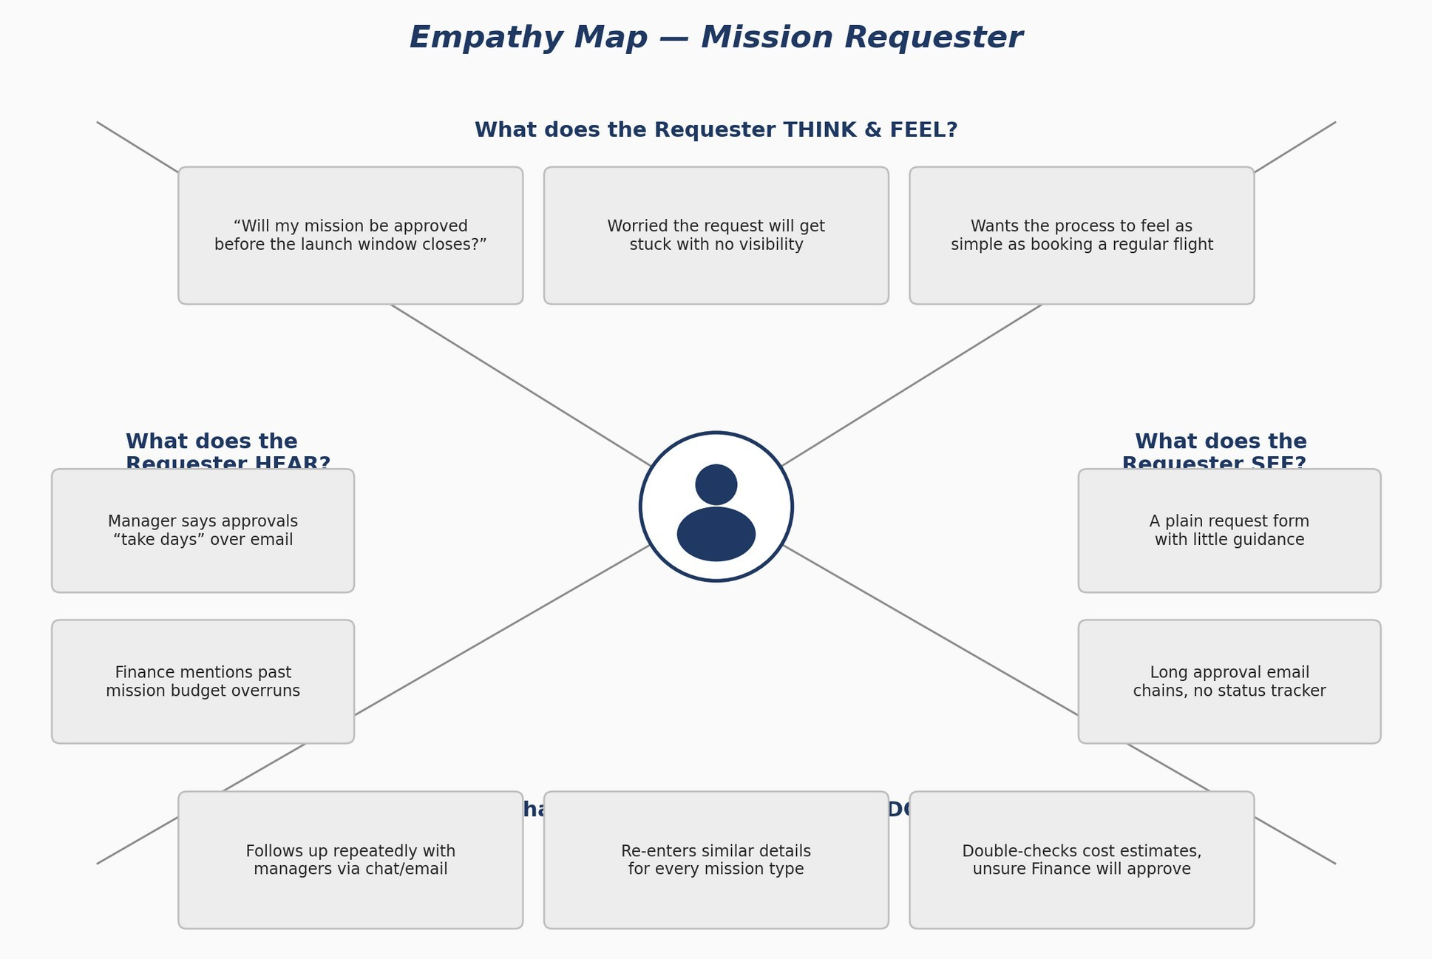

Pain  - No transparency into where a request stands in the approval chain  - Manual, repetitive data entry across mission types  - Anxiety over missing critical launch windows due to slow approvals | Gain  - Real-time dashboard showing mission status at every stage  - Instant notifications the moment an approval decision is made  - Confidence that high-risk missions get proper Mission Control review

Empathy Across Other ISTR Stakeholders
While the Requester is the primary persona, ISTR serves several other roles whose experience shapes the system design. The table below captures a quick empathy snapshot for each additional stakeholder.

Role | Thinks / Feels | Pain | Gain
Manager | “Did I miss an approval sitting in my inbox?” | No single view of pending team requests | A task-based dashboard listing exactly what needs review
Finance Officer | “Is this cost estimate even realistic?” | Budget details arrive late and inconsistently | Structured, validated cost fields visible early in the

Role | Thinks / Feels | Pain | Gain
 |  |  | flow
Mission Control | “Am I being looped in on every risky mission?” | No guarantee of being notified for High/Critical missions | Automatic routing and alerts for high-risk approvals
Admin | “Can I prove what happened if something goes wrong?” | Approval history scattered across emails and spreadsheets | A centralized, timestamped audit trail for every mission

How Strongly Each Role Feels the Pain
Not every stakeholder experiences the same level of friction. Rating each role's pain intensity on a simple 1–5 scale highlights where the emotional stakes — and therefore the design priority — are highest.

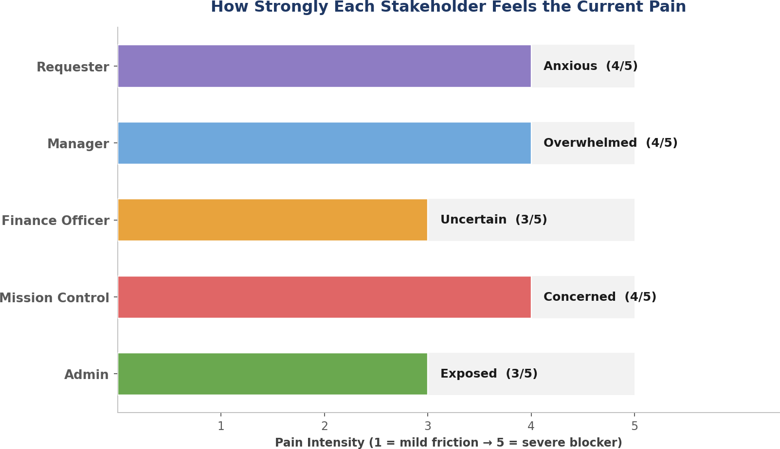

Requesters, Managers, and Mission Control all rate a 4/5 — their pain is frequent and directly blocks mission progress, which is why status visibility, dashboards, and automated risk routing were treated as first-priority design decisions. Finance and Admin rate slightly lower at 3/5, since their pain is more about data quality and long-term trust than moment-to-moment blockage, but both still needed dedicated solutions.

From Empathy to Design Decisions
Every empathy insight captured above translated directly into a concrete decision in the ISTR interface and workflow design — confirming that Phase 3's UI/UX choices were grounded in real stakeholder pain, not guesswork.

Role | Core Pain (from Empathy Map) | ISTR Design Decision
Requester | No transparency into where a request stands | Real-time status screen with SLA timers and approval history on the Request Details page
Manager | No single view of pending team requests | Role-specific Manager dashboard listing only tasks awaiting their approval
Finance Officer | Budget details arrive late & inconsistently | Structured, validated cost field editable only by Finance, captured at submission time
Mission Control | Not guaranteed to be notified for high-risk missions | Automated risk-based routing that flags every High/Critical mission for review
Admin | Approval history scattered and hard to verify | Centralized audit trail and journal logging across every state change

Summary
Mapping empathy across all five ISTR roles revealed a consistent theme: every stakeholder's frustration traces back to the same root cause — the lack of a connected, automated system of record. The Requester wants visibility, the Manager and Finance Officer want a clear queue of what needs their attention, Mission Control wants to be reliably looped in on risk, and the Admin wants a trustworthy audit trail. Because each of these needs was identified early through empathy mapping, every one of them was addressed directly in ISTR's later design phases rather than discovered late or left out.

Reference: https://www.mural.co/templates/empathy-map-canvas

