**Crime Data Analysis**

**Dataset: crime_incidents_2013.csv**

Step 1: Loading data into Dataframe

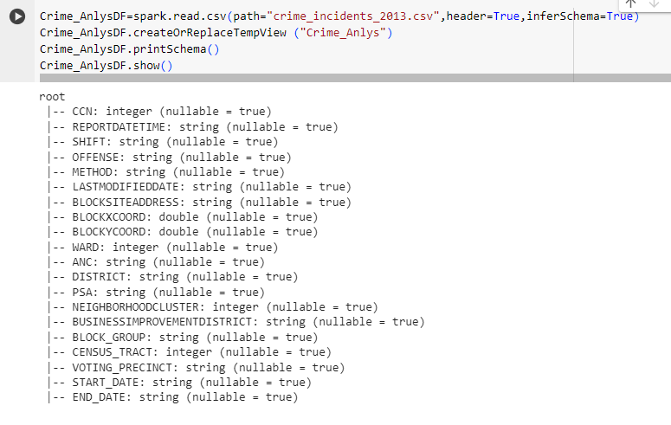

1. How many offenses were there in 2013?

Distinct Offenses happened in 2013

*>>> spark.sql("SELECT count(distinct OFFENSE) from Crime_Anlys").show()*

No of Offenses happened in 2013

1. How many crimes were committed in each offense?

1. How many different methods were used (And their count) in offense “Homicide”

1. Which shift had the maximum crimes?

Evening shift had the maximum crimes.

