**HIVE Assignment 2**

**Create external tables for drivers and timesheet data and answer the following queries**

**HIVE QL >>** Create EXTERNAL TABLE drivers_k (driverId int,name string,ssn string,location string,certified string, wage_plan string ) ROW FORMAT DELIMITED FIELDS TERMINATED BY ‘,’ tblproperties('skip.header.line.count' = '1');

Create EXTERNAL TABLE timesheet_n (driverid int,week int,hours_logged int,miles_logged int ) ROW FORMAT DELIMITED FIELDS TERMINATED BY ‘,’ tblproperties('skip.header.line.count' = '1');

Loading data into tables:

**Query:**

**How many total hours and miles logged by each driver?**

hive> select driverid , sum(hours_logged), sum(miles_logged) from timesheet_n group by driverid;

**Query:**

**Print the name of the driver in the above query**

hive> select t.driverid ,d.name, sum(hours_logged), sum(miles_logged) from timesheet_n t join drivers_n d on t.driverid

= d.driverid group by t.driverid,d.name;

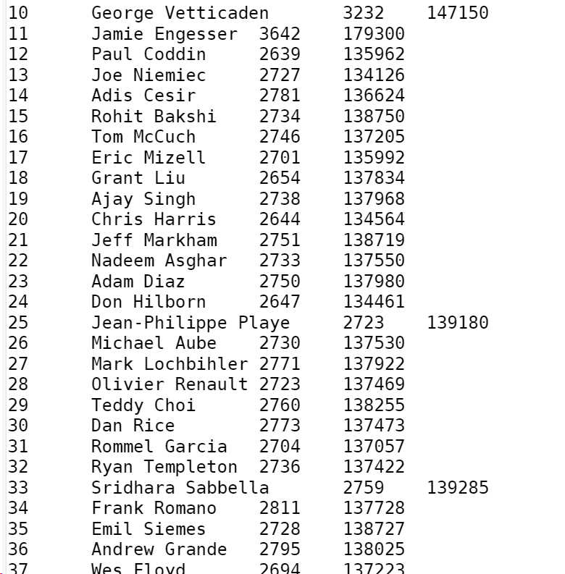

**Query:**

**Write the above query output in to hdfs directory**

hive> insert overwrite directory '/user/$USER/hive_data' row format delimited fields terminated by ',' stored a

s textfile select t.driverid ,d.name, sum(hours_logged), sum(miles_logged) from timesheet_n t join drivers_n d on t.driv

erid = d.driverid group by t.driverid ,d.name;



