**Hive Assignment 1**

**Create table Facebook:**

**Hive QL >>** create table facebook_navya(userid int,age int,dob_day int,dob_year int,dob_month int,gender string,tenure int,friend_count int,friendships_initiated int,likes int,likes_received int,mobile_likes int,mobile_likes_received int,www_likes int,www_likes_received int) ROW FORMAT DELIMITED FIELDS TERMINATED BY ‘,’ tblproperties('skip.header.line.count' = '1');



**Loading data into table facebook:**

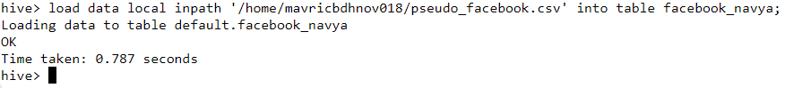

**Q1: Find out the total no of users in the dataset**

**Q2: Find out the no of users above the age of 25**

**Q3: Do male face book users tend to have more friends or female users**

hive> select gender,sum(friend_count) sum_frnd_cnt from facebook_navya where gender in ('male','female') group by gender ;

**Q4: How many likes do young people receive on facebook as opposed to old people**

**Hive QL:** select a.people , a.tot_likes from( select 'Young' as people ,sum(likes_received) as tot_likes from facebook_kavi where age <= 18 union select 'OLD' as people ,sum(likes_received) as tot_likes from facebook_navya where age > 18)a;

**Q5: Find out the count of facebook users for each birthday month**

**HIVE QL:** select count(userid), dob_month from facebook_navya group by dob_month;

**Q6: Do young members use mobile phones or computers for facebook browsing**

**HIVE QL 1: select 'Young_People' as people ,sum(mobile_likes) as Mobile_usage, sum(www_likes) as Computers_Usage from facebook_navya where age <= 18**

**HIVE QL 2: select people , greatest(Mobile_usage , Computers_Usage ) from(select 'Young_People' as people ,sum(mobile_likes) as Mobile_usage, sum(www_likes) as Computers_Usage from facebook_navya where age <= 18)a;**

**Q7: Do adult members use mobile phones or computers for facebook browsing**

**HIVE QL 1: select 'Young_People' as people ,sum(mobile_likes) as Mobile_usage, sum(www_likes) as Computers_Usage from facebook_navya where age > 18;**

**HIVE QL 2: select people , greatest(Mobile_usage , Computers_Usage ) from(select 'Young_People' as people ,sum(mobile_likes) as Mobile_usage, sum(www_likes) as Computers_Usage from facebook_navya where age > 18)a;**

