BLINKIT SALES ANALYSIS
POWER BI PROJECT
DETAILED PROJECT DOCUMENTATION

Project Information | Details
Submitted By: | U Navya
Primary Tool: | Microsoft Power BI
Supporting Tools: | Power Query, DAX, Excel / CSV
Project Type: | Sales & Business Intelligence Dashboard

GitHub: https://github.com/Navyaupparilinkdin
LinkedIn: https://www.linkedin.com/in/navya-uppari-25b8842aa

INTRODUCTION
Blinkit is a quick-commerce grocery platform where sales data can be analyzed to understand product performance, outlet performance, customer-facing ratings, and sales trends. This project uses a Power BI dashboard to present a consolidated view of Blinkit sales and outlet-related metrics.
The dashboard shown in this project brings together key business measures such as Total Sales, Average Sales, Number of Items, and Average Rating. It also provides visual analysis by Item Fat Content, Item Type, Outlet Location Type, Outlet Size, Outlet Establishment Year, and Outlet Type.
Microsoft Power BI is used to transform the underlying sales data into interactive visual information. KPI cards, donut charts, bar charts, an area/trend chart, slicers, and a summary table are used to make the analysis easier to understand.
This project demonstrates a practical business-intelligence workflow: preparing data, defining calculations, creating visuals, applying filters, identifying trends, and presenting the results through an interactive dashboard.

PROJECT OBJECTIVE
The main objective of this project is to analyze Blinkit sales data and convert the available records into meaningful business information through Microsoft Power BI.
- To understand overall sales performance through key KPI measures.
- To analyze Total Sales, Average Sales, Number of Items, and Average Rating.
- To compare sales performance across different Item Types.
- To analyze sales by Item Fat Content, including Low Fat and Regular categories.
- To compare sales across Outlet Location Types and Outlet Sizes.
- To study sales trends by Outlet Establishment Year.
- To compare performance across different Outlet Types.
- To provide interactive filtering for Outlet Location, Outlet Size, and Item Type.
- To design a professional, easy-to-understand one-page Power BI dashboard.
- To generate business insights that can be presented in a project report, portfolio, or interview.
The project combines technical Power BI skills with analytical thinking and dashboard-design practices.

DATASET & KEY FIELDS
The dashboard is based on Blinkit sales and outlet data. The screenshot provides the analyzed fields and measures visible in the final dashboard. The documentation therefore focuses on the dimensions and metrics represented in the dashboard.
Field / Dimension | Purpose in Analysis
Item Type | Analyze sales performance across product categories.
Item Fat Content | Compare Low Fat and Regular item sales.
Outlet Location Type | Compare sales across Tier 1, Tier 2, and Tier 3 locations.
Outlet Size | Analyze sales by outlet size categories.
Outlet Establishment Year | Study sales trends over outlet establishment years.
Outlet Type | Compare sales, item counts, visibility and ratings by outlet type.
Total Sales | Overall sales KPI.
Average Sales | Average sales KPI shown on the dashboard.
Number of Items | Total item-count KPI.
Average Rating | Average rating KPI.

The dashboard screenshot shows the main analytical dimensions used for the project. Exact raw-column names and source-file row counts are not assumed beyond what is visible in the supplied dashboard.

TOOLS AND TECHNOLOGIES USED
Tool / Feature | Purpose
Microsoft Power BI | Import data, create measures, build visuals, and design the interactive dashboard.
Power Query | Data preparation, transformation, and checking values before visualization.
DAX | Create calculated measures and analytical calculations where required.
Excel / CSV | Source-data preparation and storage, where applicable.
Power BI Visuals | KPI cards, donut charts, bar charts, area/trend chart, slicers, and summary table.

These tools support an end-to-end business-intelligence workflow in which data is prepared, analyzed, visualized, and presented in a single interactive report.

DATA CLEANING AND TRANSFORMATION
Data preparation is an important stage before creating a Power BI dashboard. The data should be checked for missing values, incorrect data types, inconsistent category names, and fields that require transformation.
- Reviewing the dataset structure and available columns.
- Checking missing or blank values in relevant sales, outlet, item, and rating fields.
- Checking data types for numerical, categorical, and year-related fields.
- Preparing Item Type, Item Fat Content, Outlet Location Type, Outlet Size, and Outlet Type as categorical fields.
- Preparing Outlet Establishment Year for year-based analysis.
- Ensuring sales and item-count fields can be aggregated correctly.
- Preparing fields for slicers and interactive filtering.
- Validating measures used by KPI cards and visualizations.
The purpose of these transformations is to make the data consistent and suitable for analysis so that the dashboard communicates the available sales information clearly.

DATA ANALYSIS
The dashboard provides the following headline measures visible in the supplied screenshot:
Measure | Dashboard Value
Total Sales | 1.20M
Average Sales | 140.99
Number of Items | 8.523K
Average Rating | 3.92

Additional visible analysis includes sales by outlet establishment year, item fat content, item type, outlet size, outlet location type, and outlet type.
Analysis Area | Visible Dashboard Information
Outlet Establishment Year | Sales trend with a visible peak of approximately 205K.
Item Fat Content | Comparison of Low Fat and Regular item sales.
Item Type | Ranked horizontal bar chart of item-category sales.
Outlet Size | Donut chart comparing Medium, Small, and High outlet sizes.
Outlet Location Type | Comparison of Tier 1, Tier 2, and Tier 3.
Outlet Type | Table comparing sales, number of items, item visibility, and average rating.

VISUALIZATIONS
The dashboard uses multiple visual types so that different business questions can be answered quickly.
- KPI Cards: Display Total Sales, Average Sales, Number of Items, and Average Rating.
- Area / Trend Chart: Shows Total Sales by Outlet Establishment Year.
- Donut Chart: Compares Total Sales by Item Fat Content.
- Bar Chart: Ranks Total Sales by Item Type.
- Donut Chart: Compares Total Sales by Outlet Size.
- Horizontal Bar Chart: Compares Total Sales by Outlet Location Type.
- Summary Table: Compares Outlet Type using Total Sales, Number of Items, Item Visibility, and Average Rating.
- Filters / Slicers: Allow users to interact with Outlet Location, Outlet Size, and Item Type.
Together, these visuals provide both a high-level summary and detailed comparisons across products and outlets.

POWER BI DASHBOARD
The completed dashboard is presented as a single interactive report page. The layout contains a filter panel on the left, KPI cards at the top, a sales trend on the upper-right, detailed category analysis in the center, and outlet-level comparisons at the bottom.
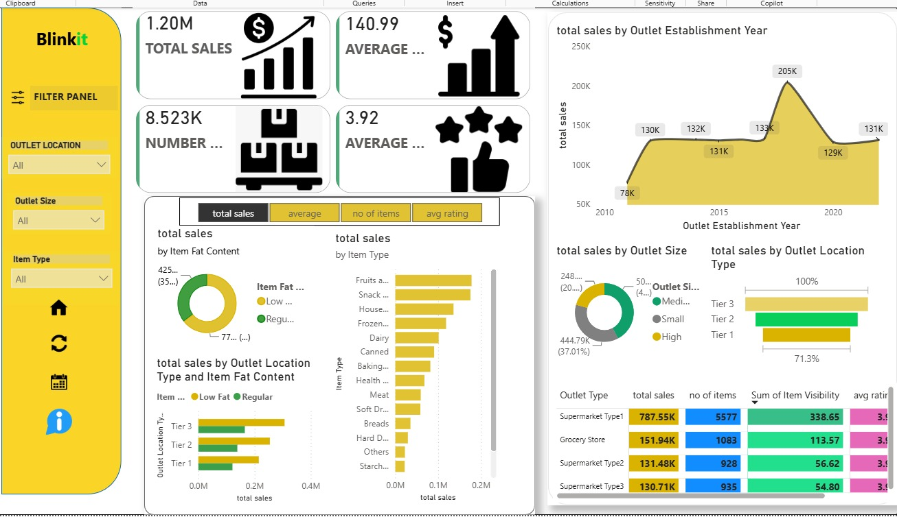
Figure: Blinkit Sales Analysis Power BI Dashboard

KEY INSIGHTS
- The dashboard reports Total Sales of approximately 1.20M.
- Average Sales is shown as 140.99.
- The Number of Items KPI is shown as approximately 8.523K.
- Average Rating is shown as 3.92.
- The Outlet Establishment Year trend shows sales changing over time, with a visible peak of approximately 205K in the chart.
- The dashboard compares Low Fat and Regular item sales through a donut chart.
- Item Type sales are ranked through a horizontal bar chart, allowing higher- and lower-performing categories to be compared.
- Outlet Size analysis compares Medium, Small, and High outlets.
- Outlet Location Type analysis compares Tier 1, Tier 2, and Tier 3 locations.
- The Outlet Type table provides a combined view of sales, item count, item visibility, and average rating.
These observations are taken from the values and visual patterns visible in the supplied dashboard screenshot.

CONCLUSION
The Blinkit Sales Analysis project demonstrates a practical application of Microsoft Power BI for sales analysis and business-intelligence reporting. The dashboard brings together key sales KPIs with product, outlet, location, size, rating, and establishment-year analysis.
The project demonstrates important skills including data preparation, Power Query transformation, DAX-based calculations, visual selection, dashboard formatting, interactive filtering, and insight generation.
The final dashboard provides a compact and interactive way to explore sales performance rather than relying on raw records alone. It can be presented as an academic project, portfolio project, or demonstration of Power BI and data-analysis skills.
Possible future improvements include adding drill-through pages, tooltip pages, more advanced DAX measures, additional time-based analysis, and deeper product- and outlet-level analysis.

PROJECT SUMMARY
Project Item | Details
Project Name | Blinkit Sales Analysis
Primary Tool | Microsoft Power BI
Supporting Tools | Power Query, DAX, Excel / CSV
Main KPIs | Total Sales, Average Sales, Number of Items, Average Rating
Main Analysis Areas | Item Type, Item Fat Content, Outlet Type, Outlet Size, Outlet Location Type, Outlet Establishment Year
Dashboard Status | Completed
Submitted By | U Navya

GitHub: https://github.com/Navyaupparilinkdin
LinkedIn: https://www.linkedin.com/in/navya-uppari-25b8842aa?utm_source=share_via&utm_content=profile&utm_medium=member_android

End of Project Documentation

