Project 3 – Data Related Job Market

Team Members: Kelvin Deng, Thao Hoang, Yijing Su, May Ang

Github Page: <https://github.com/Navyhoang/Project2-DataJobs-App>

# Project Purpose:

To aid job seekers with a tool to better understand the tech industry in various parts of the world. This includes the present job demand for data related roles such as Data Scientist, Data Engineer, Data Analyst, and Machine Learning roles. This tool will also include mental health survey responses to provide some insight into the work-life balance, which is an important factor in picking a job. The project scope includes job postings in Canada, United States, Singapore, and the United Kingdom.

# Data Sources:

1. Web scrapping from Indeed (for Canada, US, Singapore, and UK) [indeed.com]
2. Mental Health survey [https://www.kaggle.com/osmi/mental-health-in-tech-survey]
3. University data [https://www.kaggle.com/mylesoneill/world-university-rankings]
4. API for coordinates

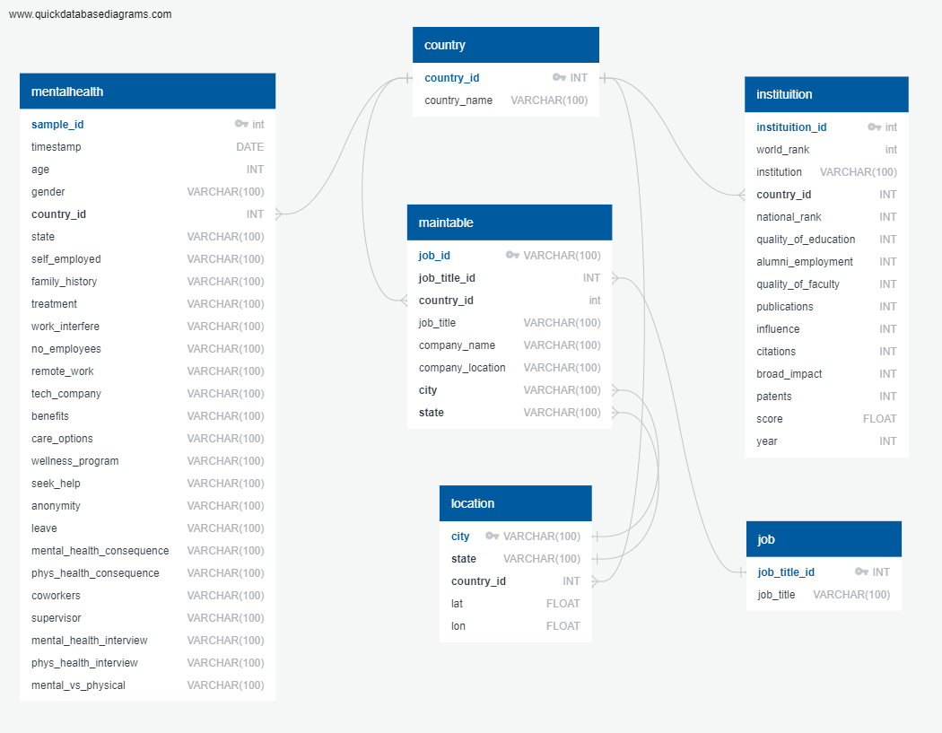

# Proposed Views

1. Heat map to show job demand / postings – *interactive (layer control)*
   * Different layers for various job roles, include option for all roles as well
   * Markers for where the universities are (tooltip for ranking)
   * Example:

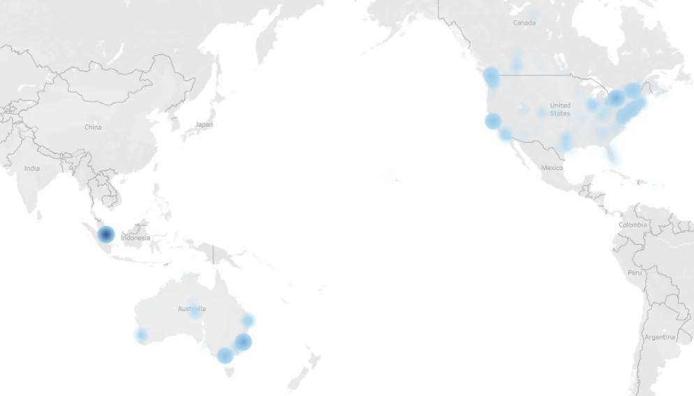

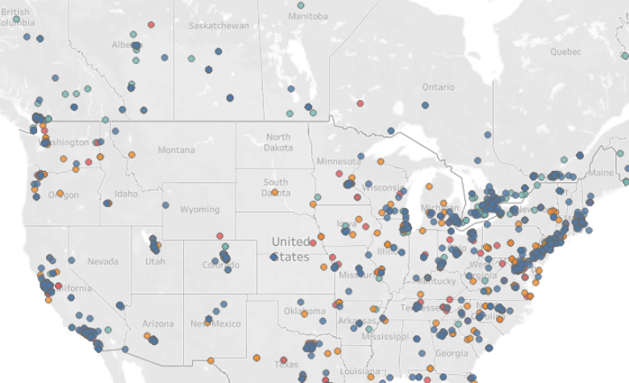

1. Gauge indicators to show mental health survey responses (based on location (country/state)) – *interactive (drop down menu)*
   * Remote work (out of 100%)
   * Benefits (out of 100%)
   * Wellness program (out of 100%)
   * Example:

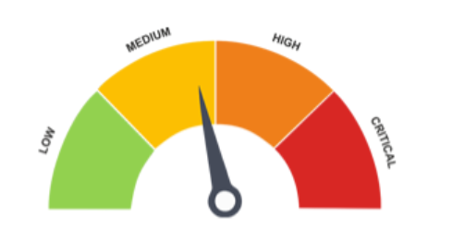

1. Bubble chart (<https://observablehq.com/@d3/bubble-chart>) – *interactive (drop down menu)*
   * Leave (is it easy to take leave?) – they have 5 types of responses so we can use the bubble chart to show the most common response in different countries / states
   * Work interfere (5 responses) ** check with data source what this means
   * Type of job roles in specific countries
   * Example:

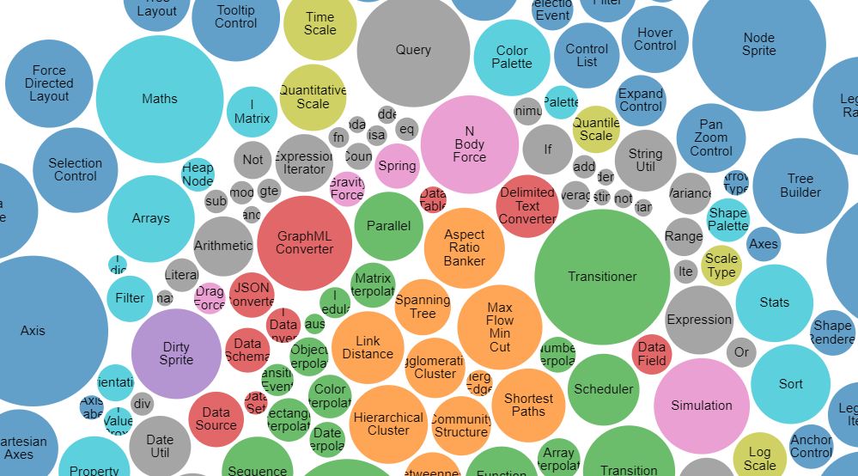

1. Stacked bar chart (based on all, countries) – *interactive (drop down menu)*
   * Show different province/state and the different job roles stacked
   * Example:

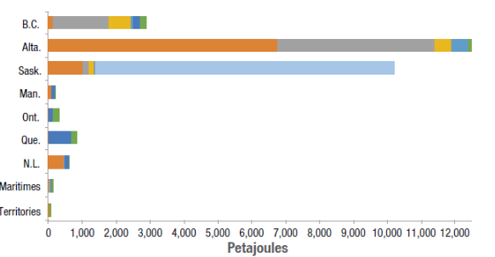

View 2, 3, and 4 will located in the dashboard, which will include a card with a summary of all the information.

