**INTI International College Penang School of Computing**

**3+0 Bachelor of Science (Hons) in Computer Science, in collaboration with Coventry University, UK**

**3+0 Bachelor of Science (Hons) in Computing, in collaboration with Coventry University, UK**

**Coursework cover sheet**

**Section A - To be completed by the student**

| Full Name: Nawa Silumelume Mubukwanu | |
| --- | --- |
| CU Student ID Number:  INTI Student ID Number: P23014801 | |
| Session: April 2023 | |
| Lecturer: **Puteri Nursyawati Azzuri (puteri.azzuri@newinti.edu.my)** | |
| Module Code and Title:  **4067CEM Software Design** | |
| Assignment No. / Title:  Continuous Assessment | % of Module Mark:  50 |
| Hand out date: 12 May 2023 | Due date:  Task 1: 02 June 2023, by 11.59pm.  Task 2: 07 July 2023, by 11.59pm  Task 3: 23 June 2023, by 11.59pm.  Task 4: 23 June 2023, by 11.59pm.  Task 5: 23 June 2023, by 11.59pm. |
| Penalties: No late work will be accepted. If you are unable to submit coursework on time due to extenuating circumstances, you ay be eligible for an extension. Please consult the lecturer. | |
| Declaration: I/we the undersigned confirm that I/we have read and agree to abide by the University regulations on plagiarism and cheating and Faculty coursework policies and procedures. I/we confirm that this piece of work is my/our own. I/we consent to appropriate storage of our work for plagiarism checking.  Signature(s): -------------------------------------- | |

**TASK 1:**

**User Story Mapping**

**1.1 Introduction**

User story mapping is a planning and visual exercise that enables a product development team to effectively implement the tasks within a feature development backlog. It serves as a means of organizing sprint tasks and can be likened to arranging the steps of a user persona's journey towards accomplishing their goal, bringing structure to the development sequence. Additionally, it serves as a valuable tool for organizing user stories within sprints (Downs, 2020).

Despite its name, user story mapping does not resemble an actual map; rather, it bears closer resemblance to a kanban board. It visually represents the natural progression of tasks and steps involved in user stories. The process involves using columns of digital cards or physical sticky notes on a whiteboard, arranged in a table or panel format, to illustrate the flow of development activities (Downs, 2020).

**1.2 Tools**

**Figma**

Figma is a widely used cloud-based design and prototyping tool for creating user interfaces, designs, and interactive prototypes. It provides designers, product teams, and developers with a range of features to streamline the design process and support collaboration. Figma operates entirely in the cloud, enabling users to access their designs from any internet-connected device (Figma, n.d.).

Figma was used to create the story map.

**Google Forms**

Google (n.d.) describes Google Forms as a free online tool within the Google Workspace suite that allows users to create customizable surveys, questionnaires, and forms for data collection purposes. Users can incorporate various question types and visual elements into their forms, personalize them with themes, images, and formatting options, and distribute them via links, email, or embedding on websites. Respondents can conveniently complete the forms on any internet-connected device.

Google Forms was used to collect the user stories used to create the story map.

**1.1 User Stories**

1. As a seller, I want to create a seller profile on the application so that I can showcase and sell my products to fellow students.
2. As a seller, I want to easily upload product images and provide detailed descriptions for my listings so that buyers can get a clear understanding of what they're purchasing.
3. As a seller, I want to be able to set my own prices for the products I list and have the option to negotiate or offer discounts to potential buyers.
4. As a seller, I want to receive notifications when a buyer expresses interest in my product or makes an offer so that I can respond promptly.
5. As a seller, I want to have access to analytics and insights about the performance of my listings, such as views and sales, so that I can improve my selling strategy.
6. As a seller, I want the ability to easily manage and update my product listings, including editing descriptions, adding new items, or marking items as sold.
7. As a seller, I want to have the option to promote my listings or highlight featured products to increase visibility and attract more potential buyers.
8. As a seller, I want to have a messaging system within the application to communicate with buyers, answer questions, and negotiate prices.
9. As a seller, I want to have a secure and reliable payment system that ensures timely and hassle-free transactions with buyers.
10. As a seller, I want to have the option to track and manage orders, including marking items as shipped, providing shipping details, and receiving feedback from buyers.

**1.1 User Story Map**

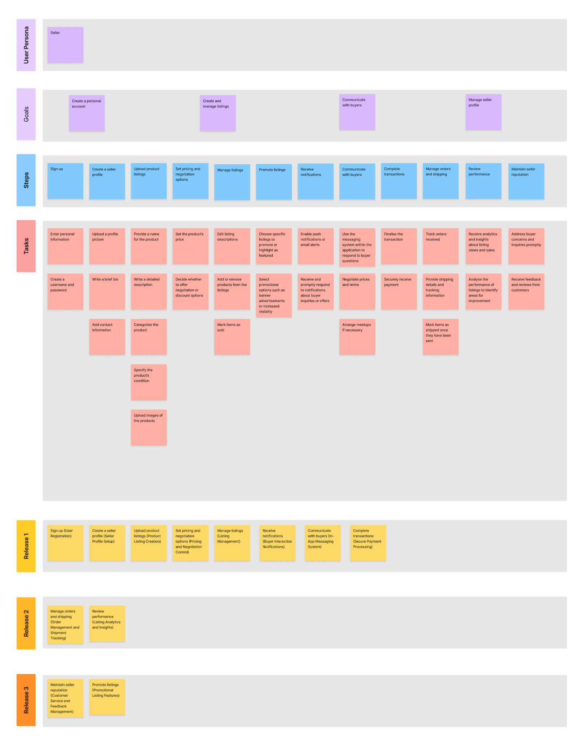

**References**

*The Collaborative Interface Design Tool.* (no date) *Figma*. Available at: https://www.figma.com/ (Accessed: 04 June 2023).

Downs, J. (2020) ‘What is user story mapping: tools and techniques’, *Justinmind*, 23 October. Available at: https://www.justinmind.com/blog/user-story-mapping/ (Accessed: 04 June 2023).

*Get insights quickly, with Google Forms* (no date) *Google forms: Online form creator | google workspace*. Available at: https://www.google.com/forms/about/ (Accessed: 04 June 2023).