**INTI International College Penang School of Computing**

**3+0 Bachelor of Science (Hons) in Computer Science, in collaboration with Coventry University, UK 3+0 Bachelor of Science (Hons) in Computing, in collaboration with Coventry University, UK**

# Coursework cover sheet

**Section A - To be completed by the student.**

| Full Name:  **Nawa Silumelume Mubukwanu** | |
| --- | --- |
| CU Student ID Number:  **14008784** | |
| Semester:  2 | |
| Session:  **April 2023** | |
| Lecturer:  **Puteri Nursyawati Azzuri (puteri.azzuri@newinti.edu.my)** | |
| Module Code and Title:  **4067CEM Software Design** | |
| Assignment No. / Title:  **Continuous Assessment** | % of Module Mark:  **50** |
| Hand out Date:  **12 May 2023** | Due Date:  **Task 1: 02 June 2023, by 11.59pm.**  **Task 2: 07 July 2023, by 11.59pm**  **Task 3: 23 June 2023, by 11.59pm.**  **Task 4: 23 June 2023, by 11.59pm.**  **Task 5: 23 June 2023, by 11.59pm.** |
| Penalties: No late work will be accepted. If you are unable to submit coursework on time due  to extenuating circumstances, you may be eligible for an extension. Please consult the lecturer. | |
| Declaration: I/we the undersigned confirm that I/we have read and agree to abide by the University regulations on plagiarism and cheating and Faculty coursework policies and procedures. I/we confirm that this piece of work is my/our own. I/we consent to the appropriate storage of our work for plagiarism checking.    Signature(s): | |

# Section B - To be completed by the module leader

| Intended learning outcomes assessed by this work:   1. Understand and apply appropriate concepts, tools, and techniques to each stage of the software development. 2. Understand and apply design patterns to software components in developing new software. 3. Demonstrate an understanding of project planning and working to agreed deadlines, along with professional, interpersonal skills and effective communication required for software production.   5. Demonstrate an awareness of, and ability to apply, social, professional, legal, and ethical standards as documented in relevant laws and professional codes of conduct such as that of  the Malaysian National Computer Confederation. | | |
| --- | --- | --- |
| Marking scheme | Max | Mark |
| 1. User Story Mapping | 20 |  |
| 2. Setting up a GitHub |  |
| Repository | 10 |
| 3. Creating a Class diagram and |  |
| design pattern selection | 30 |
| 4. Creating a Prototype User |  |
| Interface and Usability Testing | 20 |
| 5. Discuss the ethical issue |  |
| related to the software | 20 |
| Total | 100 |  |

**Task 4: Creating Prototype Interface and Usability Testing**

# 4.1 Introduction

# 

This task explores the importance of user interface prototyping in the design process of a student business application. It also introduces key elements of the user interface, including the create listing page and messaging page, highlighting their user-friendly interfaces and functionalities.

# 4.2 User Interface Prototype

# Prototypes are an essential part of designing user flows and interfaces. They allow designers to show their design through an interactive and engaging product, resulting in a better understanding of the design for everyone involved (Beaubien, 2021).

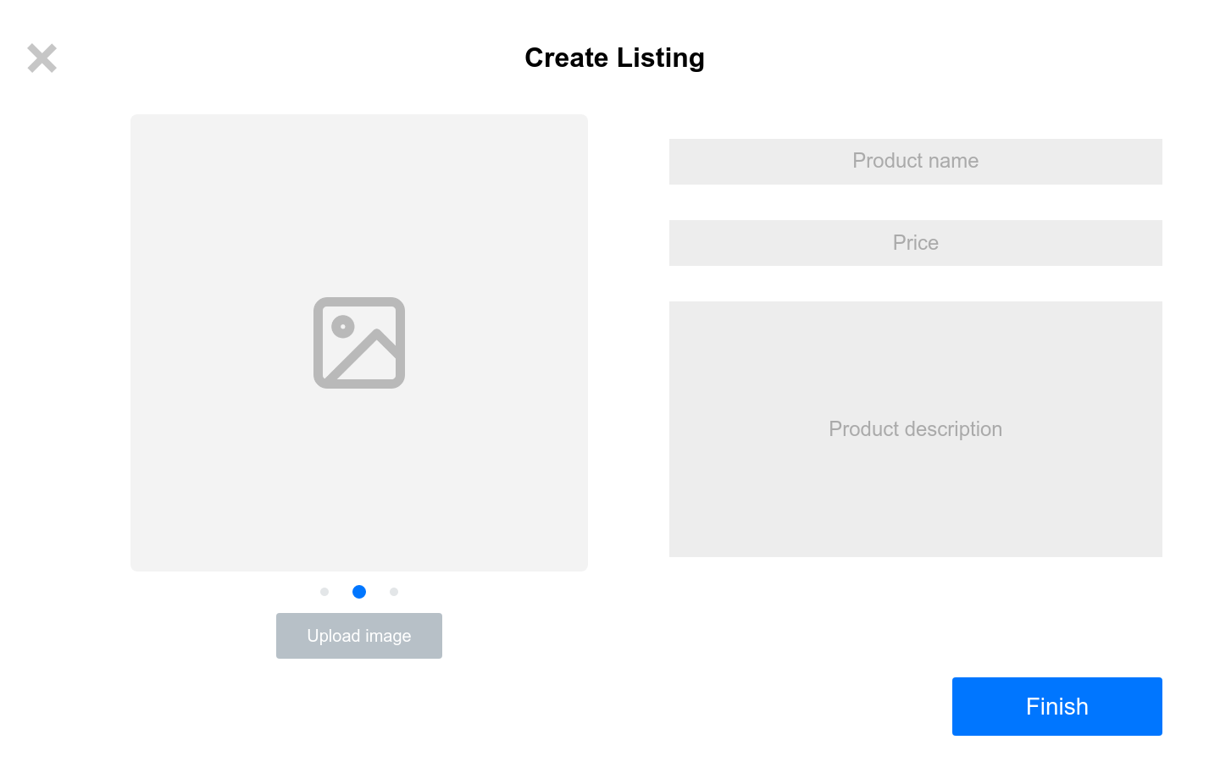

### Figure 4.2.1 shows the create listing page

The create listing page provides a user-friendly interface for users to input and submit information about an item or service they want to list. It enables users to accurately describe and showcase their listing, facilitating effective communication and transactions on a platform or marketplace.

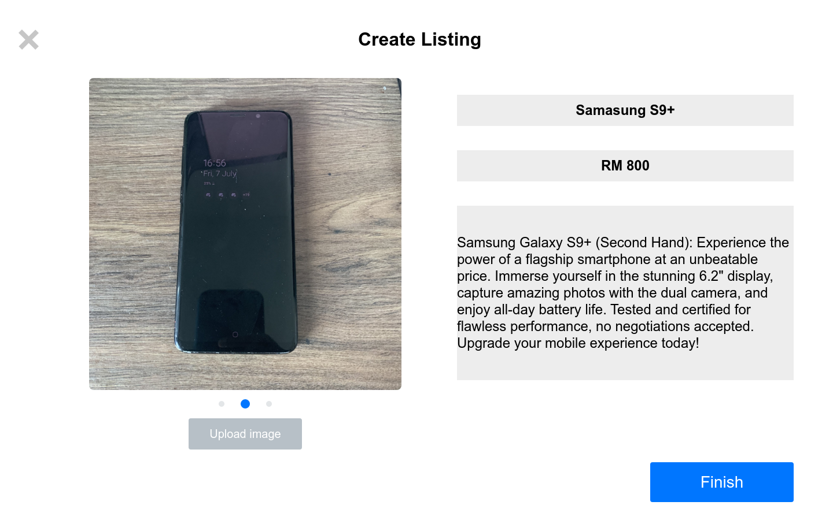

### Figure 4.2.2 shows the create listing page with the input fields filled in

Figure 4.2.2 depicts the functionality of the create listing page, displaying the input fields accurately populated with relevant information. As stated earlier, this functionality enables users to conveniently input details such as item description, price, images, and other specifications, facilitating a seamless and efficient process for creating comprehensive listings.

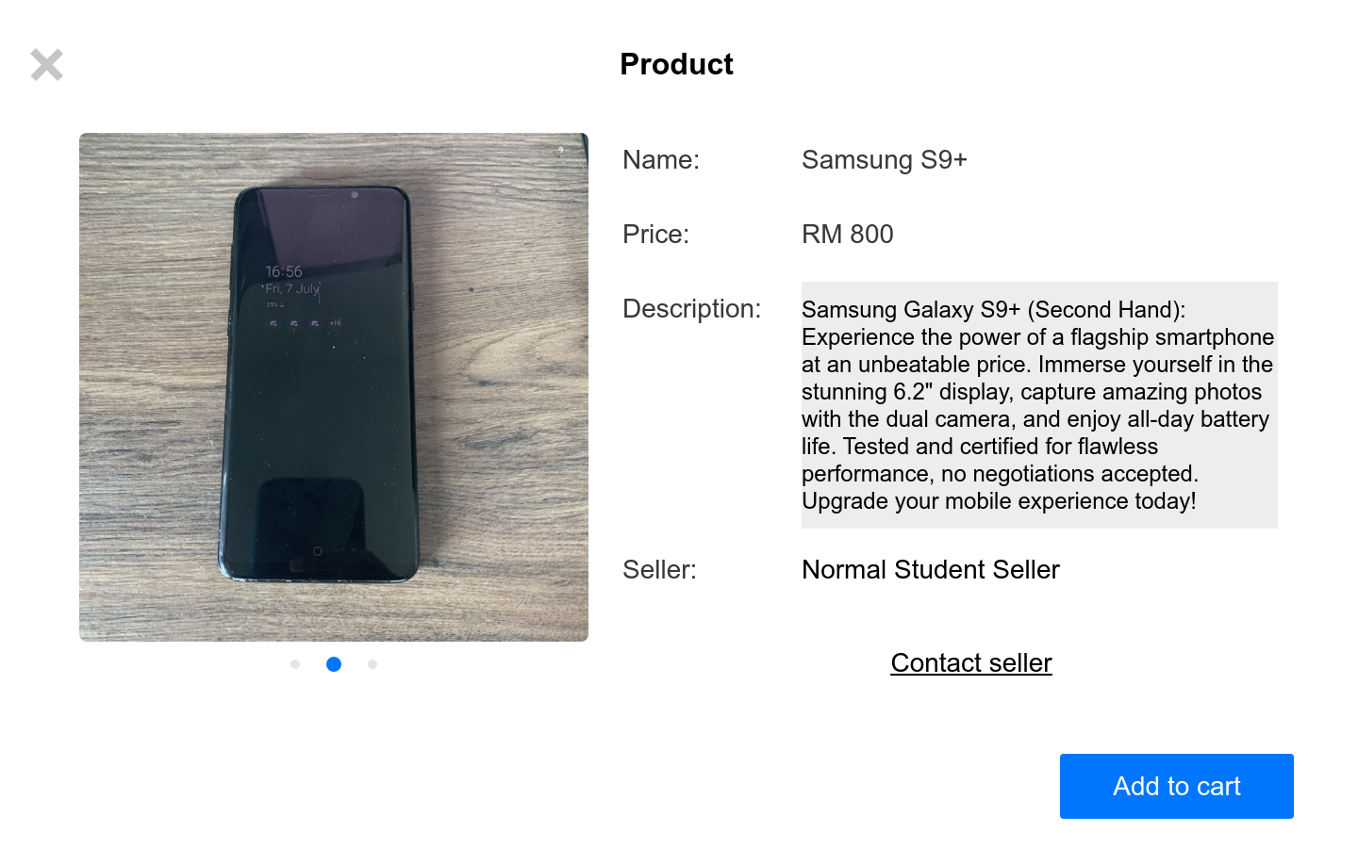

### Figure 4.2.3 shows the product page from a customer perspective

The product page provides a customer perspective, showcasing the recently created listing in all its detail. Customers can now access comprehensive information about the product, including its description, price and images. This enables them to make informed purchasing decisions and engage with the listing in a meaningful way.

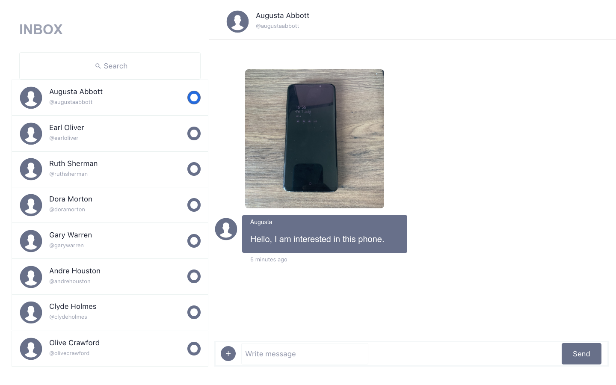

### Figure 4.2.4 shows the messaging page

The figure above depicts a platform where sellers and customers can engage in direct communication. It offers an interface for exchanging messages, inquiries, and negotiations. This functionality fosters seamless interaction, allowing sellers to address customer queries and concerns, ultimately enhancing the overall customer experience and facilitating successful transactions.

# 4.3 Usability Testing

# 

Usability testing, also referred to as User Experience (UX) testing, is a technique used to assess the ease of use and user-friendliness of a software application. This method involves a select group of end-users who interact with the application to identify any usability issues. The primary emphasis of usability testing lies in evaluating the user's ability to navigate the application, the effectiveness of its controls, and its capacity to achieve its intended goals (Hamilton, 2023).

## 4.3.2 Usability Testing Questions

Here are 15 usability testing questions for a student business app, along with the aspects they are testing for:

1. What is your first impression of the app's homepage?

* Overall app impression

2. Can you easily navigate to the page where you can create a seller profile?

* Navigation and user flow

3. How intuitive is the process of uploading product images and providing descriptions?

* Listing creation usability

4. Can you find the option to set prices and apply discounts for your products easily?

* Pricing management usability

5. How clear and visible are the notifications for buyer interest or offers?

* Notification visibility and comprehension

6. Can you access analytics and insights about your listings' performance easily?

* Analytics accessibility

7. Is it easy to manage and update your product listings, including editing descriptions and marking items as sold?

* Listing management usability

8. Can you find the option to promote or feature your listings for increased visibility?

* Listing promotion usability

9. How easy is it to communicate with buyers, answer questions, and negotiate prices through the messaging system?

* Messaging usability

10. Is the payment system secure and reliable for hassle-free transactions?

* Payment system reliability

11. Can you easily track and manage orders, including marking items as shipped and providing shipping details?

* Order management usability

12. How clear and comprehensive are the order tracking and feedback features for buyers?

* Order tracking usability

13. Is the search functionality effective in helping you find relevant products?

* Search usability

14. Can you easily filter and sort products based on different criteria, such as price or category?

* Filtering and sorting usability

15. How user-friendly is the overall app design and interface?

* General app usability

# 4.4 Conclusion

# 

# In conclusion, user interface prototyping and usability testing are vital components of designing a successful student business application. Through the creation of interactive prototypes, designers can effectively communicate their design ideas and gather feedback for refinement. Usability testing helps identify any usability issues, ensuring that the app is intuitive, user-friendly, and capable of meeting its goals. By continuously improving the user interface based on user feedback, the student business app can provide an optimal user experience, fostering successful transactions and user satisfaction.

# 

# 

# REFERENCES

Beaubien, S. (2021) *An awesome guide to prototyping in User Interface Design*, *CareerFoundry*. Available at: https://careerfoundry.com/en/blog/ui-design/the-value-of-prototyping-in-ui-design/ (Accessed: 07 July 2023).

Hamilton, T. (2023) *What is usability testing? software UX*, *Guru99*. Available at: https://www.guru99.com/usability-testing-tutorial.html (Accessed: 07 July 2023).