CSA06507 – GENERATIVE AI
UNIT I – LAB PROGRAMS
Fundamentals of Generative AI and Large Language Models
Name: ____________________ Register No.: ____________________
Each experiment includes Aim, Program, Input, Output and Result.

1. Install and Configure Python, Jupyter/Colab and AI Libraries
AIM: To verify the Python environment and install NumPy, Pandas, Transformers and PyTorch.

PROGRAM / PROMPT
# Run in Google Colab or Jupyter
!pip -q install numpy pandas transformers torch

import sys, numpy, pandas, torch, transformers
print("Python:", sys.version.split()[0])
print("NumPy:", numpy.__version__)
print("Pandas:", pandas.__version__)
print("PyTorch:", torch.__version__)
print("Transformers:", transformers.__version__)

INPUT
Use the sample text, data or model specified in the program.

OUTPUT
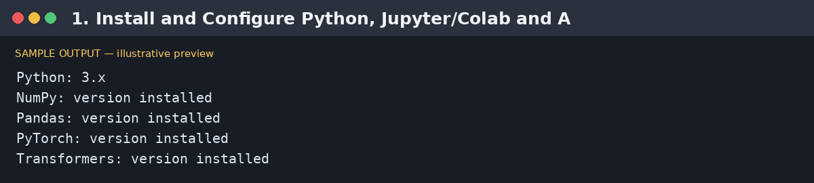
Illustrative sample output — replace with your actual execution screenshot if required.

RESULT
The Python environment was configured and the required AI libraries were imported successfully.

2. Explore Hugging Face and Load a Pre-trained Transformer
AIM: To load a pre-trained sentiment-analysis pipeline from Hugging Face and classify a sample sentence.

PROGRAM / PROMPT
!pip -q install transformers torch

from transformers import pipeline
classifier = pipeline("sentiment-analysis")
text = "Generative AI makes learning more interactive."
print(classifier(text))

INPUT
Use the sample text, data or model specified in the program.

OUTPUT
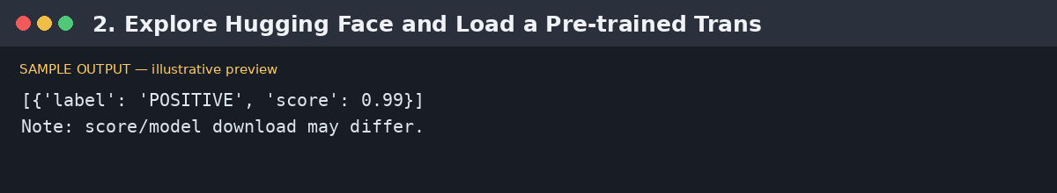
Illustrative sample output — replace with your actual execution screenshot if required.

RESULT
A pre-trained transformer model was loaded and used to analyze text.

3. Tokenization Using BERT and GPT Tokenizers
AIM: To tokenize the same sentence using BERT and GPT-2 tokenizers and compare token outputs.

PROGRAM / PROMPT
!pip -q install transformers

from transformers import AutoTokenizer
text = "Generative AI is useful!"

bert = AutoTokenizer.from_pretrained("bert-base-uncased")
gpt = AutoTokenizer.from_pretrained("gpt2")

print("BERT tokens:", bert.tokenize(text))
print("GPT-2 tokens:", gpt.tokenize(text))

INPUT
Use the sample text, data or model specified in the program.

OUTPUT
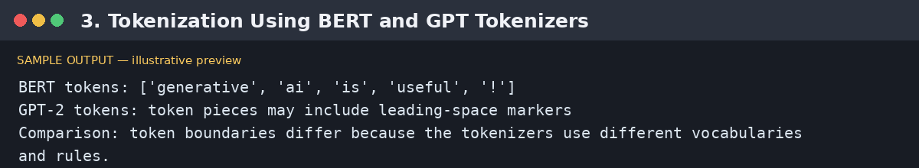
Illustrative sample output — replace with your actual execution screenshot if required.

RESULT
BERT and GPT tokenization were performed and their token boundaries were compared.

4. Generate Contextual Embeddings Using a Transformer
AIM: To generate contextual token embeddings for a sentence using a pre-trained BERT model.

PROGRAM / PROMPT
!pip -q install transformers torch

import torch
from transformers import AutoTokenizer, AutoModel

name = "bert-base-uncased"
tokenizer = AutoTokenizer.from_pretrained(name)
model = AutoModel.from_pretrained(name)
text = "AI supports engineering applications."
inputs = tokenizer(text, return_tensors="pt")
with torch.no_grad():
outputs = model(**inputs)
print("Input tokens:", tokenizer.convert_ids_to_tokens(inputs["input_ids"][0]))
print("Embedding shape:", tuple(outputs.last_hidden_state.shape))

INPUT
Use the sample text, data or model specified in the program.

OUTPUT
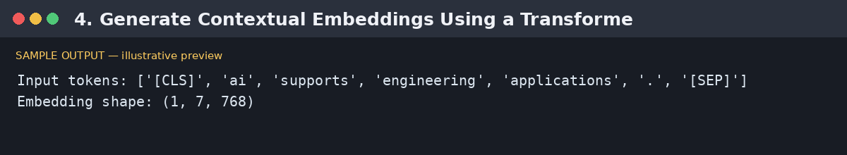
Illustrative sample output — replace with your actual execution screenshot if required.

RESULT
Contextual embeddings were generated for the input tokens.

5. Text Generation Using a Pre-trained Large Language Model
AIM: To generate text from a prompt using a small pre-trained text-generation model.

PROGRAM / PROMPT
!pip -q install transformers torch

from transformers import pipeline
generator = pipeline("text-generation", model="distilgpt2")
prompt = "Artificial intelligence in education"
result = generator(prompt, max_new_tokens=40, num_return_sequences=1,
do_sample=True, pad_token_id=50256)
print(result[0]["generated_text"])

INPUT
Use the sample text, data or model specified in the program.

OUTPUT
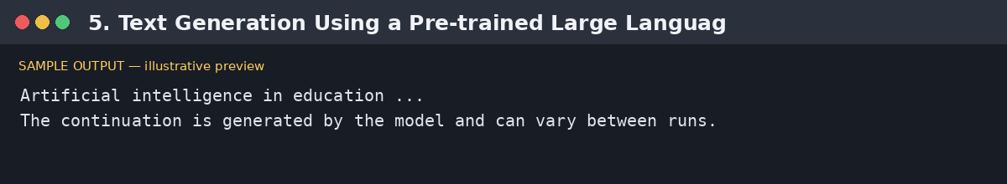
Illustrative sample output — replace with your actual execution screenshot if required.

RESULT
Text was generated from a user-provided prompt using a pre-trained language model.

