
Al-Yamamah University
College of Engineering and Architecture
Department of Software Engineering

A N K Digital Library
Prepared by:

(Abdulrahman Bakilah) (202311481)
(Khaled Alhazmi)(2024)
(Nawaf Al-Zunidi)(202221108)
CIS 201 Fundamentals of Web Design
(Ms.Sara alsabeg)

Introduction

In our digital library, we showcase some of the world’s most famous books with the aim of spreading knowledge.
Enjoy a wide variety of books on self-development, understanding others, how the world works, and more.
This library project was created by students who love learning web design under the supervision of Ms. Sara Alsabeg.
Pages Layout:
Color Scheme:
Color | Hexadecimal Value | Used For
 | #000000 & #FFFFFF | Font
 | #6a3500 | Nav menu
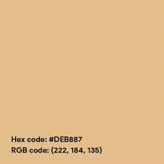 | #deb887 | Background
 | #5C4033 | Header
 | #5C4033 | Footer
Table : Color Scheme
The fonts mainly used are font-family: 'Segoe UI', Tahoma, Geneva, Verdana, sans-serif;
, including all of their variations.
All the pages are connected via the Header. The footer has the contact us information.

Page Hierarchy:
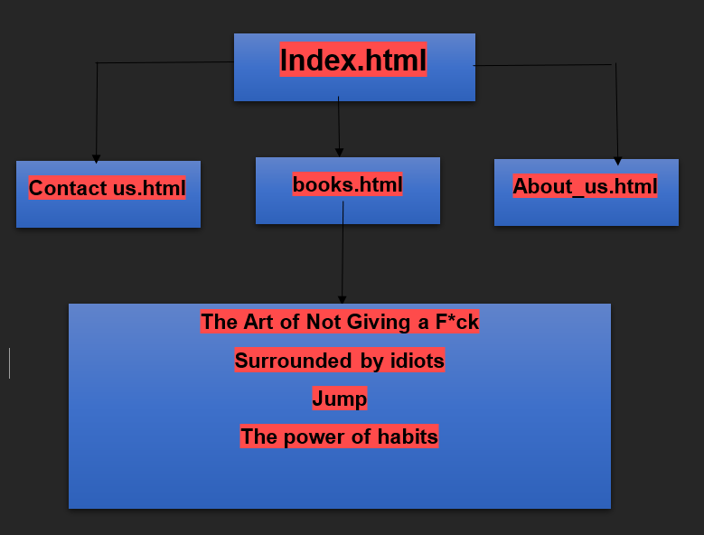

Index Page (Home Page):
The homepage includes a header, a footer, a brief introduction to the library, and several customer reviews.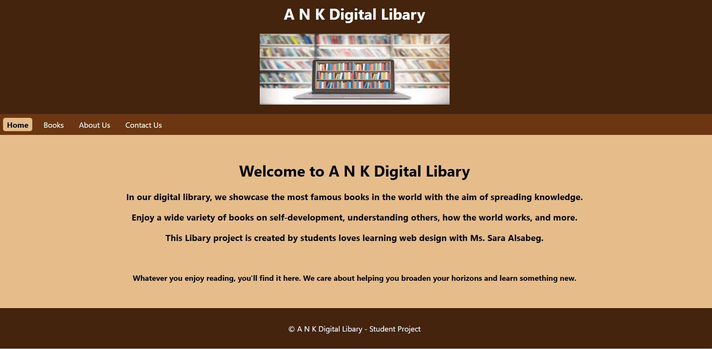

Books Page:
Initial design for the Products page:
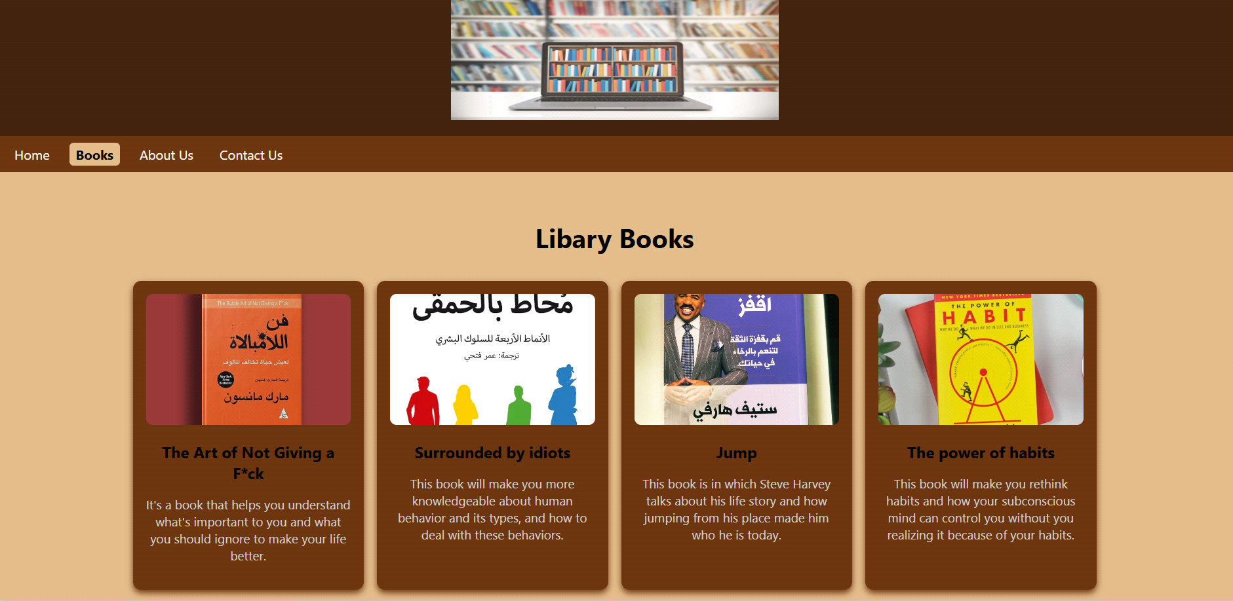

About Me Page

About us Page
We are three students who love programming and reading books, and we hope to inspire as many people as possible through our work. This project reflects our interests and our desire to share useful knowledge with others.

Education:
We are currently studying Software Engineering at Al-Yamamah University (2022–present). Our studies help us build our skills, learn new technologies, and apply what we learn to real projects like this digital library.

Skills:
- JAVA
- HTML
Contact Info:
Abdulrahman Bakilah
+966 538118282
ar.bakilah@outlook.com

Hobbies:
Reading books and Programming
External Links:
For Bootstrap:
<link rel="stylesheet" href="https://stackpath.bootstrapcdn.com/bootstrap/4.3.1/css/bootstrap.min.css" integrity="sha384-ggOyR0iXCbMQv3Xipma34MD+dH/1fQ784/j6cY/iJTQUOhcWr7x9JvoRxT2MZw1T" crossorigin="anonymous">
<script src="https://kit.fontawesome.com/81d205404b.js "crossorigin="anonymous"></script>

For CSS:
<link rel="stylesheet" href="mySheet.css">
<link rel="stylesheet" href="sss3">
<link rel="stylesheet" href="sss">

For JS:
<script src="../src/js/JavaScript.js"></script> Products Display code + Cart counter

