2022-2023

INTRODUCTION TO DATABASE

CCCS-215

Group Members:

**Airline Database Management**

***Abstract:***

An airline management system is considered with providing flight that are well scheduled and accurate. Where a passenger can book a flight and have specific tickets for each passenger in different airlines. Furthermore, database is essential to store data and manage flights accurately due to its criticality and mistakes could cost lives. Additionally, managing staff, passengers, and private information are also necessary.

**Current Situation and Problems**

**Availability of flights**  
Previously, there was no organization with data. There was a loss of time, effort, and money until we get the reservation, but now with Airline Management System. Thanks to its organized mechanisms. It allowed us to book with ease and more quality.  
  
**Flight monitoring**  
Before the system, the process of landing and taking off the planes was difficult to organize and required a lot of effort and a high cost of money.  
But after organizing it, it became less expensive, easier to organize, and less mistakes.  
  
**Staff Management**  
There was difficulty in communicating and linking employees and management in different departments.  
And it was causing delays in some cases and difficulties in rectifying them. But with the system even when mistakes occur. Remedy of it became simple, gaps are few and the organization became easier to provide a distinctive experience for the passengers.

**System Requirements:**

***Product requirement:***

- The Airline Management system shall be always available to all airlines. Downtime must not exceed 5 seconds in any one day and must be announced beforehand within 6 hours.

- The system must allow customers to book, modify, and cancel a flight before 3 days of the flight.

- The system must never have more than one aircraft on a route.

- The user must be able to add or update details of user’s name, phone number, email, and address.

- The customer shall be able to view a list of available flights and price, booked flights.

***Organizational requirement:***

- Customers shall authenticate themselves using their Passport numbers and 9-lengthed password.

- Staff members shall authenticate themselves using their Salary ID and 12-lengthed password

***External requirement:***

- The system must follow Saudi National Cybersecurity Authority (Saudi NCA) regulation.

- Risk assessment must be held every 3 months to ensure the safety of data.

**Entity:**

1- FLIGHT:

Flight is the method or the way that we use to move a person or an object through a space using an airplane.

2-AIRPLANE:

Fixed-wing aircraft that is propelled forward by thrust from a jet engine, propeller, or rocket engine.

3-SCHEDULE:

A way to manage the data through a fixed time.

4-ROUTE:

Carefully studied way a flight takes to move from a place to another safely.

5-PASSENGER:

Any person that booked a flight.

6-BOOKING:

A method that allows a passenger to go through an airplane to a specific place.

7-TERMINAL:

A huge place with multiple services to arrange the passenger going to their flight.

8-AIRLINES:

An organization providing a regular public service of air transport on one or more routes.

9-STAFF:

Any member of a ground crew or cabin crew and serve at airline companies.

10-DEPENDENCE:

Anything that is related to the staff relatives.

**E-R DIAGRAM**

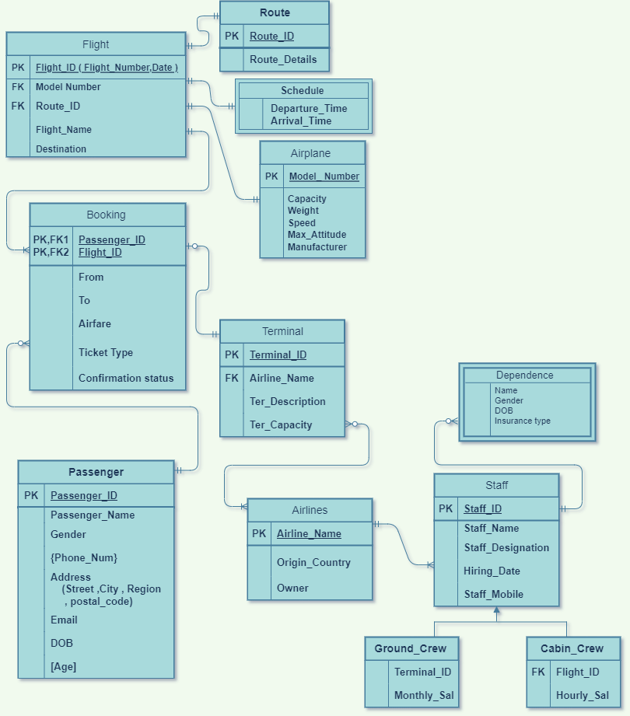

**RELATIONAL MODEL WITH NORMALIZATION**

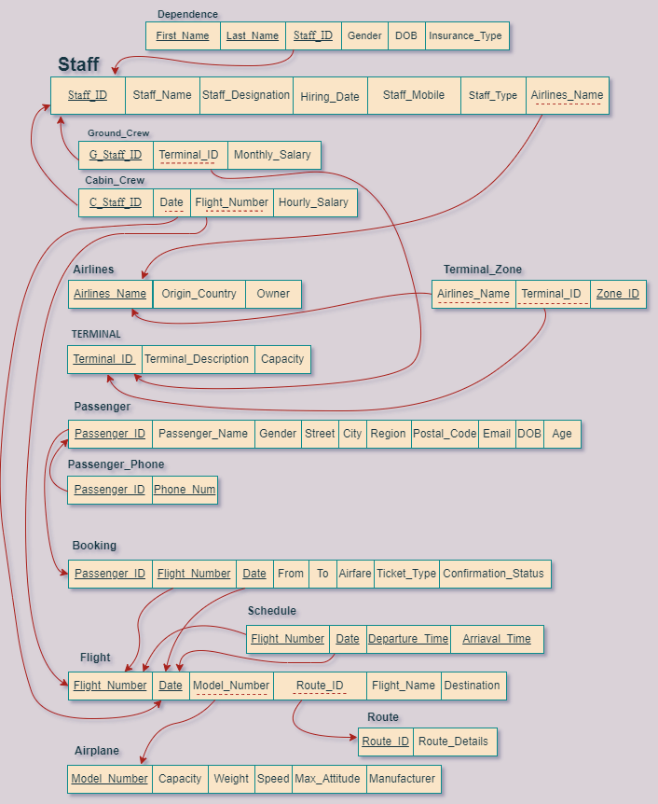

The **1NF** ( First normal form ) Any multivalued attributes have been removed .

The **2NF** (Second normal form) all non-key attributes are fully functionally dependent on the entire key (partial dependency has been removed).

The **3NF** (Third normal form) Any transitive dependencies have been removed.

**PHYSICAL AND IMPLEMENTATION**

CREATE AND INSERT CODE:

CREATE TABLE Passenger(Passenger_ID number primary key, Passenger_Name varchar2(20) not null, Gender varchar2(1) not null,

Street varchar2(20), City varchar2(15) not null, Region varchar2(15) not null, Postal_Code number(5),

Email varchar2(25) not null, DOB date not null);

Insert into Passenger Values(1111,'sameer', 'm', 'first street', 'jeddah','makkah',12345,'notsam@uj.com', date '2001-1-1');

Insert into Passenger Values(2222,'afnan', 'f', 'seconed street', 'jeddah','makkah',12345,'notafn@uj.com', date '2002-2-2');

Insert into Passenger Values(3333,'khalid', 'm', 'third street', 'Khobar','dammam',23456,'notkha@uj.com', date '2003-3-3');

Insert into Passenger Values(4444,'asmaa', 'f', 'forth street', 'Khobar','dammam',23456,'notasm@uj.com', date '2005-5-5');

Insert into Passenger Values(5555,'ahmed', 'm', 'fifth street', 'Dhahran ','dammam',34567,'notahm@uj.com', date '2005-5-5');

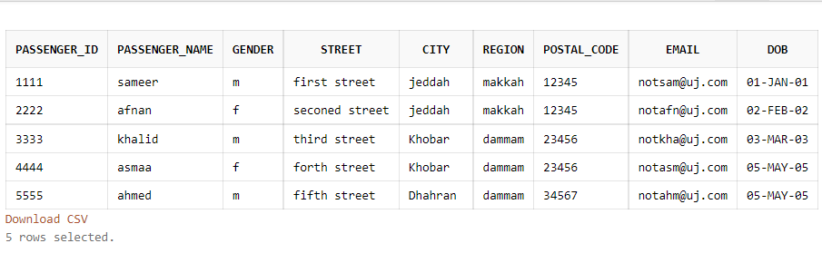

CREATE TABLE Passenger_Phone(Pass_ID, Phone_Num number(10) not null,

foreign key (Pass_ID) references Passenger(Passenger_ID) on delete CASCADE);

Insert into Passenger_Phone values(1111,0511111111);

Insert into Passenger_Phone values(2222,0522222222);

Insert into Passenger_Phone values(3333,0533333333);

Insert into Passenger_Phone values(4444,0544444444);

Insert into Passenger_Phone values(5555,0555555555);

CREATE TABLE Airplane(Model_Number number(8) primary key, Capacity number(3) not null, Weight number(3) not null, Speed number(3) not null

, Max_Attitude number(2) not null, Manufacturer varchar2(15) not null);

insert into Airplane Values(12345678,111,555,300,50,'Boeing');

insert into Airplane Values(22345678,232,555,250,50,'Boeing');

insert into Airplane Values(32345678,111,555,300,70,'Airbus');

insert into Airplane Values(42345678,333,555,100,90,'Airbus');

insert into Airplane Values(52345678,453,555,100,50,'Airbus');

CREATE TABLE Route(Route_ID number(8) primary key, Route_Details varchar2(50) not null);

insert Into Route values(87654321, 'this is a direct flight');

insert Into Route values(87654322, 'this is not a direct flight');

insert Into Route values(87654323, 'this flight will take more than a day');

insert Into Route values(87654324, 'this is not a direct flight');

insert Into Route values(87654325, 'this is a direct flight');

CREATE TABLE Flight(Flight_Number number(8), Flight_Date timestamp, Model_Number number(8), Route_ID number(8),

Flight_Name varchar2(15) not null, Destination varchar2(15) not null,

primary key (Flight_Number, Flight_Date),

foreign key (Model_number) references Airplane(Model_Number), foreign key (Route_ID) references Route(Route_ID) on delete CASCADE);

insert into Flight values(11223344,timestamp '2021-01-01 13:30:00',12345678,87654321,'first flight','malaysia');

insert into Flight values(11223345,timestamp '2022-02-02 03:00:00',22345678,87654322,'seconed flight','poland');

insert into Flight values(11223346,timestamp '2023-03-03 10:50:00',32345678,87654323,'third flight','UK');

insert into Flight values(11223347,timestamp '2024-04-04 01:30:00',42345678,87654324,'forth flight','Saudi Arabia');

insert into Flight values(11223348,timestamp '2025-05-05 06:00:00',52345678,87654325,'fifth flight','Saudi Arabia');

CREATE TABLE Schedule(Flight_Number number(8), Flight_Date timestamp, Departure_Time timestamp not null, Arrival_Time timestamp not null,

foreign key (Flight_Number, Flight_Date) references Flight(Flight_Number, Flight_Date) on delete CASCADE);

Insert into Schedule values(11223344,timestamp '2021-01-01 13:30:00', timestamp '2021-01-01 14:00:00', timestamp '2021-01-01 20:30:00');

Insert into Schedule values(11223345,timestamp '2022-02-02 03:00:00', timestamp '2022-02-02 3:30:00',timestamp '2022-02-02 7:00:00');

Insert into Schedule values(11223346,timestamp '2023-03-03 10:50:00', timestamp '2023-03-03 11:15:00', timestamp '2023-03-04 12:00:00');

Insert into Schedule values(11223347,timestamp '2024-04-04 01:30:00', timestamp '2024-04-04 01:45:00',timestamp '2024-04-04 07:30:00');

Insert into Schedule values(11223348,timestamp '2025-05-05 06:00:00', timestamp '2025-05-05 06:15:00',timestamp '2025-05-05 08:00:00');

CREATE TABLE Booking(Passenger_ID number(8), Flight_Number number(8), Flight_Date timestamp not null,

Flight_From varchar2(15) not null, Flight_To varchar2(15) not null,

Airfare number(5) not null, Ticket_Type varchar2(8) not null,

Confirmation_Status number(1) not null,

primary key(Passenger_ID, Flight_Number, Flight_Date),

foreign key(Passenger_ID) references Passenger(Passenger_ID) on delete CASCADE,

foreign key(Flight_Number, Flight_Date) references Flight(Flight_Number, Flight_Date) on delete CASCADE);

insert into Booking values(1111,11223344,timestamp '2021-01-01 13:30:00', 'KSA', 'Malaysia', 3200, 'economy', 1);

insert into Booking values(2222,11223345,timestamp '2022-02-02 03:00:00', 'UK', 'Poland', 2500, 'economy', 0);

insert into Booking values(3333,11223346,timestamp '2023-03-03 10:50:00', 'Russia', 'UK', 5500, 'Business', 0);

insert into Booking values(4444,11223347,timestamp '2024-04-04 01:30:00', 'Iraq', 'KSA', 1200, 'Business', 1);

insert into Booking values(5555,11223348,timestamp '2025-05-05 06:00:00', 'USA', 'KSA', 1700, 'economy', 1);

CREATE TABLE Terminal(Terminal_ID number(8) primary key, Terminal_Description varchar2(50) not null, Terminal_Capacity number(4) not null);

Insert into Terminal values(010,'East',10);

Insert into Terminal values(020,'South',20);

Insert into Terminal values(030,'West',30);

Insert into Terminal values(040,'North',40);

Insert into Terminal values(050,'South',50);

CREATE TABLE Airlines(Airline_Name varchar2(15) primary key, Origin_Country varchar2(20) not null, Owner varchar2(15) not null);

Insert into Airlines values('Saudi','Saudi Arabia','Government');

Insert into Airlines values('UAE','UAEC','Government');

Insert into Airlines values('Qatar','Doha','Government');

Insert into Airlines values('Oman','Muscut','Government');

Insert into Airlines values('Bahrian','Manamah','Private Company');

CREATE TABLE Terminal_Zone(Airline_Name varchar2(15), Terminal_ID number(8), Zone_ID number(8) primary key,

foreign key (Airline_Name) references Airlines(Airline_Name),

foreign key (Terminal_ID) references Terminal(Terminal_ID));

Insert into Terminal_Zone values('Saudi',010,111);

Insert into Terminal_Zone values('UAE',020,222);

Insert into Terminal_Zone values('Qatar',030,333);

Insert into Terminal_Zone values('Oman',040,444);

Insert into Terminal_Zone values('Bahrian',050,555);

CREATE TABLE Staff(Staff_ID number(8) primary key, Staff_Name varchar2(15) not null, Staff_Designation varchar2(15) not null,

Hiring_Date date, Staff_Mobile number(10) not null, Staff_Type varchar2(15) not null, Airlines_Name varchar2(15), unique(Staff_Name, Staff_Mobile),

foreign key (Airlines_Name) references Airlines(Airline_Name));

Insert into Staff values(123,'Ahmed','KAU',date'2020-2-2',0552921172,'HR','Saudi');

Insert into Staff values(124,'Sami','DMM',date'2020-2-3',0552921112,'CL','Saudi');

Insert into Staff values(125,'Samir','RUH',date'2020-2-4',0552921113,'SR','UAE');

Insert into Staff values(126,'Saeed','MED',date'2020-2-5',0552921114,'FR','Qatar');

Insert into Staff values(127,'Ameen','MAK',date'2020-2-6',0552921115,'UR','Qatar');

Insert into Staff values(134,'Nawaf','Jed',date'2022-3-2',0542921172,'Pilot','UAE');

Insert into Staff values(128,'Nasir','ISO',date'2020-2-7',0552921116,'OR','Oman');

Insert into Staff values(129,'Fawaz','ISU',date'2020-2-8',0552921117,'GR','Oman');

Insert into Staff values(131,'Fawzi','ISL',date'2020-2-9',0552921118,'MR','Bahrian');

Insert into Staff values(132,'Khalid','IST',date'2020-4-2',0552921119,'LR','Bahrian');

CREATE TABLE Dependence(First_Name varchar2(15), Last_Name varchar2(15), Staff_ID number(8),

Gender varchar2(1) not null, DOB date not null, Insurance_Type varchar2(15) not null,

primary key (First_Name, Last_Name, Staff_ID),

foreign key (Staff_ID) references Staff(Staff_ID));

Insert into Dependence values('Ali','Sameer',123,'M',date'2002-1-1','Premium');

Insert into Dependence values('Mohanned','Saleh',124,'M',date'2002-1-2','Premium');

Insert into Dependence values('Khalid','Ahmed',125,'M',date'2002-1-3','Economy');

Insert into Dependence values('Yasser','Ameen',126,'M',date'2002-1-4','VIP');

Insert into Dependence values('Moed','Nawaf',127,'M',date'2002-1-5','Fully');

CREATE TABLE Ground_Crew(G_Staff_ID number(8) primary key, Terminal_ID number(8), Monthly_Salary number(6,2) not null,

foreign key (G_Staff_ID) references Staff(Staff_ID),

foreign key (Terminal_ID) references Terminal(Terminal_ID));

Insert into Ground_Crew values(123,010,5000);

Insert into Ground_Crew values(124,020,3500);

Insert into Ground_Crew values(125,030,1000);

Insert into Ground_Crew values(126,040,2000);

Insert into Ground_Crew values(127,050,4000);

CREATE TABLE Cabin_Crew(C_Staff_ID number(8) primary key, Flight_Date timestamp, Flight_Number number(8), Hourly_Salary number(4,2),

foreign key (C_Staff_ID) references Staff(Staff_ID),

foreign key (Flight_Number, Flight_Date) references Flight(Flight_Number, Flight_Date));

Insert into Cabin_Crew values(134,timestamp '2021-01-01 13:30:00',11223344,10);

Insert into Cabin_Crew values(128,timestamp '2022-02-02 03:00:00',11223345,20);

Insert into Cabin_Crew values(129,timestamp '2023-03-03 10:50:00',11223346,30);

Insert into Cabin_Crew values(131,timestamp '2024-04-04 01:30:00',11223347,40);

Insert into Cabin_Crew values(132,timestamp '2025-05-05 06:00:00',11223348,50);

QUERY CODE:

/* FIRST QUERY */

SELECT FLIGHT_NUMBER,AIRFARE FROM BOOKING WHERE AIRFARE > 2000;

/* SECOND QUERY */

SELECT PASSENGER_ID,PASSENGER_NAME,GENDER,STREET,CITY,POSTAL_CODE,EMAIL,DOB

FROM PASSENGER ORDER BY PASSENGER_NAME;

/* THIRD QUERY */

SELECT GENDER, COUNT(GENDER) FROM PASSENGER GROUP BY GENDER;

/* FOURTH QUERY */

SELECT MAX(SPEED) AS MAX_SPEED,MIN(SPEED) AS MIN_SPEED,AVG(SPEED) AS AVG_SPEED FROM AIRPLANE;

/* FIFTH QUERY */

SELECT FLIGHT_FROM,FLIGHT_TO FROM BOOKING WHERE FLIGHT_NUMBER IN (SELECT FLIGHT_NUMBER FROM BOOKING);

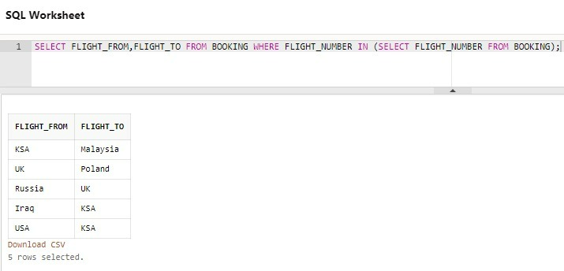

/* SIXTH QUERY */

SELECT PASSENGER_ID,PASSENGER_NAME,GENDER,STREET, CITY , FLIGHT_FROM, FLIGHT_TO, TICKET_TYPE FROM PASSENGER NATURAL JOIN BOOKING;

