ITE499A Capstone Project A
Abu Dhabi University, College of Engineering, Information Technology
Insider Threat Detection Using Behavioral Analytics and Machine Learning
Week 3 Submission
Research and Methodology and Prototype Development: Days 1, 2 and 7
Prepared by: Muhammad Fahim Zakkeer (1086830)
Group 7: Ayyub Ishnazarov (1093731), Muhammad Fahim Zakkeer (1086830), Nawaf Khaled Hussein (1099137)
Supervisor: Dr. Deepa Suresh
Submission date: 1 November 2026

About this document
This document collects the Week 3 work for Days 1, 2 and 7 of the supervisor's table, for both tracks: Research and methodology, and Prototype development. Part 1 to Part 3 are the three files written for this submission (docs/METHODOLOGY.md, docs/USE_CASES.md and docs/WEEK3_PLAN.md in the project repository).

Where each task of the supervisor's table is answered
Day | Track | Task in the supervisor's table | Where it is answered
1 | Research and methodology | Define the proposed methodology, overall workflow and processing stages | Part 1, sections 1 to 5
1 | Prototype development | Review current implementation and identify remaining core modules | Part 3, "Where the prototype stands" and "Issues and remaining core modules"
2 | Research and methodology | Prepare system use-case diagram and detailed use-case descriptions | Part 2, sections 1 to 3
2 | Prototype development | Implement user roles, authentication, access control where applicable | Part 2, section 4 (roles and access control); two new access-control tests
7 | Research and methodology | Review methodology with project objectives and research gaps | Part 1, section 6
7 | Prototype development | Conduct module-level testing and resolve major functional errors | Part 3, "Day 7 test record" and the issue table

Basis of the results
All results come from generated CERT-layout data and were measured on 31 October 2026. No result from the original CERT r4.2 dataset or from SPEDIA is claimed. Part 1, section 6 and Part 3 state what is still missing.

Changes made to the prototype this week
- Authentication and roles: no new feature was needed; the existing analyst and admin roles, signed token, throttling and access log were documented in an access matrix, and two missing tests were added (unknown role gets 403, expired token gets 401).
- Fixed: the offline assistant said "above the flag threshold" for every session, which was wrong for sessions under the threshold listed on the user page.
- Changed: the heading "What drove the score" now reads "What drove the XGBoost score", because SHAP explains the XGBoost model only.
- Five new automated tests (32 pass, plus one that needs a real MongoDB, which also passes: 33).
- Database validation rules were switched on for all six collections of the main database; stored data passed with 0 problems.
- Documentation brought up to date: README (four screens, 32 tests), requirements (test count) and demo script.

Part 1: Methodology: overall workflow and processing stages
Insider Threat Detection System (prototype), Capstone Project A, Group 7. Week 3, Day 1 (research and methodology). Facts in this file come from the code in backend/itd/ and from the Research and Methodology document. Where the code does not yet match the proposal, the text says so.

1. Approach
The project follows a design science sequence: identify the problem, define the objectives, build the artifact, demonstrate it, evaluate it, and report the findings.
Step | In this project
Identify the problem | Insider attacks are hard to tell from normal work, and analysts cannot read all logs (proposal, Problem Statement)
Define the objectives | Seven objectives in the proposal: pipeline, features, models, risk score with explanation, dashboard, assistant, evaluation
Build the artifact | The prototype in this repository: detection engine, API, dashboard, database
Demonstrate | Two connected analyst workflows (docs/DEMO.md): review a flagged session, then investigate that user
Evaluate | Held-out test set in time order; precision, recall, F1 and PR-AUC; see section 4
Communicate | Proposal, literature review, this methodology, final report

The contribution is an inspectable combination of session scoring, personal baselines and explanations. It is not a new detection algorithm.

2. Overall workflow
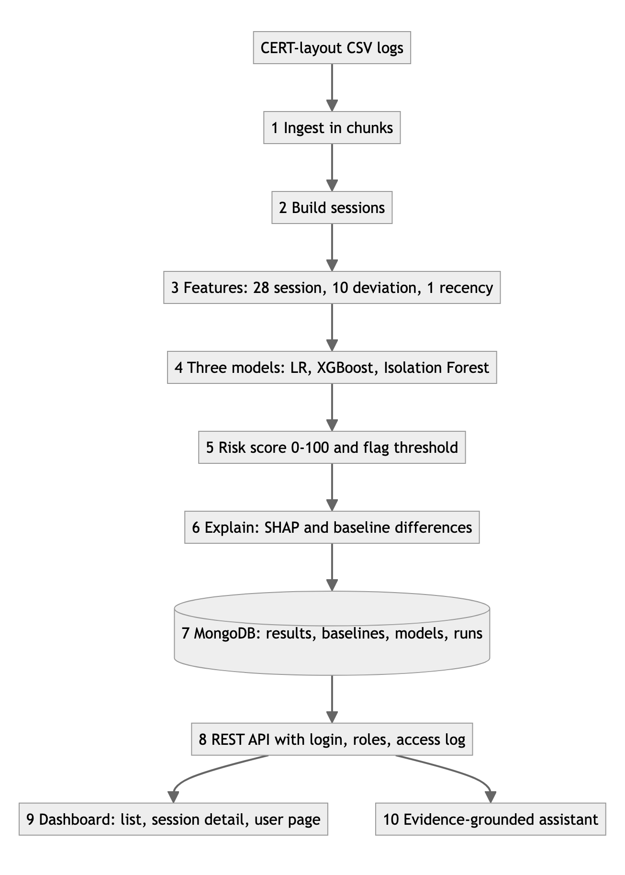
Figure 1. Overall workflow of the system (batch flow and analyst flow).
Two flows share the stored results:
- Batch flow (steps 1 to 7): an operator runs python -m itd.engine. Only the engine writes results, baselines, models and run records.
- Analyst flow (steps 8 to 10): the analyst signs in and reads stored results. The API writes only the access log.

3. Processing stages
# | Stage | Input | Rule applied | Output | Code | Test
1 | Ingest | logon, device, email, file, http CSV files, optional answers.csv (docs/CSV_LAYOUT.md) | Read in chunks of 500,000 rows, keep only needed columns; optional user-id pseudonym (keyed hash) | Per-session event counts | ingest.py, aggregate.py | test_aggregator_counts_per_session, and the pipeline fixture in test_pipeline.py
2 | Sessions | Logon events | A Logon opens a session; the matching Logoff closes it; a missing Logoff closes it at the next Logon or after 12 hours. A session is labeled malicious if it holds an event listed in the answer file | One row per user, PC and login | sessionize.py | test_sessionization_rules
3 | Features and baselines | Sessions and counts | 28 session features. 10 deviation features compare the session with the same user's earlier sessions only (running mean and standard deviation, trusted after 5 sessions, capped at 10). 1 recency feature (gap since last session, weekends removed) | 39 numbers per session | features.py, baselines.py | test_feature_count, test_baseline_uses_only_past_sessions, test_working_gap_ignores_weekend
4 | Models | 39 features | Time-ordered split 70% train, 15% validation, 15% test. Logistic Regression and XGBoost use class weights; Isolation Forest uses no labels. Trained once, saved with a SHA-256 hash, loaded to score | Three scores per session, each 0 to 1 | models.py, engine.py | test_model_tamper_is_detected
5 | Risk score | Three model scores | Weight of each model is proportional to its validation F1. Score = 100 x weighted sum. Flag threshold = best F1 on validation data | Risk score 0 to 100, flagged yes or no | risk.py | test_risk_engine_weights_and_threshold
6 | Explanation | XGBoost and feature rows | SHAP TreeExplainer on XGBoost: top 3 positive features. Top 3 positive baseline deviations. Both written in plain words | top_shap, baseline_deviations | explain.py, features.py | test_top_shap_is_positive_and_at_most_three, test_list_sorted_and_detail
7 | Storage | Results of 1 to 6 | MongoDB with validation rules, indexes and a run_id link from each result to its run | Collections: results, user_baselines, trained_models (GridFS), runs | engine.py, schema.py, db.py | test_stored_documents_follow_the_schema, test_results_are_linked_to_their_run
8 | REST API | Stored results | bcrypt login, 30-minute JWT, roles, strict input checks, throttling, access log, clear 503 and 500 messages | JSON for the dashboard | api.py, security.py | test_login_and_auth, test_injection_rejected, health and failure tests
9 | Dashboard | API JSON | No calculation in the browser; four views with hash routes | Flagged list, session detail, user page, last-run panel | frontend/src/ | test_both_workflows_end_to_end (API side)
10 | Assistant | Evidence of one session: R, S1 to S3, B1 to B3 | Hosted model if LLM_API_KEY is set, otherwise a local template. No user or PC names are sent. Read-only | Short answer plus the evidence ids used | assistant.py | test_llm_answer_is_validated, offline answer tests

4. Evaluation method
- Unit of analysis: one session (one user, one PC, login to logout).
- Split: first 70% of sessions in time order for training, next 15% for validation (weights and threshold), last 15% for the final test. No later session is used to train a model or to build the baseline of an earlier one.
- Metrics: precision, recall, F1 and PR-AUC with the malicious class as positive. Accuracy is not used because malicious sessions are very rare.
- Imbalance: class weights in training; validation and test keep their natural class balance.
- Output: reports/metrics.json and the runs collection (GET /api/run/latest).
- Data in this phase: generated CERT-layout data (scripts/generate_synthetic_cert.py). Results on it show that the software works, not how it performs on real logs. Original CERT r4.2 and SPEDIA runs come later.
Research questions to test:
ID | Question
RQ1 | Can the pipeline turn the documented logs into explainable sessions and support both analyst workflows?
RQ2 | Do user-relative features improve detection over session features alone?
RQ3 | Does combining the three models beat each model alone?
RQ4 | Can the assistant answer using only the selected session's evidence?
RQ5 | What are the time, memory and transfer limits of this design?

5. Where the code does not yet match the method
Listed in docs/WEEK3_PLAN.md and reviewed in section 6 below. The main ones: no score calibration, no statement-level check of hosted assistant answers, single-model thresholds chosen on test labels, two day-level features that use the whole day.

6. Review against the project objectives and research gaps (Day 7)
Checked on 31 October 2026 against the code on this branch. "Done" means implemented and covered by a passing test on generated data. Original CERT r4.2 and SPEDIA have not been run, so no result below is a benchmark result.

6.1 Objectives
# | Objective (proposal) | Stage | Research question | Evidence | Status and limit
O1 | Pipeline from logs to behavioral sessions | 1, 2 | RQ1 | test_sessionization_rules, test_aggregator_counts_per_session, engine run in the test fixture | Done on generated data. Memory use at full CERT size not measured
O2 | Session-level and user-relative features from logon, email, file, web, USB | 3 | RQ2 | test_feature_count, test_baseline_uses_only_past_sessions | Done. Two day-level features use the whole day, so later sessions leak into earlier ones (issue 4). Re-running without --retrain replays data onto saved baselines (issue 5)
O3 | Compare supervised and unsupervised models | 4 | RQ3 | Three models trained and scored; metrics per model in reports/metrics.json | Implemented. Single-model thresholds are chosen on test labels (issue 3). No ablation (session features only versus with deviations) or equal-weight comparison run yet
O4 | Risk score that shows the main behaviors behind each alert | 5, 6 | RQ3 | test_risk_engine_weights_and_threshold, test_top_shap_is_positive_and_at_most_three | Implemented. No calibration (issue 1). SHAP explains XGBoost only and the heading now says so
O5 | Dashboard for review and investigation | 8, 9 | RQ1 | test_both_workflows_end_to_end, frontend build | Done: four views. Page load time in a browser not measured; the two-second check covers the API list only
O6 | Evidence-grounded assistant | 10 | RQ4 | test_llm_answer_is_validated, offline answer tests, test_assistant_gets_no_identifiers | Offline answers done. Hosted answers only have evidence ids filtered, no statement check (issue 2); never tried with a real key
O7 | Evaluate detection, generalizability and computing cost | section 4 | RQ2, RQ3, RQ5 | Metrics on a held-out time-ordered test set | Partly. Generated data only; no CERT or SPEDIA result; no calibration measures; no run time at scale

6.2 Research gaps (literature review, Table 9.1)
# | Gap | How the prototype addresses it | Status and honest limit
G1 | Alerts are not explained to the analyst | SHAP top 3 and top 3 baseline differences with every session, in plain words | Addressed in the product. Whether analysts find it useful has not been tested
G2 | Few studies score single sessions against a per-user baseline | Session unit; 10 deviation features against the user's earlier sessions | Addressed, with the leakage and replay limits in O2. The baseline shown on the user page is the end-of-batch state, not the state used to score older sessions
G3 | Results are hard to compare and may be too optimistic | Time-ordered split, precision, recall, F1 and PR-AUC, combined threshold from validation data | Partly. The code reports average precision under the key pr_auc. Single-model thresholds break the rule (issue 3)
G4 | Little testing beyond CERT | SPEDIA adapter and cross-dataset evaluation (spedia.py, cross_eval.py) | Not closed. Tested only on a stand-in file; real SPEDIA columns are not mapped; SPEDIA contains sampled CERT events
G5 | Research models are far from the tools analysts use | Dashboard, user page and assistant | Demonstrated as a prototype. No analyst study

6.3 Inconsistencies between our documents
- Two different sets of search strings: the Week 2 literature document and the Research and Methodology document list different seven-query sets. The search log must list only the strings that were run.
- The proposal names five collections; the code has six (runs was added).
- The proposal lists three API functions; the code has seven endpoints (login, session list, session detail, chat, user history, latest run, health).
- The proposal and literature review say no selected study combines session scoring, a personal baseline, explanations and multi-dataset evaluation. The Research and Methodology document words this more carefully (limited evidence for this combination). Use the careful wording.
- The proposal promises calibrated scores (Platt scaling) and a statement-by-statement answer check. Neither is implemented yet.

6.4 Limits to state in every report
Generated CERT-layout data only; batch processing, not live; no peer-group comparison; results show feasibility, not readiness for real logs; a flag is a lead for a human, not proof.

Part 2: Use cases, roles and access control
Insider Threat Detection System (prototype), Capstone Project A, Group 7. Week 3, Day 2. Requirement ids (FR-n) refer to docs/REQUIREMENTS.md. Endpoints are in docs/API.md.

1. Actors
Actor | Who | How they use the system
Security Analyst | Member of the security operations team | Works only in the dashboard. Read-only access to results
Administrator | A team member who runs the prototype | Works on the command line, not in the dashboard: places the log files, starts the batch run, manages accounts, applies database rules, takes backups
Hosted LLM API | External service (optional) | Receives the stored evidence of one session and a question, returns an answer

CERT r4.2 and SPEDIA are data sources outside the system.

2. Use-case diagram
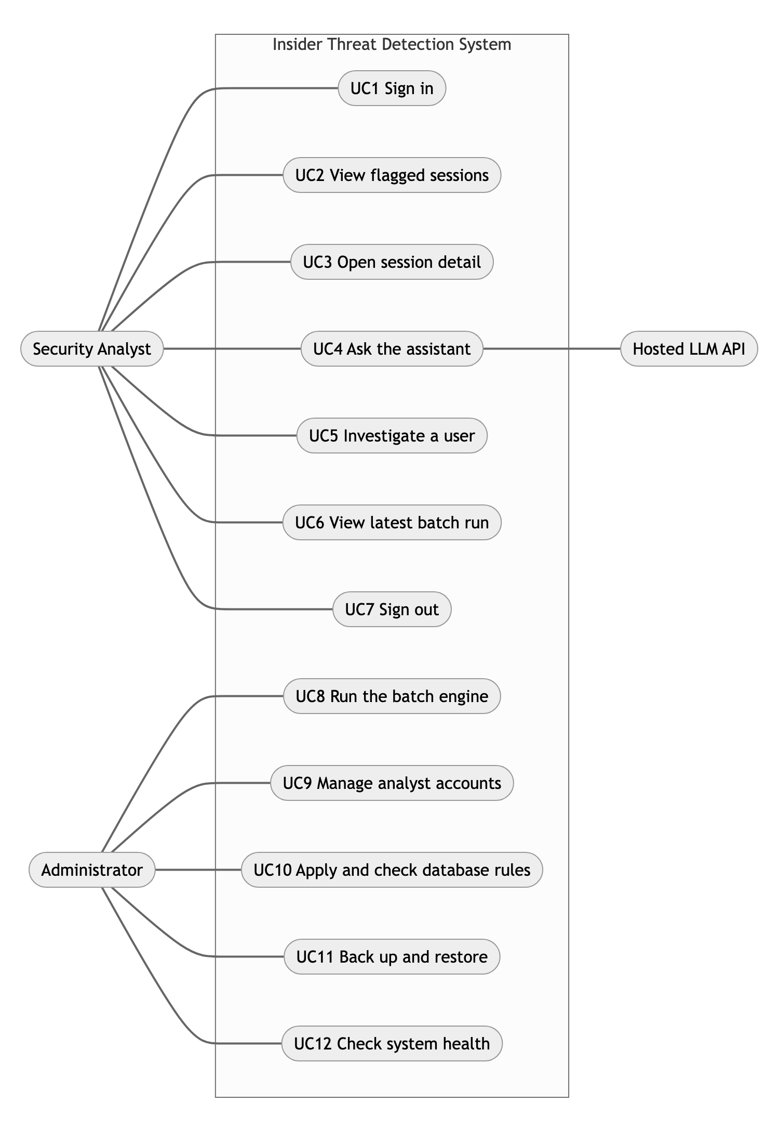
Figure 2. Use-case diagram of the system.
Order of use: UC1 comes first. UC2, UC3, UC5 and UC6 need a valid token. UC3 can lead to UC4 and UC5, and UC5 leads back to UC3 (the two connected workflows in docs/DEMO.md).

3. Use case descriptions

Security Analyst
UC1 Sign in (FR-9, FR-13) POST /api/login
- Precondition: an account exists in analyst_accounts.
- Main flow: the analyst enters a username and password. The API checks the bcrypt hash and returns a token valid for 30 minutes. The dashboard keeps it for the browser session.
- Alternatives: wrong password gives 401 "Wrong username or password". Five failed logins for a username or address in 15 minutes gives 429. Input with database operators gives 422. Database down gives 503 with a retry message.
- Postcondition: an access-log entry login_ok or login_failed.
UC2 View flagged sessions (FR-10) GET /api/sessions
- Precondition: signed in with a valid token.
- Main flow: the dashboard shows the sessions at or above the flag threshold, highest risk first, with the counts and the threshold.
- Alternatives: missing or expired token gives 401 and the dashboard returns to sign-in with a notice. No batch run yet gives an empty list. Database down gives 503 and "Try again".
- Postcondition: none stored.
UC3 Open session detail (FR-7, FR-10, FR-13) GET /api/sessions/{id}
- Precondition: signed in; the id is a session from the latest run.
- Main flow: the analyst opens a row. The page shows the 0 to 100 score, the three model scores, the top three SHAP reasons, the top three differences from the user's normal, and the notice that a flag is not proof.
- Alternatives: id not in S<digits> form gives 422. Unknown id gives 404 "That session was not found. It may belong to an older run."
- Postcondition: access-log entry session_viewed.
UC4 Ask the assistant (FR-8, FR-13) POST /api/sessions/{id}/chat
- Precondition: UC3 is open.
- Main flow: the analyst types a question (at most 300 characters). The API builds the evidence of that session only (R, S1 to S3, B1 to B3; no user or PC names), asks the hosted model or answers from a local template, and returns the answer with the evidence ids used.
- Alternatives: no API key, or the hosted call fails, gives the offline template answer. Longer question gives 422.
- Postcondition: access-log entry assistant_question with the question. The assistant cannot change a score or flag.
UC5 Investigate a user (FR-11, FR-13) GET /api/users/{id}
- Precondition: signed in; started from a session or a link.
- Main flow: the page shows the user's sessions over time (default latest 500), the flag threshold, a summary and the ten normal-behavior values. The analyst opens another session from the timeline.
- Alternatives: bad id gives 422; unknown user gives 404.
- Postcondition: access-log entry user_viewed.
UC6 View latest batch run (FR-12) GET /api/run/latest
- Main flow: shows when the engine last ran, how long it took, threshold, model weights and test results.
- Alternative: no run yet gives 404 "No batch run recorded yet. Run the detection engine first."
UC7 Sign out
- Main flow: the dashboard removes the token from the browser session.
- Limit: the token is not revoked on the server; it stays valid until it expires (30 minutes).

Administrator
UC8 Run the batch engine (FR-1 to FR-7, FR-14) python -m itd.engine --data <folder> [--retrain] [--pseudonymize]
- Precondition: the five CSV files (and optional answers.csv) are in the folder; MongoDB is running.
- Main flow: ingest, sessions, features, models, risk score and SHAP, then results, baselines, models and a run record are saved.
- Alternatives: a missing file stops the run with a clear message. Train, validation or test without a malicious session stops the run. A saved model that fails its SHA-256 check stops the run with "Retrain with --retrain".
- Postcondition: new results, user_baselines, runs (and models if retrained).
UC9 Manage analyst accounts python -m scripts.analysts list|add|role|password|delete
- Main flow: the administrator creates or changes accounts. Roles are analyst or admin.
- Alternative: any other role is refused by the script and by the database rule.
UC10 Apply and check database rules (NFR-8) python -m itd.schema apply|check
- Main flow: creates or updates collections with strict validation rules and indexes; check tests stored documents against the same rules.
UC11 Back up and restore python scripts/backup_db.py --out <folder> and --restore <folder>
UC12 Check system health GET /api/health (no login), scripts/check_connection.py, scripts/check_setup.py
- Main flow: reports whether the API is up and can reach the database (200 ok or 503 degraded).

4. Roles and access control
Rules in the code: security.py (current_user, require_analyst), api.py, schema.py.
Endpoint | No token | Invalid or expired token | Role analyst | Role admin | Any other role
GET /api/health | 200 | 200 | 200 | 200 | 200
POST /api/login | allowed | allowed | allowed | allowed | allowed
GET /api/sessions | 401 | 401 | 200 | 200 | 403
GET /api/sessions/{id} | 401 | 401 | 200 | 200 | 403
POST /api/sessions/{id}/chat | 401 | 401 | 200 | 200 | 403
GET /api/users/{id} | 401 | 401 | 200 | 200 | 403
GET /api/run/latest | 401 | 401 | 200 | 200 | 403

Notes:
- Analyst and admin have the same rights on the API. No endpoint is admin-only. Administration is done on the command line (UC8 to UC12). A user-administration screen is out of scope.
- The database allows only the roles analyst and admin, so "any other role" can only occur with a forged or old token.
- The API writes only to access_log (login_ok, login_failed, session_viewed, user_viewed, assistant_question). Results, baselines, models and runs are written by the engine only.
- With the secure database set-up (docker-compose.secure.yml, docs/SECURITY.md), the API account is also denied writes outside the access log at the database level. In the default development set-up this separation is not enforced.
- Other controls: 30-minute token, strict request models, session and user ids limited to a fixed pattern, login throttling, HTTPS when REQUIRE_HTTPS=1.
- Development defaults to change before any real use: JWT_SECRET has a built-in value (config.py), and HTTPS is off by default.

Part 3: Week 3 prototype plan: review of the current implementation and remaining core modules
Insider Threat Detection System, Capstone Project A. Prototype track, submission 1 November 2026. Day 1 (review). Written on 31 October 2026 from the code on branch main (commit 86fdfc5) and the Week 2 documents.

Where the prototype stands
- Detection engine: reads CERT-layout CSV logs, builds sessions, 39 features and per-user baselines, trains three models (Logistic Regression, XGBoost, Isolation Forest), combines them into a 0 to 100 risk score, and explains each session with SHAP and baseline differences.
- REST API: login, flagged session list, session detail, assistant chat, user history, latest run, health check.
- Dashboard: four views (Login, Flagged Sessions, Session Detail with chat, User Page with risk timeline).
- Database: MongoDB with six collections, validation rules, indexes and run_id links.
- Security: bcrypt, expiring token, analyst and admin roles, input checks, throttling, access log, model hash check.
- Checks: 27 automated tests passed at the start of Week 3; 32 pass now, plus one that needs a real MongoDB and is skipped by default. The frontend production build passes (40 modules).
- Data: generated CERT-layout data only. Original CERT r4.2 and SPEDIA have not been run.

Issues and remaining core modules
Each row was checked in the code.
# | Issue | Where | Type | Priority | Suggested day | Status
1 | No score calibration. The proposal promises Platt scaling; the code combines raw scores and only rescales Isolation Forest | risk.py | Missing module | High | Day 4 (algorithm and logic) | Open
2 | Hosted assistant answers are not checked statement by statement; only unknown evidence ids are removed | assistant.py:111 | Missing module | High | Day 4 | Open
3 | Thresholds for single models are picked on the test labels, so their test numbers are too optimistic. The combined score is correct (validation only) | risk.py:38-40, engine.py:97-98 | Evaluation | High | Day 4 | Open
4 | n_distinct_pcs_day and n_sessions_day use the whole day, so later sessions leak into earlier ones | features.py:87-88 | Method | Medium | Day 4 | Open
5 | Re-running the engine without --retrain loads saved baselines and replays the same data on top; last-session time is not saved, so recency breaks between runs | engine.py:72-73, baselines.py | Method | Medium | Day 5 (connect to database) | Open
6 | Offline answer always says the score is "above the flag threshold", which is wrong for below-threshold sessions reachable from the user page | assistant.py:46 | Functional error | Medium | Day 7 | Done: answer says "below" when the session is not flagged; test added
7 | Heading "What drove the score" does not say that SHAP explains the XGBoost model only | SessionDetail.jsx:46 | Accuracy of wording | Low | Day 7 (one line) | Done: heading now reads "What drove the XGBoost score"
8 | Not yet run: original CERT r4.2, SPEDIA, secure MongoDB start-up script, HTTPS in a browser, hosted model with a real key | environment | Verification | Medium | After this week | Open
9 | The dashboard has no automated tests | frontend/ | Testing | Low | After this week | Open
10 | README said three screens; the code has four | README.md:18 | Documentation | Low | Day 1 | Done
11 | Some modules have no direct test: risk score, aggregation, SHAP selection. Role and expired-token cases are not tested | backend/tests/ | Testing | Medium | Day 2 and Day 7 | Done: 5 tests added (unknown role and expired token, below-threshold answer, risk score, aggregation, SHAP selection)

Day 7 test record (31 October 2026)
Check | Result
pytest -q in backend | 32 passed, 1 skipped (real-MongoDB test, no test server configured)
ITD_TEST_MONGO=mongodb://127.0.0.1:27017 pytest -q | 33 passed, including the real-MongoDB schema test (it uses its own temporary database)
npm run build in frontend | passed, 40 modules
python -m itd.schema apply, then check | Validation rules switched ON for all six collections of the main database. 7,329 results, 120 baselines, 1 account, 37 access-log entries, 2 runs, 1 model record: 0 problems
scripts/demo_schema.py | valid documents accepted; unknown role, plain-text password, unknown log action, over-long question and a role update to "root" all rejected by MongoDB (code 121); demo documents removed
scripts/demo_db.py | every collection shown; create, read, update, delete on a temporary account worked; temporary data removed
scripts/check_connection.py | every line OK: database, results (7,329 sessions, 66 flagged), accounts, models, API, health, login, session list, dashboard proxy
scripts/demo_api.py | all 13 calls returned the expected status (401, 401, 422, 200, 200, 200, 200, 200, 200, 422, 422, 404, 422)
Live check of issue 6 | a session scored 5 (threshold 19.5) now gets "which is below the flag threshold" from the offline assistant

Not planned for the prototype: peer-group comparison, real-time scoring, saving analyst decisions, a user-administration screen.

Day plan for this submission (days owned by Fahim)
Day | Research and methodology | Prototype development
1 | docs/METHODOLOGY.md: approach, workflow, processing stages | This file: review and issue list
2 | docs/USE_CASES.md: use-case diagram and descriptions | Roles and access matrix; tests for unknown role (403) and expired token (401)
7 | Review of the methodology against objectives and research gaps (docs/METHODOLOGY.md, section 6) | Run all tests and the build; fix issue 6 and 7; add module tests for issue 11

Days 3 to 6 are owned by teammates. The issues marked Day 4, Day 5 are suggestions for them and need their agreement.

