Library Management System
CMPSC-363 Database Systems Project
Full-Stack Web Application with Java Spring Boot & MySQL
Nawaf Alshahrani

1. Project Description
This project implements a comprehensive Library Management System designed to manage library branches, librarians, books, members, and loan transactions. The system provides a user-friendly web interface for performing CRUD operations on all entities and managing the book borrowing workflow.
Technology Stack:
- Backend: Java Spring Boot 3.x with Spring Data JPA
- Database: MySQL (MariaDB compatible)
- Frontend: HTML5, CSS3, JavaScript with Thymeleaf templates
- API: RESTful web services

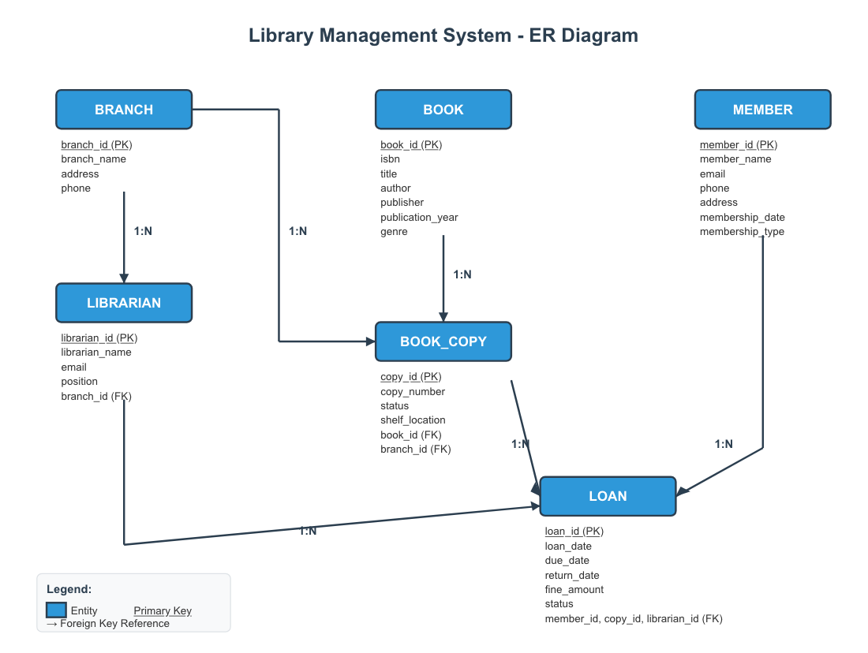

2. Entity Sets and Relationships
The system consists of 6 entity sets with various relationships:
Entity | Attributes | Relationships
Branch | branch_id (PK), branch_name, address, phone | 1:N with Librarian, 1:N with BookCopy
Librarian | librarian_id (PK), name, email, position, branch_id (FK) | N:1 with Branch, 1:N with Loan
Book | book_id (PK), isbn, title, author, publisher, year, genre | 1:N with BookCopy
BookCopy | copy_id (PK), copy_number, status, shelf_location, book_id (FK), branch_id (FK) | N:1 with Book, N:1 with Branch (M:N resolver)
Member | member_id (PK), name, email, phone, address, date, type | 1:N with Loan
Loan | loan_id (PK), dates, fine, status, member_id (FK), copy_id (FK), librarian_id (FK) | N:1 with Member, BookCopy, Librarian

3. Database Schema (Phase II)

3.1 Relational Schema
Branch(branch_id, branch_name, address, phone)
Librarian(librarian_id, librarian_name, email, position, branch_id)
Book(book_id, isbn, title, author, publisher, publication_year, genre)
BookCopy(copy_id, copy_number, status, shelf_location, book_id, branch_id)
Member(member_id, member_name, email, phone, address, membership_date, membership_type)
Loan(loan_id, loan_date, due_date, return_date, fine_amount, status, member_id, copy_id, librarian_id)

3.2 Keys and Functional Dependencies
Relation | Primary Key | Functional Dependencies
Branch | branch_id | branch_id → branch_name, address, phone
Librarian | librarian_id | librarian_id → name, email, position, branch_id
Book | book_id | book_id → isbn, title, author, publisher, year, genre
BookCopy | copy_id | copy_id → copy_number, status, location, book_id, branch_id
Member | member_id | member_id → name, email, phone, address, date, type
Loan | loan_id | loan_id → all other attributes

3.3 Normalization (3NF Verification)
All relations are in Third Normal Form (3NF) or higher:
- 1NF: All attributes contain atomic values; no repeating groups
- 2NF: No partial dependencies (all non-key attributes depend on the entire primary key)
- 3NF: No transitive dependencies (no non-key attribute depends on another non-key)

4. REST API Endpoints (Phase IV)
The application provides comprehensive RESTful APIs:
Method | Endpoint | Description
GET | /api/branches | Get all branches
POST | /api/books | Create new book
GET | /api/books/search?keyword={q} | Search books by title/author
PUT | /api/loans/{id}/return | Return a borrowed book
GET | /api/loans/overdue | Get all overdue loans
DELETE | /api/members/{id} | Delete a member

5. Sample SQL Queries

Query 1: Find Available Books at a Branch
SELECT b.title, b.author, bc.shelf_location FROM book b JOIN book_copy bc ON b.book_id = bc.book_id JOIN branch br ON bc.branch_id = br.branch_id WHERE br.branch_name = 'Downtown Central Library' AND bc.status = 'Available';

Query 2: Find Overdue Loans
SELECT m.member_name, b.title, l.due_date FROM loan l JOIN member m ON l.member_id = m.member_id JOIN book_copy bc ON l.copy_id = bc.copy_id JOIN book b ON bc.book_id = b.book_id WHERE l.status = 'Active' AND l.due_date < CURDATE();

Query 3: Most Borrowed Books
SELECT b.title, COUNT(l.loan_id) as borrow_count FROM book b JOIN book_copy bc ON b.book_id = bc.book_id JOIN loan l ON bc.copy_id = l.copy_id GROUP BY b.book_id ORDER BY borrow_count DESC LIMIT 5;

6. Application Features
- Dashboard: Overview with statistics and quick navigation
- Branch Management: Full CRUD operations for library branches
- Librarian Management: Staff management with branch assignments
- Book Catalog: Book management with search functionality
- Member Registration: Member management with membership types
- Loan Management: Borrow/return books with automatic fine calculation
- Overdue Tracking: Monitor and manage overdue books

7. For professor Xu ((How to Run the Application ))
- Install Java JDK 17+ and MySQL Server
- Create database: Run sql/schema.sql and sql/sample_data.sql
- Update application.properties with your MySQL credentials
- Run: mvn spring-boot:run or run from IDE
- Access: http://localhost:8080

8. Source Code
GitHub Repository: https://github.com/NawafWork/library-management-system

Application Screenshots:
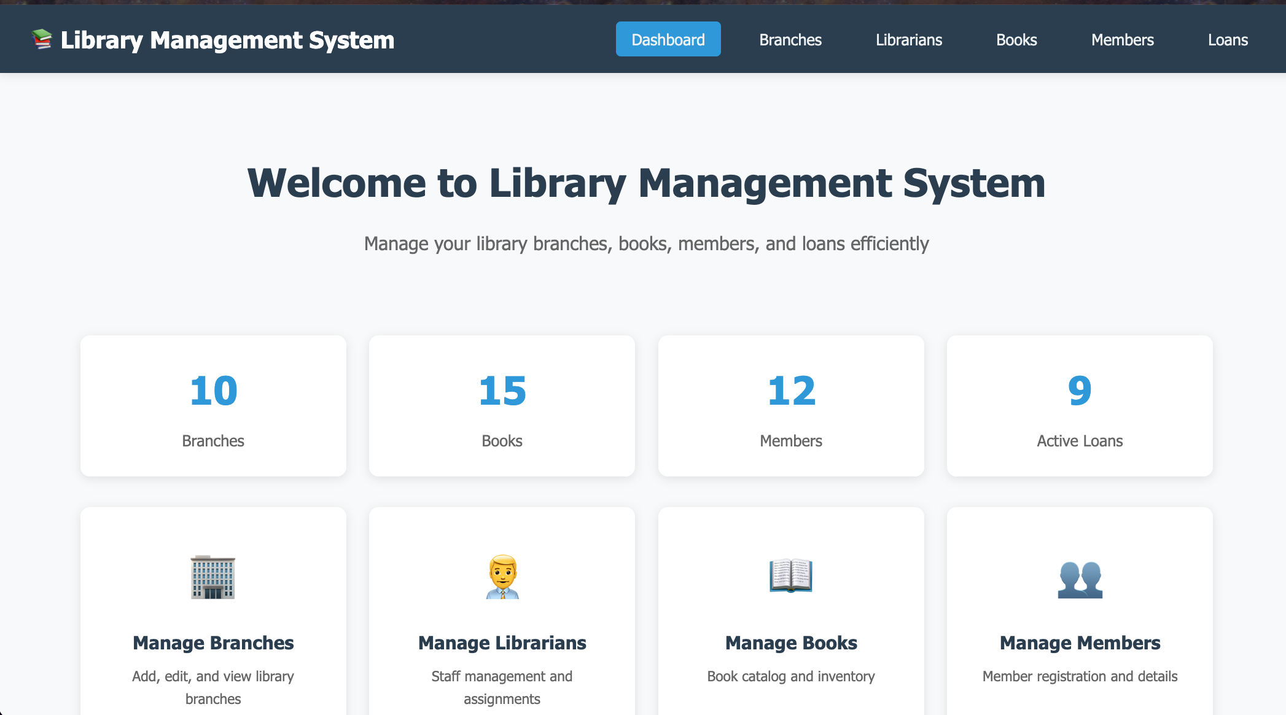

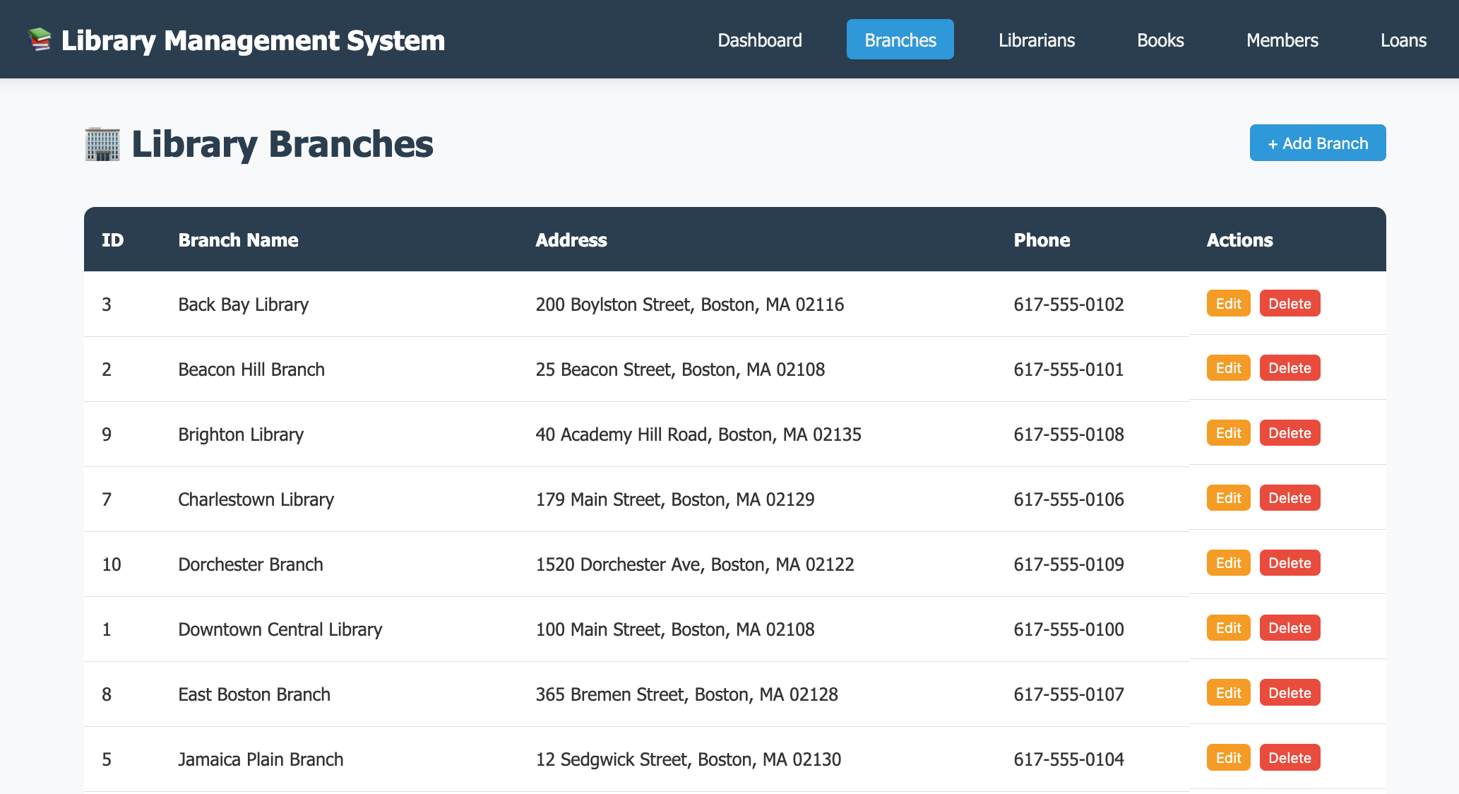

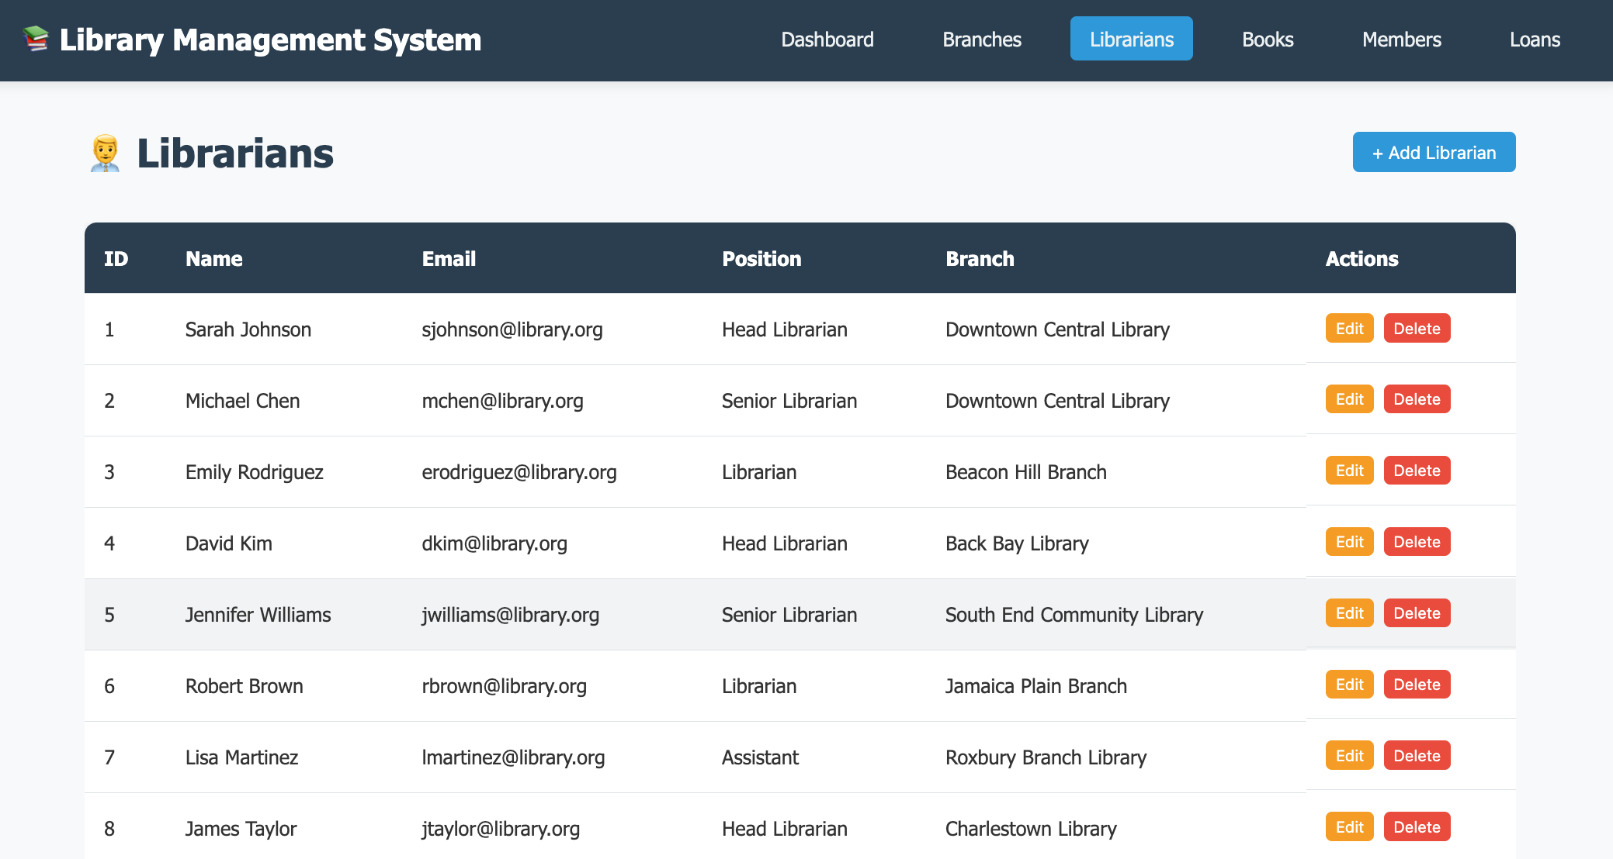

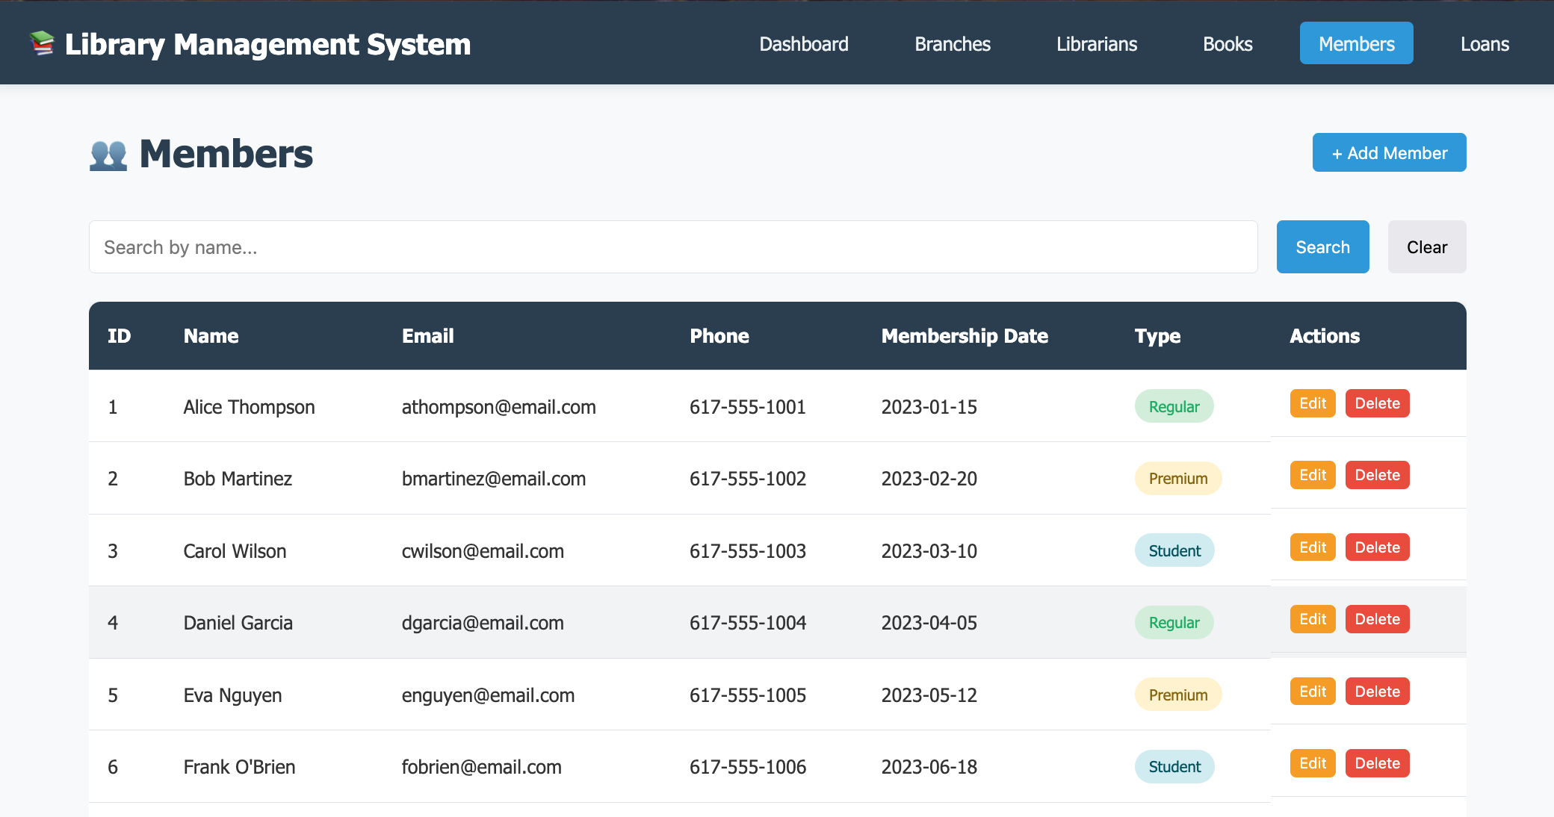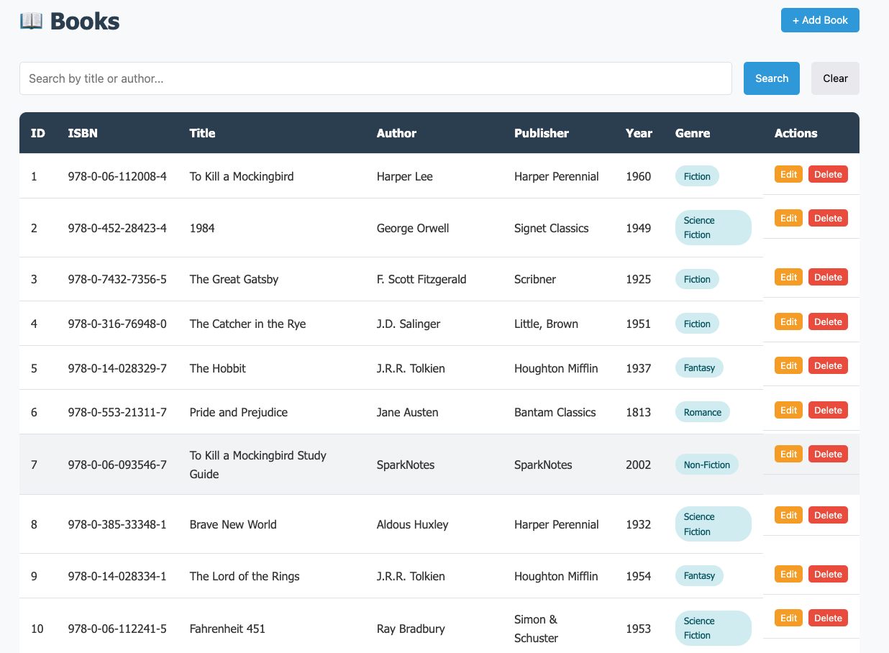

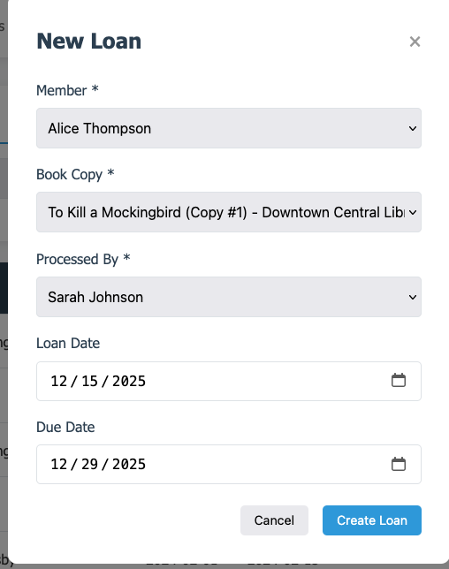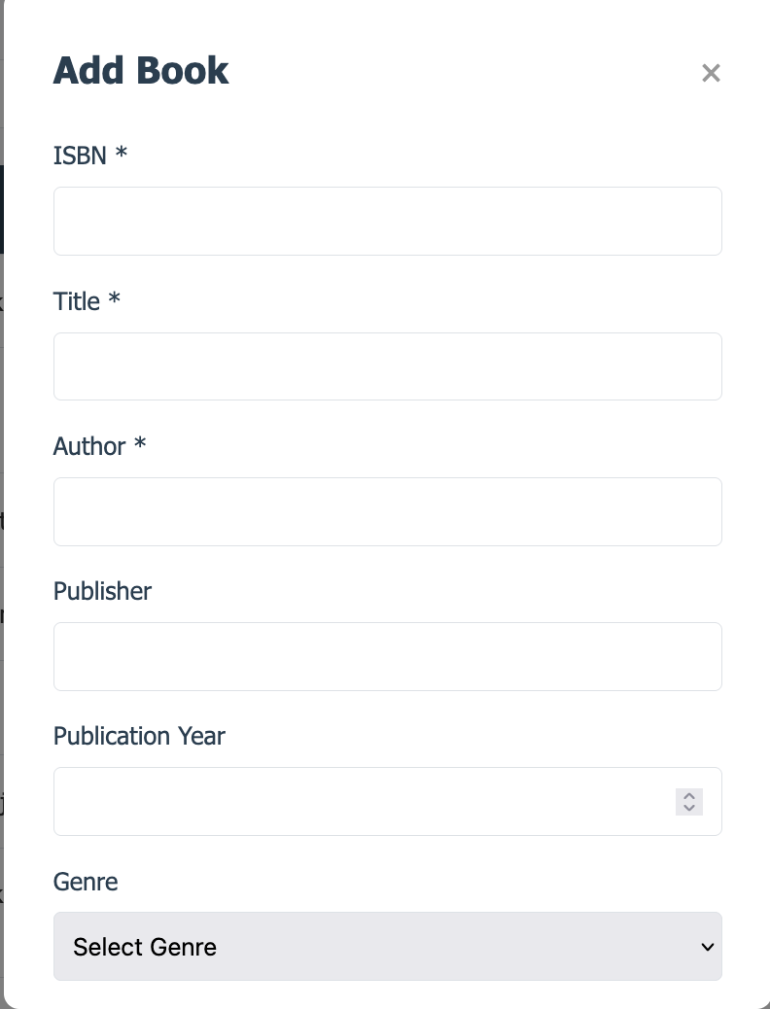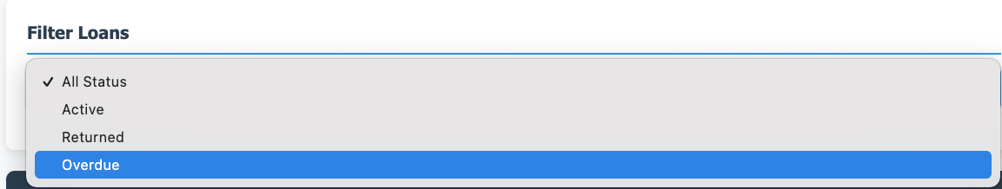

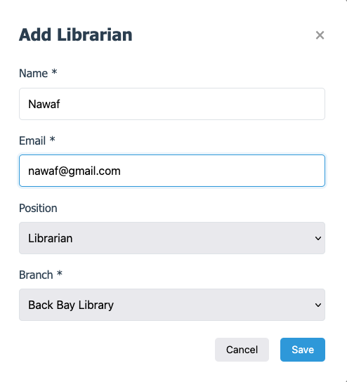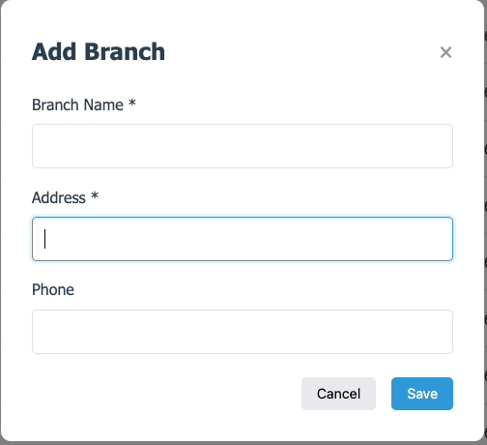

9. Conclusion
This Library Management System demonstrates practical application of database concepts including ER modeling, relational database design, normalization to 3NF, SQL query optimization, and full-stack web development. The system provides a user-friendly interface for managing all aspects of library operations while maintaining data integrity through proper foreign key constraints and business logic validation.

