344 SKINNER ET AL.: Implant Electrode Position

TABLE 6

CT-based estimates of array insertion depth

|  |  |  |  |  |  |
| --- | --- | --- | --- | --- | --- |
| en | o cocc e r  enn c mmm | Fnc on rr  nser on enn c mmm | Arr nser on  enn ch  cocc e r enn c | Ap c e ec rode pos on from  pee denreesm | Ap c e ec rode pos on from  ben nn nn of frs  Frn denrees) |
|  | 6 |  |  |  |  |
|  |  |  |  |  |  |
|  |  | 6 |  |  |  |
|  | 6 | 6 | 6 |  |  |
|  |  |  |  | 6 |  |
| 6 | 6 6 | | 6 |  |  |
|  |  | | 6 |  |  |
|  |  | |  |  |  |
|  | 6 | |  |  |  |
|  |  |  | |  |  |
|  |  | 6 | | 6 |  |
|  | | | | | |
|  |  |  |  |  |  |
| Mean | 6 | 6 |  |  |  |
| so |  |  | |  | |
| Minimum |  |  | |  | |
| Maximum | 6 | |  |  |  |
| Median |  | | 6 | 6 |  |

Arithmetic means

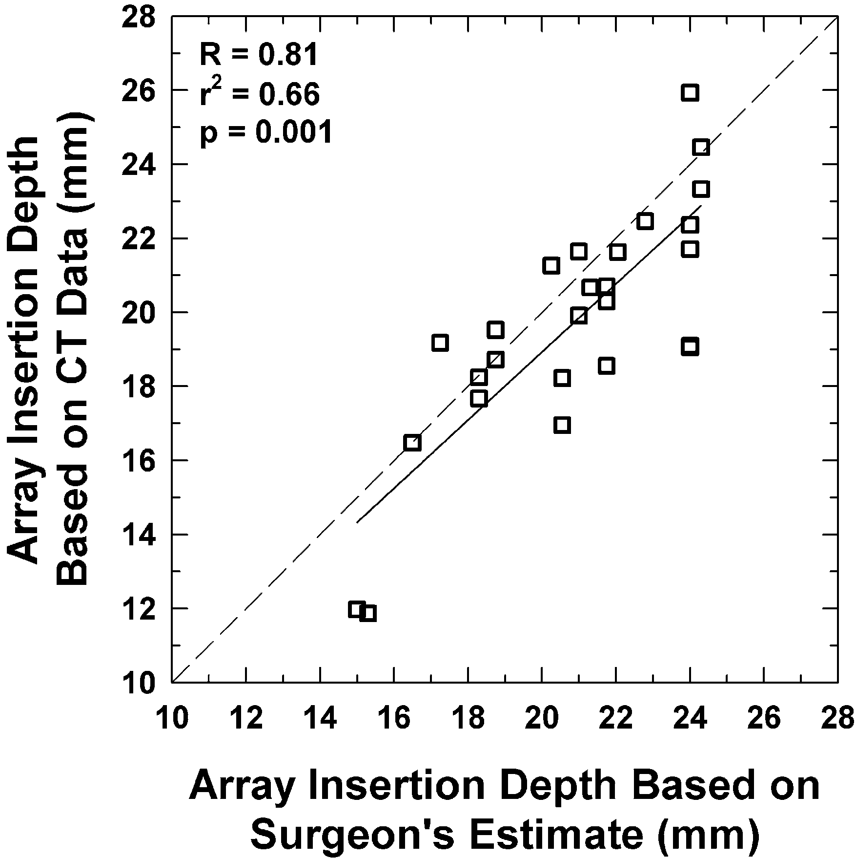

FIG. 3. Electrode array insertion depth in mm estimated from CT analysis and from the surgeon's report and nominal measurements of the array dimensions for the 6 patients The dashed line represents the points at which the insertion depths would be the same as esti- mated from CT analysis and the surgeon's report The linear re- gression line, correlation, and signifcance values are shown

r2 = 0.66, p = 0.001). The fact that the regression line lies below the equality line (dashed line in Fig. 3) shows that, on average, array insertion depth esti- mated from the surgeon's report is longer than the CT-derived estimate. Although there is a strong linear

relation between these two estimates of array inser- tion depth, there were a number of patients for which there was a relatively large difference in the insertion depth estimates. For example, insertion depth re- ported by the surgeon for P5 and P7 was 4.95 and

4.90 mm longer than that based on CT analysis, re- spectively. In contrast, CT-derived insertion depth was

1.93 mm longer than that reported by the surgeon for

P1 and P12.

Estimates of cochlear and array characteristic frequency distributions

Characteristic frequencies at the apical and basal ends of the cochlear canal (including the hook), as well as those at the most apical electrode in the ar- ray, were calculated based on the following assump- tion: The total range of hearing (Hz) differs for different cochleae because each critical band covers the same linear distance along the basilar membrane (i.e., variable hearing range). These values are given for P1 through P13 in Table 7 and for P14 through P26 in Table 3 in Ketten et al. (1998). For P1 through P13, the calculated harmonic mean char- acteristic frequency was 20 Hz at the apical end of the cochlea and 21,113 Hz at the basal end using Greenwood's basic formula with a constant of 165.4. This result compares reasonably well with the gen- erally accepted fixed hearing range of 20-20,000 Hz; however, the calculated mean characteristic fre-