1. Introduction
Knowledge of the quality of the subsurface reservoirs plays a critical role in the prediction of fluid flow behaviour and informed decisions in petroleum engineering development. Three basic characteristics, porosity, which is the capacity of the rock to store something, permeability, which is a measure of its capability to transmit fluids, and facies, which are a response to the environments of deposition which determine pore structure and connectivity, lie at the heart of this understanding. All these properties help in the efficiency with which hydrocarbons could be produced out of a formation.
Reservoir engineers in real field situations do not normally rely on a single source of information. Core measurements are very accurate and can only be found at a limited number of depths. Well logs are indirect and give continuous data. Pore scale images are microscopic images but only a small fraction of the reservoir. With these three data scales combined, we are getting closer to the process of making decisions in actual reservoir assessments, that is, combining fine-scale data with coarse-scale trends to come up with a robust, multi-scale analysis (Dahiru, Habiba et al. 2023).
This project will recreate the complete reservoir-analysis process with Python, but it would be done in a manner that reflects how these activities were traditionally performed in a professional subsurface study. In order to achieve this, three sets of data were analyzed simultaneously: a core-derived porosity-permeability dataset containing facies labels, a complete wireline log suite in LAS format and, lastly, a high-resolution pore-scale image of Berea sandstone. These data sets can be collectively used to assess a reservoir at the microscopic level all the way to the entire wellbore (Singh, Rabbani et al. 2021).
In order to derive information in these datasets, we use a blend of exploratory data analysis, and supervised/unsupervised learning algorithm, such as a linear regression, K-means clustering algorithm and a neural network classifier.
The objectives of this project are specific and to:
- Examine and investigate each dataset, determine anomalies, trends and distributional features.
- Calculate visualization of key reservoir properties at appropriate scales with the help of proper plotting techniques.
- Examine quantitatively relationships of porosity, permeability and facies by regression, clustering and classification.
- Assess and interpret wireline logs to determine shale content, mark net reservoir intervals, match patterns of the logs with measurements (core) of properties.
- Carry out pore-scale image analysis to approximate indicators of porosity, pore size distribution and relative permeability.
- Combine the results of all the three scales to give a general evaluation of reservoir quality and its heterogeneity.
It is also a multi-scale method, which in addition to strengthening the analytical tools taught in PETE 219 shows how current data analytics can be used to aid in subsurface decision making by integrating direct laboratory studies, continuous well logs and microscopic image analysis in an intuitively understandable reservoir interpretation.

2. Methods
In this project, a workflow written in Python was used to predict the core poro-perm data, wireline well logs and pore-scale images. Everything was done in JupyterLab with standard scientific libraries, and a version control system was used in GitHub.

2.1 Poro-Perm Data Methods
Poro-perm dataset was loaded with the help of pandas and transformed into a clean data frame. Fields (porosity, permeability and log-permeability) were cast to float and facies labels standardised by shedding off any rogue characters. There were invalid entries which included negative values of permeability and these were eliminated. The computation of log-permeability was done to correct skewness of initial permeability distribution.
Crossplots of porosity, permeability, facies, coloured scatter plots, log-transformed crossplot and histograms were used as visualisation steps. The steps involved in the analysis were the following: the linear regression model was used to measure the porosity-permeability trend, the k-means clustering algorithm divided the rock quality groups, and an artificial neural network (ANN) classifier (scikit-learn) was implemented to forecast facies using poro-perm input data (Bishop and Nasrabadi 2006).

2.2 Well Log Data Methods
The LAS file was read with the lasio library and then it was converted into a structured pandas dataframe that was easy to analyse. A number of inconsistencies were found during this step such as missing depth intervals, negative value or physical impossibility of readings and repetitions. These problems were solved by deleting the wrong rows or substituting the erroneous values with NaN in order to make the interpolation and subsequent analysis to be done accordingly. This guaranteed that the ultimate data of logs was clean and credible prior to interpretation. The major logs were the gamma ray (GR), bulk density (RHOB), neutron porosity (CNPOR) and deep resistivity (RILD) as they were chosen to be related to lithology interpretation, shale estimation and fluid identification. Various visualisation methods were employed in order to understand the well-log behaviour better. These consisted of a multi-track display of GR, RHOB, CNPOR and RILD over the same depth axes making it easy to compare the lithology, porosity and fluid effects. Moreover, histograms were drawn to analyze the shape of distribution and determine the skewness or prevalence of specific rock types. To differentiate between clean sands and shaly intervals a neutron-density crossplot was plotted, and a heatmap of the correlation between the measurements was used to evaluate the strongest ones. The log interpretation was based on these visualisations. The analytical processes involved calculation of Vshale (GR), categorization of net intervals of the reservoir based on a shale cutoff and statistics on high-resistivity regions and reservoir non-reservoir (Asquith, Krygowski et al. 2004).

2.3 Pore-Scale Image Methods
A .tif file image (pore scale picture of Berea sandstones) was imported into scikit-image A non-local means filtering method was used to enhance the image of the pore-scale before segmentation. The next binary segmentation step was much more precise by increasing the clarity of the pore boundary, and the pore network can now be quantified with more confidence. A binary segmentation of the denoised grayscale image was performed using the Otsu thresholding. Pores and the area of pores were counted and area of pores was calculated through blob analysis (regionprops) (Cnudde and Boone 2013).
Pore-pixel fraction was used to estimate two dimensional porosity. The pores distribution as indicated by the area was approximated by a simple geometry to obtain a relative permeability value. Other visualisation procedures involved showing the original, denoised and binary images, pore-size histogram and pore-body overlay.

2.4 Software and Version Control
All the analyses were done in JupyterLab with Python libraries such as numpy, pandas, matplotlib, seaborn, scikit-learn and scikit-image. GitHub was used to maintain version control, figures collaboration, storage and code and datasets.

3. Results

3.1 Poro-Perm Data (Core Data)
Core-plug measurements of variables are depth, porosity, permeability and facies. Such measurements are tiny cylindrical rock samples that have been removed out of the reservoir. Storage and flow capacity are measured as porosity and permeability. Facies classification identifies the depositional environments including channel, crevasse slay and overbanks (Terry, Rogers et al. 2015).
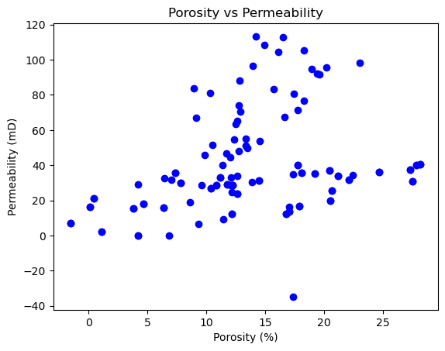
Figure 1 Porosity vs permeability scatter plot
Scatter plot of core plug porosity and permeability versus core plug permeability, with two variables. The expected positive trend and diffusion of the quality of the reservoirs throughout the sampled depths are brought out in the plot.

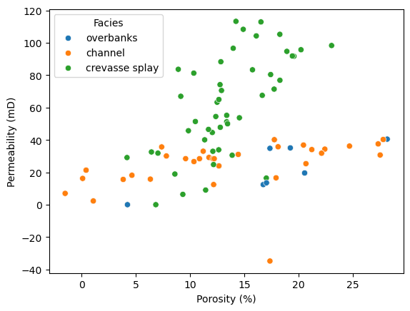
Figure 2 Facies-coloured poro-perm crossplot
Scatter plot of porosity and permeability and points coloured in by facies. This visualizing distinguishes between channel, crevasse slay samples and portrays the manner in which every type of facies assembles within poro-perm space.
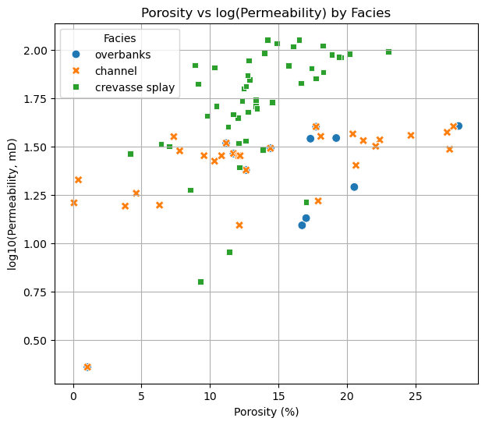
Figure 3 Porosity vs log-permeability crossplot

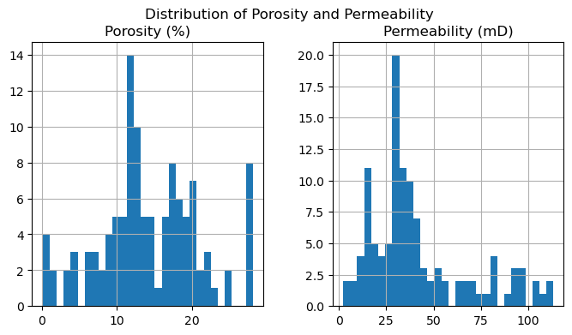
Figure 4 Histogram of porosity distribution
Histogram showing the distribution of core porosity values. The plot highlights skewness and the presence of multiple facies-related populations.
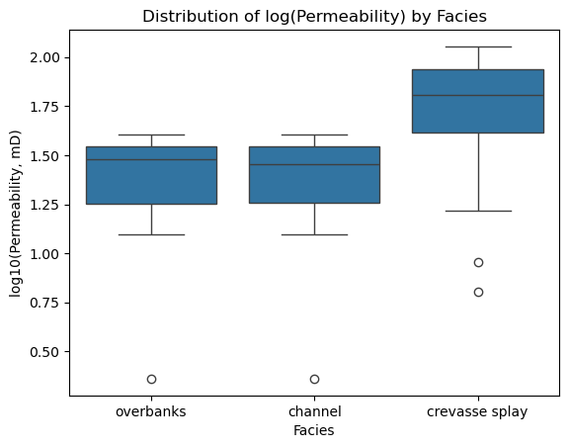
Figure 5 Histogram of permeability distribution
Histogram showing the distribution of permeability measurements. The data exhibit positive skew due to high-permeability outliers typical of heterogeneous fluvial reservoirs.
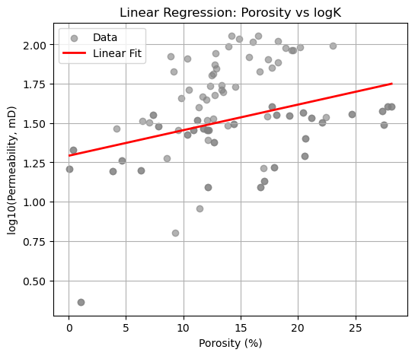
Figure 6 Linear regression between porosity and log-permeability
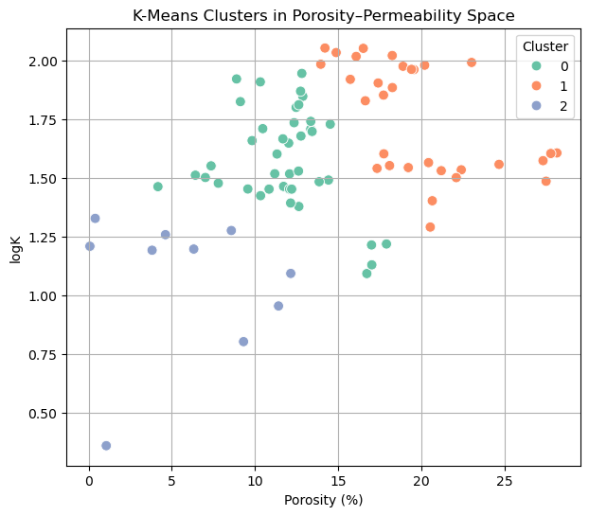
Figure 7 K-means cluster plot
Scatter plot of porosity vs log permeability with data points coloured by k-means cluster membership. The figure illustrates the three statistically derived rock quality groups.
Table 1 K-means clustering results
Cluster | Porosity (%) | Permeability (mD) | logK
0 | 11.9769 | 38.3188 | 1.5339
1 | 20.7213 | 55.6695 | 1.6858
2 | 5.0747 | 14.0006 | 1.0781
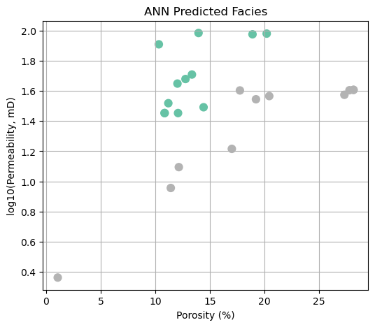
Figure 8 ANN-predicted facies classification

Table 2 ANN classification report
Class | Precision | Recall | F1-score | Support
channel | 0.64 | 0.64 | 0.64 | 11
crevasse splay | 0.58 | 0.78 | 0.67 | 9
overbanks | 0.00 | 0.00 | 0.00 | 3
accuracy | - | - | 0.61 | 23
macro avg | 0.41 | 0.47 | 0.43 | 23
weighted avg | 0.53 | 0.61 | 0.57 | 23

The core-derived porosity and permeability data give direct information about the quality of the reservoir at the plug scale. Figure 1 is a scatter plot depicting that the relationship between porosity and permeability is generally positive with higher pore volume samples having higher flow capacity. Nevertheless, the dispersion of the data also demonstrates high heterogeneity which is typical of the fluvial depositional systems. Facies are important in the explanation of this variability (Katz and Thompson 1986). Figure 2 shows that the channel samples are concentrated around the larger range of porosity and permeability, with the samples of overbank occupying the lower-quality area. In between fall crevasse splay samples. This distribution is in agreement with the geology of reservoirs, in which the channel sands tend to be more sorted and to have more connected pore spaces than plants composed of smaller grains . Figure 3 shows the use of the log-permeability because extremely high values of permeability skew the result, and a linear trend emerges better with the use of the log-permeability. This conversion enhances visualisation as well as modelling particularly on the regression and clustering tasks. Further heterogeneity is also depicted by the use of histogram analyses (Figures 4 and 5). Porosity is skewed to moderate and this indicates the existence of more than one population of facies. Permeability has far more positive skew and tends to have a long high-value tail, as is typical of situations where a small number of well-sorted sandy intervals control flow. Figure 6 shows that the linear regression gave rise to a moderate correlation between porosity and log-permeability. This confirms the notion that in mixed lithologies, porosity cannot be used to purely predict flow behaviour. Using K-means clustering (Figure 7 and Table 1) is effective in separating the data in terms of three classes of quality.
The K-means algorithm automatically formed three distinct clusters of core measurements that indicate reservoir quality differences. The best cluster has samples that have porosity of about 20.72 percent and permeability of about 55.67 mD, which is in line with well-sorted and clean sands. The poor sorting or tight packing is observed by the medium-quality cluster with the porosity nearer to 11.98 percent. The most quality cluster has the tightest samples, and the porosity and permeability of approximately 5.07 percent and around 14.00 mD are the closest ones (Ma and Morrow 1996).
These statistically obtained clusters are in agreeable correlation with the anticipated facies trend which lends more credibility to the workflow. The ANN facies classifier (Figure 8 and Table 2) had a total accuracy of 61 percent. The model works well on channel and crevasse-slay facies and poor on overbank samples because of their limited representation by the data. This disproportion influences recall and this means that more sampling or class balancing methods should be used to enhance model robustnesss (Parimontonsakul 2021).

3.2 Well Log Data

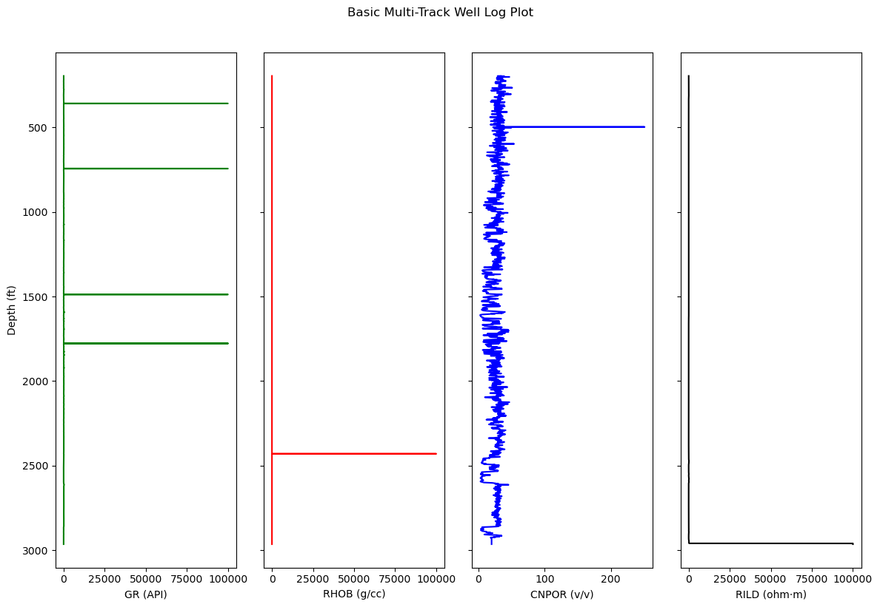
Figure 9 Multi-track well log plot
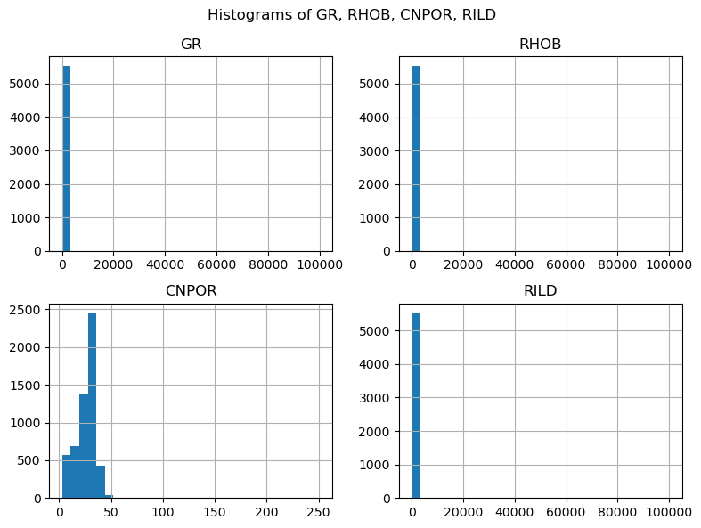
Figure 10 Histograms of GR, RHOB, CNPOR, and RILD
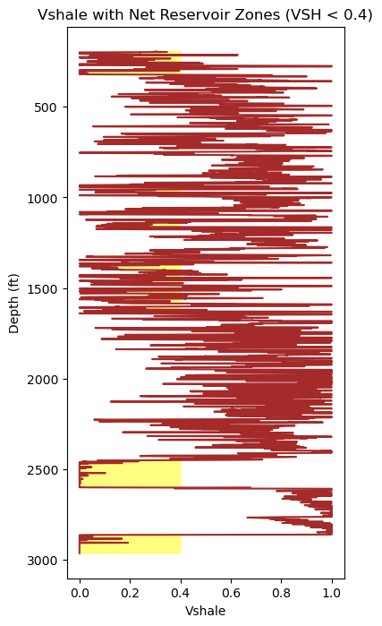
Figure 11 Vshale profile with net reservoir identification
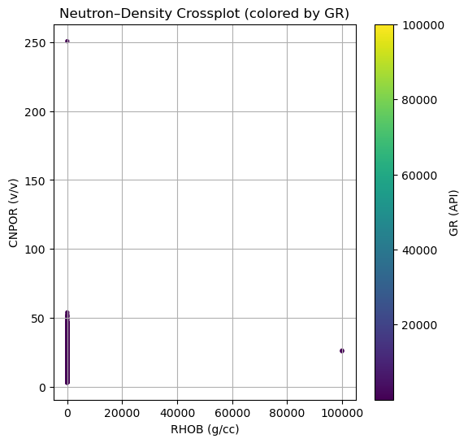
Figure 12 Neutron–density crossplot coloured by gamma ray
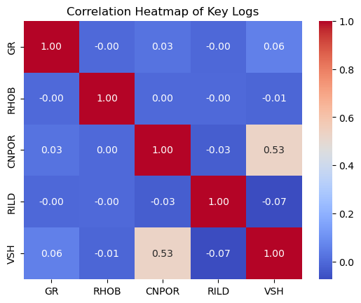
Figure 13 Correlation heatmap of key well log curves
Table 3 Correlation matrix of logging curves
 | GR | RHOB | CNPOR | RILD | VSH
GR | 1.0000 | -0.0008 | 0.0263 | -0.0025 | 0.0595
RHOB | -0.0008 | 1.0000 | 0.0004 | -0.0008 | -0.0094
CNPOR | 0.0263 | 0.0004 | 1.0000 | -0.0278 | 0.5280
RILD | -0.0025 | -0.0008 | -0.0278 | 1.0000 | -0.0736
VSH | 0.0595 | -0.0094 | 0.5280 | -0.0736 | 1.0000

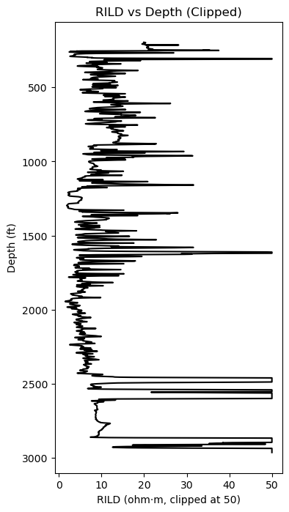
Figure 14 Deep resistivity (RILD) versus depth
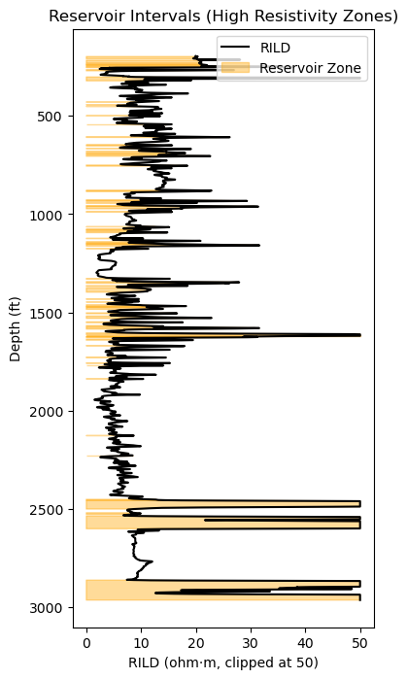
Figure 15 Reservoir interval identification based on high resistivity

Table 4 Reservoir vs Non-reservoir summary
Zone | GR | RHOB | CNPOR | RILD | VSH
Non-Reservoir | 266.8572 | 47.0427 | 28.0739 | 7.9379 | 0.6702
Reservoir | 37.8322 | 2.6553 | 15.8555 | 987.5444 | 0.0614

The well log data gives continuous measurements depending on depth that supplements the plug-scale porosity-permeability measurements. Figure 9 is the multi-track plot indicating the main curves utilized in the characterisation of the reservoir: gamma ray, density, neutron porosity and deep resistivity. The reason behind the selection of these logs is that they are beneficial in the identification of lithology, estimation of the shale, and detection of hydrocarbons directly. GR, RHOB, CNPOR and RILD distributions (Figure 10) show that there is high variability along the well. GR shows a wide dispersion, which represents clean and shaly units. Density and neutron porosity exhibit fewer variations in response to more stable mineral matrix and compaction environments. RILD is characterized by skewed distribution, as would be true when the number of intervals containing high-resistivity hydrocarbons is small (Asquith, Krygowski et al. 2004). Figure 11 is the Vshale log and shows that the sections with the lower level of GR than the 40 percent mark that is used to establish net reservoir. The net intervals identified cover a length of about 1057ft of the section that is logged and this has proved that the well cuts several sand-rich units. These areas help in the estimation of reservoir thickness and give an approximation on the magnitude of production. The neutron-density plot (Figure 12), coloured by gamma ray, indicates there is an apparent demarcation between clean sands, shaly sands and shale-rich intervals. The trends of clean sandstone reservoirs are concentrated around the sandstone trend with the high-shale intervals falling towards the upper density and low neutron porosity (Doll 1949). This is in favor of the lithology explanation based on Vshale. The correlation heatmap (Figure 13) and numerical matrix (Table 3) demonstrate that the correlations between the logs are mostly weak, as it is expected of mixed lithologies where each of the tools reacts to various physical properties. The best-correlation found is the positive one between Vshale and CNPOR (0.5280) indicating the shale to tendency to increase neutron-porosity reading artificially. The weak negative correlations anticipated by the fluid sensitivity and not the matrix composition are reflected in the resistivity log. The deep resistivity trend (Figure 14) shows that there are a few high resistivity intervals, which agree with the clean zone located in Vshale. Such are viewed as possible hydrocarbon-bearing fields. It can be seen that in Figure 15 and Table 4, the reservoir intervals have a lower GR (37.8 vs 266.9) and Vshale (0.06 vs 0.67) and a higher RILD (987.5 vs 7.9). This substantiates clean, resistive sites that are in line with the presence of hydrocarbons. In general, the well log interpretation is also in solid agreement with the core data observations. High quality facies and high resistively responding intervals of sand are associated with clean sand. On the other hand, low resistivity and unfavorable reservoir characteristics are found in shale-rich intervals. The logging integration with the parameters derived in the core increases the trust in the reservoir characterization (Tiab and Donaldson 2024).

3.3 Pore-Scale Image Data

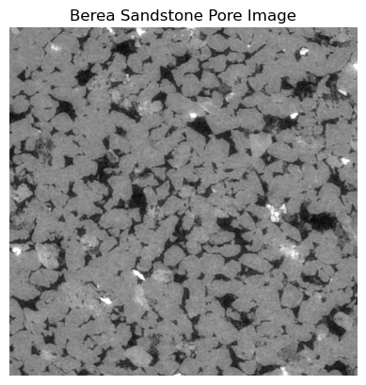
Figure 16 Porosity vs permeability scatter plot
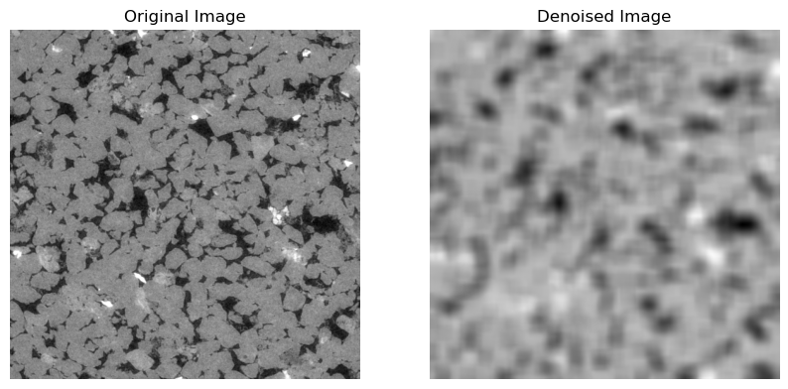
Figure 17 Berea sandstone pore image and denoised pore-scale images
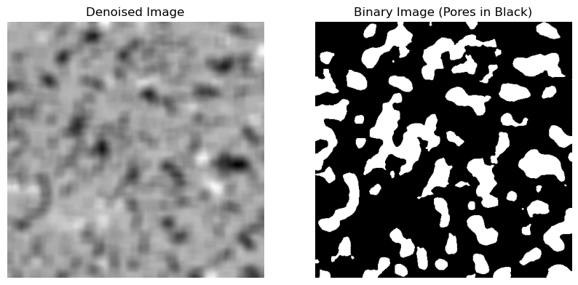
Figure 18 Denoised and binary pore segmentation images
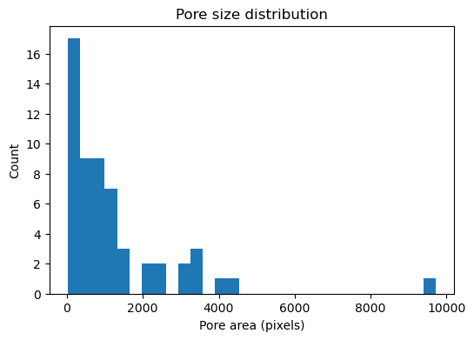
Figure 19 Pore size distribution histogram
Table 5 Image analysis summary
Metric | Value
2D Porosity (%) | 28.63
Number of pores | 57
Mean pore area (px) | 1255.12
Median pore area (px) | 766
Relative permeability | 0.41

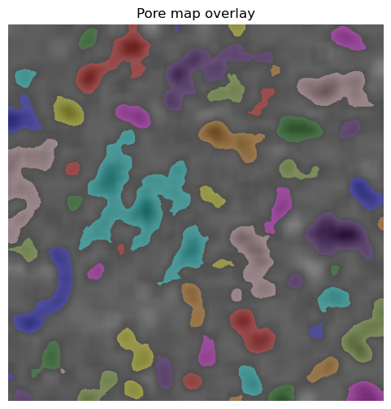
Figure 20 Pore map overlay
The pore-scale analysis of the image gives a microscopic view of the reservoir rock which is complementary to both the core poro-perm data and well log interpretation. The Berea sandstone sample (Figure 17) is a well-sorted, quartz-rich sandstone, which is normally used as a model to clean reservoir units. The tif image format has high spatial resolution that can be used in pore segmentation and quantitative pore analysis.
The original and denoised images (Figure 17) reveal the efficacy of the non-local means filtering in eliminating the grain-boundary noises and still retaining the pore geometries. It leads to the enhancement of contrast, which makes the later segmentation more trustworthy. The binary segmentation (Figure 18) manages to segregate pore space in black and provides a basis of quantitative measures (Blunt, Bijeljic et al. 2013).
The 2D porosity estimate of the image is 28.63 percent (Table 5), which is agreeable with high-quality sandstones in reservoirs and perfectly fits the upper end of the core-plug porosity data.
The size distribution of the pores (Figure 19) shows the existence of a large variety of pore areas, the average of which is 1255 px, and the median 766 px. There is presence of large flow-dominant pores and large number of small micropores as shown by the long tail.
The simplified estimate of relative permeability (0.41) gives an approximate value of the flow capacity which is dependent on pore geometry and distribution of size. Although it cannot be directly compared with the permeability determined in the laboratory, it supports the fact that this rock can be considered a moderately good-quality flow unit(Buades, Coll et al. 2011).
Lastly, the pore map overlay (Figure 20). This gives assurance in the computed pore statistics and indicates that Python-based pore-scale analysis is useful in reservoir characterisation.
In general, the pore-scale observations are in line with the core poro-perm data and interpretation of the well logs: the sample has a high porosity, moderate-to-high pore connectivity and pore-size dispersion which is characteristic of productive sandstone reservoirs (Carman 1997).
The findings indicate a high level of consistency of reservoir quality trends across all the three datasets. The K-means clusters and core poro-perm measurements determine three quality levels, which are the same as clean and high-resistivity depths on the well logs. The observed pores are closely correlated with the apparent pore arrangement and few signs of false identifications, artificial artefacts and broken pore edges are observed. This provides an assurance that the computed pore-size distribution, porosity estimate and statistics are indeed reflective of the underlying rock fabric and not some noise that was added in the processing (Foroughi, Shojaei et al. 2025). The reservoir intervals that are observed based on logs (low GR, low Vsh, high RILD) are geologically consistent with the good facies found in the core data, and with pore connectivity evident in microscopy images. Although this agreement was reached, one can list such limitations as a comparatively small number of core samples, only one slice of the pore-scale image and the imbalance in the classes of the facies, which influenced the performance of ANN. The machine learning classifier did not perform well with underrepresented facies, with moderate accuracy, which points to the sensitivity to dataset size and distribution. However, the overlapping trends presented in all the three scales gives an assurance in the general interpretation of the reservoir (Ma and Zhang 2019).

5. Limitations
The small number of core samples that takes place in this study is a limitation of this study because it decreases the exhaustiveness of the poro-perm trends. The 2D pore-scale image slice was only a single slice, which could not be used to assess the pore connectivity fully 3D. There are slight noise and measurement errors in the well logs which can impact the identification of reservoir intervals. The ANN facies classification was affected by the unbalanced data especially the under-representation of overbank facies. Although limited, the results of the multiscale have good internal consistency and corroborate the overall interpretation of the reservoirs.

4. Conclusions
- The core poro-perm analysis revealed that there was a positive relationship that was significant between porosity and permeability with three clusters of rock-quality identified using K-means. Channel facies had always the highest quality reservoir properties and overbank samples were a measure of low-quality intervals. ANN classifier performed moderately, recognising better quality facies effectively but under-represented classes.
- These trends were established at the well level by interpreting the well logs. The low-gamma-ray and low-Vsh areas were associated with clean reservoir intervals and consistent with the high-resistivity response indicating the presence of hydrocarbons. Correlation matrix indicated some limited log-log interrelationships because of mixed lithology and Vsh and CNPOR exhibited anticipated behaviour of shale.
- Pore-scale image analysis showed that the porosity was 28.63 percent (2D), there were 57 pores and a widespread distribution of pore-size, which are characteristic of a moderately to well-connected sandstone. These microscopic observations were in line with the high-quality intervals determined during the core and logs.
- The interpretation of integrated reservoir has shown that the formation has numerous clean and well-sorted sandstone units that have good porosity and moderate flow capacity. The core and pore-image results are both consistent with the resistivity-based hydrocarbon zones that are indicated in the logs.
- Although both datasets are limited, their combination creates a more reliable and consistent reservoir characterisation than any of the datasets.

5. References
- Asquith, G. B., D. Krygowski and C. R. Gibson (2004). Basic well log analysis, American Association of Petroleum Geologists Tulsa.
- Bishop, C. M. and N. M. Nasrabadi (2006). Pattern recognition and machine learning, Springer.
- Blunt, M. J., B. Bijeljic, H. Dong, O. Gharbi, S. Iglauer, P. Mostaghimi, A. Paluszny and C. Pentland (2013). "Pore-scale imaging and modelling." Advances in Water resources 51: 197-216.
- Buades, A., B. Coll and J.-M. Morel (2011). "Non-local means denoising." Image processing on line 1: 208-212.
- Carman, P. C. (1997). "Fluid flow through granular beds." Chemical engineering research and design 75: S32-S48.
- Cnudde, V. and M. N. Boone (2013). "High-resolution X-ray computed tomography in geosciences: A review of the current technology and applications." Earth-Science Reviews 123: 1-17.
- Dahiru, D. M., D. M. Habiba, S. Abdullahi, A. I. Abdullahi and K. A. Murana (2023). Petrophysical Analysis of Well Logs Data for Sandstone Reservoir Hydrocarbon Evaluation In Niger Delta Sedimentary Basin. Journal of Pure and Applied Sciences (Science Forum).
- Doll, H. t. (1949). "The SP log: Theoretical analysis and principles of interpretation." Transactions of the AIME 179(01): 146-185.
- Foroughi, S., M. J. Shojaei, N. Lane, B. Rashid, D. Lakshtanov, Y. Ning, Y. Zapata, B. Bijeljic and M. J. Blunt (2025). "A framework for multiphase pore-scale modeling based on micro-CT imaging." Transport in Porous Media 152(3): 18.
- Katz, A. and A. Thompson (1986). "Quantitative prediction of permeability in porous rock." Physical review B 34(11): 8179.
- Ma, S. and N. R. Morrow (1996). Relationships between porosity and permeability for porous rocks. International symposium of the Society of Core Analysts, Montpelier France.
- Ma, Y. Z. and X. Zhang (2019). Quantitative geosciences: Data analytics, geostatistics, reservoir characterization and modeling, Springer.
- Parimontonsakul, M. (2021). An Analytical Approach to Automate Stratigraphic Correlation using Well Logging Information, Massachusetts Institute of Technology.
- Singh, A., A. Rabbani, K. Regenauer-Lieb, R. T. Armstrong and P. Mostaghimi (2021). "Computer vision and unsupervised machine learning for pore-scale structural analysis of fractured porous media." Advances in Water Resources 147: 103801.
- Terry, R. E., J. B. Rogers and B. C. Craft (2015). Applied petroleum reservoir engineering, Pearson Education.
- Tiab, D. and E. C. Donaldson (2024). Petrophysics: theory and practice of measuring reservoir rock and fluid transport properties, Elsevier.

6. Appendix
- Git log contribution evidence (for your group submission requirement)

