

project report



**UNIVERSITY OF ENGINEERING & TECHNOLOGY**

**LAHORE**

**SEARCH ENGINE OPTIMIZATION**

**INSTITUTE OF BUSINESS AND MANAGEMENT**



**SUBMITTED TO**: **SIR SHEHBAZ RAO**

**SUBMITTED BY**: **AYESHA NAWAZ (2021-BBIT-43)**

**SUBJECT: SEARCH ENGINE OPTIMIZATION**

**RANI SWEET JUICE**

* **Introduction of Website with Screenshots:**

Rani Sweet Juice is a well-known brand that specializes in producing a wide range of fruit juices and beverages. Originating from Saudi Arabia, Rani Sweet Juice has established itself as a trusted name in the beverage industry globally. The company prides itself on using high-quality fruits sourced from various regions to create refreshing and flavorful juices that cater to diverse consumer preferences. With a commitment to quality, freshness, and innovation, Rani Sweet Juice offers a variety of products, including classic fruit juices, nectar, blends, and exotic flavors, providing consumers with a taste of pure fruit goodness in every sip. Whether enjoyed on their own or as part of cocktails and mock-tails, Rani Juice products are synonymous with freshness, taste, and enjoyment, making them a preferred choice for individuals and families seeking wholesome and delicious beverages.

**HOME PAGE:**

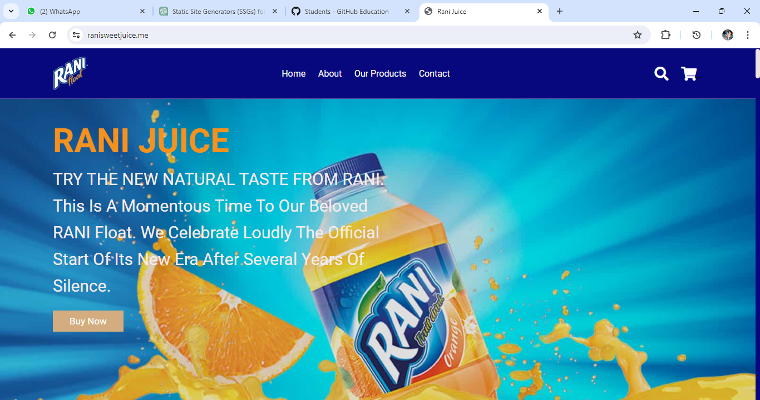

**ABOUT US PAGE:**

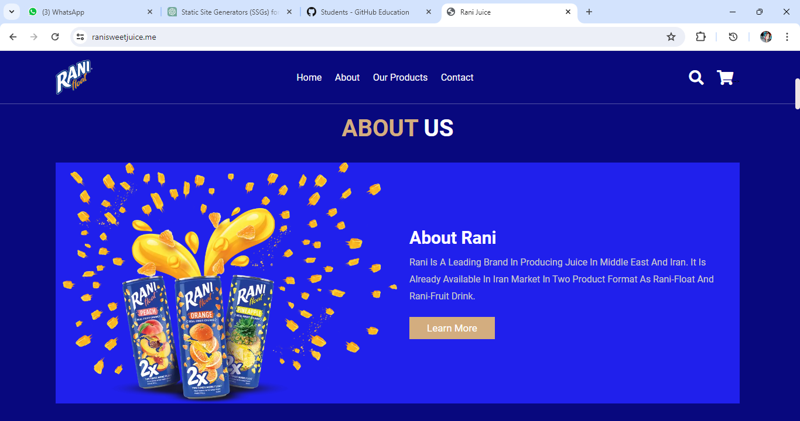

**MENU PAGE:**

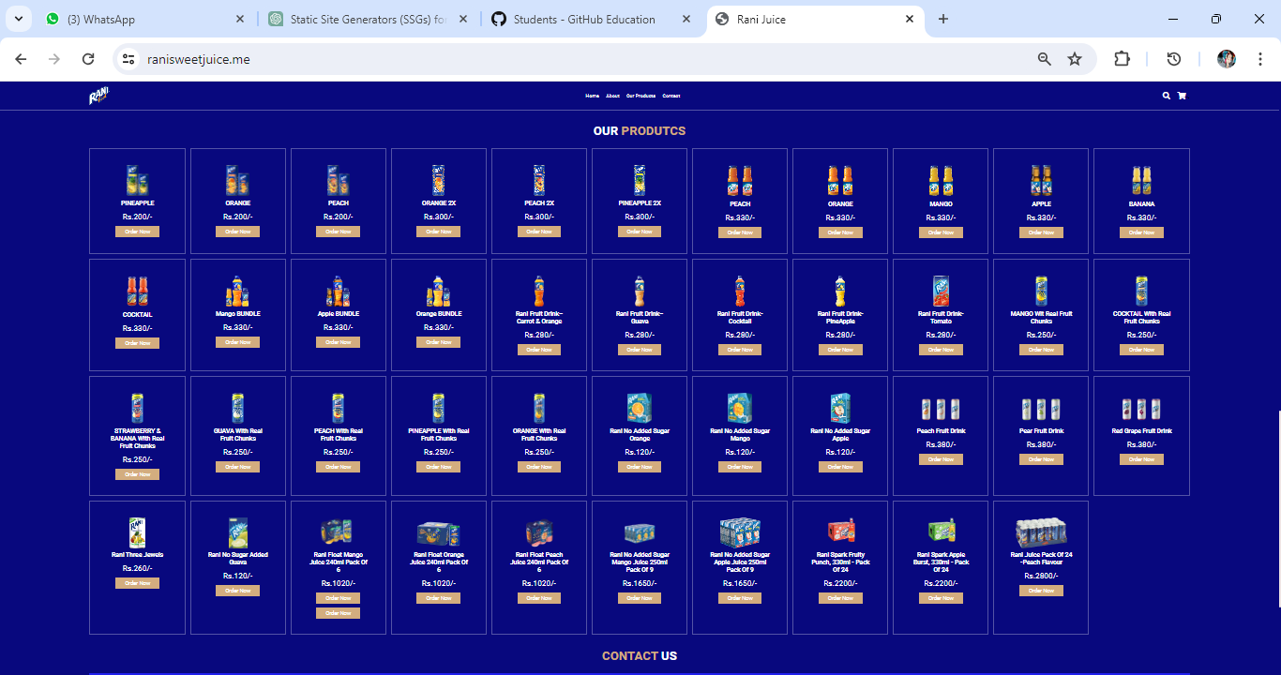

**CONTACT US PAGE:**

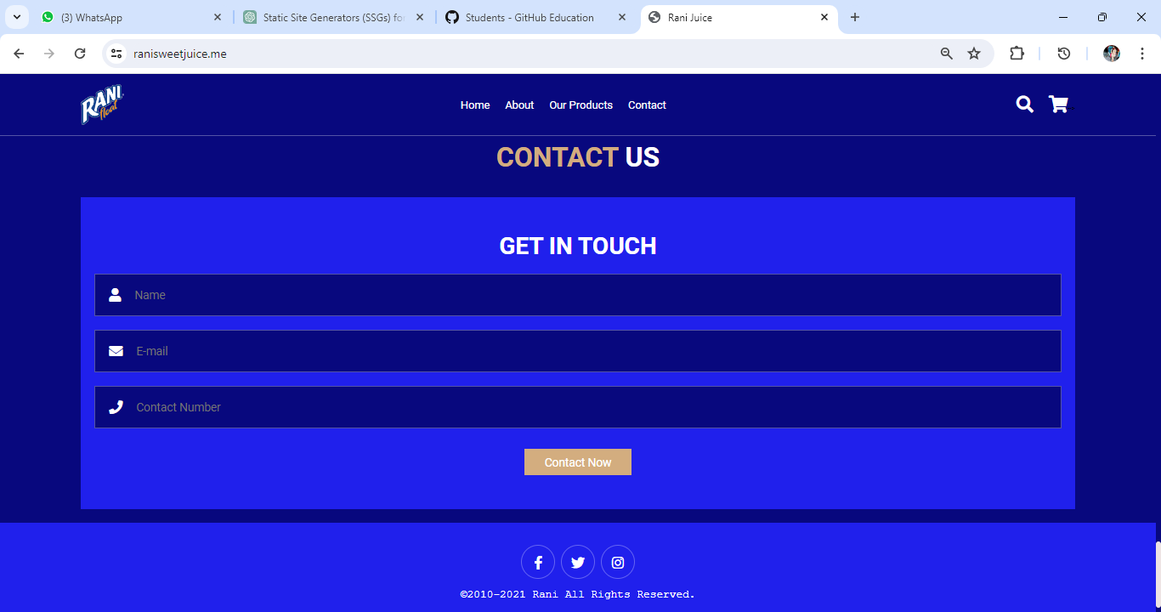

* **Tools and Technology Used:**

These are the Tools and technologies which I used for my project.

* **HTML (**Hyper Text Markup Language**)**
* **CSS** (Cascading Style Sheets)
* **JAVASCRIPT**
* **GIT HUB PAGES**
* **VISUAL STUDIO CODE**
* **NAME CHEAP**
* **GOOGLE SEARCH CONSOLE**
* **SITEMAP**
* **HTML (**Hyper Text Markup Language**):**

I used HTML which is the standard markup language used to create and structure content on the World Wide Web. It provides the building blocks for web pages by defining the structure and layout of text, images, links, and other elements. HTML uses tags to denote different types of content and their relationships, allowing web browsers to interpret and display the content correctly. With HTML, web developers can create the skeletal framework of a web page, including headings, paragraphs, lists, forms, and more. HTML forms the foundation upon which websites are built, serving as the backbone for delivering information and facilitating user interaction on the internet.

* **CSS** (Cascading Style Sheets)**:**

I used CSS to style and format web pages, controlling the visual presentation of HTML elements. It allows web developers to define the appearance of text, images, backgrounds, layouts, and more, ensuring consistency and enhancing the overall aesthetics of a website. With CSS, you can adjust colors, fonts, spacing, borders, and other design aspects, creating visually appealing and user-friendly web experiences across various devices and screen sizes. Additionally, CSS facilitates responsive design, enabling websites to adapt and display optimally on different devices, from desktops to smartphones. Overall, CSS plays a crucial role in defining the look and feel of web content, improving readability, usability, and brand identity.

* **JAVASCRIPT:**

JavaScript is a versatile programming language primarily used for adding interactivity and dynamic behavior to web pages.

I used **JavaScript** because It allows developers to create interactive elements that respond to user actions, such as clicks, taps, and keyboard input, enhancing user experience. With JavaScript, developers can manipulate the Document Object Model (DOM) of a web page, dynamically updating content and structure based on user interactions or other events. JavaScript is also commonly used for asynchronous programming, enabling the execution of non-blocking operations like fetching data from servers or handling user input without disrupting the user interface. Additionally, JavaScript can be employed to create animations, validate user input, manipulate data, and interact with browser APIs, making it an essential tool for building modern web applications.

* **GitHub Pages:**

I host my website using platform like GitHub Pages by following the steps given below:

1. **Create a GitHub Repository:** First of all I created a new repository on GitHub. Name it like this: ‘username.github.io’, where ‘username’ is my GitHub username.
2. **Push Website Files:** I Push my website files (HTML, CSS, JavaScript, images, etc.) to the repository. I Make sure I have an ‘index.html’ file in the root directory, as GitHub Pages will serve this as the homepage by default.
3. **Enable GitHub Pages:** I went to my repository settings on GitHub, scroll down to the GitHub Pages section, and choose the branch I want to publish from (usually ‘main’ or ‘master’). If you're just getting started, you might want to choose the ‘main’ branch.
4. **Wait for Deployment:** GitHub Pages will build and deploy my website. It might take a few moments for changes to go live.
5. **Access Website:** Once deployed, my website was accessible at ‘https://username.github.io’, where ‘username’ is my GitHub username. It may take a few minutes for the changes to propagate.

* **Visual Studio Code:** I need a text editor or an Integrated Development Environment (IDE) for writing and editing my code. So, I used Visual Studio Code for writing and editing my code. Visual Studio Code (VS Code) is a versatile and lightweight code editor used by developers for writing, editing, and debugging code across various programming languages. It offers a customization and user-friendly interface with features like syntax highlighting, code completion, and Git integration. Developers use VS Code for a wide range of purposes, including web development, software engineering, data analysis, and more. Its extensive ecosystem of extensions allows users to tailor the editor to their specific needs, enhancing productivity and facilitating collaboration on projects. Overall, VS Code is a powerful tool that streamlines the coding process and provides a seamless development experience for professionals and beginners alike.
* **NameCheap:**

I used namecheap to purchase domain name for my website. Namecheap is a domain registrar and web hosting provider used by individuals and businesses to secure and manage their online presence. It allows users to register domain names, transfer existing domains, and purchase various web hosting services, including shared hosting, VPS hosting, and dedicated servers. Additionally, Namecheap offers SSL certificates, email hosting, website builders, and other tools to help users create and maintain their websites. With its user-friendly interface, competitive pricing, and reliable customer support, Namecheap is a popular choice for those looking to establish and grow their online presence effectively. Here's a brief guide on how I purchase a domain from Namecheap:

1. **Visit Benefits in GitHub Education:** Go to the Namecheap and create an account.
2. **Search for Desired Domain:** Using the domain search bar on the Namecheap homepage to enter the domain name I want to purchase. Namecheap display available domain options along with their prices.
3. **Select Domain:** Once I've found the domain I want i.e. (.me) I click on the "Add to Cart" button next to it.
4. **Review Cart:** After adding the domain to cart, I review my order to ensure everything is correct.
5. **Proceed to Checkout:** Click on the "View Cart" or "Checkout" button to proceed to the checkout page.
6. **Verify Email:** After completing my purchase, I verify my email address. Namecheap send me a verification email with instructions on how to verify email address.
7. **Access My Domain:** Once my purchase is complete and my email address is verified, I was able to access and manage my domain through Namecheap account dashboard.

* **Google Search Console:**

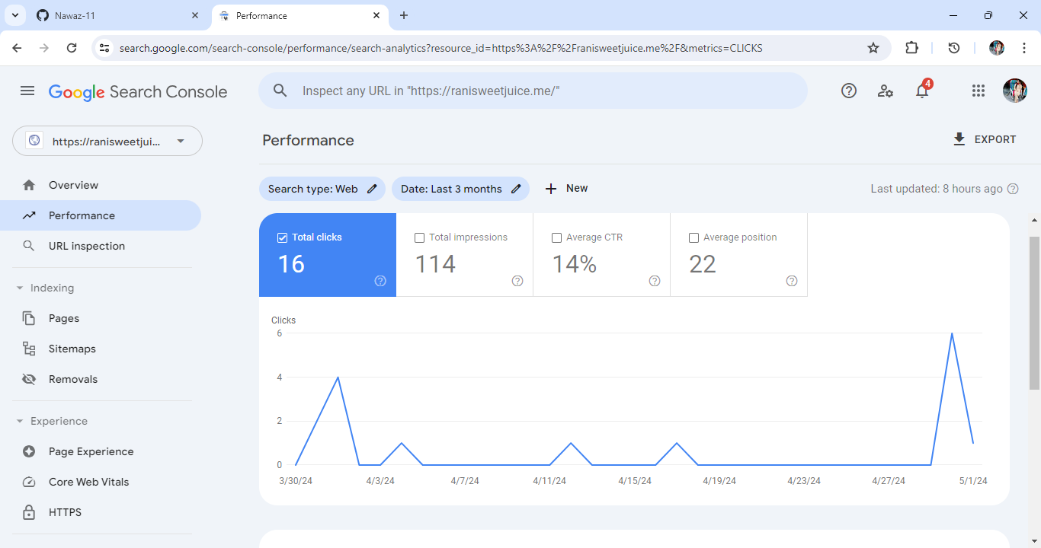I used **Google Search Console** which is a vital tool for website owners and webmasters to monitor and optimize their website's performance in Google search results. It provides valuable insights into how Google views and interacts with your site, including data on search queries, indexing status, crawl errors, and more. By using Search Console, you can identify opportunities to improve your site's visibility, fix technical issues that may impact search rankings, and ensure that your content is being properly indexed and displayed in search results. Ultimately, Google Search Console empowers website owners to enhance their online presence and drive more organic traffic to their site from Google search.

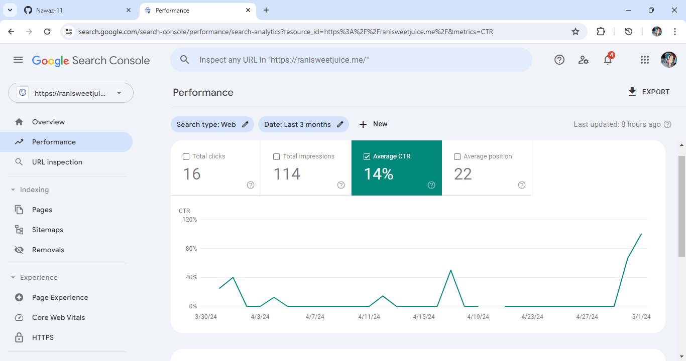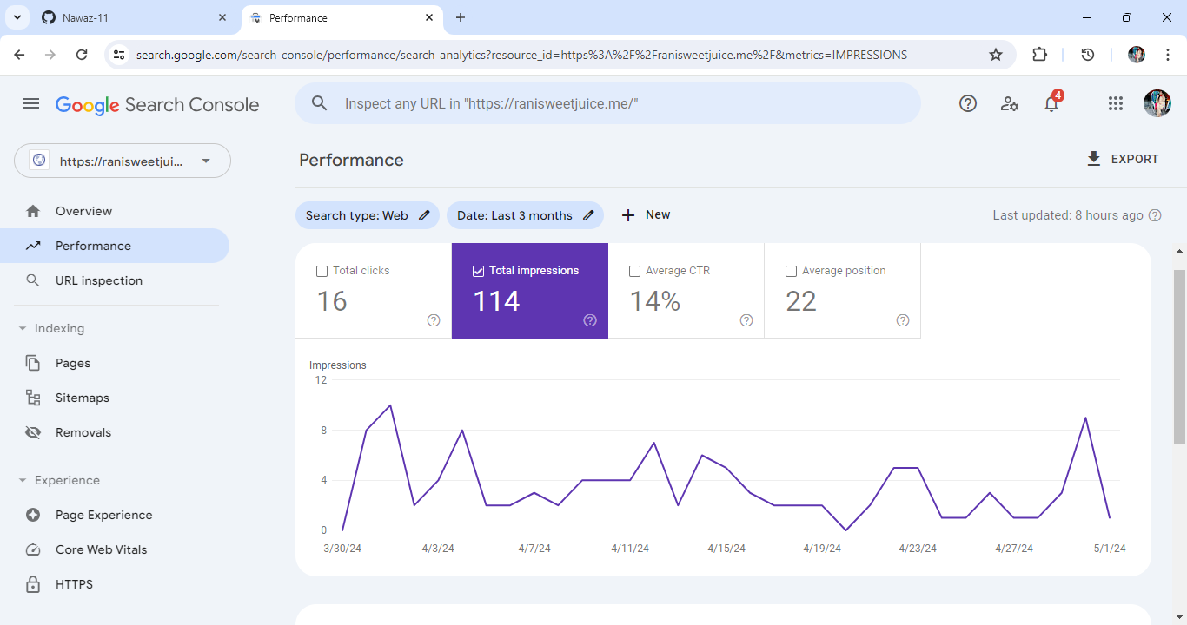

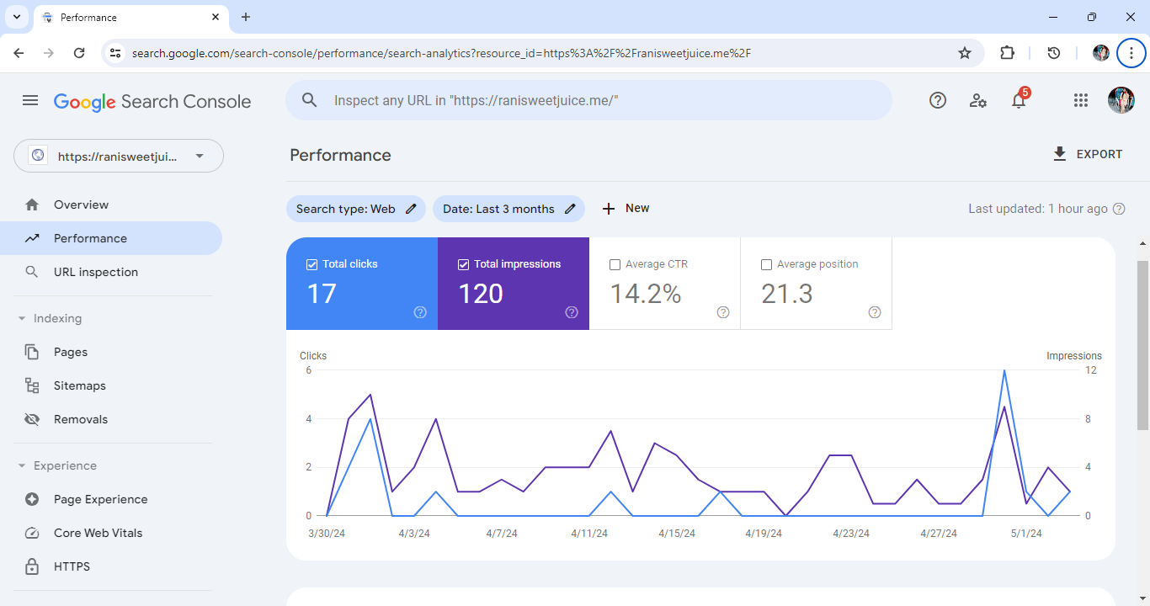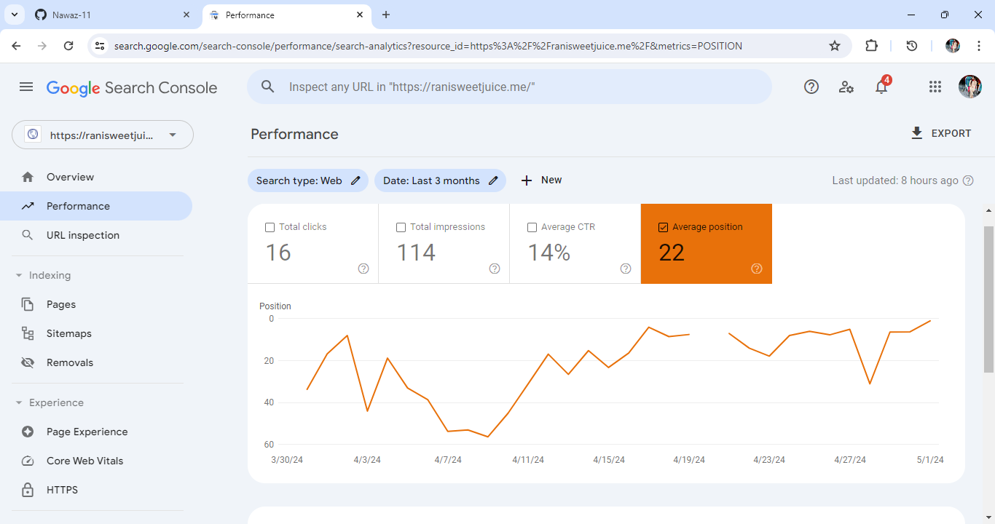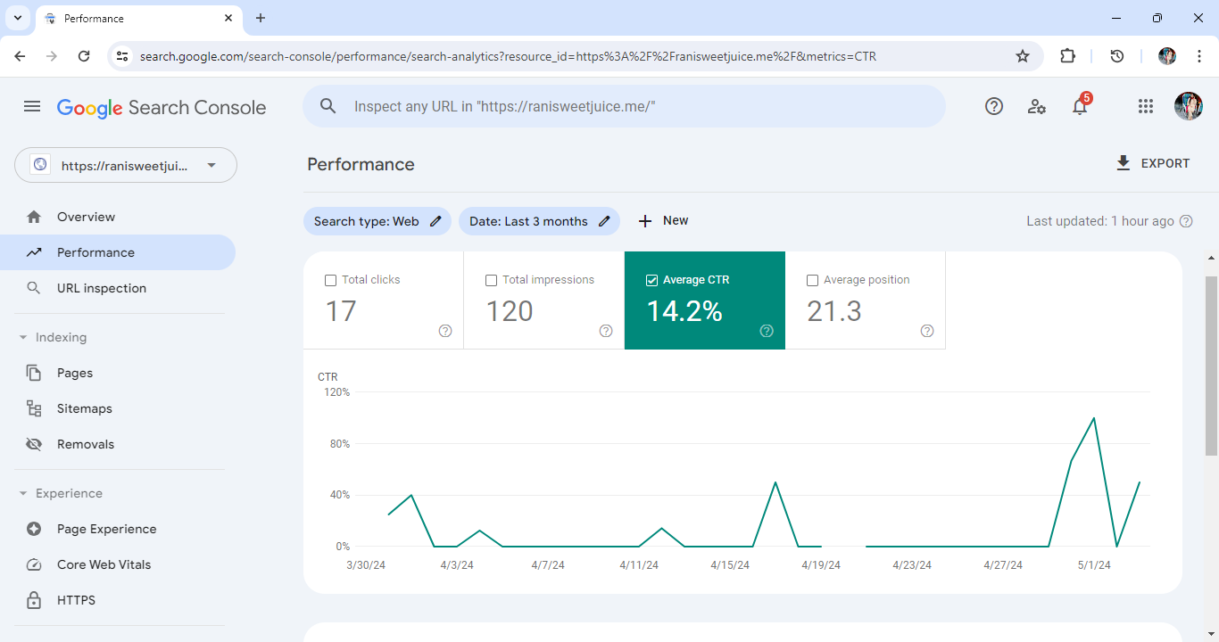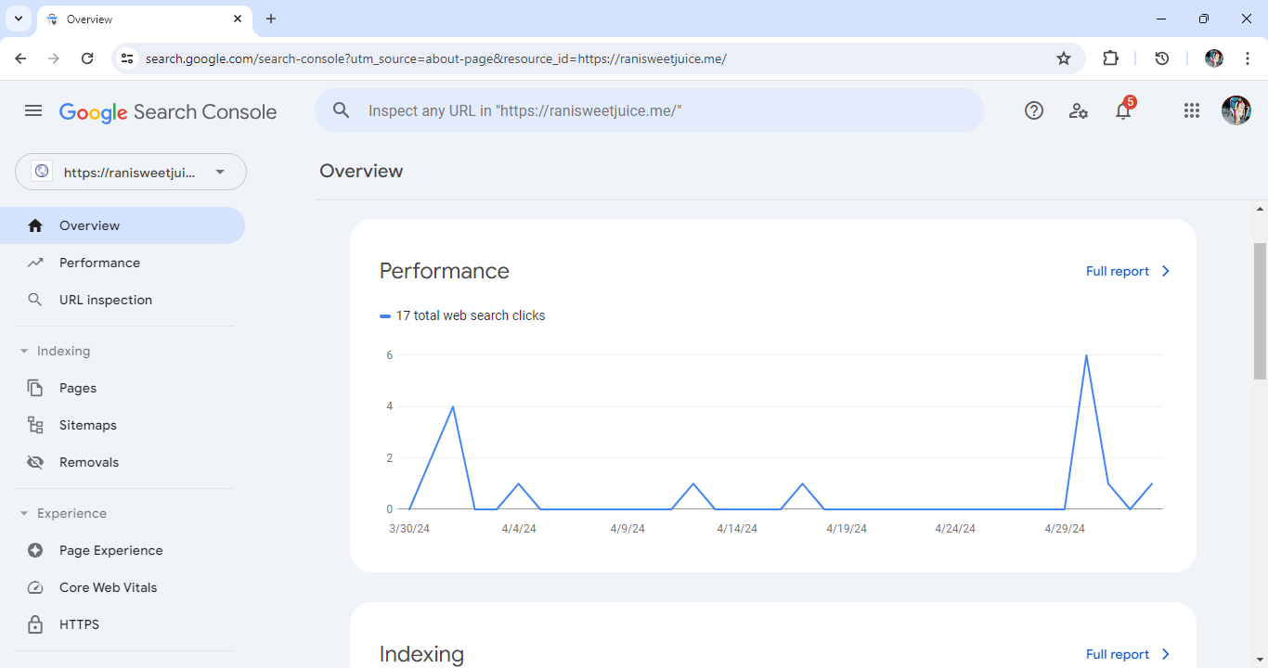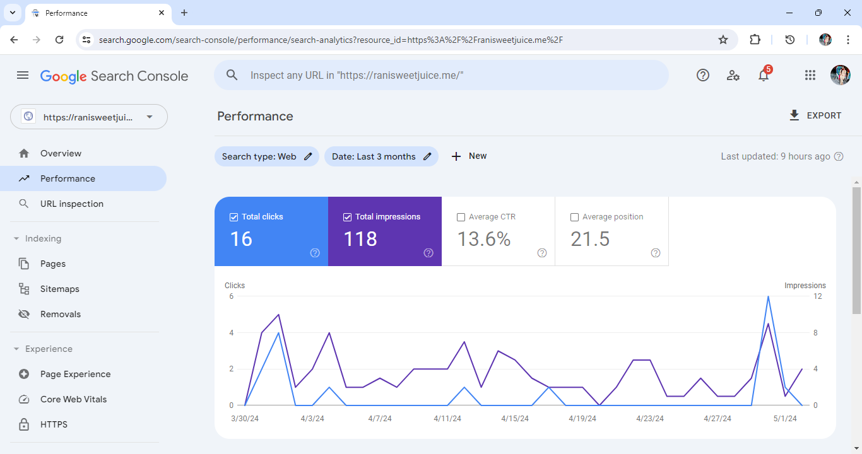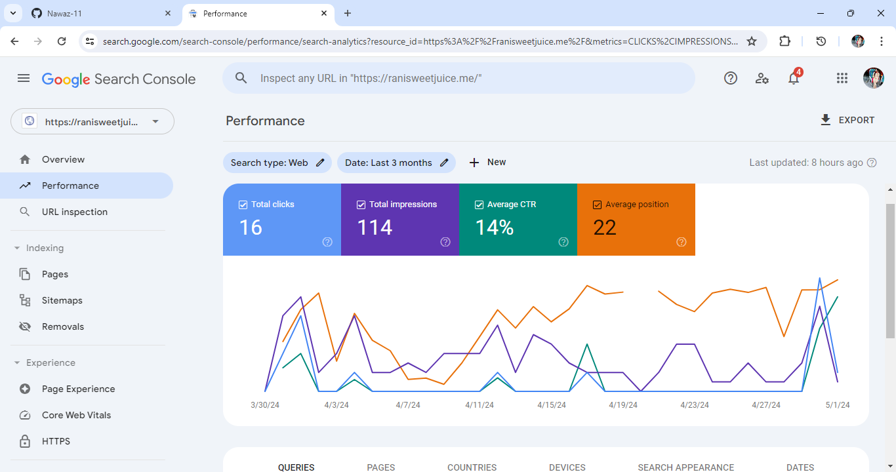

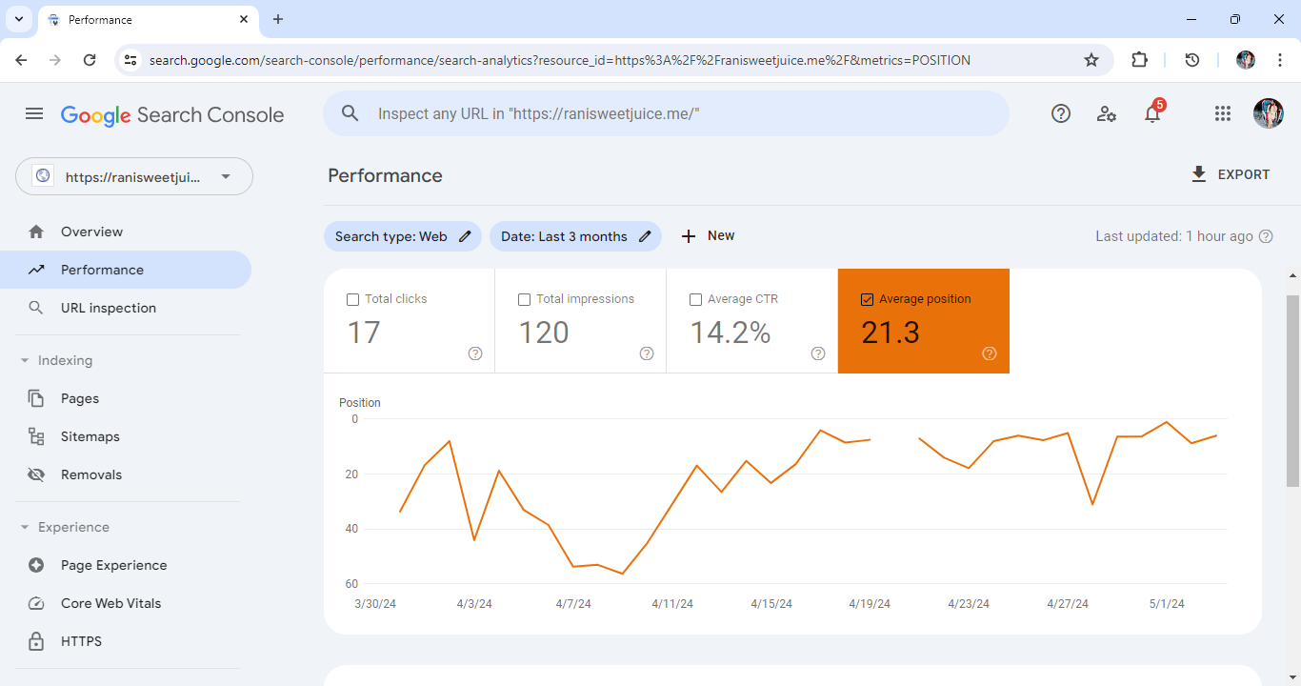

* **SiteMap:**

I used sitemap which is a file that provides a road map of your website's structure to search engines like Google. It lists all the pages on your site, along with metadata such as when each page was last updated and how important it is relative to other pages. By submitting a sitemap to search engines, you help them discover and crawl your website more efficiently, ensuring that all of your pages are indexed and appear in search results. Sitemaps also provide valuable insights into your site's architecture, helping you identify any crawl errors or areas for optimization. Overall, sitemaps play a crucial role in improving the visibility and accessibility of your website to both users and search engines.

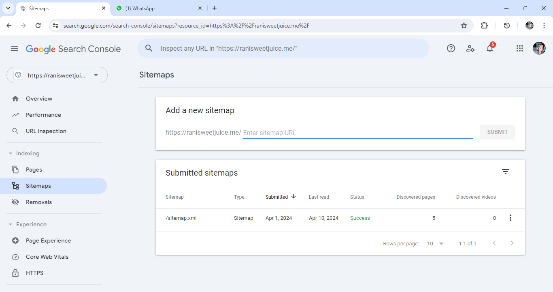

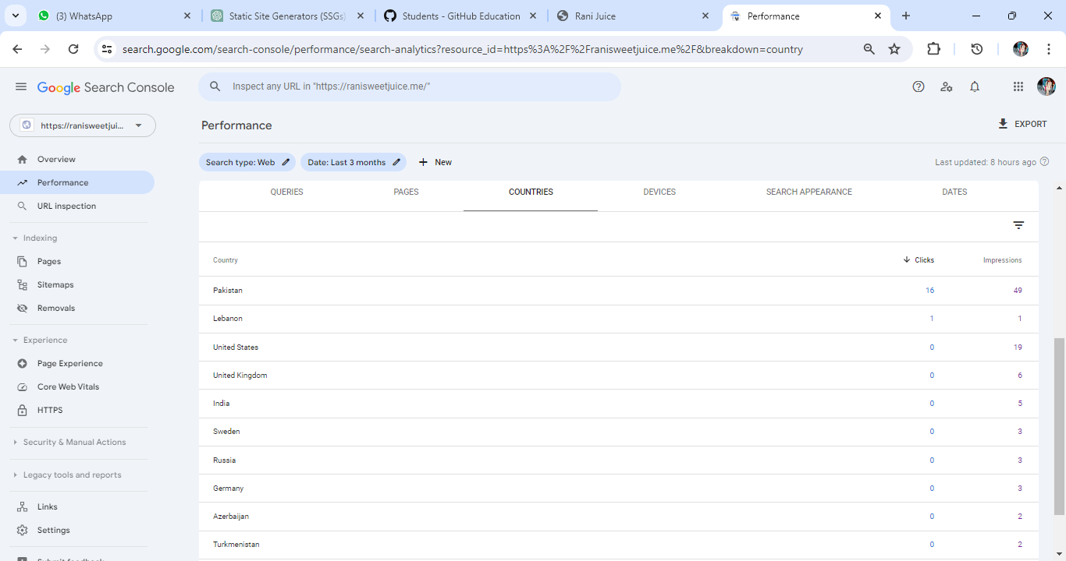

* **Products:**

#### PINEAPPLE:

It’s Made From 100% Natural Pineapple And Is A Refreshing Choice For Those Who Love The Tropical Flavor Of Pineapples. Available In Two Sizes: 180ml And 240ml.

#### ORANGE:

This Refreshing Beverage Packs The Goodness Of Real Oranges. Enjoy The Zesty Flavor Of Rani Orange Juice! Available In Two Sizes: 180ml And 240ml.

#### PEACH:

Once Peach Drink ,Always Peach Drink. Available In Two Sizes: 180ml And 240ml.

#### ORANGE 2X:

Strong And Young, Let's Just Have Fun With Two Times More Floats. Available In Two Sizes: 180ml And 240ml.

#### PEACH 2X:

Once Peach Drink, Always Peach Drink With Two Times More Floats. Available In Two Sizes: 180ml And 240ml.

#### PINEAPPLE 2X:

Happiness Tastes More Like Pineapple With Two Times More Floats. Available In Two Sizes: 180ml And 240ml.

#### PEACH:

Till You Reach The Beach, Drink A Peach. Available In Two Sizes: 180ml And 240ml.

#### ORANGE:

Never Age, Just Change With Orange. Available In Two Sizes: 180ml And 240ml.

#### MANGO:

Crave For Mangoes, Treat Yourself With One. Available In Two Sizes: 180ml And 240ml.

#### APPLE:

Rani Apple Juice Presents A Refreshing Option With Its Crisp And Natural Apple  
Flavor. It Offers A Balance Of Essential Nutrients. Available In Two Sizes: 180ml And 240ml.

#### BANANA:

The Flavor Profile Of Rani Juice Banana Flavor Is Characterized By The Sweet And Creamy Taste Of Ripe Bananas, Reminiscent Of Freshly Blended Banana Smoothies. Available In Two Sizes: 180ml And 240ml.

#### COCKTAIL:

A Refreshing Fusion Of Ripe Mangoes, Tangy Pineapples, And Citrusy Oranges And Lemons, With A Hint Of Floral Essence. Perfectly Balanced And Invigorating, Ideal For Sunny Days Or Social Occasions. Available In Two Sizes: 180ml And 240ml.

#### MANGO BUNDLE:

Rani Juice's Mango Flavor Is A Tropical Delight, Embodying The Essence Of Ripe Mangoes With Its Golden Hue And Refreshing Aroma. Its Perfect Balance Of  
Sweetness And Tanginess Offers A Taste Of Summer In Every Sip.

#### APPLE BUNDLE:

Rani Juice Apple Flavor Captures The Crisp Essence Of Handpicked Apples, Offering A Pure, Balanced Taste. Enjoyed Chilled, It's A Refreshing Choice Alone Or As A Mixer, Promising A Delightful, Authentic Apple Experience For Any Occasion.

#### ORANGE BUNDLE:

Rani Juice's Orange Flavor Offers A Refreshing Burst Of Freshly Squeezed Oranges, Perfect For A Revitalizing Pick-Me-Up, It's A Delightful Treat Whether Enjoyed Alone Or Paired With Snacks.

#### Rani Fruit Drink-Carrot & Orange:

Rani Carrot & Orange Fruit Juice Is Your Refreshing Boost That Packs The Goodness Of Fruits. It’s A Win-Win, Really. Available In Two Sizes: 180ml And 240ml.

#### Rani Fruit Drink–Guava:

Rani Guava Fruit Juice Is Your Refreshing Boost That Packs The Goodness Of Fruits. It’s A Win-Win, Really. Available In Two Sizes: 180ml And 240ml.

#### Rani Fruit Drink–Cocktail:

Rani Fruit Cocktail Juice Is Made From A Blend Of Real Fruit Juices, Giving It A Natural And Fruity Taste. Available In Two Sizes: 180ml And 240ml.

#### Rani Fruit Drink–Pine Apple:

Taste The Delightful Fusion Of Real Pineapple Chunks With Refreshingly Delicious Pineapple Juice. Available In Two Sizes: 180ml And 240ml.

#### Rani Fruit Drink–Tomato:

Made From Real Tomatoes, This Juice Offers A Delightful Blend Of Natural Flavors. Whether You Enjoy It Chilled Or Use It As A Base For  
Mock-tails. Available In Two Sizes: 180ml And 240ml.

#### MANGO With Real Fruit Chunks:

Mango Is The Best, Forget The Rest. Available In Two Sizes: 180ml And 240ml.

#### COCKTAIL With Real Fruit Chunks:

Rani Fruit Cocktail Juice Is A Refreshing And Delicious Beverage That Combines The Flavors Of Various Fruits. Available In Two Sizes: 180ml And 240ml.

#### STRAWBERRY & BANANA With Real Fruit Chunks:

Your Senses Will Be WOWED By This Delightful Fusion Of Ripe Strawberries And Creamy Bananas. Available In Two Sizes: 180ml And 240ml.

#### GUAVA With Real Fruit Chunks:

A Rich Source Of Nutrients And Vitamins, It’s The Perfect Way To Kick Start Your Day. Available In Two Sizes: 180ml And 240ml.

#### PEACH With Real Fruit Chunks:

Rani Peach Juice Presents A Refreshing Option With Its Crisp And Natural Peach Flavor. It Offers A Balance Of Essential Nutrients. Available In Two Sizes: 180ml And 240ml.

#### PINEAPPLE With Real Fruit Chunks:

Contains Real Fruit Pieces, Giving It A Rich And Delectable Taste. Ideal For Long-Lasting Use Due To Its Sturdy Packaging. Available In Two Sizes: 180ml And 240ml.

#### ORANGE With Real Fruit Chunks:

Rani Float Orange Juice Is Sure To Delight. Each Bottle Of Rani Float Orange Juice Is Conveniently Sized At 240ml, Making It Easy To Take On The Go. Available In Two Sizes: 180ml And 240ml.

#### Rani No Added Sugar Orange:

A Delightful Blend Of Refreshing Citrus Flavor Without The Guilt Of Added Sugar. Crafted With Care, This Tangy Beverage Offers The Perfect Balance Of Sweetness And Tanginess,  
Made From The Finest Oranges Handpicked From Orchards.

#### Rani No Added Sugar Mango:

Experience The Luscious Taste Of Ripe Mangoes Without Any Added Sugar. Sourced From The Finest Orchards, Our Mangoes Are Handpicked At The Peak Of Freshness To Ensure Premium Quality And Flavor.

#### Rani No Added Sugar Apple:

Rani No Added Sugar Apple" Is A Delectable Treat For Health-Conscious Individuals Who Desire The Natural Sweetness Of Apples Without The Added Sugars. Crafted With Precision And Care, Our Product Ensures That You Enjoy The Pure Essence Of Ripe, Juicy Apples Without Compromising On Flavor Or Nutrition.

#### Peach Fruit Drink:

Rani Peaches Are Prized For Their Delicious Taste, Juicy Texture, And Versatility In The Kitchen, Making Them A Favorite Among Peach Enthusiasts.

#### Pear Fruit Drink:

Refreshing Blend Of Fresh Pear Juice With Water And Sweeteners For A Naturally Sweet And Fruity Flavor. Light, Crisp Texture And Pleasant Aroma.

#### Red Grape Fruit Drink

Rani Red Grape Drink Is A Sweet, Fruity Beverage Made From Ripe Red Grapes, With A Deep Red Or Purple Color. Enjoyed Chilled, It's Perfect For Hot Days Or As A Meal Accompaniment.

#### Rani Three Jewels

The Rani Three Jewel Drink Is A Refreshing Blend Of Ripe Mango, Juicy Lychee, And Exotic Passion Fruit Flavors. Each Sip Offers A Symphony Of Fruity Goodness, Transporting You To A Tropical Paradise.

#### GUAVA:

Rani Juice's Guava Flavor Is A Delightful Blend Of Ripe Guavas. Its Vibrant Pink Hue Reflects The Fruit's Natural Vibrancy, Promising A Visual Treat.

#### Rani Float Mango Juice 240ml Pack Of 6:

Perfect For Those Seeking A Healthier Alternative, Rani Float Mango Juice Offers All The Natural Sweetness And Goodness Of Mangoes, Without Any Compromise.

#### Rani Float Orange Juice 240ml Pack Of 6:

Indulge In The Refreshing Taste Of Rani Float Orange Juice, Now Conveniently Available In A Pack Of 6 Bottles, Each Containing 240ml Of Pure Delight.

#### Rani Float Peach Juice 240ml Pack Of 6:

Indulge In The Delightful Taste Of Rani Float Peach Juice, Now Available In A Convenient  
Pack Of 6 Bottles, Each Containing 240ml Of Pure Refreshment.

#### No Sugar Mango Juice 250ml Pack Of 9:

Rani No Added Sugar Mango Juice Is A Delicious And Refreshing Beverage That Comes In A Convenient 250ml Pack Of 9. Made With Real Mangoes, This Juice Is Bursting With Natural Flavours And Sweetness, Without Any Added Sugar.

#### No Sugar Apple Juice 250ml Pack Of 9:

Rani No Added Sugar Apple Juice, The Perfect Blend Of Health And Taste. Our 250ml Pack Of 9 Bottles Ensures You Have  
A Refreshing Burst Of Natural Apple Goodness Whenever You Need It.

#### **Rani Spark Fruity Punch-Pack Of 24:**

A Burst Of Refreshing Flavor With Rani Spark Fruity Punch! Our Vibrant Concoction Blends The Essence Of Ripe Tropical Fruits With A Fizzy Twist, Creating A Delightful Symphony Of Taste And Energy.

#### Rani Spark Apple Burst-Pack Of 24:

Experience The Electrifying Fusion Of Crisp Apple Flavor With A Burst Of Refreshing Energy.Crafted With Precision And Innovation, Rani Spark Apple Burst Tantalizes Your Taste Buds With Its Invigorating Blend, Delivering A Delightful And Revitalizing Sensation With Every Sip.

#### Rani Juice Pack Of 24 -Peach Flavour:

Experience The Pure Bliss Of Summer In Every Sip With Rani Peach Juice. Add A Touch Of Sunshine To Your Day And Elevate Your Refreshment Game With This Irresistible Peachy Delight.

* **Github link:**

<https://github.com/Nawaz-11/ranijuice.git>

* **Website Link:**

<https://ranisweetjuice.me/>

* **REFRENCES:**

<https://ranimania.com/en/>

<https://raniworld.com/ae/rani-juices/>