TEST AGENCY

MONTHLY SEO REPORT
────────────────────────────────────

Test Client Inc.
June 2026

Generated: 2026-06-13T12:00:00
CONFIDENTIAL

Executive Summary
Test Client Inc. showed solid organic growth this month with 2 new #1 rankings and 12% growth in clicks. Mobile Core Web Vitals need attention (score: 62/100). Backlink profile: 156 links from 42 domains.

Executive Dashboard
At-a-glance view of your search performance this period.
Keywords Tracked | #1 Rankings | Top 3 | Top 10
25 | 1 | 3 | 7
+4 Improved | 2 Dropped | 2 Stable
Mobile CWV: 62/100 | Desktop CWV: 85/100 | Tech Health: 72/100

- Keywords: 8 tracked | #1: 1 | Top 3: 3 | Top 10: 7
- Mobile CWV: 62/100 (below 90 threshold)
- Tech health: 72/100

Core SEO Metrics
How your page's foundational SEO elements are configured for search engines and users.
Element | Value | Status
Title Tag | Test Client Inc. - Luxury Products & Services (45 chars) | Good
Meta Description | Discover premium products from Test Client Inc. with free shipping worldwide. (77 chars) | Needs Improvement
H1 Headings | 1 H1 tag(s) found | Good
H1 Text | Welcome to Test Client Inc. | —
Word Count | 650 words | Good

Recommendations:
- Meta description is 77 characters (ideal: 120-160). Adjust to avoid truncation in SERPs.

Backlinks & Authority
Your website's external link profile and internal link distribution.
Metric | Value
Total Backlinks | 156
Referring Domains | 42
Follow Links | 98
Nofollow Links | 58

Internal Link Distribution:
Total | Internal | External
47 | 32 | 15

- Your site has 156 backlinks from 42 domains.
- 32 internal links help distribute page authority and guide users through your site architecture.

Marketing & Usability
Social sharing, crawl access, and technical foundation checks.
Check | Status
Open Graph Tags | Yes
robots.txt | Found
XML Sitemap | Found

- Open Graph tags are properly configured — your pages will display rich previews on Facebook, LinkedIn, and Twitter/X.
- robots.txt is accessible — search engines can find your crawl directives.
- XML sitemap detected — helps Google discover and index your pages efficiently.

Google Search Console Performance
Month-over-month comparison of how users discover your website through Google search.
Metric | Value
Total Clicks | 2450
Total Impressions | 45200
Clicks Change | 12%
Impressions Change | 8%

GSC metrics:
- Impressions: 45200
- Clicks: 2450
- Clicks change: 12
- Impressions change: 8

Search Visibility & Brand Keyword Rankings
How your brand and product keywords perform in Google search results.
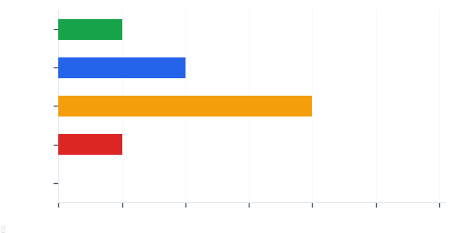

- Keywords tracked: 8 | #1: 1 | Top 3: 3 | Top 10: 7
- Movement: +4 improved, 2 dropped, 2 stable

Current keyword positions (top 10 shown):
Keyword | Position | Change | Intent
luxury perfume brand india | 2 | 0 | high
premium body care products | 3 | +1 | medium
organic essential oils | 5 | -1 | medium
natural fragrance for men | 1 | +2 | low
best attar perfume online | 8 | 0 | high
sandalwood oil for skin | 12 | +3 | medium
rose water face mist | 4 | -2 | low
herbal shampoo natural | 7 | +1 | medium

Top Performing Keywords
These keywords gained the most positions this month — a sign that your content and SEO efforts are paying off.
Keyword | Position | Gain | Intent
sandalwood oil for skin | 12 | +3 | medium
natural fragrance for men | 1 | +2 | low
premium body care products | 3 | +1 | medium
herbal shampoo natural | 7 | +1 | medium

Biggest gains:
- 'sandalwood oil for skin' +3 positions (now #12)
- 'natural fragrance for men' +2 positions (now #1)
- 'premium body care products' +1 positions (now #3)

Keywords Needing Attention
These keywords dropped in position and need targeted content optimization to recover.
Keyword | Position | Drop | Intent
rose water face mist | 4 | -2 | low
organic essential oils | 5 | -1 | medium

Recommended actions:
- 2 keywords dropped — assign content refresh per keyword.

Local SEO — Google My Business
How your GMB profile performs for local searches. This directly drives foot traffic to your flagship store and local discovery of your brand.

Core Web Vitals
Google's user experience metrics — directly impact search rankings and how users experience your website.
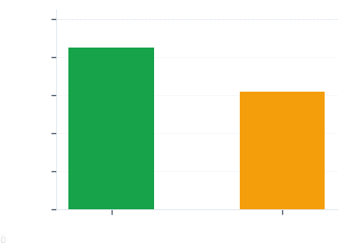
Device | Score
Desktop | 85/100 (Needs Work)
Mobile | 62/100 (Needs Work)

- Desktop: 85/100 | Mobile: 62/100 | LCP: 3.2s | INP: 180ms | CLS: 0.15

Technical SEO Health
A technical audit identifies issues that may prevent search engines from properly crawling, indexing, and ranking your pages.
Health Score: 72/100
Category | Count
Pages Audited | 5
Missing H1 | 2
Missing Meta | 1
Missing Alt Tags | 4
Thin Pages | 1

- 2 pages are missing H1 headings — these are important for both SEO and accessibility.
- 1 pages are missing meta descriptions — adding them improves click-through rates from search results.
- 4 images lack alt text — this is a quick fix that improves accessibility and image search visibility.

Issues Detected (3 found):
Severity | Issue | Page
HIGH | Missing H1 tag | https://example.com/
CRITICAL | Broken link (404) | https://example.com/about
MEDIUM | Thin content (<200 words) | https://example.com/contact

Critical issues (1) will be prioritized this week — these directly impact how Google crawls and indexes your site.

Recommendations & Strategy for Next Month
Prioritised actions for the coming period, organised by urgency and impact.

Priority breakdown for execution:
P0 — Immediate (This Week)
- [Dev] Fix broken 404 links on /about page ETA: Week 1

P1 — High Priority (Next Week)
- [SEO] Add missing H1 tags to 2 pages ETA: Week 1
- [Content] Rewrite thin content on /contact (target 500+ words) ETA: Week 2

P2 — Medium (This Sprint)
- [SEO] Build 5 new backlinks from industry directories ETA: Week 3

Action Plan by Team
Who owns what — every action item assigned to a specific team with priority level.
Team | Tasks | Top Priority
SEO | 2 | P1
Dev | 1 | P0
Content | 1 | P1
Local | 0 | —
Off-Page | 0 | —

Team responsibilities:
• SEO: Keyword optimisation, technical fixes, site structure
• Dev: CWV improvement, site performance, technical implementation
• Content: Content creation, keyword recovery, blog strategy
• Local: GMB management, local listings, review responses
• Off-Page: Link building, outreach, social bookmarking, PR SEO

Summary & Next Steps
This audit covered 8 tracked keywords, 1 at #1, 7 in top 10, 5 pages audited.

Priorities for the upcoming period:
- Recover rankings for 2 dropped keywords
- Improve mobile CWV from 62/100 (LCP at 3.2)
- Fix critical issues: Broken link (404)

This report was prepared exclusively for Test Client Inc. by Test Agency. For questions or a walkthrough of any section, please reach out to your account manager.

