TECHNICAL SEO AUDIT
────────────────────────────────────

Test Client Inc.
June 2026
Generated: 2026-06-13T12:00:00

Executive Summary
Test Client Inc. showed solid organic growth this month with 2 new #1 rankings and 12% growth in clicks. Mobile Core Web Vitals need attention (score: 62/100). Backlink profile: 156 links from 42 domains.

Technical Dashboard
At-a-glance technical health metrics from the automated crawl.
Tech Health | Pages Audited | Total Issues
72/100 | 5 | 3

Issue Category | Count
Missing H1 | 2
Missing Meta Descriptions | 1
Missing Alt Tags | 4
Thin Pages | 1
Schema Markup | —

Core Web Vitals
Google user experience metrics — directly impact search rankings.
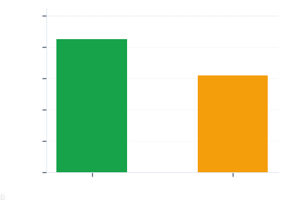
Device | Score | Status
Desktop | 85/100 | Needs Work
Mobile | 62/100 | Needs Work

Lab Metrics: LCP: 3.2s | INP: 180ms | CLS: 0.15

Core SEO Metrics
Foundational on-page elements parsed from the rendered DOM.
Element | Value | Status
Title | Test Client Inc. - Luxury Products & Services (45 chars) | Good
Meta Desc | Discover premium products from Test Client Inc. with free shipping worldwide. (77 chars) | Needs Work
H1 Tags | 1 found | Good
H1 Text | Welcome to Test Client Inc. | —
Word Count | 650 | Good

Internal Link Health
Link distribution and health from the initial page crawl.
Total | Internal | External | Healthy
47 | 32 | 15 | 44

Broken/Redirect URLs (1 found):
- [Critical] Broken link (404): https://example.com/about

Backlink Profile
External backlink data from automated checks.
Metric | Value
Total Backlinks | 156
Referring Domains | 42
Follow Links | 98
Nofollow Links | 58

Issues Log
All detected issues (3 total).
Severity | Issue | Page
HIGH | Missing H1 tag | https://example.com/
CRITICAL | Broken link (404) | https://example.com/about
MEDIUM | Thin content (<200 words) | https://example.com/contact

Recommendations
4 recommended fixes — 1 critical — 2 high priority.
Critical (This Week)
- [Dev] Fix broken 404 links on /about page ETA: Week 1

High Priority (Next Week)
- [SEO] Add missing H1 tags to 2 pages ETA: Week 1
- [Content] Rewrite thin content on /contact (target 500+ words) ETA: Week 2

Medium (This Sprint)
- [SEO] Build 5 new backlinks from industry directories ETA: Week 3

