Project Title: Travel Blog Website

**Objective:**

The objective of the travel blog project is to create a dynamic and engaging website that allows users to explore and share their travel experiences. This website will serve as a platform for travelers to document their journeys, share travel tips, and connect with like-minded individuals. The main goals of the project include:

1. User-Friendly Experience: Create a user-friendly interface that encourages users to explore and contribute to the travel blog.

2. Content Creation: Enable users to easily create and manage their travel blog posts, including text, images, and videos.

3. Community Building: Facilitate the creation of a vibrant online travel community where users can interact, share experiences, and connect with fellow travelers.

4. Monetization: Implement features for potential monetization, such as ads, sponsorships, or premium content.

**Design Thinking Process:**

1. Empathize: Understand the needs and desires of the target audience, which may include travel enthusiasts, tourists, and adventure seekers. Conduct user interviews and surveys to gather insights into their preferences and pain points.

2. Define: Create user personas to represent different segments of the target audience. Clearly define the project's objectives, scope, and success criteria. Identify key features that users expect from a travel blog website.

3. Ideate: Brainstorm ideas for features and functionalities based on user feedback and needs. Explore design concepts and create wireframes and mockups to visualize the user interface and user experience.

4. Prototype: Develop a functional prototype of the website to test the usability and gather feedback. This may involve creating a minimal viable product (MVP) to validate the concept.

5. Test: Gather user feedback through usability testing, A/B testing, and surveys. Analyze the data to refine the design and functionality based on user preferences.

6. Implement: Develop the full website based on the refined design and functionality. This phase includes frontend and backend development, database integration, and content management system (CMS) implementation.

7. Test and Iterate: Perform thorough testing to identify and fix any bugs or issues. Continuously iterate on the design and functionality based on user feedback and testing results.

8. Launch: Deploy the travel blog website to a production server, making it accessible to users. Promote the launch through various marketing channels.

**Development Phases:**

1. Planning:

- Project scoping and requirements gathering.

- Technology stack selection (e.g., web development frameworks, CMS).

- User story and feature prioritization.

- Creation of a project timeline and budget.

2. Design:

- Creation of wireframes and mockups.

- User interface (UI) and user experience (UX) design.

- Selection of color schemes, fonts, and branding elements.

- Development of the information architecture.

3. Development:

- Frontend development: Implement the website's layout, design, and interactivity using HTML, CSS, and JavaScript.

- Backend development: Develop server-side logic, user authentication, content management, and database integration.

- Content creation and management system implementation.

- Integration of third-party services (e.g., social media sharing, payment gateways).

4. Testing:

- Usability testing to ensure a smooth user experience.

- Performance testing for site speed and responsiveness.

- Security testing to protect against vulnerabilities.

- Compatibility testing across different browsers and devices.

5. Launch:

- Deployment of the website to a production server.

- DNS configuration and domain setup.

- Monitoring tools implementation for performance tracking.

6. Post-Launch and Maintenance:

- Continuous monitoring of site performance and user feedback.

- Regular updates and feature enhancements based on user needs.

- Security updates and patches.

- Marketing and user engagement strategies.

The travel blog project follows a user-centric design thinking process and progresses through various development phases to achieve its objectives of creating a user-friendly, content-rich, and engaging platform for travelers. The iterative nature of design thinking allows for continuous improvement based on user feedback, ensuring a successful and evolving travel blog website.

**Website Structure:**

The travel blog website structure includes the following main pages: Home, Destinations, Blog, About, and Contact. Each of these pages serves a specific purpose and provides a clear navigation path for users.

1. Home Page:

- Introduction to the website, its mission, and featured content.

- Eye-catching visuals, possibly a carousel or hero image, to grab visitors' attention.

- Links or teasers to recent blog posts or popular destinations.

- A search bar or filtering options to help users find relevant content quickly.

2. Destinations Page:

- A dedicated page showcasing a list of popular travel destinations.

- Thumbnails or images representing each destination.

- Clickable links or buttons that lead to detailed destination pages with information and related blog posts.

3. Blog Page:

- The main hub for all blog posts and travel stories.

- A grid or list layout displaying blog post titles, excerpts, and publication dates.

- Categories or tags to help users filter and find specific types of travel content.

4. About Page:

- Information about the website, its founders, and the mission behind the platform.

- Author bios and profiles for transparency and credibility.

- Any awards or recognition received by the website.

5. Contact Page:

- A dedicated page with a contact form for user inquiries or feedback.

- Contact details, such as an email address, for direct communication.

- Possibly links to the website's social media profiles for additional contact options.

**Content Creation:**

1. User Profiles:

- Registered users can create and manage their own profiles.

- Users provide personal details, a profile picture, and information about their travel interests.

2. Blog Post Creation:

- Registered users can create and publish their travel blog posts.

- Post editor with rich text formatting options for creating engaging content.

- Ability to upload and embed images and videos within the posts.

- Option to specify the destination or location of the travel experience.

- Scheduling feature for posts to be published at a later date.

**Technical Implementation Details:**

1. Web Development Stack:

- Frontend: HTML, CSS, JavaScript, and a frontend framework (e.g., React, Angular, or Vue.js).

- Backend: Server-side scripting using a programming language (e.g., Python, Ruby, or Node.js).

- Database: A relational database (e.g., MySQL, PostgreSQL) for storing user data and content.

2. Content Management System (CMS):

- Use of a CMS like WordPress or a custom-built solution for managing blog posts and user profiles.

3. User Authentication:

- Secure user registration and login systems with authentication libraries or frameworks.

- Integration of social media login options (e.g., Facebook, Google) for user convenience.

4. File and Media Storage:

- Cloud-based storage solutions (e.g., Amazon S3, Google Cloud Storage) for hosting and serving images and videos.

5. Search and Filtering: - Implementation of search and filtering functionalities to enable users to find specific content, such as posts related to destinations.

6. Security:

- Robust security measures to protect against common web vulnerabilities.

- Regular security updates and monitoring for the website's safety.

7. Responsive Design:

- Ensuring the website is responsive and mobile-friendly for users on various devices.

8. Hosting and Deployment:

- Selection of a web hosting provider and server setup.

- Continuous integration and continuous deployment (CI/CD) for efficient updates and maintenance.

This technical implementation, combined with the website structure and content creation features, will create a functional and user-friendly travel blog platform for users to explore, share, and engage with travel-related content.

**Photos of User Interface**

Home Page

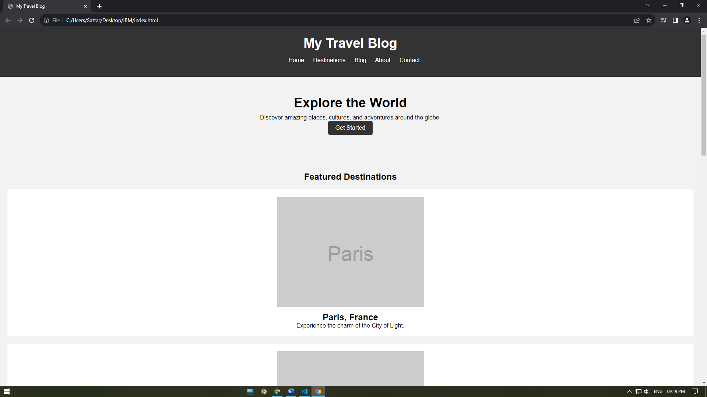

Destinations Page

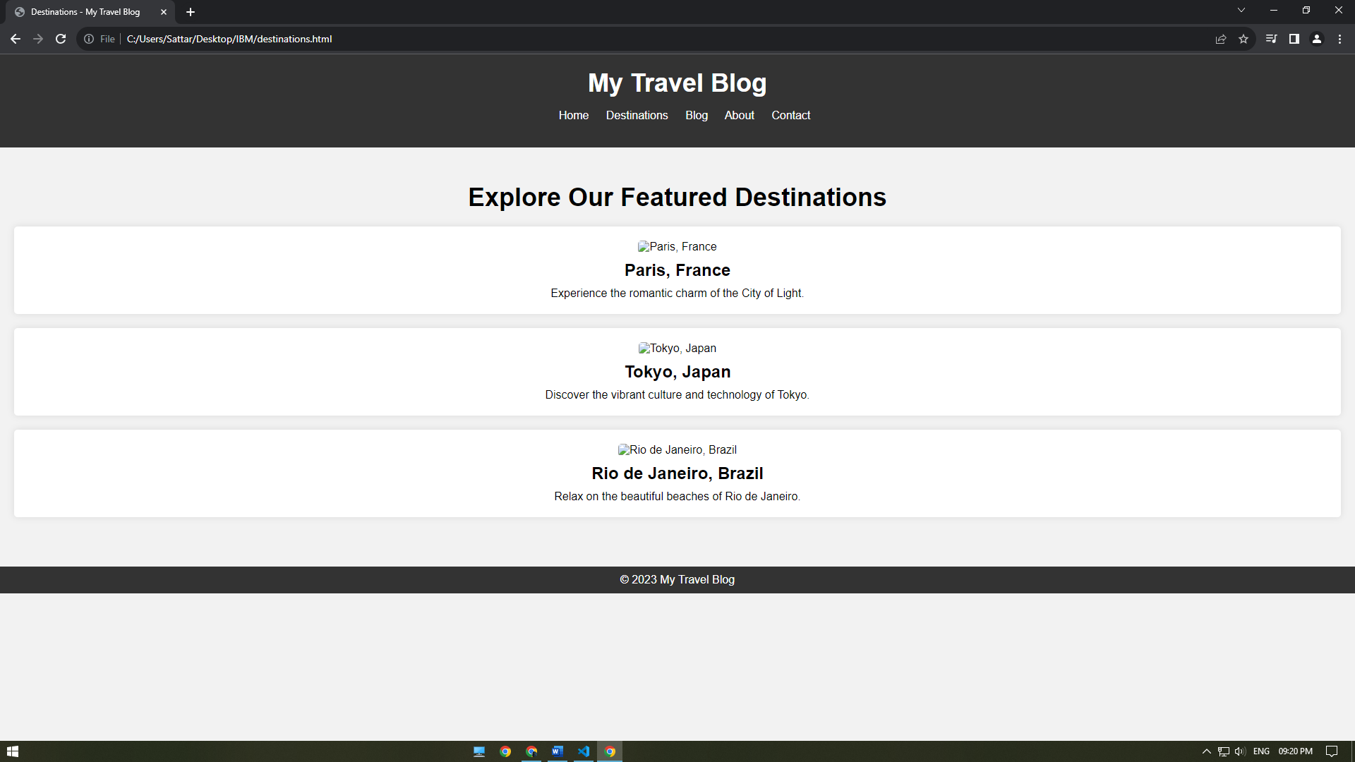

Blog Page

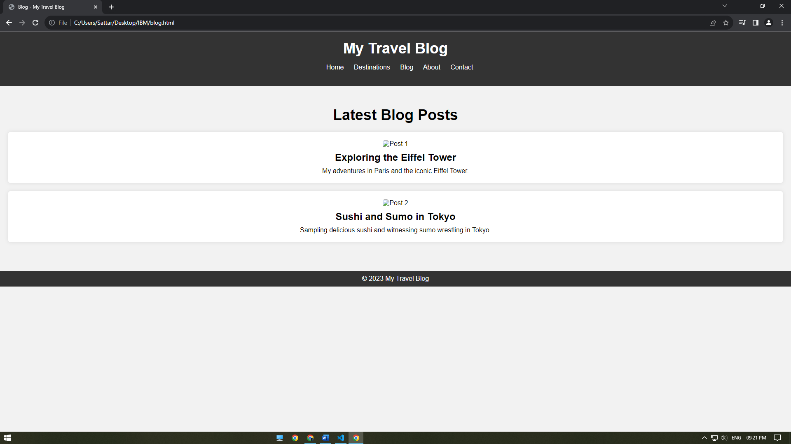

About Page

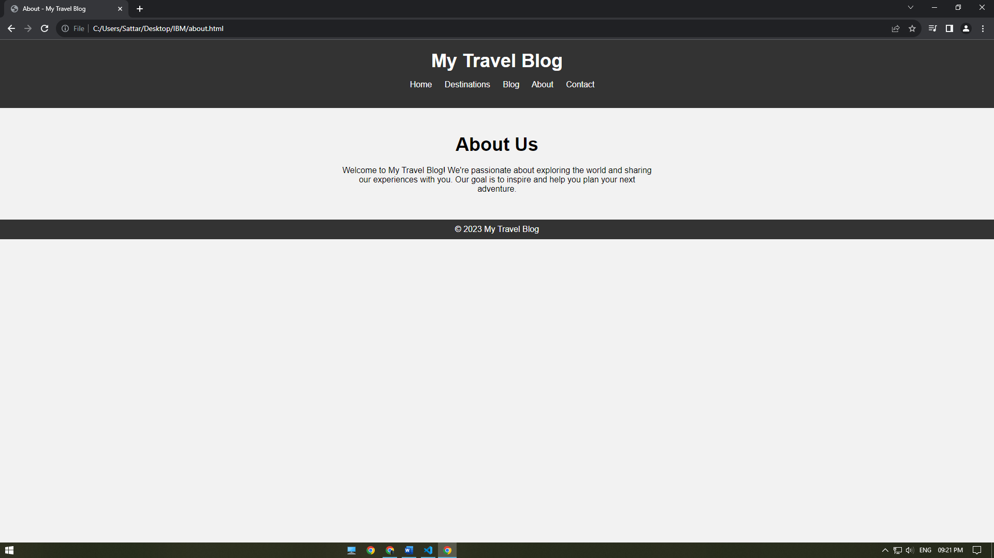

Contact Page

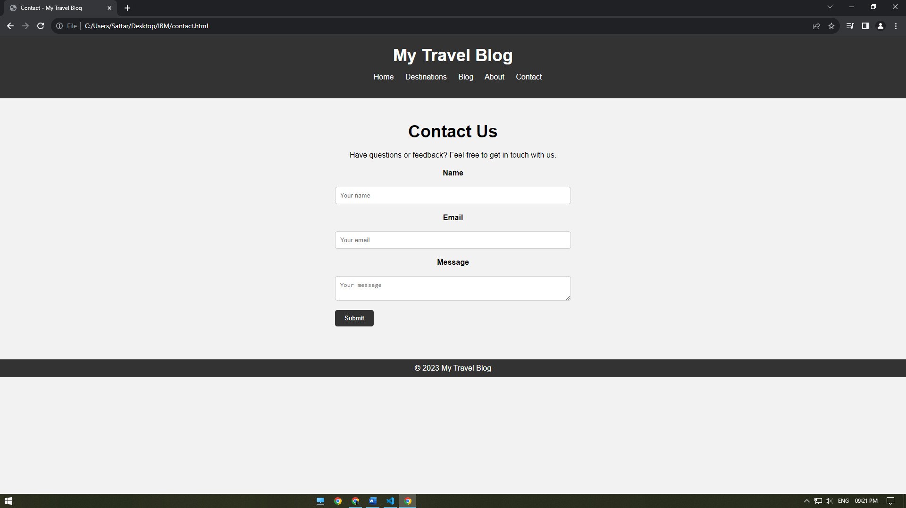

Here are the general steps to deploy a static blog using a service like IBM Cloud Static Web Apps:

1. Create Your Static Website:

- Develop your static website or blog using HTML, CSS, JavaScript, and any other static assets.

- Ensure that your website is organized in a folder structure with an `index.html` file as the main entry point.

2. Create a GitHub Repository:

- You'll need a version control system to manage your code. Create a GitHub repository for your project if you haven't already.

3. Push Your Code to GitHub:

- Push your static website code to your GitHub repository. Ensure that your GitHub repository contains all the necessary files and folders.

4. Set Up IBM Cloud Account:

- If you don't have an IBM Cloud account, sign up for one.

5. Install IBM Cloud CLI:

- Install the IBM Cloud Command Line Interface (CLI) on your local machine.

6. Install Node.js and npm:

- Some static site hosting services require Node.js and npm. Make sure you have them installed.

7. Install the IBM Cloud Static Web Apps CLI:

- If it's not pre-installed, install the IBM Cloud Static Web Apps CLI. You can usually do this using npm:

```bash

npm install -g @cloudflare/wrangler

```

8. Login to IBM Cloud:

- Open your terminal and log in to your IBM Cloud account using the CLI:

```bash ibmcloud login ```

9. Create a Static Web App on IBM Cloud:

- Use the IBM Cloud CLI to create a new static web app. You'll need to provide some basic information and connect your GitHub repository during this process. The exact command might differ based on the current interface. Refer to IBM Cloud's documentation for the most up-to-date command.

10. Configure Your App:

- Configure your app settings, such as the build and output directory if needed. You can specify the directory that contains your static files (e.g., `public` or `dist`).

11. Build and Deploy Your App:

- Build your static website using your preferred build process (if necessary).

- Deploy your app to IBM Cloud Static Web Apps using the CLI.

12. Configure Custom Domain (Optional):

- If you have a custom domain, configure the necessary DNS settings in your domain registrar to point to your IBM Cloud Static Web App.

13. Testing and Monitoring:

- Test your deployed website thoroughly to ensure everything is working as expected.

- Set up any necessary monitoring and error tracking.

14. Scaling and Maintenance:

- As your blog grows, you may need to scale your hosting plan to accommodate increased traffic.

- Regularly update and maintain your website.

Please keep in mind that IBM Cloud's interface and CLI commands may have changed or been updated since my last knowledge update. Refer to IBM Cloud's official documentation and support for the most accurate and current information on deploying a static blog using IBM Cloud Static Web Apps.

**Important**

Travel Blog Website

Welcome to the Travel Blog website! This README will guide you on how to navigate the website, update its content, and manage any dependencies.

Navigation

Home

- The Home page is your starting point. It provides an overview of the website's purpose and showcases featured content. You can scroll through the homepage to discover compelling travel stories and destinations.

Blog

- The Blog page lists all published blog posts. Click on a post to read it in detail. You can also filter posts by categories or tags to find specific content that interests you.

Destinations

- Discover our curated list of popular travel destinations on the Destinations page. Click on a destination to access detailed information and related blog posts.

About

- Learn more about the website and the team behind it on the About page. This section provides insights into our mission and values.

Contact

- If you have questions, suggestions, or feedback, the Contact page is the place to reach out to us. You can use the contact form or find our contact details for direct communication.

Content Management

Managing Blog Posts

- To create a new blog post or edit existing ones, follow these steps:

1. Log in to the admin panel using your administrator credentials.

2. Once logged in, you'll find a "New Post" option.

3. Create a new post by filling in the title, content, and optionally, images or videos.

4. Set the publication date and select relevant categories or tags.

5. Click "Publish" to make the post live. You can also save drafts to continue editing later.

Managing Comments

- If you have moderation privileges, you can manage comments on blog posts. Here's how:

1. Log in to the admin panel.

2. Navigate to the comments section.

3. Review pending comments, approve or reject them, and mark any as spam.