Course Part: Agile Development Methods. Project. (5.5 ECTS)

Autumn Semester 2024

Faculty of Software Development

**Authors:**

**Fakhirah Kanwal**

**Sirajum Munira**

**Samira Khakimdjanova**

**Dawood Rafaqat**

**Mohammed Nawaz Azim Pawaskar**

Wellness Bridge

Table of Contents

Table of Contents 2

1. Introduction 3

1.1 Restrictions 3

1.2 Enhancements 4

2. Requirements 5

3. Design and Implementation 6

3.1 Sign-in Page 6

3.2 Home Page 7

3.3 Motivational 7

3.4 Podcast 7

3.5 Library 7

3.6 Reminders 7

4. Test Results 7

5. Summary and Conclusion 9

5.1 Weekly Progress 9

5.1.1 Week 1 9

5.1.2 Week 2 9

5.1.3 Week 3 10

5.1.4 Week 4 10

5.2 Difficulties and challenges 10

5.2.1 Kivy Framework Integration and Development Challenges: 11

5.3 Correctness of time estimates 11

5.4 Priority decisions 11

5.5 Conclusion 12

# Introduction

In today's fast-paced world, maintaining mental health is more crucial than ever. The pressures of daily life, work, and social obligations can often lead to stress, anxiety, and other mental health challenges. Understanding and managing these challenges is essential for leading a balanced and fulfilling life.

Wellness Bridge is an innovative application designed to support mental health journey. The app offers a full range of features including mood tracking, a library with a focus on restoring inner balance, specialized podcasts, motivational quotes and more.

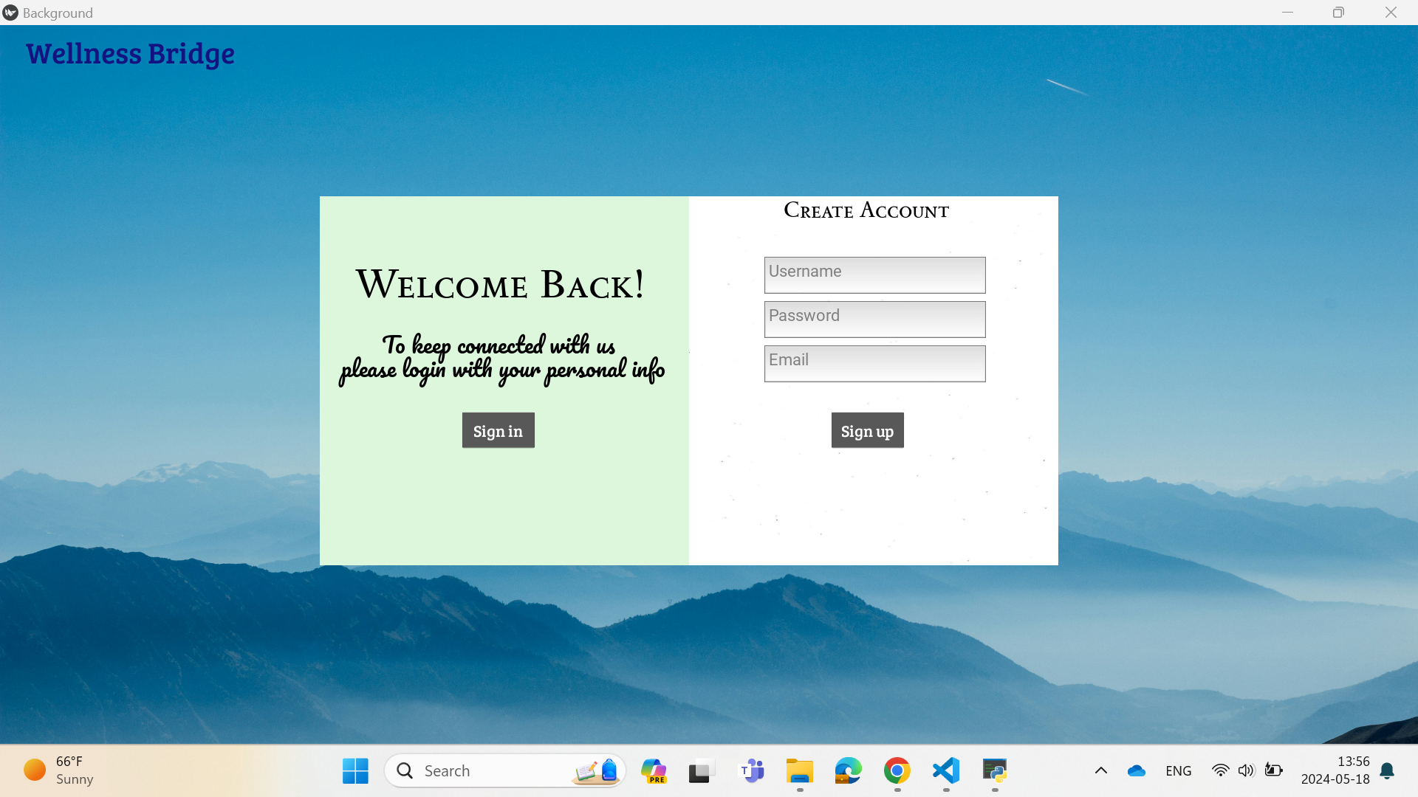

## 1.1 Restrictions

While developing Wellness Bridge using the Kivy framework, we encountered several notable restrictions:

1. Limited Platform Features: The Kivy framework has inherent limitations, particularly in terms of platform-specific features. Certain functionalities that are readily available in other frameworks may be more challenging to implement or may not be supported at all within Kivy.
2. Lack of Features: We found that the Kivy library lacks some features that are commonly found in other development frameworks. This limitation sometimes required us to find workarounds or compromise on certain aspects of our application's functionality.
3. Poor Error Message Display: During the development process, we experienced difficulties with error message display in the terminal when encountering issues within the Kivy framework. This made troubleshooting and debugging more challenging than desired, as clear error messages are crucial for efficient problem resolution.
4. Figma design to code: Additionally, transitioning from design in Figma to actual code posed challenges. Although we initially designed the application layout and user interface in Figma, converting this design into functional code within the Kivy framework proved to be more complex than anticipated. We encountered difficulties in translating the design elements accurately, leading to delays in the development process.

## 1.2 Enhancements

As we continue to evolve Wellness Bridge, our goal is to provide even more valuable tools for mental health. Here are some exciting features we plan to implement:

**Software Enhancements:**

**Comprehensive Blog Section:**

* Expert Articles: Featuring articles written by mental health professionals, covering a wide range of topics.
* Personal Stories: Allowing users to share their own experiences and journeys.
* Practical Tips and Guides: Offering actionable advice and step-by-step guides on managing stress, improving sleep, and practicing mindfulness in daily life.

**Interactive Workshops and Webinars:**

* Live Sessions: Hosting live workshops and webinars with mental health experts, providing users with the opportunity to learn, ask questions, and participate in real-time.
* On-demand content: Access to a library of recorded sessions on a variety of mental health topics, so users can access these resources at their convenience.

**Hardware Enhancements:**

In addition to the features already integrated into the Wellness Bridge app, we are excited to explore enhancements for the physical device. One such enhancement is the incorporation of a physical calendar feature directly into the device. This calendar functionality aims to assist users in organizing their schedules effectively, contributing to stress reduction by providing a tangible method for time management.

To implement this, the device would feature an LCD display capable of showcasing dates, events, and appointments. Similar to the motivational quote feature, the calendar display could periodically refresh to ensure users stay up-to-date with their schedules, changing every 30 minutes to provide continual guidance and support.

Moreover, we envision integrating a podcast feature directly into the Wellness Bridge device. By adding speakers to the device, users would have the convenience of listening

to mental health podcasts directly through the interface. This audio capability complements existing resources, offering users an immersive way to engage with valuable mental health content.

Expanding on the reminder functionality, we propose incorporating an additional LCD display dedicated solely to reminders. This display would prominently showcase important tasks or events, serving as a visual cue for users. Furthermore, utilizing the device's speaker for alarm notifications ensures that users receive timely reminders and alerts, enhancing the overall user experience and support for mental wellness.

With these enhancements, our goal is to provide users with a comprehensive wellness solution that seamlessly integrates digital and physical components, offering valuable tools and support for their mental health journey.

# Requirements

Table 1 - Requirements

|  |  |  |  |  |  |
| --- | --- | --- | --- | --- | --- |
| **Req.**  **No** | **Req. Name** | **Req. Description** | **EMH** | **AMH** | **Prio** |
| 1 | Registration Page | A page where the user can create an account. | 2hrs | 2-3 hrs | 6 |
| 2 | Sign In Page | A page where the user can sign in. | 1 hrs | 1-2 hrs | 7 |
| 3 | Home Page | The main page, where user can select different features according to their needs. | 3 hrs | 4-5 hrs | 9 |
| 4 | Motivational Quotes | Quotes which will help the user feel boosted. | 4 hrs | 6 hrs | 10 |
| 5 | Podcast | Podcast page is designed to inspire and support individuals on journey to mental illness. | 7 hrs | 9-10hrs | 12 |
| 6 | Library | A page where the user can find books on various topics focused on balancing their mental health. | 5 hrs | 6-7 hrs | 13 |
| 7 | Reminders | This feature will give the user a reminder with an alarm for daily quotes according to the user's preferred time. | 8 hrs | 10 hrs | 11 |
| 8 | Analytics/Mood tracking | This feature will help the user track their mood progress as they engage with the app. | 3 hrs | 5 hrs | 14 |
| 9 | Testing | Required for making sure that all the features and the app are working without any error. | 8 hrs | 10 hrs | 8 |
| 10 | Design | Creating design for each page using Figma. | 5 hrs | 7 hrs | 4 |
| 11 | Jira/Scrum Master | Keeping track of the meetings to ensure smooth project progress. | 5 hrs | 5 hrs | 2 |
| 12 | GitHub | Place where we all as a team committed the code so that it was accessible for all of us and the teacher to know the work flow. | 3 hrs | 4 hrs | 3 |
| 13 | Database | Space where we added the user detail which we extracted from the user registration and for mood tracking. | 3 hrs | 6 hrs | 1 |
| 14 | Daily sprints/ Stand up meetings | Meetings that we had almost every day discussing each part of our application and creating a plan for the next steps. | 20hrs | 60hrs | 5 |

# Design and Implementation

In our project model, we have different relationships, for example association and compositions, between our project classes.

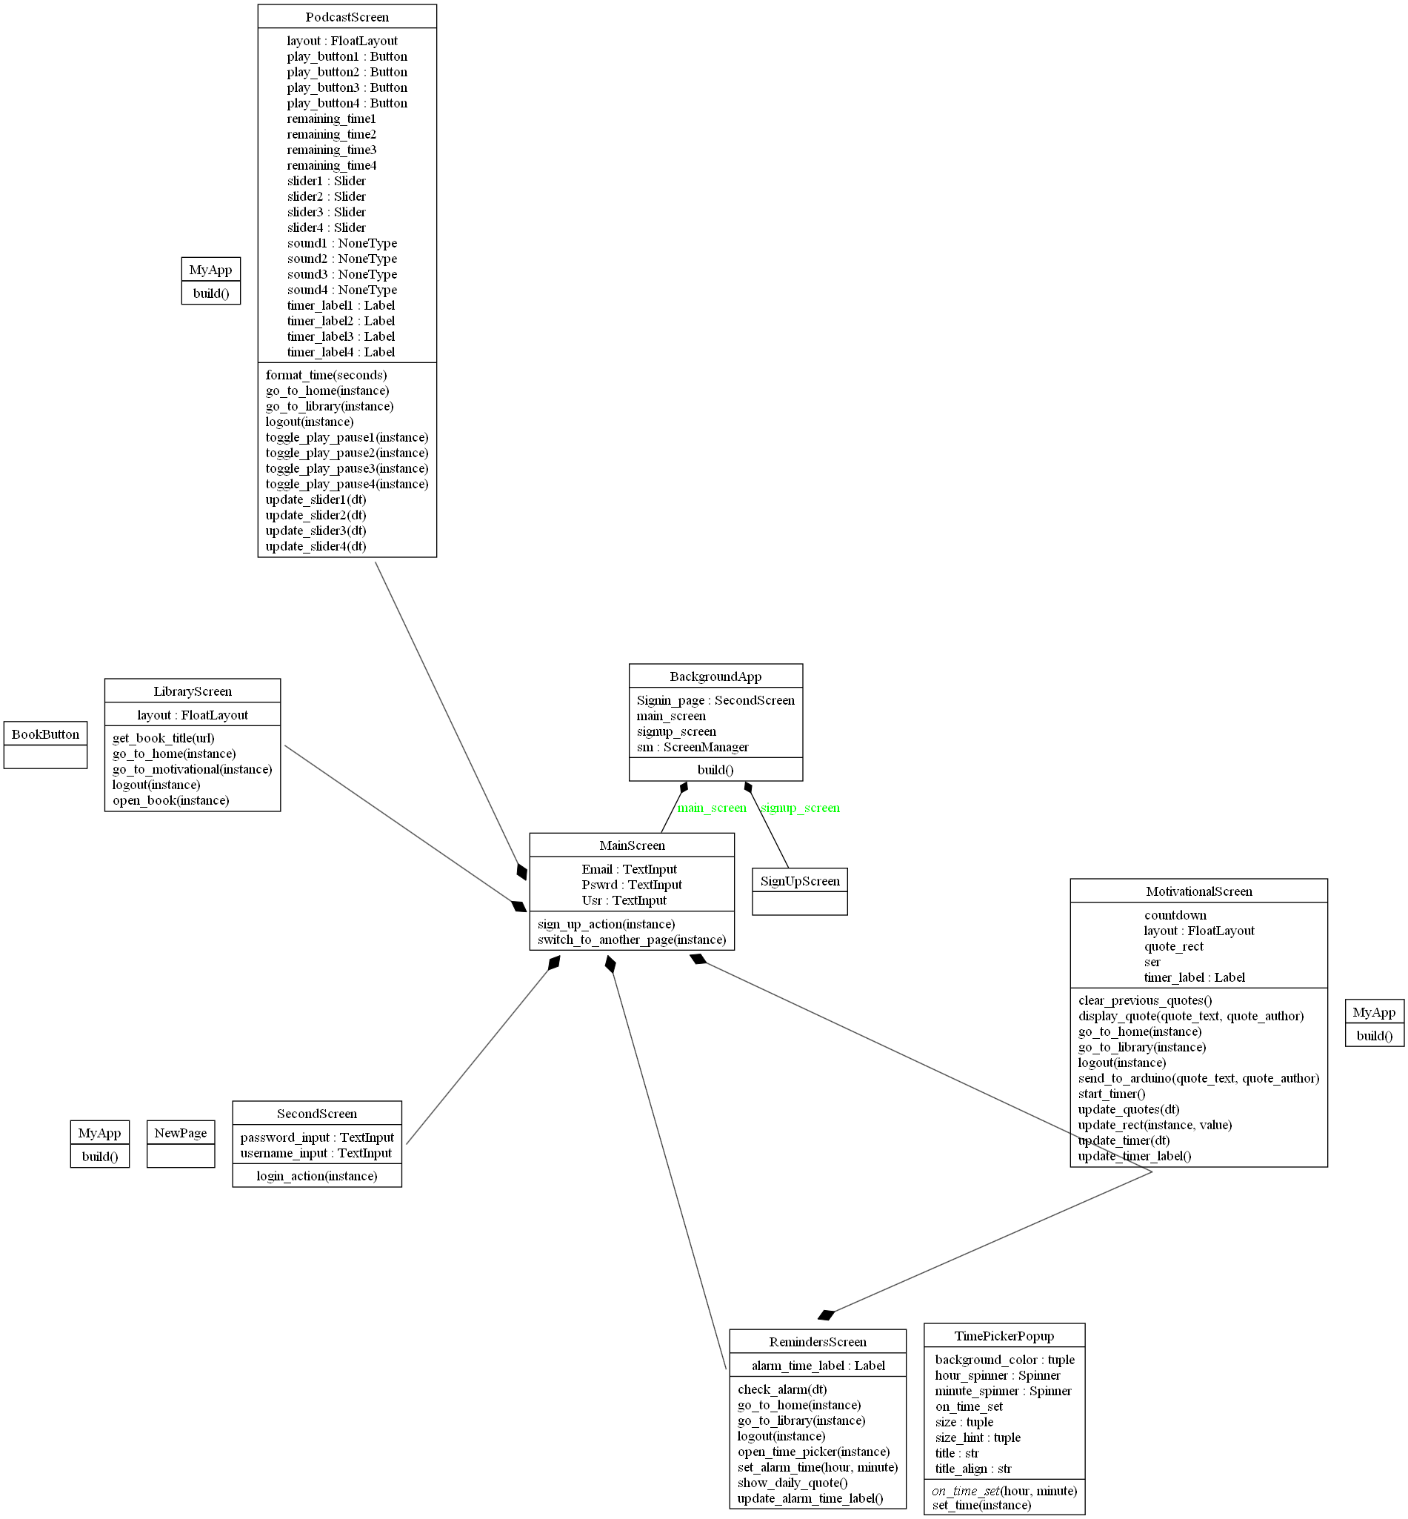

## Sign-in Page

The Sign In page handles sign up and login functionality. It is connected to SQLite database here it saves user information.

## Home Page

This class is responsible for displaying pop up box that could get user input and shows as a graph. It also displays buttons for podcasts, library, motivational, analytics, reminder and logout. After clicking on each button, it redirects to a separate page.

## 3.3 Motivational

This class is responsible for displaying a quote that is fetched by the API and displayed on the LCD screen via an aurdino uno which uses ATMega 328p (micro processor) and the same quote is displayed on the application, The quotes which are displayed are changed every 20-30 seconds.

## 3.4 Podcast

This class is responsible for playing the podcast which is played in the application, and it is connected to the speaker.

## 3.5 Library

This class is responsible for displaying books and gives the opportunity to open and read books. The books are clickable and scrollable.

## 3.6 Reminders

This class lets the user set an alarm for getting reminders for daily quote. When the alarm rings, a pop-up button shows up on the screen and displays a message.

# Test Results

Table 2 below contains the current status of implemented and tested requirements.

Requirement 1: Main Screen should switch to another page

Requirement 2: Main Screen should handle valid sign-up actions

Requirement 3: Main Screen should handle invalid sign-up actions

Requirement 4: SignUp Screen should display necessary elements

**Table 2 - Test Results of main.py file**

|  |  |  |
| --- | --- | --- |
| **Req.**  **No** | **Req. Name** | **Test Result** |
| 1 | Switch to another page | PASSED |
| 2 | Valid signup action | PASSED |
| 3 | Invalid signup action | PASSED |
| 4 | Display signup elements | PASSED |

**Test Results of home.py file**

Requirement 1: Home Page should have the correct initial layout

Requirement 2: Home Page should navigate to the Library screen on button press

Requirement 3: Home Page should navigate to the Motivational screen on button press

Requirement 4: Home Page should handle logout correctly

|  |  |  |
| --- | --- | --- |
| **Req.**  **No** | **Req. Name** | **Test Result** |
| 1 | Correct initial layout | PASSED |
| 2 | Navigate to Library screen | PASSED |
| 3 | Navigate to Motivation screen | PASSED |
| 4 | Navigate to Podcast screen | NOT IMPLEMENTED |
| 5 | Handle logout correctly | PASSED |

**Test Results of signin.py file**

Requirement 1: Sign-in Screen should handle successful login action

Requirement 2: Sign-in Screen should handle invalid login action

|  |  |  |
| --- | --- | --- |
| **Req.**  **No** | **Req. Name** | **Test Result** |
| 1 | Successful login action | PASSED |
| 2 | Invalid login action | PASSED |

**Test Results of library.py file**

Requirement 1: Library Screen should contain the correct number of widgets

Requirement 2: Library Screen should display correct labels

Requirement 3: Library Screen should display correct buttons

Requirement 4: Library Screen should return correct book titles from URLs

Requirement 5: Library Screen should open the correct book URL

Requirement 6: Library Screen should navigate to the home and motivation screen

Requirement 7: Library Screen should handle logout correctly

|  |  |  |
| --- | --- | --- |
| **Req.**  **No** | **Req. Name** | **Test Result** |
| 1 | Correct number of widgets | PASSED |
| 2 | Correct labels displayed | PASSED |
| 3 | Correct buttons displayed | PASSED |
| 4 | Return correct book titles | PASSED |
| 5 | Open correct book url | PASSED |
| 6 | Navigate to home and motivation screen | PASSED |
| 7 | Handle logout correctly | PASSED |

**Test Results of database.py file**

Requirement: Fetch data from the database and verify its correctness

|  |  |  |
| --- | --- | --- |
| **Req.**  **No** | **Req. Name** | **Test Result** |
| 1 | Fetch and verify database | PASSED |

# Summary and Conclusion

This chapter contains a summary and conclusion of the work that was carried out in this project as well as reflections and thoughts about working methods and challenges.

## Weekly Progress

Below is a short summary of what was done each week.

### 5.1.1 Week 1

(Plan, Features and Characteristics, Computer Language, Application type)

In our initial meeting, we presented our project idea and its features, and we discussed various aspects such as programming languages, features, frameworks, and team roles. It was a highly productive discussion with the teacher, as we clarified all necessary details to ensure a strong start to the project for the first week.

### 5.1.2 Week 2

(Registration page, Sign In page, Creating Database, GitHub and Jira pages, Design)

In our PM2 meeting, we discussed the GUI that we programmed using the Kivy framework. We also talked about the roles and features we plan to add to the application. Overall, it was a productive meeting with the teacher, as we clarified our doubts and gained a clear understanding of our tasks for the upcoming week.

### 5.1.3 Week 3

(Library feature, Motivational Quotes feature, Podcast Feature, Testing)

In our third PM meeting, our group presented various aspects of the project, including our GitHub repository, Jira setup, login/signup page, home page, and the motivational quotes page developed. presented the testing part of the project. However, we couldn't showcase other features like the podcast and library pages, as they were not yet completed by other team members.

We also discussed the publishing aspect of the project, where we explored the idea of integrating software and hardware—a novel approach for this course. Successfully implementing this integration could significantly enhance our chances of getting the project published. Overall, the meeting was productive and provided valuable insights for the next steps.

### 5.1.4 Week 4

(Reminder Feature, Library feature, Mood Tracker feature, Podcast Feature, Testing.)

In the final meeting with the teacher, we discussed the work we had completed. We also discussed the addition of a speaker for playing motivational quotes and podcasts, allowing users to listen to audio content. We addressed issues we encountered with branching in GitHub and challenges with the Kivy framework that consumed a significant amount of our time and hindered progress on the app's features. Based on the teacher's recommendation, we decided to use the main branch for uploading our code to GitHub.

During the meeting, Nawaz demonstrated the LCD display connected to our application, which shows a motivational quote that changes every 20-30 seconds. Munira presented her reminder feature, Samira showcased the library feature, Fakhirah demonstrated the podcast feature, and Dawood once again handled the testing part for the week. Overall, it was a productive session where we received valuable feedback and guidance for finalizing our project.

## Difficulties and challenges

Below is a list of notable challenges that came up during this project and that took a long time to solve.

### 5.2.1 Kivy Framework Integration and Development Challenges:

The integration of the Kivy framework presented one of the most significant challenges during the project. As it is a new framework for all team members, navigating its complexities and limitations proved to be a time-consuming endeavor. The primary difficulties stemmed from the framework's inherent constraints, particularly its limited platform features. Compared to other development frameworks, Kivy lacked certain functionalities crucial for our project, making their implementation more arduous or impossible within the Kivy environment.

Moreover, the lack of features within the Kivy library posed additional hurdles. Common functionalities found in other frameworks were absent, necessitating the development of workarounds or compromises to achieve desired outcomes. This required a significant investment of time and resources to ensure the application's functionality met our standards. Furthermore, we encountered challenges with error message display within the terminal while working with Kivy. Inadequate error messages made troubleshooting and debugging more cumbersome, impeding our progress and necessitating extensive efforts to diagnose and resolve issues efficiently.

Navigating through these challenges provided valuable learning opportunities, particularly in problem-solving and adapting to new technologies. Despite the difficulties, overcoming these obstacles reinforced our team's resilience and enhanced our skills in handling complex programming problems within a challenging development environment.

## Correctness of time estimates

Reflecting on our time estimates reveals several insights into their accuracy and areas for improvement. Tasks took longer than anticipated due to unforeseen difficulties such as technical problems or the need for additional research. More complex tasks were harder to estimate accurately. Simpler, repetitive tasks had more precise estimates. Unplanned interruptions or changes in project scope affected the timeline significantly.

To make improvements on future projects, these strategies can be used: Adding buffer time to each task can accommodate unexpected delays or complications. Regularly reviewing and adjusting estimates as the project progresses can help in maintaining a realistic timeline. Take more time in the planning phase to analyze each task in detail.

## Priority decisions

We prioritized databases first because they are the foundation for storing user information, which is essential for getting users started with the app. Next, we prioritized Jira as it is crucial for proper planning and execution of the project. Without a solid plan, we cannot effectively develop the application.

Third, we prioritized GitHub because it provides a collaborative storage solution that is accessible to everyone in the group. Following this, we placed design in the fourth position because having a well-thought-out design is necessary before we can execute the code structure.

Daily sprints were prioritized fifth to ensure that the team stays aware and aligned on the project's progress and objectives. Finally, we prioritized all other features from sixth to fourteenth based on their relative importance and dependencies within the project.

## Conclusion

Working on the Wellness Bridge project has been an incredibly enriching experience for us. Developing this application highlighted the importance of mental health in today's fast-paced world and reinforced our commitment to creating tools that can make a meaningful difference in people's lives.

Our overall experience with the project was both challenging and rewarding. The development process using the Kivy framework presented several obstacles, including platform-specific feature limitations, lack of certain functionalities, and difficulties with error message displays. Converting designs from Figma into functional code was particularly complex, but these challenges provided invaluable learning opportunities. Overcoming these hurdles was satisfying and underscored the importance of perseverance and problem-solving in software development.

Teamwork was a crucial element of our success. Our team collaborated effectively, bringing diverse skills and perspectives to the table. Regular meetings and open communication helped us tackle issues collectively and maintain a clear vision for the project. This collaborative environment not only facilitated the development process but also made it more enjoyable.

In conclusion, this project has been a significant milestone in our professional journey. It has strengthened our skills, broadened our understanding of mental health technology, and underscored the importance of teamwork and effective communication. We are eager to apply these lessons to future projects and continue contributing to meaningful and impactful solutions.