CURRICULUM VITAE
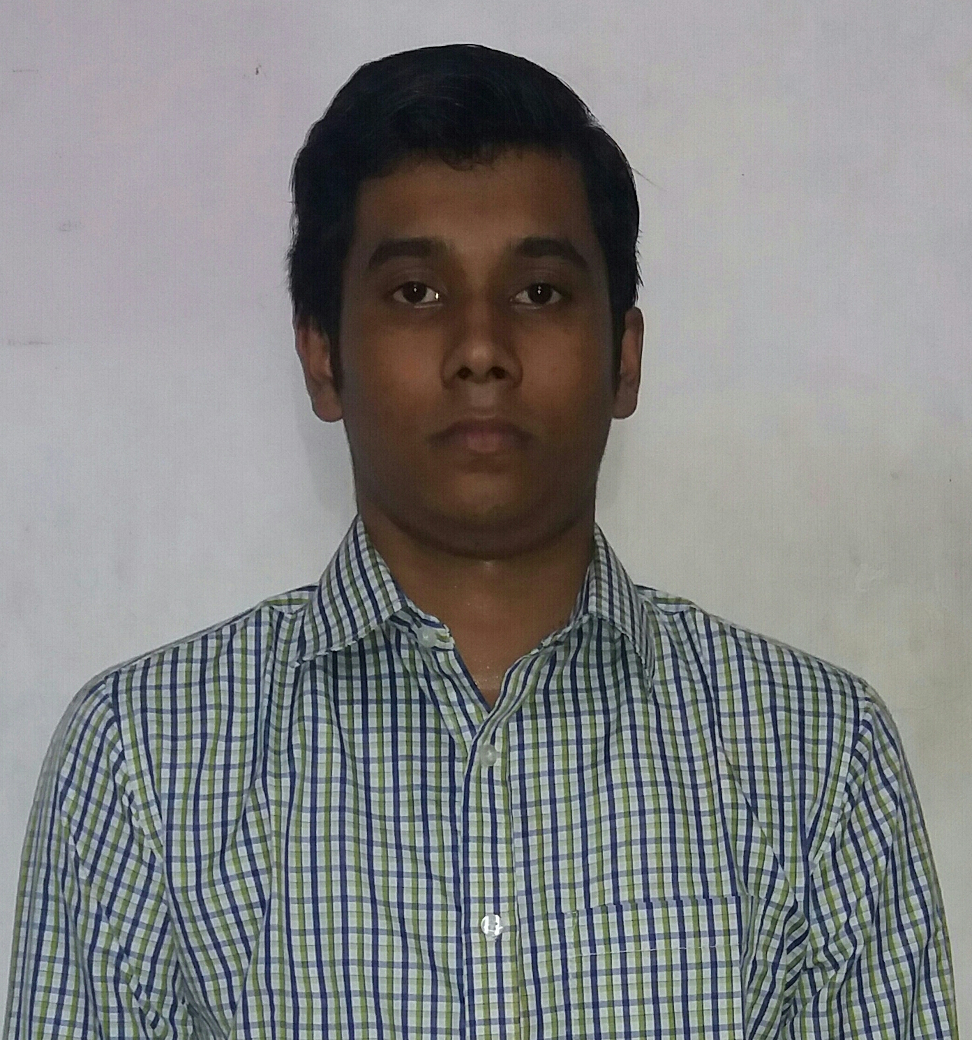
NAME: NAWNEET KUMAR SINGH
Address:
Qrt-No-664, Street-22, Sector-9/D
Bokaro Steel City Mobile: 9523309719
Jharkhand Email: Nawneet051.nalanda@gmail.com

OBJECTIVE

A position to constantly learn, contribute and grow along with the organization.
ACADEMIC PERFORMANCE

COURSE | INSTITUTION | BOARD /UNIVERSITY | YEAR OF PASSING | AGGREGATE
B-Tech(CSE) | Nalanda Institute Of Technology | BPUT | 2016 | 7.18
12th | BISSS-11/D | CBSE | 2012 | 62.2
10th | GGPS | CBSE | 2010 | 81.5

COMPUTER SKILLS

- Microsoft Technologies : C#, ADO.NET,ASP.NET
- Language Known : C,C++
- Web Technologies :HTML,CSS
- Scripting Language :JAVASCRIPT
- Databases :SQLSERVER2014
- Operating Systems :Windows XP,Windows7,8,8.1,10
- IDE :Visual Studio 2015
PROJECTS:

Project name: HAPPYDEALS (E-Commerce Site)
Language of Implementation: .Net
Operating System: Windows 8.1, Windows 10
Description: E-Commerce is associated with the buying and selling of information, products and services via computer network today. Consumer desires are very hard to predict pin point or decipher in electronic markets whose shape, structure and population are still in early stages.
Group-Member: We Have 3 Members in our Group
Abhishek Thakur Pramod Kumar Nawneet Kumar Singh
INDUSTRIAL TRAINING:
- Done 1 months training in SAIL(BOKARO) from May 2015 to June 2015
PERSONAL TRAITS:

- Commitment and Smart Working.
- Optimistic and having good time management.
- Bit Easygoing and Eloquent
- Confident and Determined
ACHIEVEMENTS

- Successfully completed .NET certification course from NARESH i TECHNOLOGY

PERSONAL PROFILE

- Name : Nawneet Kumar Singh
- Date of birth : 25-08-1993
- Father’s name : Jai Karan Singh
- Nationality : Indian
- Marital Status : Unmarried
- Languages known : English, Hindi
DECLARATION

I hereby declare that the above information is true and correct to the best of my knowledge. I bear the responsibility for the correctness of the mentioned particulars.
Place: Bangalore Name: Nawneet Kumar Singh

