**CSE 301: Database Systems**

**[Summer 2020]**

**Project Report**

Formula 1 Championship

https://apex.oracle.com/pls/apex/formula1_project/r/formula-1-championship3

**Course Code and Section: CSE301(1)**

# Final version of the E-R Model of the Project

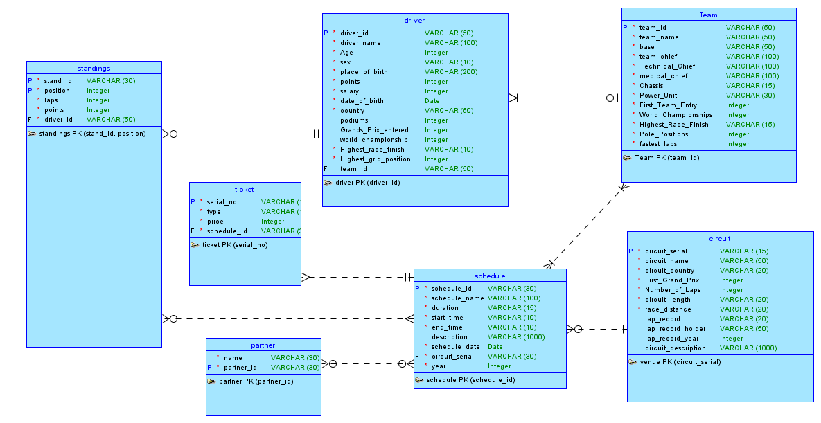

# Final Version of the Relational Data Model of the Project

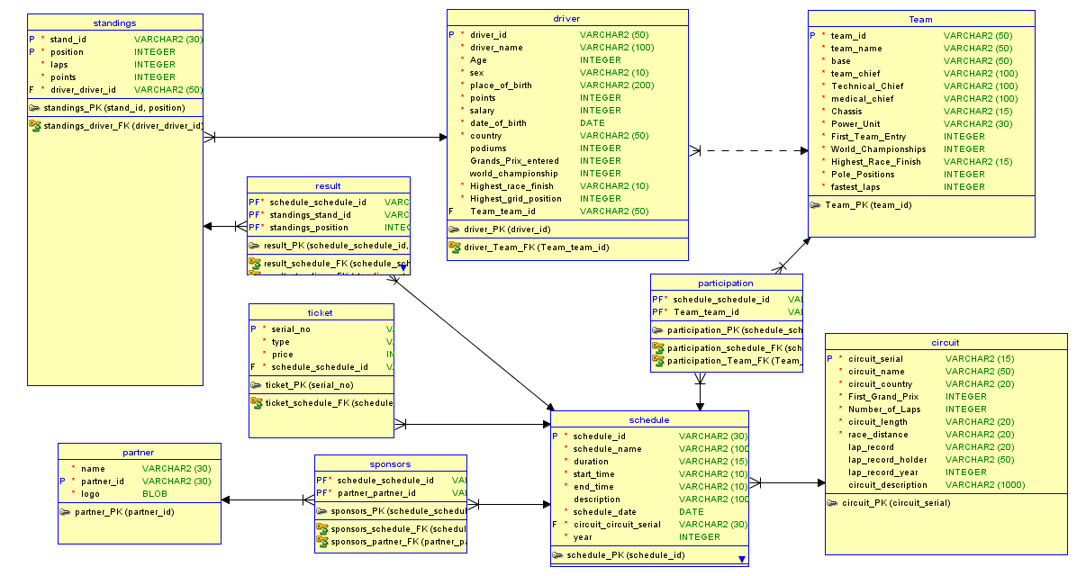

# Implementation Checklist

|  |  |
| --- | --- |
| Description | Remarks |
| Project ID | Application 112338 |
| Workspace Name | formula1_project |
| Workspace Email | 2018-1-60-028@std.ewubd.edu |
| Workspace Password | *formula1* |
|  |  |
| Authentication Type | Custom |
| Username and Password to Login | admin |
|  | *admin1234* |
|  | ahiad  *ahiad28* |
|  | rbs  *rbs123* |
|  | jarin  *jarin123* |
| Uploaded and Displayed Images in Reports | yes |
| Implemented Page-wise Authorization | yes |
|  |  |
| Number of Reports with Forms | 10 |
| Number of Master-detail Forms | 1 |
| Number of Reports based on Queries, Aggregate Queries | 0 |
| Number of Parameterized Reports | 1 |
| Number of Graphs/Charts | 0 |
|  |  |
| Included any trigger/other feature which is not taught in class. If yes, please explain briefly. |  |
| Write the most unique feature/functionality in your application or the page of your application which you are proud of. Explain briefly. |  |

# Reports with Forms

|  |  |  |  |
| --- | --- | --- | --- |
| Report Page Number and Name | | Form Page Number and Name | Table |
| 2-Drivers | | 3-Drivers Input | Driver |
| 4-Team | | 5-Team Input | Team |
| 6-Citcuit | | 7-Circuit Input | Circuit |
| 8-Partners | | 9-Partners Input | Partner |
| 10-Schedule | | 11-Schedule Input | Schedule |
| 12-Participation | | 13-Participation Input | Participation |
| 14-Sponsors | | 15-Sponsors Input | Sponsors |
| 16-Tickets | | 17-Tickets Input | Ticket |
| 18-Standings | | 19-Standings Input | Standings |
| 20-Schedule Result | | 21-Schedule Result Input | Result |
|  |

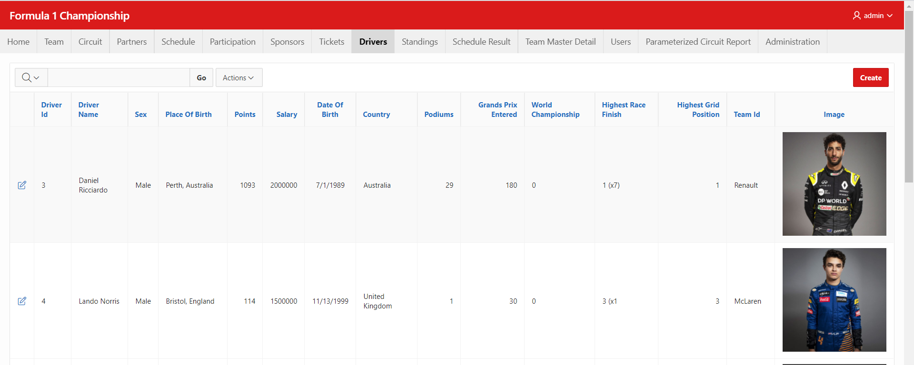

Figure 4.1: Drivers Report

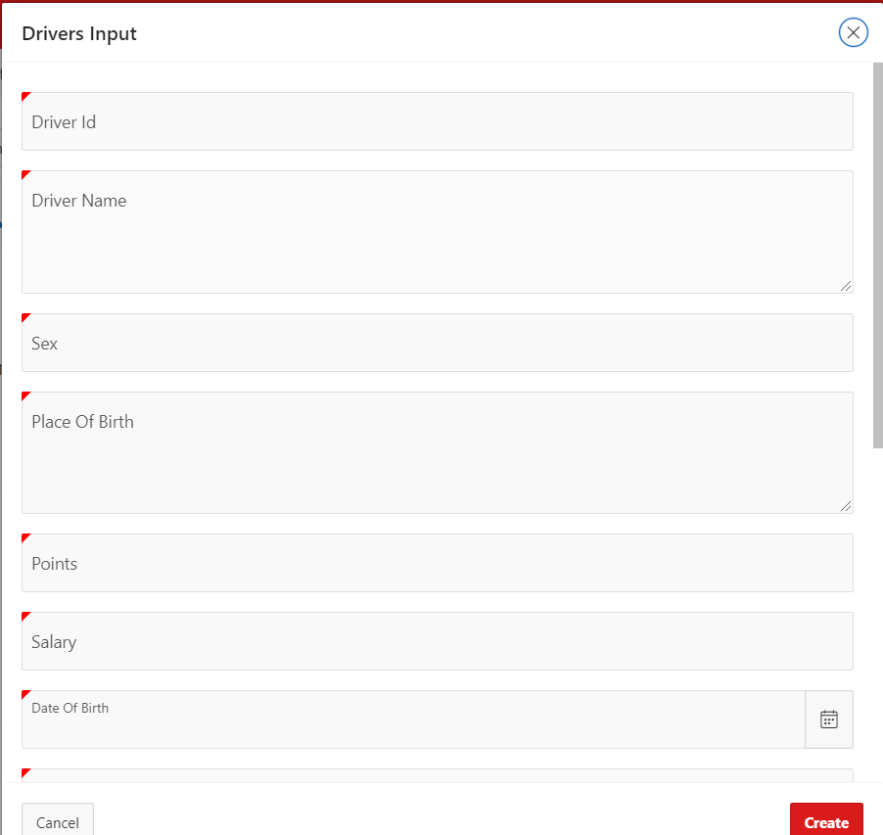

Figure 4.2: Drivers Input

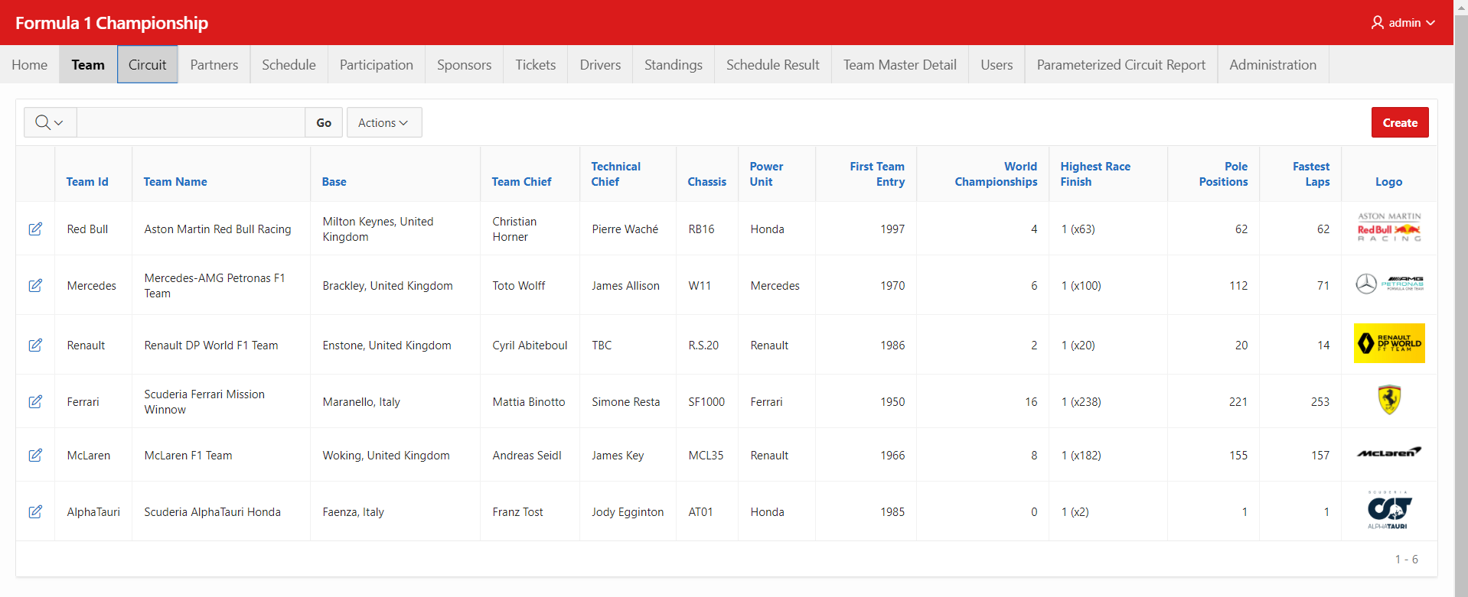

Figure 4.3: Team Report

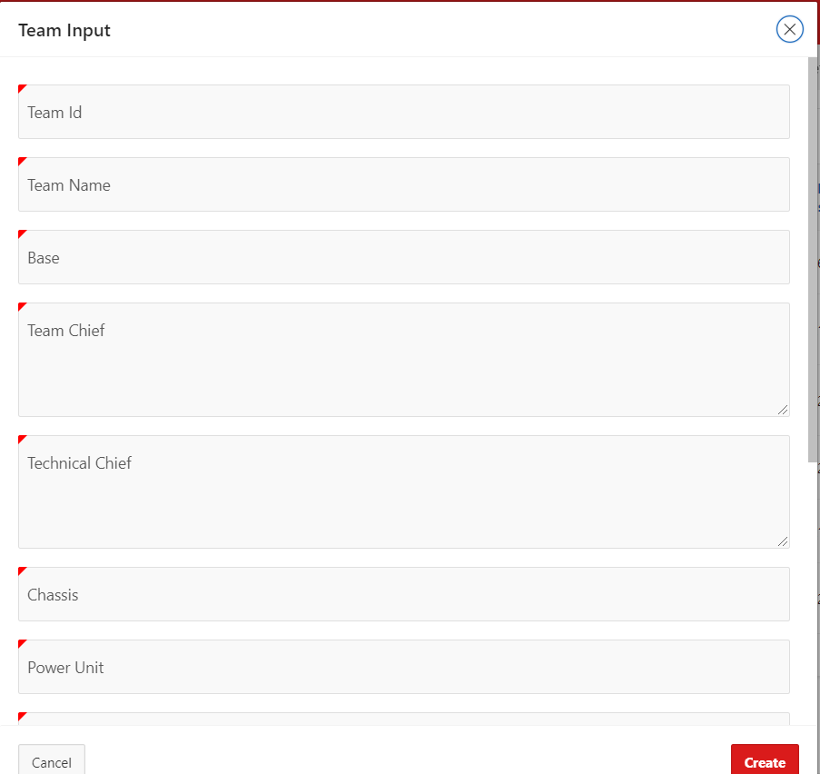

Figure 4.4: Team Input

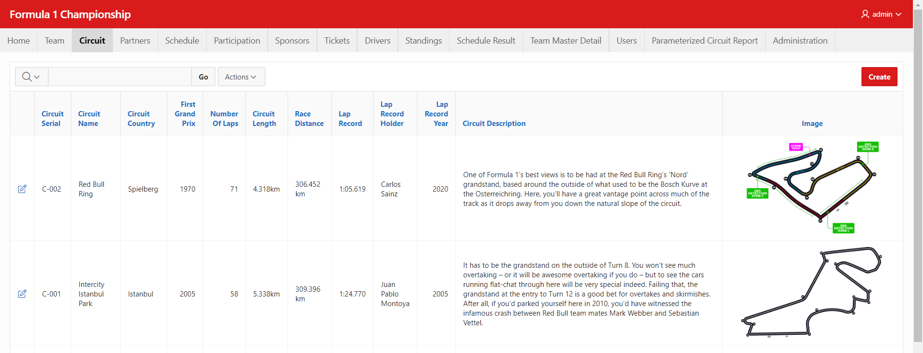

Figure 4.5: Circuit Report

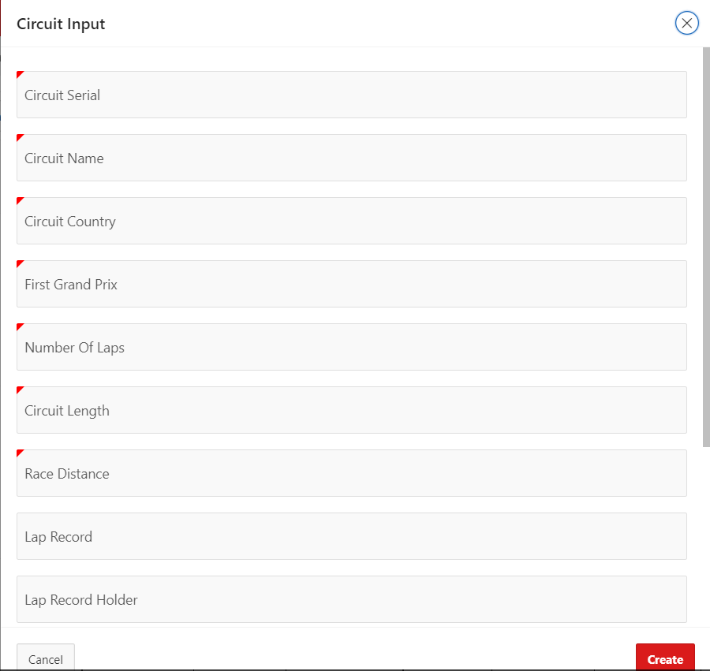

Figure 4.6: Circuit Input

: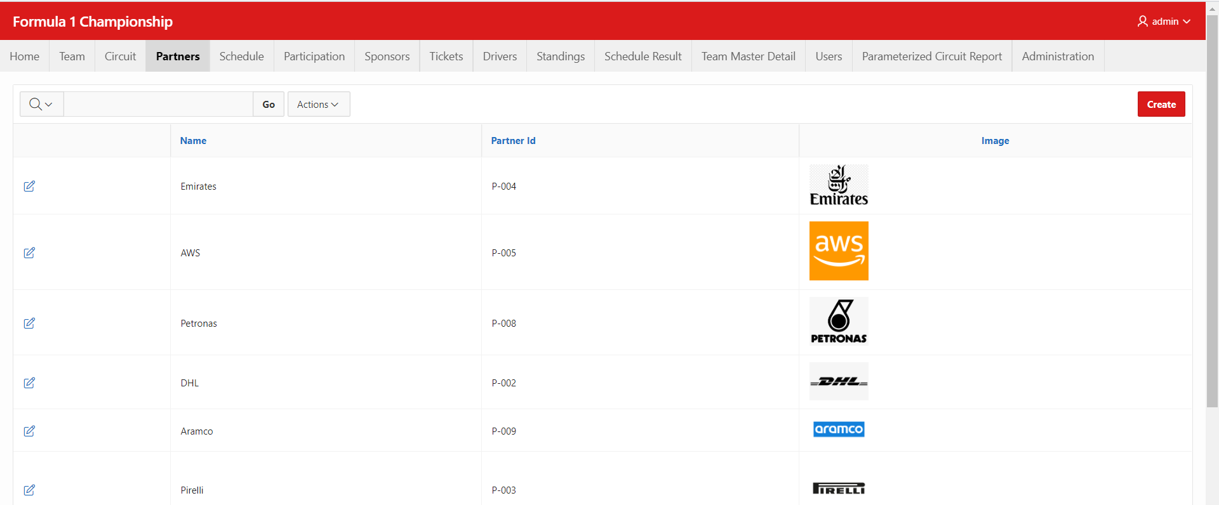

Figure 4.7: Partners Report

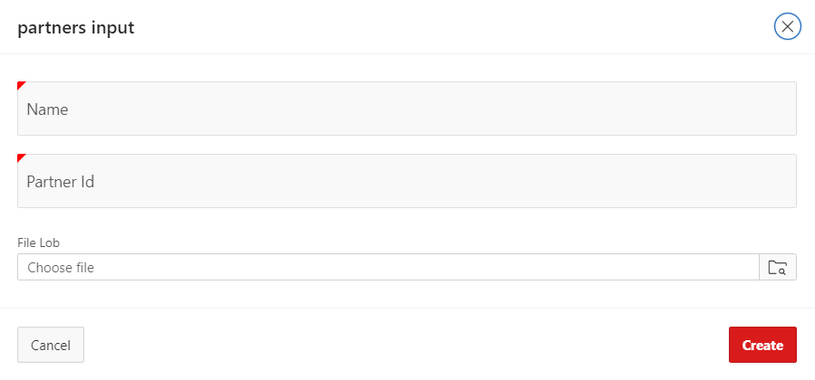

Figure 4.8: Partners Input

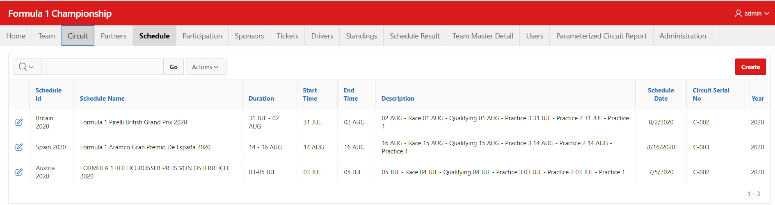

Figure 4.9: Schedule Report

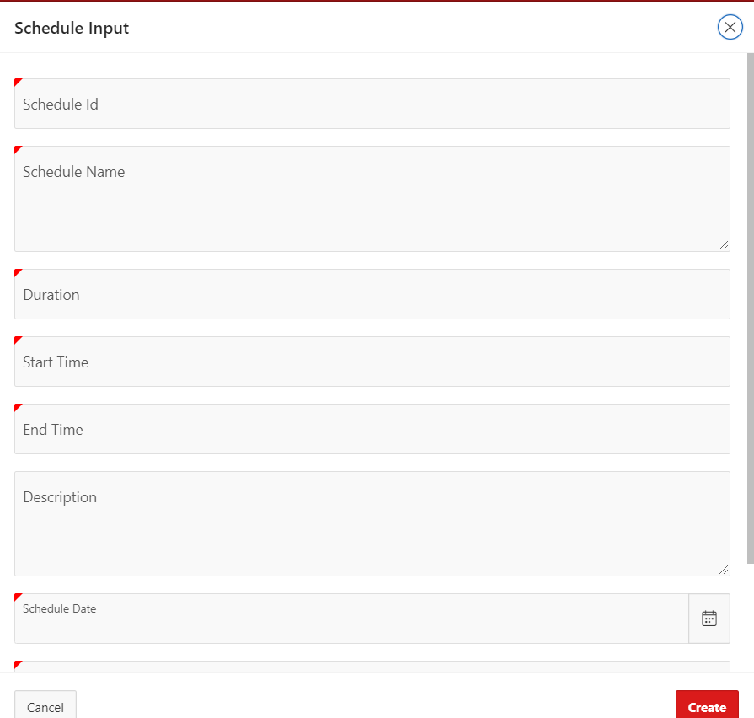

Figure 4.10: Schedule Input

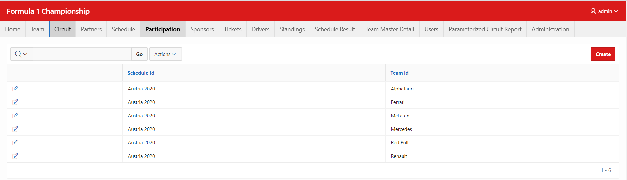

Figure 4.11: Participation Report

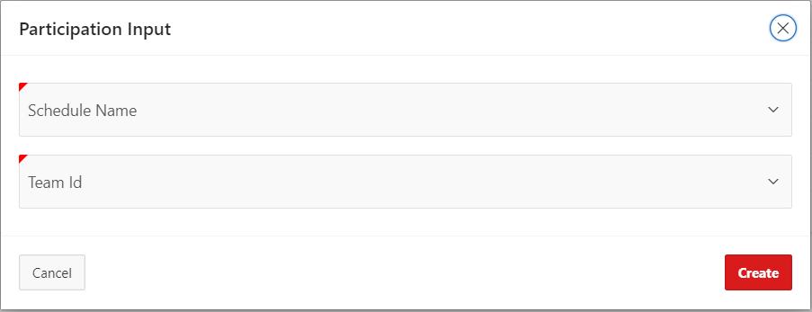

Figure 4.12: Participation Input

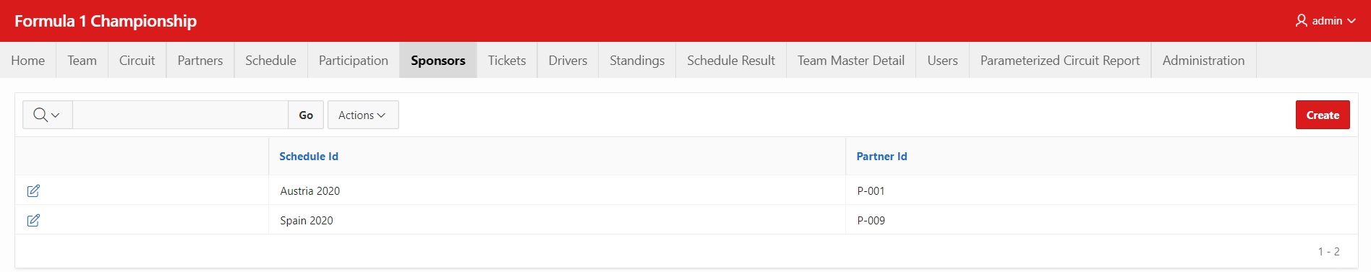

Figure 4.13: Sponsors Report

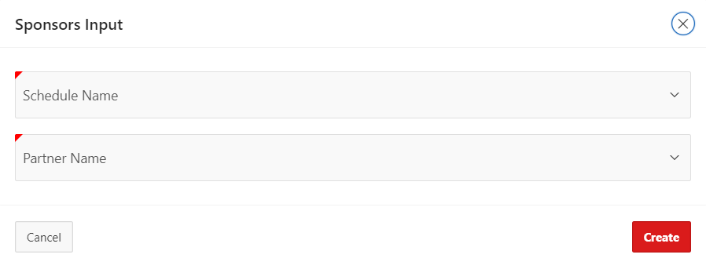

Figure 4.14: Sponsors Input

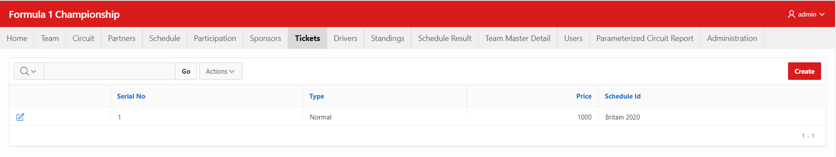

Figure 4.15: Tickets Report

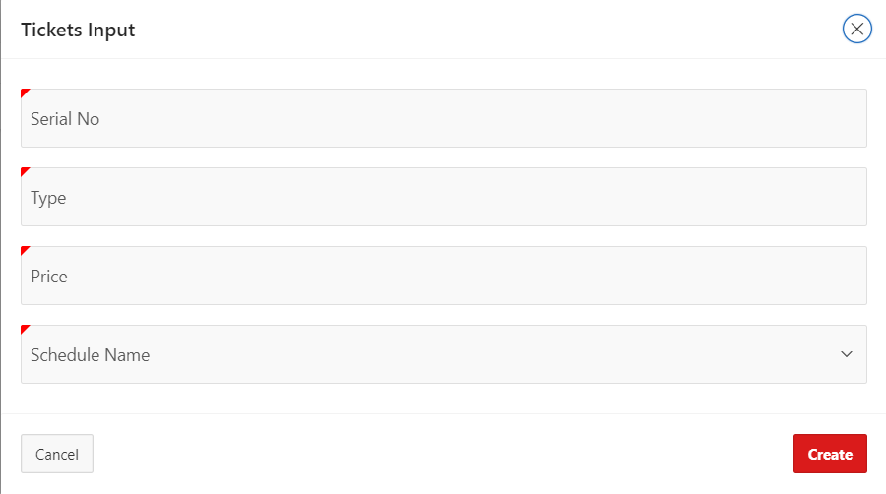

Figure 4.16: Tickets Input

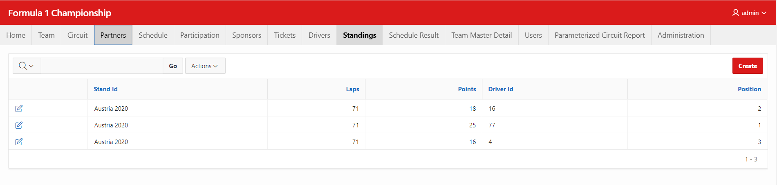

Figure 4.17: Standings Report

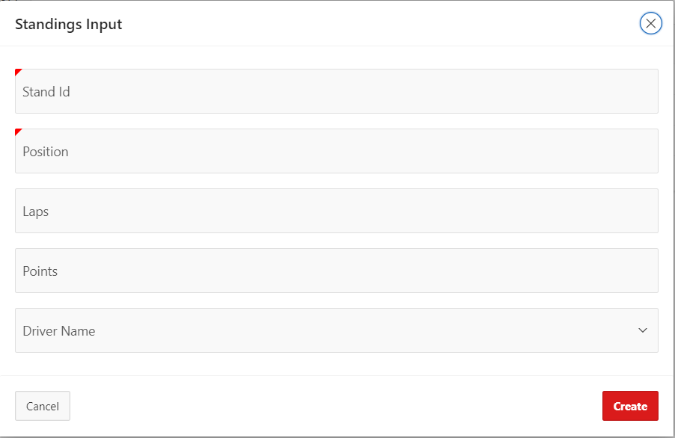

Figure 4.18: Standings Input

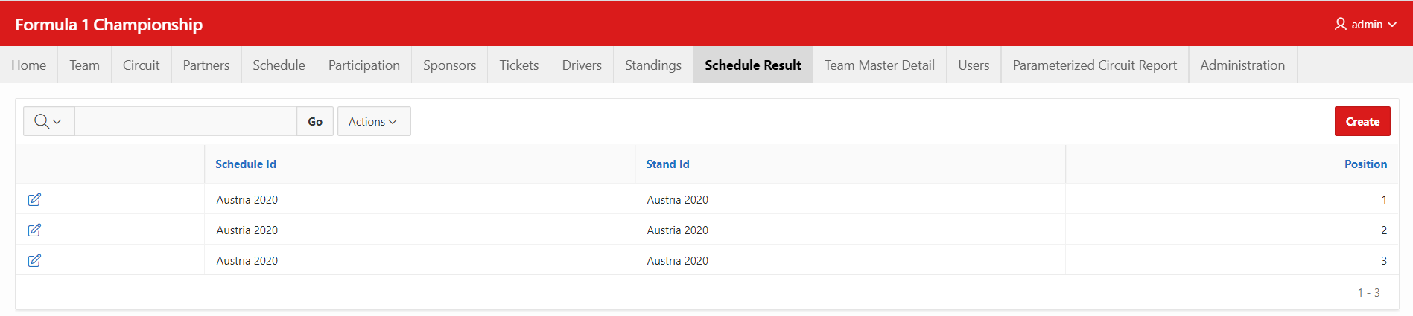

Figure 4.19: Schedule Result Report

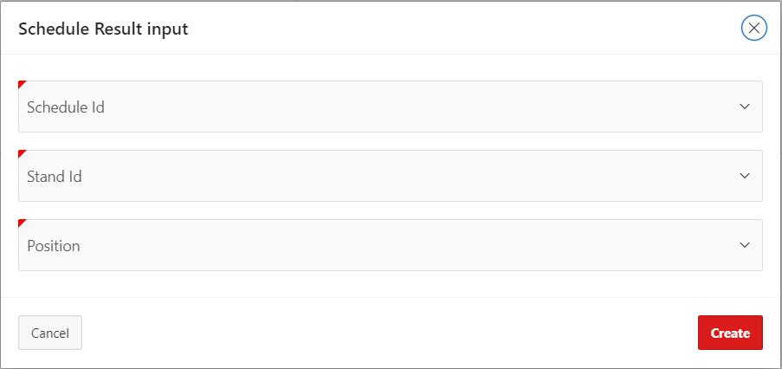

Figure 4.20: Schedule Result Input

# Master-Detail Form

|  |  |  |
| --- | --- | --- |
| Page Number and Name | Master Table (Parent) | Detail Table (Child) |
| 22-Team Master Detail | Team | Driver |

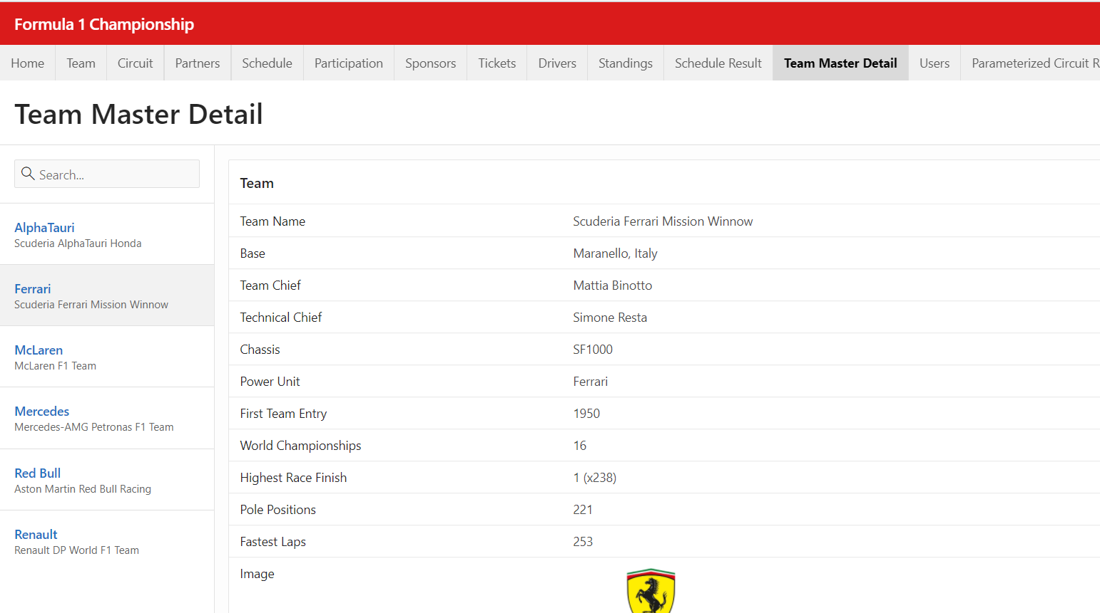

Figure 5.1: Team wise Driver’s Information(Part 1)

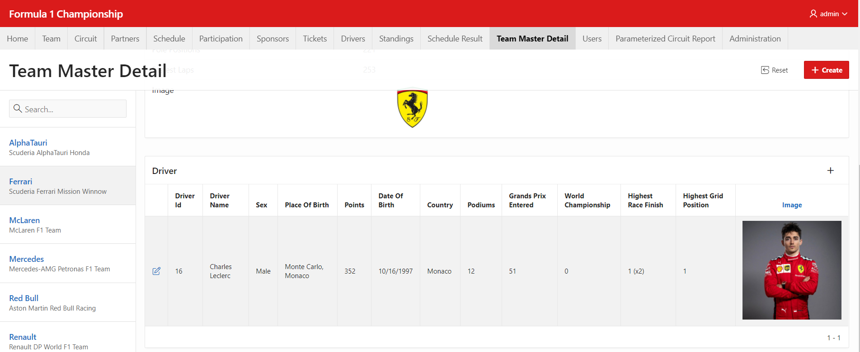

Figure 5.2: Team wise Driver’s Information(Part 2)

# Reports based on Multi-Table and Aggregate Queries

(Not Included yet)

# Parameterized Reports

|  |  |  |
| --- | --- | --- |
| Page Number and Name | Given Input | Report description |
| 27-Parameterized Circuit Report | Circuit_name | The report shows schedule information based on the circuit. |

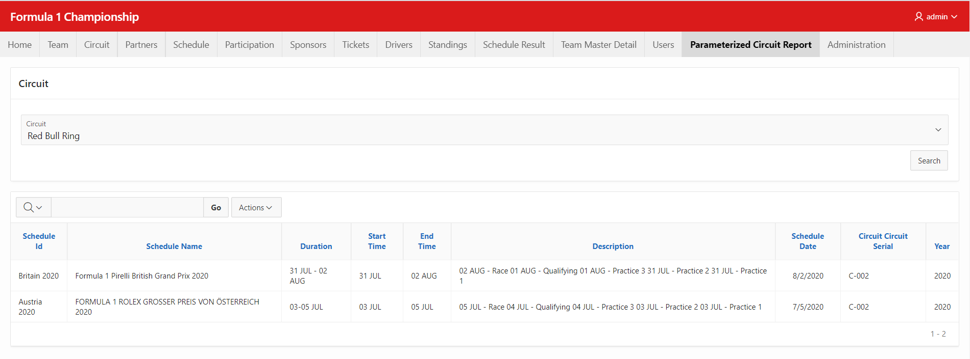

Figure 7.1: Parameterized Circuit Report

# Charts

(Not included yet)

# Authorization and User Role Assignment

**User Role Assignment**

|  |  |  |
| --- | --- | --- |
| User name | Password | Role |
| admin | admin1234 | Administrator |
| ahiad | ahiad28 | Reader |
| rbs | rbs123 | Contributor |
| jarin | jarin123 | reader |

**Page-wise Authorization Information**

|  |  |
| --- | --- |
| Page number and name | Authorization Level |
| P1: Home | Reader |
| P2: Drivers | Reader |
| P4: Team | Reader |
| P6: Circuit | Reader |
| P8: Partners | Reader |
| P10: Schedule | Reader |
| P12: Participation | Administrator |
| P14: Sponsors | Reader |
| P16: Tickets | Reader |
| P18: Standings | Administrator |
| P20: Schedule Result | Administrator |
| P22: Team Master Detail | Reader |
| P25: Users | Administrator |
| P27: Parameterized Circuit Report | Reader |
| P10000: Administration | Administrator |