

NORTH SOUTH UNIVERSITY

Department of Electrical & Computer Engineering

PROJECT REPORT

Course Code: CSE323

Section: 13

Course Title: Operating Systems Design

Faculty: Farhan Tanvir Khan(FTH)

Semester: Fall 2025

Project: Design and Implementation of “ps” and “cp” commands in the xv6 Operating System

Team Name: SysCall

Team Members:
Names | ID
- Shahabuddin Ahmed Ovi | 2312245042
- Nawsin Hossain Barta | 2311465042
- Nafia Haque Muskan | 2311677042

Abstract
The xv6 operating system is a simple, Unix-like teaching OS widely used for understanding core operating system concepts such as process management, system calls, and file systems. Although xv6 provides essential functionality, it lacks several user-friendly utilities that are commonly available in modern operating systems like Linux. This project focuses on enhancing xv6 by introducing two important features: a process listing system call (ps) and a file copy command (cp). These additions aim to improve system usability, monitoring, and file management while maintaining the simplicity of xv6. The project involves kernel-level modifications, system call integration, and user-space program development.

1. Introduction
Operating systems act as an interface between hardware and users, providing abstractions such as processes, files, and system calls. xv6 is designed primarily for educational purposes and includes only minimal utilities. As a result, common commands like process monitoring and file copying are absent or limited.
The goal of this project is to extend xv6 with practical features that reinforce understanding of kernel-user interaction. By implementing a ps system call and a cp user command, we explore how system calls are added, how kernel data structures are accessed safely, and how user-level programs interact with kernel services.

2. Project Objectives
The main objectives of this project are:
- To implement a new system call that displays information about currently running processes.
- To design a user-level command that copies data from one file to another.
- To understand system call mechanisms and process table management.
- To enhance xv6 usability while preserving its simplicity.

3. Feature 1: Process List System Call (ps)

3.1 Description
The process list system call provides users with a way to view information about all currently active processes. This feature is conceptually similar to the Unix ps command and allows users to observe how processes are managed and scheduled within the system.The information provided includes:
- Process ID (PID)
- Parent Process ID (PPID)
- Current process state

3.2 Design Overview
- User-space program (ps.c): Contains the main() function that invokes the system call cps().
- Kernel-side system call handler (sysproc.c): Implements sys_cps() which serves as the bridge between the user program and the kernel function.
- Kernel function (proc.c): Contains cps() that iterates over the process table and prints process details.

3.3 Implementation Plan
- System Call Definition
- Add a new system call sys_ps() in sysproc.c.
- Assign a unique system call number in syscall.h.
- Kernel Logic
  - Iterate through the process table (ptable.proc).
  - Extract PID, PPID, and state for each active process.
  - Print the information to the console or copy it to user space.
- User-Level Program
  - Create a new user program _ps.c.
  - The program will invoke the ps system call.
  - Format and display the process information.
- Build Integration
  - Update the Makefile to include _ps in the list of user programs.

3.4 Expected Outcome
After implementation, executing the _ps command in xv6 will display a list of all active processes along with their PIDs, PPIDs, and states. This feature will allow users to monitor system behavior and better understand process management in xv6.
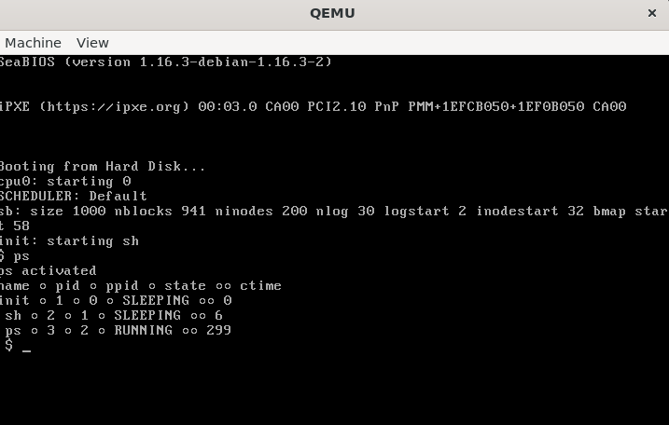

4. Feature 2: File Copy Command (cp)
4.1 Description
The file copy command (cp) enables users to duplicate the contents of one file into another file within the xv6 file system. This functionality is similar to the Unix cp command and is essential for basic file management tasks. Since xv6 provides only minimal user utilities, implementing cp enhances its usability while giving deeper insight into file system operations and system call usage.
The cp command takes two arguments: a source file and a destination file. If the destination file does not exist, it is created; if it exists, its contents are overwritten.

4.2 Design Overview
- User-space program (cp.c):
- Handles command-line arguments, opens source and destination files, and invokes the helper function.
- Helper function (ulib.c):
- Contains copyfd() which performs the file copying by reading bytes from the source and writing them to the destination.
4.3 Implementation Plan

1. User Program Creation
- A new user program named _cp.c is created in xv6.
- The main() function is implemented as the program entry point.
- Command-line arguments are parsed using argc and argv.
- The program checks that exactly two arguments (source and destination) are provided.

2. File Operations
- The source file is opened using open() in read-only mode (O_RDONLY).
- The destination file is opened or created using open() with write and create flags (O_WRONLY | O_CREATE).
- Proper checks are performed to ensure both files are opened successfully.

3. Data Transfer Logic
- A fixed-size buffer is used to copy data in chunks.
- Data is read from the source file using read().
- The exact number of bytes read is written to the destination file using write().
- The process repeats until the entire file is copied.

4. Error Handling
- Displays a usage message for incorrect command-line arguments.
- Handles missing or inaccessible source files.
- Detects read/write failures and exits safely.
- Ensures open file descriptors are closed on errors.

5. Build Integration
- _cp.c is added to the xv6 Makefile.
- The program is compiled as part of the xv6 user programs.
- The _cp command becomes available in the xv6 shell after building.
4.4 Expected Outcome
After successful implementation, users will be able to copy files within xv6 using the cp command. For example, executing cp file1 file2 will create a duplicate of file1 named file2. This feature improves file management capabilities and reinforces understanding of file descriptors, system calls, and user-space programming in xv6.
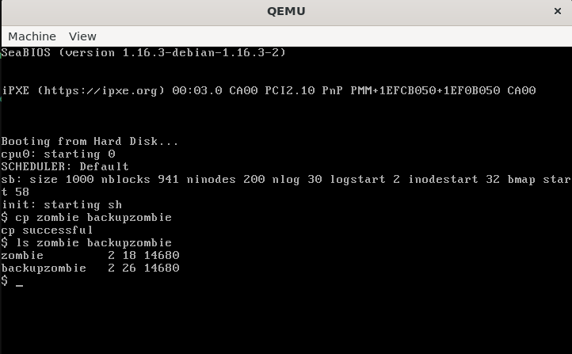

- Conclusion
This project enhanced xv6 by adding a process listing system call (ps) and a file copy command (cp). The ps system call displays active processes, while cp allows basic file copying. Through this, we learned how system calls work and how user programs interact with the kernel. These simple features make xv6 more practical and provide a foundation for exploring advanced operating system concepts.

