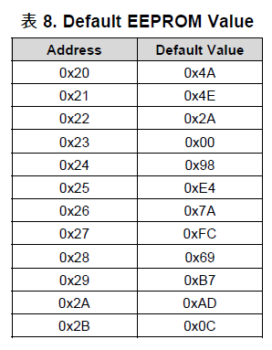

|  |  |  |  |  |
| --- | --- | --- | --- | --- |
| 0x23 | 7:6 | ISDThr[1:0] |  |  |
|  | … |  |  |  |
| 0x24 | 7:6 | OpenLCurr[1:0] | 00 |  |
|  |  |  |  |  |
| 0x25 | 7:6 |  | 00 | 0x3F |
|  | 5:3 |  | 111 |
|  | 2:0 |  | 111 |
| 0x26 | 7:3 |  | 00001 | 0x08 |
|  | 2:0 |  | 000 |
|  |  |  |  |  |
|  |  |  |  |  |
|  |  |  |  |  |
| 0x2A |  | IPDCurrThr[3:0] | 0001 | 0x14 |
|  |  | LockEn[4] | 0 |
|  |  |  | 1 |
|  |  |  | 00 |
| 0x2B |  | FGOLesl[1:0] | 00 |  |
|  |  |  | 00 |  |
|  |  |  | 00 |  |
|  |  | SpdCtrlMd | 1 |  |
|  |  | CLoopDis | 1 |  |
|  |  |  |  |  |
|  |  |  |  |  |

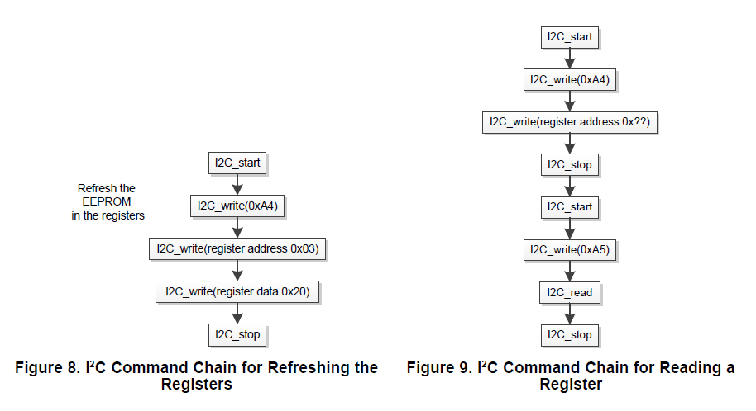

读操作

寄存器地址