**Technology**

Technology is present in practically any part of our life, so you should always be aware of the latest news. Technology is an area in which new advances and discoveries are made every day, don't miss the latest news, we take care of keeping you informed about it. Find out with us about all the new discoveries of this wonderful world

**NASA’s new rocket would be the most powerful ever. But it’s the software that has some officials worried.**

*NASA’s newest moon rocket is powered not only by four RS-25 engines that, combined,* ***unleash*** *2 million pounds of thrust, but by two solid fuel side boosters that burn six tons of propellant a second at such enormous temperatures that during a recent test fire in the Utah desert, the [flames turned sand to glass.](https://www.youtube.com/watch?v=EOyBNUJ5bA8" \t "_blank)*

When it launches, NASA’s Space Launch System rocket, a towering 322-foot behemoth — taller than the Statue of Liberty — would be the most powerful rocket ever flown, eclipsing both the Saturn V that flew astronauts to the moon and SpaceX’s Falcon Heavy, which has launched commercial and national security satellites as well as founder Elon Musk’s Tesla Roadster on a trip to Mars.

But as NASA moves toward the SLS’s first flight, putting the Orion **spacecraft** in orbit around the moon, it’s not the rocket’s engines that concern officials but the software that will control everything the rocket does, from setting its trajectory to opening individual valves to open and close.

*Computing power has become as critical to rockets as the brute force that lifts them out of Earth’s atmosphere, especially rockets like the SLS, which is really an* ***amalgamation*** *of parts built by a variety of manufacturers*

All of those components need to work together for a mission to be successful. But NASA’s Aerospace Safety Advisory Panel (ASAP) recently said it was concerned about the **disjointed** way the complicated system was being developed and tested.

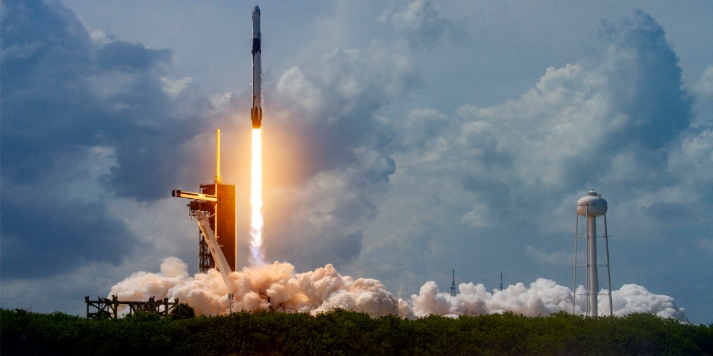Also troubling to the safety panel was that NASA and its contractors appeared not to have taken “advantage of the lessons learned” from the botched flight last year of Boeing’s Starliner spacecraft, which suffered a pair of software errors that prevented it from docking with the International Space Station as planned and forced controllers to cut the mission short.

NASA has since said that it did a poor job of overseeing Boeing on the Starliner program and has since vowed to have more rigorous reviews of its work, especially its software testing.

*The SLS software concerns are the latest red flags for a program that has struggled to overcome cost overruns and setbacks. A slew of government watchdog reports over the years have painted a troubling picture of mismanagement.*

The report chided Boeing, the main contractor, which it said “consistently underestimated the scope of the work to be performed and thus the size and skills of the workforce required.” 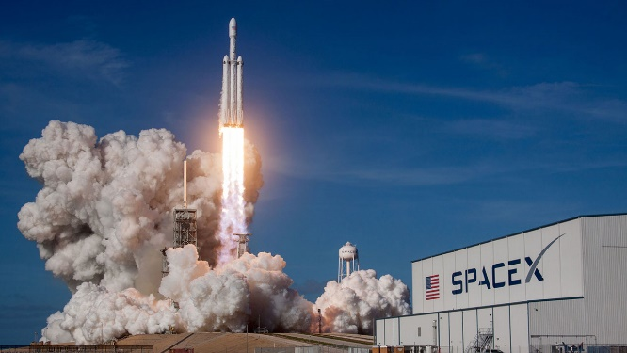

There was **perhaps** no better illustration of the significant role software plays in space flight, and how flaws in the coding can have severe consequences, than Starliner’s test flight.

NASA officials in charge of the SLS program said they are confident the testing protocols for the SLS rocket and Orion spacecraft are far more robust. For starters, the program is set up differently. Boeing owns and operates the Starliner spacecraft and uses it to perform a service for NASA — namely flying its astronauts to the space station.

**Opinión:**

The software has taken great importance in our lives and even more when people's lives depend on it, I believe that the most rigorous quality standards should be followed to ensure that no failure occurs since if so, people could suffer serious consequences. Quality standards must be improved and authorities must act precisely to ensure that these protocols are met.

<https://www.washingtonpost.com/technology/2020/10/31/nasa-sls-moon-rocket/>

# Waymo to launch fully driverless service to the public — a first just in time for the pandemic

*Waymo is launching fully driverless vehicles to the public, a milestone* ***achievement*** *for Silicon Valley’s self-driving car industry that comes during a global pandemic in which efforts to limit person-to-person contact have found a welcoming audience.*

The company, a part of Google parent Alphabet, said Thursday it is opening up its driverless ride-hailing service to riders in the Phoenix metro area, **enabling** anyone in the region to download its app and hail a ride without a driver in the front seat. It follows an extended public trial for the company’s ride-hailing service in which riders were able to use it for commutes, grocery runs and routine tasks, such as bringing their kids to school. *During that launch period, Waymo said, it gradually expanded its service and the capabilities of its vehicles — the vast majority of which were monitored by human drivers. Waymo spokeswoman Katherine Barna said the company was giving between 1,000 and 2,000 weekly rides before the coronavirus pandemic, 5 to 10 percent of which were fully driverless.*

So far, progress has been slow as companies have **delayed** their rollouts and extended their timelines, confronted by the challenge of programming cars to respond to the near-infinite stream of scenarios a driver could face. The pandemic threw a further wrench into the companies’ plans.

Waymo has long been seen as the industry leader in the space, trailed by competitors such as ride-hailing services Uber and Lyft, Amazon-acquired Zoox, General Motors’ Cruise and automakers pursuing autonomy, such as Tesla. 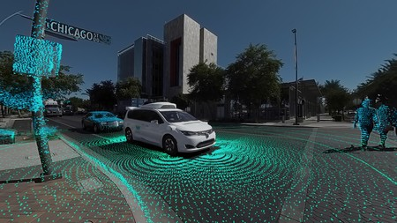

But the experiments have not been without incident. In 2018, a self-driving Uber fatally struck a **pedestrian** crossing a darkly lit street with her bicycle in Tempe, Ariz. The driver monitoring the car was looking at her phone, authorities said.

Waymo relied on a process including a “rigorous review of our safety readiness” before making the decision to launch driverless cars to the public, Barna said. The company informed the state’s transportation department of its testing plans before the **announcement**, she said.

**Opinion:**

Technological advances are more amazing every day and autonomous cars are becoming a reality, without a doubt they are a great technological advance but as in everything, with great power, comes great responsability (Uncle ben). Before they are released to the public, they must undergo rigorous tests to ensure that they will not put people at risk and that they will respond appropriately to the adversities of the cities.

<https://www.washingtonpost.com/technology/2020/10/08/waymo-driverless-rides/>

**International**

In a world as globalized as ours is today, it is important to stay abreast of the latest events worldwide. Don't miss out on the latest events, stay informed with us. We have the latest international news for you. In this section you can find the latest news from around the world.

# U.S. agrees to drop charges against former Mexican defense minister

*Weeks after arresting Mexico's former defense minister on drug trafficking charges, the United States has agreed to return Gen. Salvador Cienfuegos Zepeda to Mexico, a retreat from incendiary charges that sent a shock through U.S.-Mexico relations.*

The extraordinary decision to release Cienfuegos after a long-term, top-secret U.S. investigation allegedly revealed his ties to Mexico’s criminal underworld is an unexpected twist in one of the highest-profile drug-trafficking cases in recent decades. U.S. Justice Department officials depicted Cienfuegos’s arrest as a window into dramatic institutional corruption in Mexico. Mexican officials have not committed to trying him upon his return.

*The decision is sure to be greeted as a* ***triumph*** *in Mexico, where the government considered Cienfuegos’s arrest a violation of sovereignty. But it raises questions about the trade-off between U.S. investigations into Mexican drug trafficking and attempts to maintain a delicate bilateral relationship.*

“In recognition of the strong law enforcement partnership between Mexico and the United States, and in the interests of demonstrating our united front against all forms of criminality, the United States Department of Justice has made the decision to **seek** dismissal of the U.S. criminal charges against former Secretary Cienfuegos, so that he may be investigated and, if appropriate, charged, under Mexican law,” Attorney General William P. Barr and Alejandro Gertz Manero, his Mexican counterpart, said in a news release.

U.S. prosecutors asked to dismiss the case in such a way that it could be filed again, and they asserted, as they have previously, that the evidence against him is “strong.” They requested the judge not formally grant their request until Cienfuegos could be transported to Mexico by U.S. Marshals.

*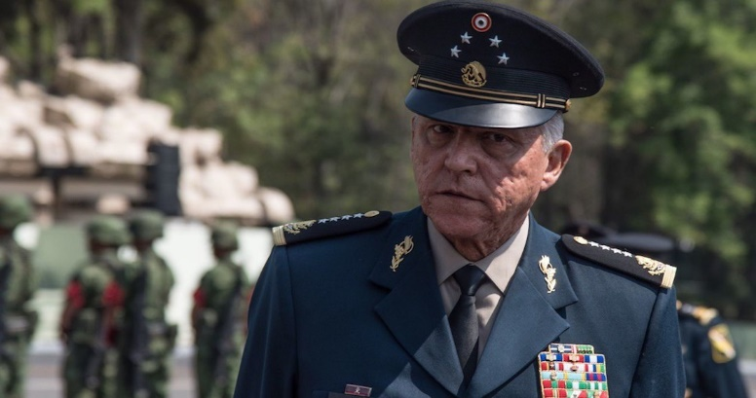The decision appeared to be an attempt to repair a growing breach in relations over Cienfuegos’s arrest. Mexican President Andrés Manuel López Obrador suggested the arrest might have been made “for political or other reasons” and accused the Drug Enforcement Administration of “****meddling****.”*

Mexican Foreign Minister Marcelo Ebrard told a news conference Tuesday that he had spoken with Barr twice in recent weeks to express Mexico’s “surprise and unhappiness” that it wasn’t notified in advance of the investigation. Ebrard said the deal to investigate Cienfuegos in Mexico did not imply impunity but “respect for Mexico and its armed forces.” He said cooperation on drugs “will be maintained” but added “that can only exist if there is respect for Mexico’s sovereignty.”

For decades, the United States relied on extradition to try Mexican drug traffickers in U.S. courtrooms, believing that they would never be held to justice in Mexico. Then last year the Justice Department arrested Genaro García Luna, the former public security secretary, in Miami for **allegedly** accepting millions in bribes from the Sinaloa cartel. And this year, the department moved against Cienfuegos.

*Both indictments were brought by prosecutors in the Eastern District of New York. But U.S. investigators did not inform the Mexican government of the cases until after the arrests, leading to mistrust. Some current and former U.S. officials believed that Cienfuegos’s arrest in particular might not have been worth* ***upsetting*** *the delicate but important relationship between the countries.*

It’s not clear that Mexico has done much to probe possible ties between Cienfuegos and drug traffickers. On Oct. 21, López Obrador indicated growing concern in Mexico about the Cienfuegos case. “Show us those operations of complicity if they have the proof,” he said. He said Mexico would open its own investigation only if it received credible evidence of wrongdoing. “We can’t allow someone to be judged only for political or other reasons if there is no proof.”

**Opinion:**

This issue is quite delicate, I consider that the arrest of General Cienfuegos was appropriated by the US government but I understand the response that the Mexican government gives of feeling excluded from the operation, I think that the best thing would be for both countries to collaborate in order to catch the criminals and bring them to justice, regardless of the country they are, I hope that General Cienfuegos carries out an adequate legal process and takes responsibility for the crimes committed and that he does not go unpunished as on previous occasions.

<https://www.washingtonpost.com/world/the_americas/mexico-cienfuegos-drug-charges-dropped/2020/11/17/430bd056-291f-11eb-92b7-6ef17b3fe3b4_story.html>

# Protests turn to celebrations as Peru’s interim president offers resignation

*Facing furious nationwide protests and growing international pressure, interim President Manuel Merino resigned on Sunday, less than a week after he was inaugurated to replace ousted popular president Martín Vizcarra.*

The resignation set Peruvians up for their fifth president in five years, as the South American nation faced its worst constitutional crisis since the fall of Alberto Fujimori’s tainted presidency two decades ago.

*For millions of Peruvians, particularly the young, Merino had become the face of a corrupt political class that has entrenched itself in Congress and sought to stop Vizcarra’s attempts to end their careers through sweeping changes. The mass protests that forced Merino to step down were less about defending Vizcarra than expressing public outrage at the political forces that had removed him.*

In a brief televised speech, Merino said his de facto cabinet would continue while Congress worked to name a new president. But it was unclear who he was talking about; at least 11 ministers, including the heads of the ministries of interior, justice, trade, and energy and mines, announced their resignations, some on Twitter, overnight.

Peru has been in **turmoil** since the scandal-racked Congress removed Vizcarra on Nov. 9 over unproven claims that he accepted bribes when he was a regional governor. Vizcarra is widely seen here as a reformer; he has denied wrongdoing and has said consistently that he will cooperate fully with prosecutors. On Saturday, a judge ordered him not to leave the country.

Two demonstrators were killed and scores were injured Saturday night as officers in riot gear used tear gas and other means to attempt to quell largely peaceful protests in Lima, the capital, and other cities across the Andean nation

The political chaos has unfolded as Peru struggles against one of the world’s most lethal coronavirus outbreaks. The country has reported more than 934,000 cases and 35,000 deaths from covid-19

Like his cabinet, made up largely of aging far-right politicians, Merino had appeared incapable of **comprehending** the fury of the protesters — many of them millennials or younger in a country where the median age is just 31 — or their chant of “They messed with the wrong generation.”

Merino had vowed to remain in office. But as protests mounted, he relented on Sunday. Before his resignation speech, his **whereabouts** had been a mystery amid a growing power vacuum.

Vizcarra remains popular for his anti-corruption crusading. Polls show that 4 out of 5 Peruvians opposed his ouster. A similar majority favored prosecutors investigating him, but only once he left office. He was due to step down at the end of his term next July.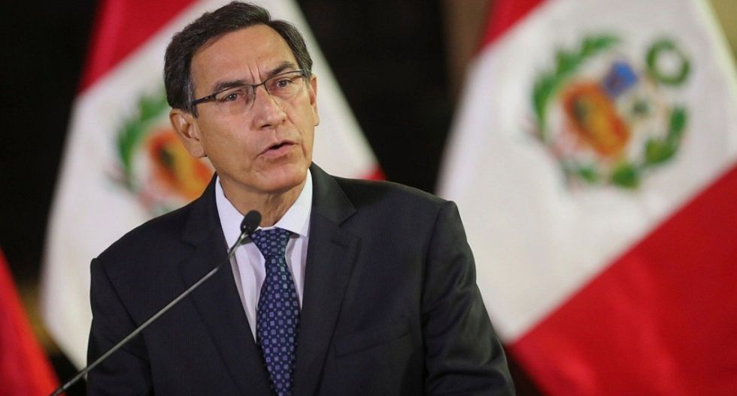

Vizcarra’s ouster has been widely interpreted as an attempt by a corrupt political class to stop his policy changes that threatened their grip on power — and their ability to monetize that power through kickbacks, influence-peddling and populist legislation that favored shadowy economic interests including illegal mining and the informal taxis and minibuses that help make Peru’s roads so ­lethal.

Laws that Vizcarra passed in the teeth of congressional resistance included banning candidates with convictions from running for office and ending consecutive reelection for members of Congress. He was trying to curb the parliamentary immunity that has allowed 68 of the 130 lawmakers to hang on to their jobs despite being the targets of criminal investigations for ­offenses ranging from asset-laundering to homicide.

“The members of Congress had a short window to save their corrupt interests, including reversing the education reforms,” Maldonado said. “They **miscalculated** that the pandemic would mean that people would only protest online and not take to the streets. Obviously, they made a mistake.”

**Opinion:**

What is happening in Peru is a shame, people are not coming out to protest to defend Vizcarra, they are coming out to protest because what the Congress has been doing is totally undemocratic. The elections in Peru are scheduled for April of next year but the interests of the members of Congress made them make these kinds of decisions that go against everything that democracy represents.

<https://www.washingtonpost.com/world/the_americas/peru-president-merino-resigns-vizcarra/2020/11/15/47cb0a54-275c-11eb-92b7-6ef17b3fe3b4_story.html>

**Glosario:**

**Technology**

**Article 1:**

* **Unleash:** to suddenly release a violent force that cannot be controlled.
* **Spacecraft:** a vehicle used for travel in space
* **Amalgamation:** the process in which separate organizations unite to form a larger organization or group, or an organization or group formed in this way
* **Disjointed:** not well connected or well ordered
* **Perhaps:** used to show that something is possible or that you are not certain about something

**Article 2:**

* **Achievement:** something good that you have done that was difficult
* **Enable**: to make someone able to do something
* **Delayed:** to make something happen at a later time than you planned
* **Pedestrian:** a person who is walking
* **Announcement:** something that someone says officially, giving new information about something

**International**

**Article 1:**

* **Triumph:** an important success
* **Seek:** to try to find or get something
* **Meddling:** the act of trying to change or have an influence on things that are not your responsibility, especially by criticizing in a damaging or annoying way.
* **Allegedly:** to say that someone has done something illegal or wrong without giving proof.
* **Upsetting:** making someone feel worried, unhappy, or angry

**Article 2:**

* **Entrenched**: to place within or surround with a trench especially for defense.
* **Turmoil:** a state of confusion, uncertainty, or disorder.
* **Comprehending:** to understand something completely.
* **Whereabouts:** the place where a person or thing is.
* **Miscalculated:** to calculate an amount wrongly.

**Referencias.**

* Christian Davenport (Oct 31, 2020). “NASA’s new rocket would be the most powerful ever. But it’s the software that has some officials worried”. *The Washington Post.* <https://www.washingtonpost.com/technology/2020/10/31/nasa-sls-moon-rocket/>
* Daiz Siddiqui (Oct 08, 2020). “Waymo to launch fully driverless service to the public — a first just in time for the pandemic”. *The Washington Post.* <https://www.washingtonpost.com/technology/2020/10/08/waymo-driverless-rides/>
* Kevin Sleff, Mary Beth Sheridan, Matt Zapotosky (Novembre 17, 2020). “U.S. agrees to drop charges against former Mexican defense minister”. *The Washington Post.* <https://www.washingtonpost.com/world/the_americas/mexico-cienfuegos-drug-charges-dropped/2020/11/17/430bd056-291f-11eb-92b7-6ef17b3fe3b4_story.html>
* Simeon Tegel (November 15, 2020). “Protests turn to celebrations as Peru’s interim president offers resignation”. *The Washington Post.* <https://www.washingtonpost.com/world/the_americas/peru-president-merino-resigns-vizcarra/2020/11/15/47cb0a54-275c-11eb-92b7-6ef17b3fe3b4_story.html>